Newton Primary School Closure Contingency Learning Plan
Primary 6 18.5.20 - 29.5.20

Green – Recommended tasks to prioritise if you wish.
Over the following period of time these activities offer your child the opportunity to enhance and practise the skills they have been developing in class as well undertake a variety of differing tasks of their choosing. They also give you an idea of the type of things you can perhaps task your child with should they complete all the tasks on this sheet. There are also relevant and appropriate websites and apps which may be of help.
Numeracy and Maths  Money - Profit and Loss  Time for Task - 30 minutes (per challenge set)  Watch the following video, about profit and loss:  https://www.youtube.com/watch?v=wCds6YxPUv8  Profit: A financial gain, especially the difference between the amount earned and the amount spent in buying, operating or producing something.  Loss: An amount of money lost by a business or organisation. This happens if the money spent is more than the money earned.  Try to calculate profit and loss using the following challenge cards. If you find the SPICY straight forward, then try HOT for an extra challenge.  Profit and Loss - SPICY  Profit and Loss - HOT |  |  | Numeracy and Maths  Money Calculations - Addition and Subtraction  Time for Task - 30 minutes (per worksheet)  It is important that we continue to practise the four operations and the skills we have learned this year. Having been able to add and subtract decimal numbers, we are now going to look at the same processes with MONEY.  Below are worksheets to complete:  Worksheet 1 gives you a chance to recap addition and subtraction with decimals:  Remember to carry when you are adding and exchange when you are subtracting.  Worksheet 1  Worksheet 2 gives you the chance to apply what you know about addition and subtraction with money word problems.  Money Problems - SPICY  Money Problems - HOT |  |  |  | Mental Maths  Daily Practise  Time for Task - 15 minutes each day  It is important to continue to have regular mental maths practise - a little a day makes a big difference.  Please access the mental maths challenge folder and complete either a GREEN or ORANGE challenge activity.  Mental Maths Challenge Folder  Write the answers down in your jotters, on a piece of paper or you can use a word document.  Additionally, you can log on to the online programmes we currently have access to:  Times Table Rock Stars  https://play.ttrockstars.com/login/82669  Play in the studio to achieve your Rock Status  and challenge your friends (or teacher) to Rock Battles.  Sumdog  https://www.sumdog.com/user/sign_in  Look out for weekly P6 Challenges and Competitions!  **From 15th - 21st May there is a Stirling wide Sumdog contest. How high up the leaderboard can your class get?**
Numeracy and Maths  Probability  Time for Task - 45 minutes  Probability is the chance of an event happening  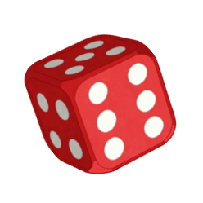  At the moment, we are all aware of the risk of catching Coronavirus (COVID-19). Read this article about the risk. It uses dice to show the probability of catching it.  In the attached link you’ll find a presentation about probability - read through this then answer the questions - there are some answers to help you.  https://drive.google.com/drive/folders/1_Lfyhh7tINPREafDHekY4lrvXduwrrEA?usp=sharing  Thanks to Mr Edwards for sharing this task! | Reading  Comprehension Questions  Time for Task - 30 minutes  To celebrate Outdoor Classroom Day 2020, please read this text titled: 'All about Art and Nature'  On the pages following the extract, you will find a series of comprehension questions about what you have read. Answer these in your jotter or on a piece of paper.  At the end of the question pages, you will find the answers so that you can mark your own work or ask someone at home to mark it for you.  Remember to try to read a text of your choice for at least 20 minutes every day. This could be a book, magazine, webpage, newspaper. |  |  |  |  | Writing  Personal Journal Entry  Time for Task - 50 minutes (10 minutes per day)  A journal is like a diary. You enter daily news, thoughts and opinions you have.  Challenge yourself with writing an entry a day into a journal for 5 days (school week). You may write this in your jotter or you could create a document on Google Drive to note down your thoughts and activities each day.  This journal should focus on what life is like in lockdown.  Think about:  - how school is similar or different  - what it is like being at home with your family  - daily activities, tasks, what you have been up to  - how you feel each day  At the end of each entry I want you to write down 1 thing that made you feel happy that day.  Ext: Can you share your entries on Google Drive?
Writing - Poetry  Cinquain Poem  Time for Task - 30 minutes  Read about Cinquain Poems, see some examples and learn how to create your own by clicking on this link:  https://www.poetry4kids.com/lessons/how-to-write-a-cinquain-poem/  Have a go at creating your own Cinquain Poem, based on a topic of your choice. You could choose sport, food, games, film/TV, celebrities...You may even write about your time on lockdown.  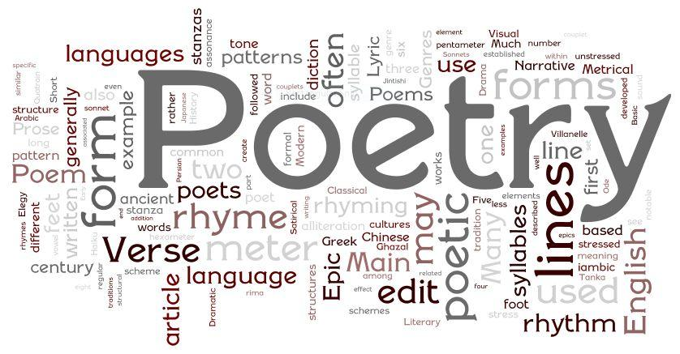 |  |  | Literacy  Pobble365  Time for Task - 40 minutes  This website https://www.pobble365.com/ produces a new image every day with a selection of activities to go alongside it, such as questions to get you thinking, sentences to fix/up level, story starters to finish and drawing challenges to complete.  Here is one to try, called ‘Superhero Treats’:  https://www.pobble365.com/superhero-treats  Record your ideas/answers in your jotter.  Ext: Access this website on a different day and try out the tasks linked to a new picture. Alternatively, click the ‘Pick a Day’ link at the top of the webpage and you can choose any picture you like! |  |  |  |  | PE  Virtual Sports Day  Time for Task - 90 minutes  (organising and event may be split)  Unfortunately, we will be missing our annual school Sports Day this year. But no need to miss out! Why not host your very own Sports Day for your family?  The attached document gives you some creative ideas to try at home https://drive.google.com/open?id=1lfdyGK3i6nyf8Nf1edrIusVH0V3XMabQRfz_Ei4jwqM  Ext: Can you upload pictures of your day to Classroom?
Spelling and Grammar  Time for Task - 20 minutes (as often as possible)  Login to Sumdog and complete the spelling and grammar tasks:  https://www.sumdog.com/user/sign_in  Keep an eye out for P6 Spelling Challenges and Competitions!  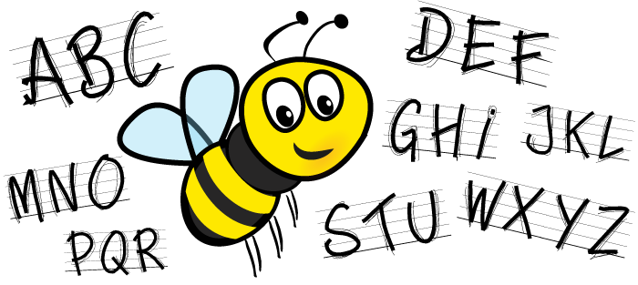  Try Doorway Online Active Spelling Speller 2 to practise tricky words: https://www.doorwayonline.org.uk/activities/speller/  Remember you also have access to Nessy where you can work on your individual targets: https://www.nessy.com/us/ |  | Outdoor Classroom Day - Thursday 21st May  Outdoor Adventures  Who can camp in their back garden?  If you have a tent, can you pitch it and spend the night in your garden? Make a camp with all you will need to stay in the outdoors for a day and a night.  If not, have you tried star gazing? How many stars can you see? Research the constellations. Which ones do you think you can spot around Dunblane?  For more outdoor activities to try out, why not download the Nature Passport App if you have access to a portable device.  Here, you can unlock badges for engaging in different outdoor experiences with your family ‘team’. It might be a good way to keep your daily walks interesting and to learn new things about the natural environment.  https://outdoorclassroomday.com/resource/play-explore-learn-nature-passport/ |  |  |  |  |  |  | Art  Andy Goldsworthy  Time for Task - 60 minutes+  Learn about the famous British artists, Andy Goldsworthy, by watching the following PowerPoint:  https://drive.google.com/open?id=1dn4VpqZAMVHbjrary3efFv2dHV4Fcbtb  Inspired by the work of Andy Goldsworthy, create a piece of environmental art or a sculpture using natural materials.  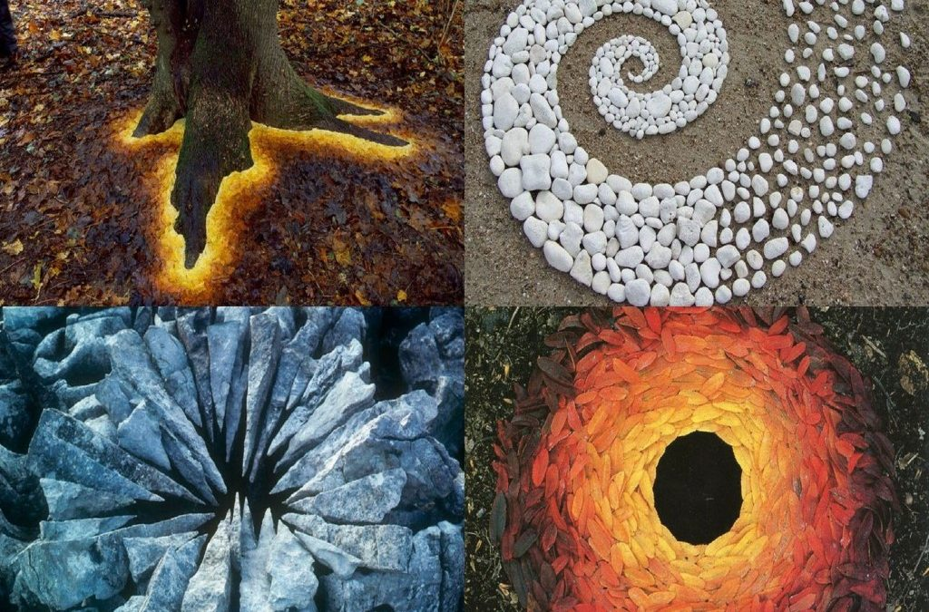  You could collect and arrange different coloured leaves to create patterns, weave twigs and branches together to form a structure or stack pebbles in an interesting formation.  Be as creative as you can and share a picture of your masterpiece on Google Classroom!
FRENCH/SPANISH  Weekly Sticky Note Challenge  Time for Task - 20 minutes (daily practise 5 minutes)  Following on from the food vocabulary you learned last time, can you extend your learning to include more items in your home?  The Challenge:  Use sticky notes (or bits of paper and blu tack/Sellotape) to label items/places in French (and Spanish if you wish!)  Say the word out loud every time you spot the label.  By the end of the week, you will most likely remember the word by heart!  Week 1: Label the rooms in your house  Week 2: Appliances in your kitchen |  |  |  | Relationships and Sexual Health Education  Lesson 3 - Feelings and Puberty  Time for Task - 30 minutes  Use the following PowerPoint as a prompt to think about and discuss feelings and how they might change during puberty.  https://drive.google.com/open?id=1JPk28K49MXA4SSiks2XTRd1S3guWoOcZ | Music  Film Music  Time for Task - 20 minutes (snippets of film music)  Mrs Moore, our music specialist, has kindly shared some ideas to enjoy music at home.  These ideas are based on each level therefore, children across P5, 6 and 7 will perhaps complete similar activities.  This week please listen to a piece of film music.  Can you describe what you think might be happening in the film by the soundtrack?  It may be that you have recently watched Titanic from our previous learning context and can think about the changes in music as the story unfolds.
Learning Context - Healthy Heroes  Body Systems Research  Time for Task - 2+ hours (you may split this over a few days)  Watch this fun introduction to the human body systems:  https://www.youtube.com/watch?v=3Zp6qPIJsAo  (It is an hour long as it goes on to cover the different organs in the body - don’t feel you need to watch it all!)  As part of this context, we are focusing on the 5 key body systems: circulatory, respiratory, skeletal, reproductive, skeletal.  TASK:  Research each of these body systems and create a PowerPoint presentation about them. You may wish to work collaboratively on this with a friend.  Include the following information about each of these 5 systems:  - The organs that make up the system (include pictures)  - what the body system does for the body  - The problems that can develop within the system  - Ways to keep the system healthy  Ext: Research an additional body system to add to your PowerPoint (there are 11 in total to choose from!)  Share your PowerPoint with your teacher on Google Drive. |  |  | Learning Context - Healthy Heroes  Food Hygiene  Time for Task - 90 minutes (you may split tasks up)  View the following presentation to learn a little more about food hygiene:  Food and Health PowerPoint  The following videos will also support your learning in this area:  Contamination Safe Food Storage  Tasks:  - Try out this game to see if you can store the items safely, in the right areas of the fridge: Fridge Storage Game  - Create a ‘Food Safety’ poster to display in your kitchen. Use the key facts from the PowerPoint to help.  - Play Cookin' Castle a fun game to try out everything you have learned about food safety and healthy eating! |  |  |  |  |  |  | Learning Context - Healthy Heroes  Healthy Eating/ Food Preparation  Time for Task - 1 hour+  (may vary depending on preparation and cooking time)  Last week you planned a healthy menu for a day.  Using your menu plan, can you create a simple, healthy lunch or dinner for your family.  Ask nicely for support if required. I am sure your parents would appreciate the effort!  Make sure you refer to the ‘Eatwell Guide’ to consider the appropriate proportions of the different food groups in your menu and current dietary advice. Make sure you also consider food hygiene to reduce risk of contamination as well!  E.g. Are there enough fruit and vegetables included? Have you included enough to drink?  https://www.nhs.uk/live-well/eat-well/the-eatwell-guide/  https://www.foodstandards.gov.scot/downloads/Eatwell_Guide_Booklet_-_new.pdf  Ext: Can you tidy up after yourself? Wash any dishes you have made, load or unload the dishwasher, wipe the work surfaces?  What products do you use around the house to make sure surfaces and dishes are clean?

