To Primary 3 and their parents,
PLEASE READ, THANK YOU
These activities offer your child the opportunity to enhance and practise the skills they have been developing in class as well as undertake a variety of differing tasks of their choosing. They also give you an idea of the type of things you can perhaps task your child with should they complete all the tasks on this sheet. There are relevant and appropriate websites and apps which may be of help. We encourage you to assist your child in uploading any work onto Google Classroom should they wish to share it. Some of the boxes have been shaded green – these are activities you might choose to prioritise.
Miss Porter and Miss Myles.
LITERACY - Writing  30 minutes - 1 hour in total. This could include planning what to write and checking it over.  theself.club/future-self  Write a letter to yourself in the future using the website above. It will be like a time capsule but in a letter! You can copy and paste the link to send us a copy on Google Classroom.  Remember which features we normally use in a letter:  - Begin with ‘Dear’ and your name (since it is to yourself!) and end with ‘Yours sincerely,’ and your name again.  - Try to write in separate paragraphs. Miss a line whenever you start talking about something new.  - Use connectives to make some of your sentences long.  - Talk about your thoughts and feelings.  - Write about your life in lockdown and how it is different.  Mild: Underline every capital letter and full stop with coloured pencil.  Medium: Use one exclamation mark and one question mark in your story.  Hot: Use three adverbs (like the ones in the next task -->) | LITERACY - Grammar  20 - 30 minutes approx.  Recap: An adverb is a word that describes a verb (an action or a doing word). An adverb usually ends in ‘ly’.  For example;  • He ate his breakfast quickly.  The word quickly is an adverb as it tells us how he ate his breakfast. It makes the sentence more interesting.  Add an adverb into the following sentences.  - The lion roared.  - The baby laughed.  - I ran for the bus.  - Tom jumped over the fence.  - Dave kicked the ball.  - Susan was singing in the shower.  - The choir sang in assembly.  - David wrote the sentences in his book.  - Mrs Smith placed the book on the table.  - Mr Filch ate the entire cake. | LITERACY - Reading/Talking & Listening  30 - 45 minutes approx.  When reading it can be interesting to imagine what might have happened if the characters made different choices. For example, what would’ve happened to Goldilocks if she had decided not to eat the Three Bears' porridge?  Choose an alternative ending for either Jack and the Beanstalk or Three Little Pigs. Think about the key events in the story and how the characters' decisions could change the ending. You could write your alternative endings as a story or record your thoughts and upload them to Google Classroom as an audio or video clip.  You can remind yourselves of the stories here:  Jack and Beanstalk : https://www.youtube.com/watch?v=zurz-pL-uzw  Three Little Pigs:  https://www.youtube.com/watch?v=CtP83CWOMwc
LITERACY - Reading  30 - 45 minutes approx.  A reading comprehension has been set as a task on the Google Classroom in the ‘Classwork’ tab.  When completing a reading comprehension remember:  - Read the passage once to gain an understanding of the story.  - Read a second time.  - Answer in full sentences using full stops and capital letters. This means that the sentence should make sense on its own, we shouldn’t need to read the question to understand the answer sentence. | LITERACY- Spelling  20 minutes, 2 or 3 times a week.  Spend 10 minutes on Nessy to warm up your spelling brain! Access Google Classroom to see the spelling word banks and choose a challenge level. Practise your words using active spelling strategies (like the ones in the back of your red jotter) and ask someone in your house to give you a spelling test once you think you’re ready. | LITERACY – Languages  45 minutes approx, depending on whether hand-drawing.  Use the flashcards on Quizlet to learn the names of the family in french.  https://quizlet.com/gb/422011775/family-french-french-family-flash-cards/French family tree  Create a family tree of the members of your family written in French. The app ‘Popplet’ is useful for making diagrams, or you could hand-draw it. Be creative and use bright colours, pictures and labels.  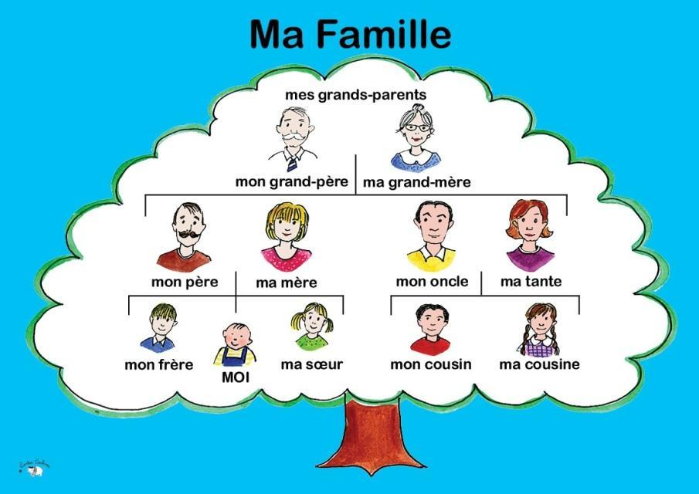
MATHS/GRAMMAR - Sumdog online learning  20 minutes approx, as often as you like!  Complete a variety of reading and maths challenges set on Sumdog. New challenges will be posted every 2 weeks for both Maths and Grammar by your teacher. | MATHS - Time  15 - 20 minutes approx.  Reading timetables  Station Train A Train B  London 9 o’clock 2 o'clock  Birmingham -- 4 o’clock  Manchester 10 o’clock --  Liverpool 11 o’clock 7 o’clock  (1) How many trains run on this track every day?  (2) Which station does Train A not stop at?  (3) Which station does Train B not stop at?  (4) How many hours does Train A take to travel from London to Liverpool?_____hours  (5) How many hours does Train B take to travel from London to Liverpool?_____hours | NUMERACY- Fractions  20 - 30 minutes approx.  Folding paper exercise  - Gather several pieces of paper, it doesn't matter if they are different sizes.  - Take a piece of paper at a time and fold it once. unfold it and label each half ½ .  - Fold the next piece of paper twice and label the equal thirds ⅓. The folds should be as neat as possible to make sure the sections are equal.  - Continue to fold pieces of paper using one more fold each time until you reach tenths 1/10. Label the equal parts.  Top tip. Your numerator (the number at the top should always be 1 in this activity as we are dividing 1 object into equal parts. The denominator (the number at the bottom) is how many equal parts you have after you completed a fold.  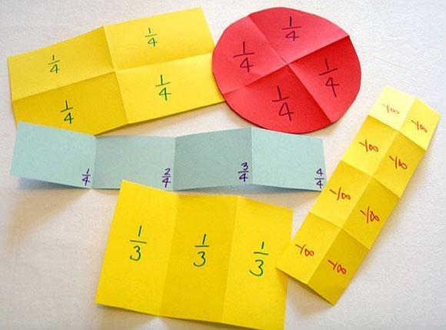
HEALTH AND WELLBEING - RSHP  As much time as you like.  Explore the powerpoint “All our families are different” https://rshp.scot/wp-content/uploads/2019/07/My-Family-Slides.pptx  Choose a story book you have recently read and explore the family members in the book. Who is in the story? What do family members do to help look after each other? Draw a portrait of your family or write a paragraph about the members of your family.  Finally, watch the youtube video on different types of families:  https://www.youtube.com/watch?v=ZcpZKXPnbZs&feature=youtu.be | HEALTH AND WELLBEING - P.E.  20 - 30 minutes approx.  Play 'climb the ladder' to practise your throwing skills.  1. Place 3 targets on the floor in a line and mark a starting point. They should all be 1m apart from each other (use a tape measure if you have one!)  2. Find a small object and use it to try and hit the first target from the starting point.  3. When you have managed to hit the first target, move on to trying to hit the next target.  4. How many throws does it take to hit all three targets? Play against someone else and make it a competition!  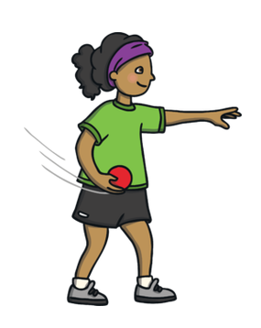 | RME- Values  20 - 30 minutes approx, or longer if the whole family is involved.  In Newton Primary, the school values are Respect, Responsibility, Kindness, Fairness and Unity.  Values are things that we see as important and qualities that guide us in life towards making good choices.  Interview members of your family and discuss your values as a family. Design a poster about your family values and upload the picture to Google Classroom.  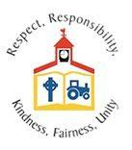
CONTEXT- TOYS AND FORCES  This could take one 30 minute session or several sessions depending on designs and enthuasiasm!  Watch this video from the James Dyson Foundation about marble runs.  https://www.youtube.com/watch?v=IN0Wn0XgPXQ#action=share  Your challenge is to engineer a marble run which takes the marble 60 seconds to go from beginning to end, no more, no less!  By using different materials you can increase the friction which can slow down the force of gravity. Which materials create the most friction? | CONTEXT-TOYS AND FORCES  20-30 minutes approx.  Watch the BBC Bitesize clip “Weightlessness in space”-  https://www.bbc.co.uk/bitesize/clips/zbm76sg  In a space station, you can no longer feel the effects of the gravitational pull from the Earth. Where there is no gravitational force, you cannot tell up from down.  Create a dance based on the effects of the absence of gravity. How would this affect your ability to move? Would your movements be quick and sharp or slow and graceful? | CONTEXT-TOYS AND FORCES  20 minutes approx.  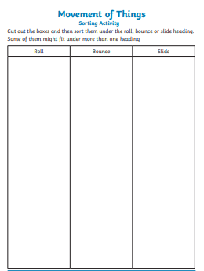  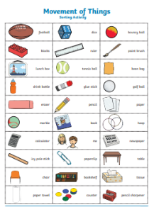  Complete the ‘Movement of Things’ sorting activity available on Google Classroom in the ‘Classwork’ tab. Sort the pictures by either cutting and sticking, or writing a list. The three categories are roll, bounce and slide.

Suggested web sites and apps:
- Maths with Carol Vorderman https://www.themathsfactor.com/
- Literacy with David Walliams https://www.worldofdavidwalliams.com/
- Cooking https://www.jamieoliver.com/features/category/get-kids-cooking/
- Horrible Histories https://www.bbc.co.uk/cbbc/shows/horrible-histories
- Free Children’s Audio Books https://www.amazon.co.uk/Childrens-Books-Audiobooks/s?rh=n%3A69%2Cp_n_binding_browse-bin%3A308724031
- Range of resources available for free from (free 1 month membership available) https://www.twinkl.co.uk/
- Literacy Shed https://www.literacyshed.com/home.html
- Mindfulness https://www.headspace.com/meditation/kids
- Coding http://www.scratch.mit.edu
- NESSY spelling http://play.nessy.com
- TOPMARKS https://www.topmarks.co.uk/maths-games/ (choose from games under the 7-11 tab)
- BBC Bitesize (Choose 1st level Scotland, there are resources for all curricular areas) https://www.bbc.co.uk/bitesize/levels/zgckjxs
- Snappy Maths http://www.snappymaths.com/
- Cosmic Kids Yoga https://www.youtube.com/user/CosmicKidsYoga
- Joe Wicks Body Coach Schools https://www.youtube.com/watch?v=d3LPrhI0v-w&list=PLyCLoPd4VxBuxu3sLztrvWFehzv-LnR2c
- BBC Newsround https://www.bbc.co.uk/newsround/news/watch_newsround

