***Newton Primary School - Closure Contingency Learning Plan - Primary 2***



Task you may wish to prioritise

|  |  |  |
| --- | --- | --- |
| **Outdoor Classroom Day** will take place on **Thursday 21st May** this year. It is a global movement to inspire and celebrate outdoor play and learning, at home and at school. Usually we would organise a special day outdoors for the children. As this is not possible this year, we have decided to try and incorporate some outdoor activities into our learning grid over the next two weeks. If you would like some more activities/ideas, then follow the link to the Outdoor Classroom Day website - <https://outdoorclassroomday.com/resources/lesson-ideas/> Miss Kenny and Miss McDonald | | |
| **Literacy – Reading** (as long as you would like)  Listen to the online audio book - *‘The Day the Crayons Quit’* - <https://www.youtube.com/watch?v=489micE6eHU>    Discuss the complaints that the crayons had. How did Duncan help each colour feel more appreciated? You are going to appreciate the crayons too! Draw a picture of anything you wish, it can be your favourite toy, the view from your window or even your family! Can you colour your picture using different colours e.g. instead of brown hair, make it pink etc? Post your picture to our **Primary 2** **Google Classroom** when you are done.  **Just for fun:** Play a game of word association. Choose a random colour and see how many related items you can come up with e.g. yellow – sunflower, sun, buttercup, custard etc. | **Literacy – Writing** (approx. 30 mins)  Using the Power Point ‘*The Haunted House!’* on our **Primary 2 Google Classroom** as a stimulus write a short descriptive story. You can also choose your own interesting house picture to write about.  When you are writing, remember to include:   * Finger spaces * Capital letters and full stops * A beginning, middle and end to your story   Newport Primary School - Maths Week ScotlandHave a look at the chilli challenge on the Power Point for an extra challenge in your writing. When you complete this upload it to our **Primary 2 Google Classroom** and ***you will receive a printable reward from your teacher.*** | **Literacy – Grammar** (approx. 30 mins)  Watch the video clip to remind yourself about alphabetical order - <https://www.bbc.co.uk/bitesize/topics/zp7mn39/articles/zfp66v4>  Using a dictionary that you have at home, complete the activity *‘Use a Dictionary’* on our **Primary 2 Google Classroom.**  You will need to:   * Look up the words * Complete the chart * Write the correct spellings in the last column |
| **Literacy – Phonics**  (approx. 15 - 20 mins, 2 – 3 times a week)  The ‘Oxford Owl’ website has lots of free Read Write Inc. Phonics resources to help your child continue learning, including eBooks, practice sheets, Ditty sheets, slideshows, and parent films.  Follow the link – <https://home.oxfordowl.co.uk/reading/reading-schemes-oxford-levels/read-write-inc-phonics-guide/>  Access our **Primary 2 Google Classroom** where you will find differentiated phonics sounds to revise and introduce for your child. | **Literacy – Questions** (approx. 30 – 40 mins)  Have a look at the *‘Would you Rather?’* Power Point on our **Primary 2 Google Classroom** and answer the questions with your parent/carer or siblings.  Can you then create your own style would you rather questions?  **Extra challenge** – Can you make your questions into a game? E.g. a boardgame, a pick-up card game, a quiz game etc. | **French** (approx. 15 – 20 mins)  Can you recognise and colour the French flag correctly? Complete the activities on **our Primary 2 Google Classroom.**   * ‘Cherchez les differences’ (Spot the difference) – Spot the 5 differences between the two French flags * ‘French flag colouring’ - Print out the flag colouring activity if you can, if not, draw and colour your own French flag   **Extra Challenge -** Create a shield, logo or poster that displays the French motto ‘Liberte, Egalite, Fraternite' (Liberty, Equality, Fraternity). |
| **Numeracy -** Mental Maths (approx. 15 - 20 mins daily)  Log-in to [www.sumdog.com](http://www.sumdog.com) using the log-in details which were sent via ParentMail on 25.3.20  **Week 1**  We have signed you up for the Stirling and Clackmannanshire Competition which goes live on **Friday 15th May** until **Thursday 21st May.** For every student who answers 100 questions they will receive an item for their Sumdog house. Prizes are also available in the form of class and individual certificates for highest amount of correct answers.  **Week 2**  Complete the differentiated challenge set for you. This challenge will begin on **Friday 22nd May at 9am**, and finish on **Friday 29th May at 3pm.** | **Numeracy –** times tables (arrays) (approx. 30 – 40 mins)  You will have been practising your 2 times tables at home. It is important that children understand their times tables through visual representations. Arrays are a great way to develop their understanding of times tables. Watch the video below to learn more about arrays - <https://www.bbc.co.uk/teach/class-clips-video/maths-ks1--ks2-how-to-use-arrays-to-multiply/zrks382>  Can you use materials from your garden to create arrays to represent your times tables? Have a look at the bottom of our grid for an example.  **Extra challenge** – If you feel confident with the 2 times table, why not try other times tables? | **Numeracy –** Fractions: Halves and quarters of numbers/quantities (approx. 30 mins)  Continue to practise fractions of quantities/numbers. Think about the strategy of grouping objects and splitting objects equally.  Use the sums on the worksheet ‘*Halves and Quarters Fractions’* in our **Primary 2 Google Classroom** and work them out actively by using things that you might find in the garden e.g. stones, twigs etc. or even chalk.  **Extra challenge –** Play the *‘Fraction Forest Game’* (saved in our **Primary 2 Google Classroom**) or make your own fractions game – be as creative as you like! |
| **RME** (approx. 30 mins or as long as you would like for decorating)  Watch the video story about ‘The Good Samaritan’  Link - <https://www.bbc.co.uk/bitesize/clips/zcyr87h>  Discuss the message in the story (we call it the moral of the story). The story is about helping people in need. Think about people you can help, what can you do to help them? Can you help your mum with the dishes? Can you help your grandparents by taking them food packages? Draw around your hand or use the printable template on our **Primary 2 Google Classroom** and write down 5 people, one in each finger, who you can help. Then decorate your hand and make it look good.  **Extra challenge -** Think about and discuss local charities like Start-up Stirling – why is it important to help local charities? Can you do anything to help at all? | **Expressive Arts – Drama/Role Play** (as long as you would like)    Make a little corner of your bedroom into an estate agents – pretend you are trying to sell houses to your parents/siblings. What kind of things might you say to persuade them to buy a house from you?  Have a look at some of the inspirational images on our **Primary 2 Google Classroom** and the‘*Property Information Sheet’* to help you set up your role play area. | **Art –** Explore Patterns in Nature (as long as you would like)  Choose a leaf, flower, pinecone, stick, or stone, and bring it home to examine. If you cannot get outside, look online, or find a picture. Take time to observe and talk about the patterns you see. What shapes/ colours can you find? How are they organized? Why might these patterns exist? Then, draw/ recreate the patterns. What do the patterns make you think of? What other things in the world have you seen that are similar? Finally, have fun, and make your own picture with the same shapes and colours!  Check out the following website link to watch the accompanying video - <https://www.wildernesskids.net/activities-2> or have a look at the bottom of our grid to see an example. |
| **Health and Wellbeing – Relationships, Sexual Health and Parenthood** (approx. 20 mins)  Learning Intention – *I can begin to understand ways in which families may differ and that there are a variety of people who may care for us*  Use the PowerPoint ‘*Every Kind of Family’* on our **Primary 2 Google Classroom** as a discussion starter with your child. Talk about how there are lots of different kinds of families that children may be a part of.  You could even watch some episodes on ‘Our Family’ on BBC iPlayer which follows the lives of eight young children and their families -<https://www.bbc.co.uk/iplayer/episodes/b07950p4/our-family>  **Extra Challenge** – Can you create your own family tree? | **Health and Wellbeing - PE** approx. 30 mins)  Continue to access Joe Wicks, Cosmic Kids and Go Noodle (links below) to keep yourselves fit and active.  You can find some extra challenges on our **Primary 2 Google Classroom** which can be completed with minimal resources and the whole family can take part in – you could even do these outside, if the weather is nice! | **Health and Wellbeing – Family Time – Movie Night**  As much as it is important to continue to work and learn it is also important to focus on our mental health and spending quality time with our families.  As a family, you can follow the step-by-step guide to add some fun and learning into a family movie night. Have a look at the bottom of our grid for the guide. Enjoy! |
| **IDL – Houses and Homes – Animal Homes** (approx. 20 mins)  Look at the PowerPoint *‘Animal Homes’* saved in our **Primary 2 Google Classroom.**  Answer the questions on the last slide with a parent/carer. | **IDL – Houses and Homes – Materials** (approx. 30 – 40 mins)  Watch the video clip below, which shows different materials.  How many different materials can you spot and name?  <https://www.bbc.co.uk/bitesize/clips/zm2jmp3>  Discuss the difference between man-made materials (plastic, concrete etc.) and natural materials (wood, rock etc.)  Collect some materials from your home and garden (a mixture of man-made and natural) and sort your materials into 2 piles – man-made and natural materials or alternatively complete the sorting PowerPoint saved in our **Primary 2** **Google Classroom**. | **IDL – Houses and Homes - Bug Hotel** (approx. 30 – 40 mins)  Watch the video clip below -  <https://www.bbc.co.uk/newsround/49051965>  Why not use materials you have in your garden to make your very own fantastic bug hotel? You can create a great little house for many of the little creatures who inhabit your garden.  You could use spare bricks, tiles, slabs etc. Pack with layers of sticks, twigs, hay, or stones to create places for the bugs to crawl into and hide. |

**Suggested web sites and apps:**

**HWB**

* Cosmic Yoga - <https://www.youtube.com/user/CosmicKidsYoga>
* Joe Wicks PE (Monday- Friday 9am) <https://www.youtube.com/thebodycoachtv>
* Youth Sport Trust Challenges <https://www.youthsporttrust.org/pe-home-learning>
* Go Noodle (for movement breaks and mindfulness) <https://www.gonoodle.com/>

**ICT**

* Scratch Jr. App (details <https://www.scratchjr.org/> )

**Phonics/Reading**

* Ruth Miskin Training (RWI information and resources for parents) <https://www.ruthmiskin.com/en/>
* David Walliams free audio books <https://www.worldofdavidwalliams.com/>
* Audio Stories - <https://www.storynory.com/>
* Alphablocks BBC Iplayer - <https://www.bbc.co.uk/iplayer/episodes/b01cz0p1/alphablocks>
* Oxford Owl (reading/phonics) - <https://www.oxfordowl.co.uk/>

**Numeracy and Maths**

* Topmarks - <https://www.topmarks.co.uk/>
* Sumdog - [www.sumdog.com](http://www.sumdog.com)

**Other:**

* BBC Bitesize – variety of resources for primary aged children -<https://www.bbc.co.uk/bitesize/levels/zgckjxs>
* Twinkl – variety of resources (Use code UKTWINKLHELPS) - <https://www.twinkl.co.uk/offer>
* Learning and Exploring Through Play - <https://www.learningandexploringthroughplay.com/>
* Messy little monster -<https://www.messylittlemonster.com/>
* Red Ted Art - <https://www.redtedart.com/>

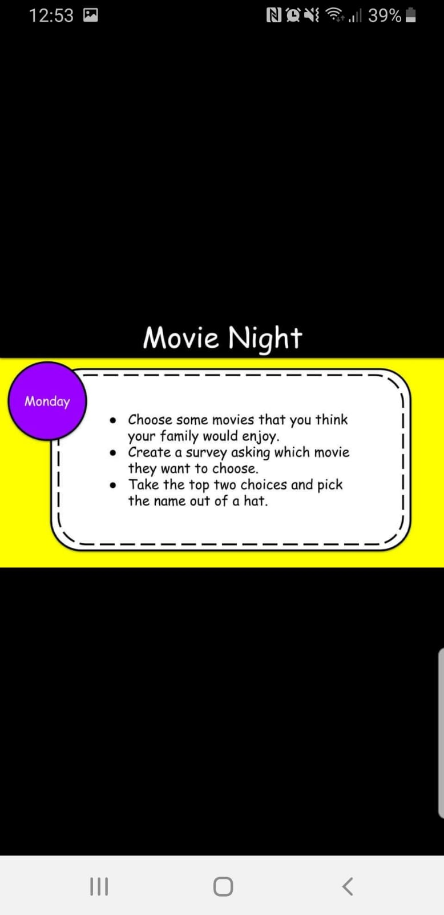

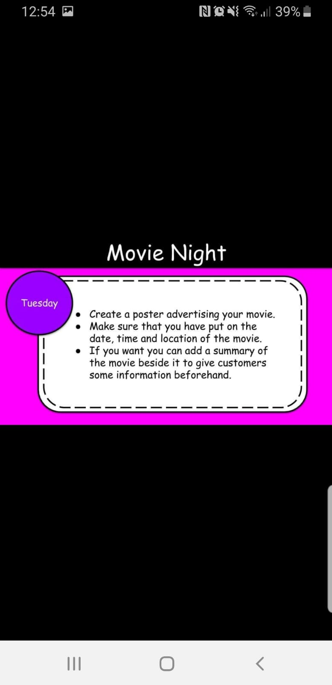

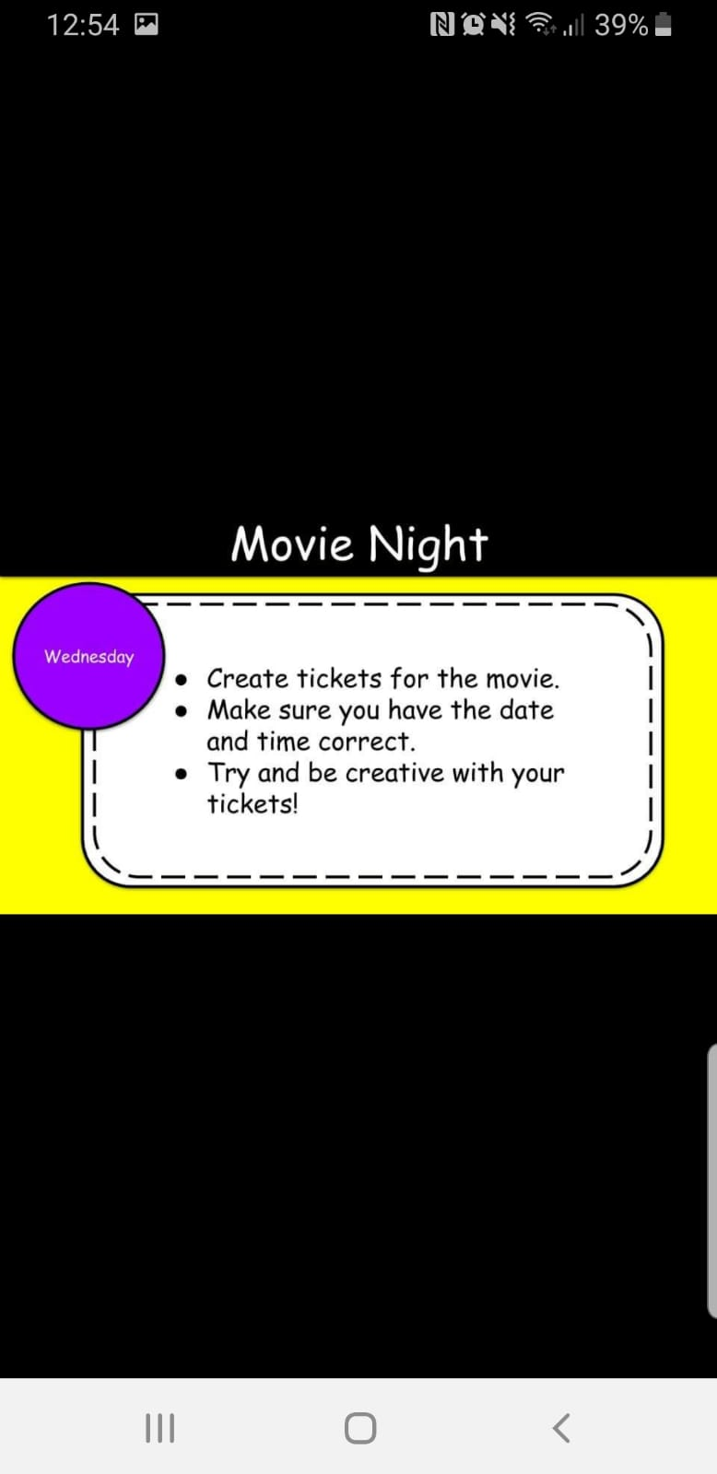

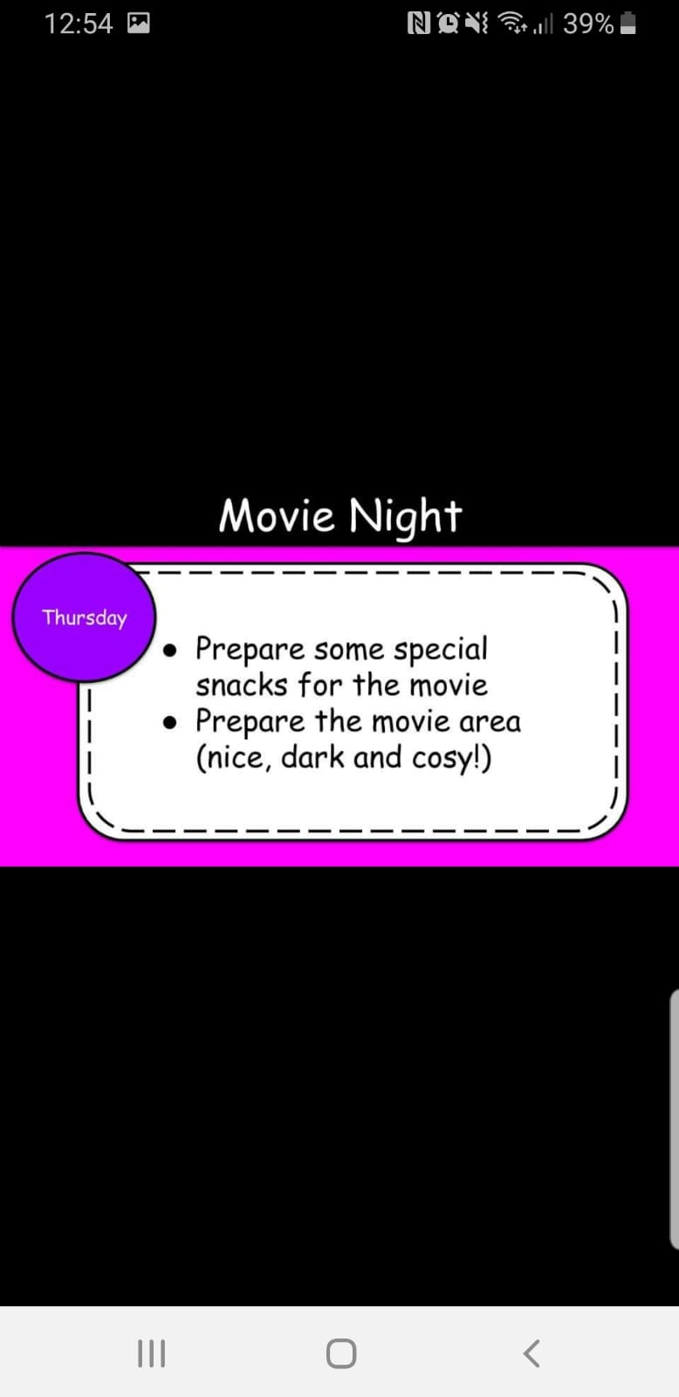

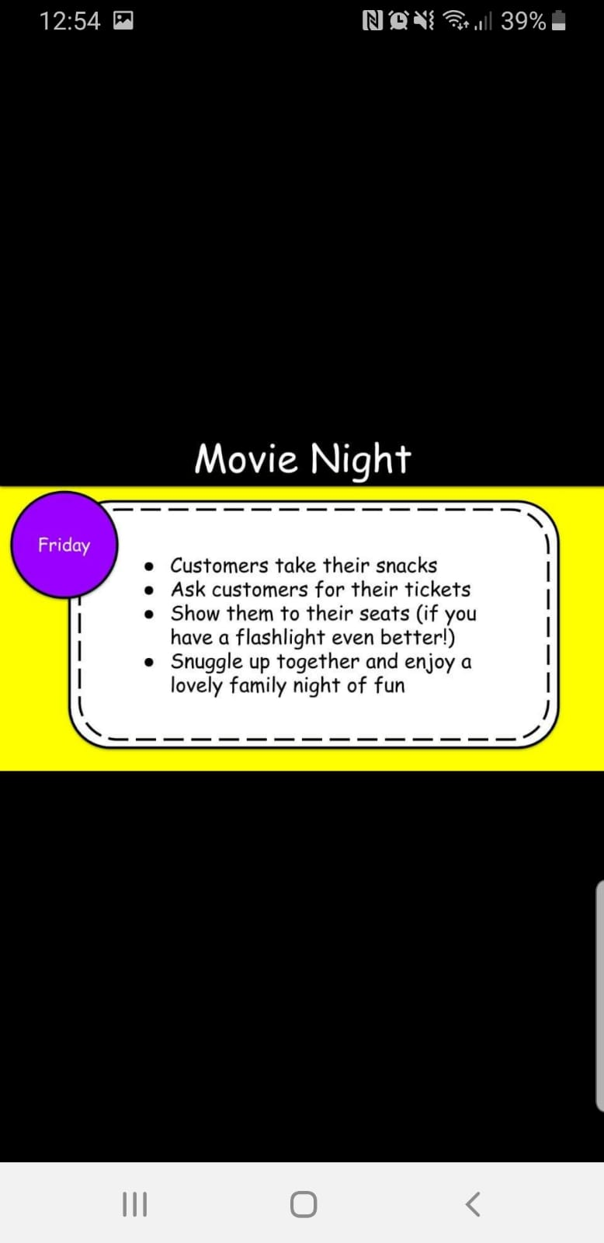

**Numeracy – times tables (arrays)**

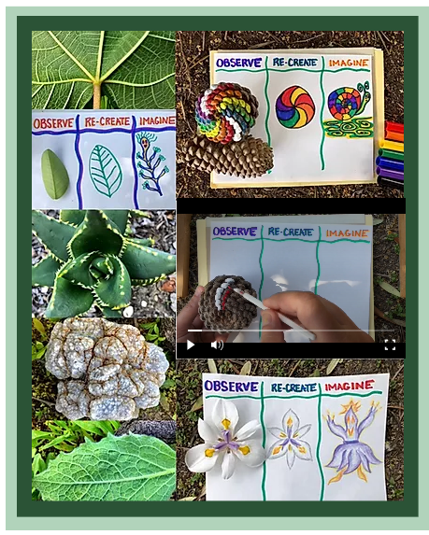**Art –** Explore Patterns in Nature

