Home Learning Activity Grid 4- Primary 1, Newton Primary School
Monday 18th May- Friday 29th May

Dear P1 Families,

Please note we have again made a few amendments to our learning grid. We appreciate some families can only manage a limited amount of remote learning so we have indicated, through highlighting green, some activities we would suggest you might like to prioritise for the children. We have also indicated, in red text, an approximate time for how long it may roughly take to complete each activity. Hopefully you find these adaptations helpful.

Otherwise, this activity grid follows the same format as in previous weeks; the variety of activities will allow your child to build on prior learning and undertake some new planned learning as detailed in our Sharing Learning Leaflet for Term 4. This grid sees the end of our ‘Living Things’ context and begins work on our ‘Healthy Bodies’ context. As has been shared previously, we do not wish to give families extra pressure at this challenging time by having a requirement for pupils to complete work at home so please see the activities below as optional suggestions and ideas. We will also continue to post additional resources to support the grid activities, as well as some ‘Play Challenges’ to our Google Classroom so please do check in regularly.

We have really loved hearing and seeing what the children have been doing and learning via our Google Classroom so please continue to keep in touch. We are really missing the children and it is lovely to maintain some contact. We hope you and your families are staying healthy and keeping well.

Best wishes,
Mrs Russell and Miss Johnstone

Please see grid below.

Literacy and Languages | Maths and Numeracy | Context/Health and Wellbeing/Other
18.5.20-22.5.20 SOUND OF THE WEEK- AR- start the cAR to say, recognise and identify the ‘ar’ sound and to read/write words with the ‘ar’ sound  (20-25 mins approx.)  Watch Read, Write Inc phonics lesson at www.youtube.com/channel/UCo7fbLgY2oA_cFCIg9GdxtQ - the lesson for ‘ar’ will be shown on Tues 19th May at 10am and available for 24 hours thereafter  Differentiated follow up activities (using the ‘ar’ Speeds Sound Practice Sheet posted on our Google Classroom)  * Adult to sound out the ‘ar’ words and child to orally blend and say the word  ** Child to sound out and blend to read the ‘ar’ words  ***Adult to say the ‘ar’ word and child to segment into sounds to write the word  Additional follow-up activity ideas on Google Classroom. | Measurement- to use parts of the body to measure the length/height of objects  (approx. 15-30 mins but this activity is usually a winner and goes on longer)  1. First discuss which body parts could be used for measuring- whole body, hand span, foot. Emphasise that when measuring it is important there are no gaps between footsteps etc. Discuss how different people would get different measurements.  2. Next choose an item/place to measure (e.g. length of bed, height of table, length of garden) and discuss which body part would be most suitable.  3. Then estimate/have a clever guess- how many hands/feet etc. it might be. Perhaps members of your family could play along too.  4. Finally, measure using your chosen body part. | Living Things- to explore simple life cycles of animals (e.g. frog, butterfly) and plants  (Video plus one follow up - 20 mins approx.)  - Watch and learn about the life cycle of a plant at https://www.bbc.co.uk/bitesize/topics/zpxnyrd/articles/z2vdjxs  - Watch and learn about the life cycle of animals at  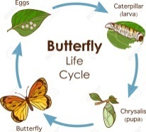  - www.bbc.co.uk/bitesize/topics/z6882hv/articles/zttckqt  - Act out the life stages of a butterfly/frog  - Access one of the life cycle cut and stick activities on Google Classroom  - Try out this life stages sequencing game at http://www.stormedapps.co.uk/lifestages/lifestages.html  - Read The Very Hungry Caterpillar
25.5.20-29.5.20 SOUND OF THE WEEK- OY- tOY for a bOY to say, recognise and identify the ‘oy’ sound and to read/write words with the ‘oy’ sound  (20-25 mins approx.)  Watch Read, Write Inc phonics lesson at www.youtube.com/channel/UCo7fbLgY2oA_cFCIg9GdxtQ - the lesson for ‘oy’ will be shown on Tues 26th May at 10am and available for 24 hours  Differentiated follow up activities (using the ‘oy’ Speeds Sound Practice Sheet posted on our Google Classroom)  * Adult to sound out the ‘oy’ words and child to orally blend and say the word  ** Child to sound out and blend to read the ‘oy’ words  ***Adult to say the ‘oy’ word and child to segment into sounds to write the word  Additional follow-up activity ideas on Google Classroom. | Measurement- to estimate with some accuracy in non-standard units the capacity of an object and then measure using non-standard units (20-30 mins)  - Watch this video to learn what capacity is  www.bbc.co.uk/bitesize/topics/zt9k7ty  - Find items around the home which you could measure the capacity of. E.g. cup, bowl, shoebox  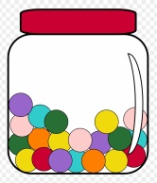  - Choose an item to be your non-standard unit e.g. Lego blocks, pasta pieces  - Estimate/have a clever guess how many ‘units’ to fill up your chosen item  - Finally measure by filling up your item and counting how many ‘units’ you used  - Compare and discuss the capacity of different items | Healthy Bodies/Relationships, Sexual Health and Parenting- to name parts of the body using the correct names (head, thumb, shoulders etc. including penis & testicles and vagina) (As much time as you like )  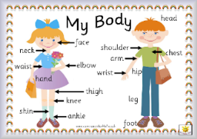  - Draw/create a picture of yourself and label body parts (head, shoulders, arm, hand, thumb, knee, foot, hair, forehead, eyes, ears, teeth etc)  - Ask an adult or sibling to give instructions for a new creature you could draw (e.g. 5 heads etc). You could do the same for them. Use your super imagination!  - With an adult, discuss correct names for body parts including penis, testicles, vagina
Reading- to apply phonic knowledge to read words and simple texts (15-20 mins approx., two or three times each week if possible)  There are RWI texts available at https://home.oxfordowl.co.uk/books/free-ebooks/. You will need to register to access these but it is free. There are Ditty sheets available on our Google Classroom for those working on simple blending, progressing on to Red, Green, Purple then Pink texts available on Oxford Owl. You may wish to have a go at a few colour levels to work out which is now suitable.  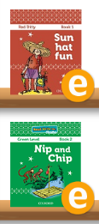  - Select Book. Make predictions based on title.  - Practice speed sounds at the beginning of  the book  - Practice reading the Speedy Green Words  - Practice any Red Words  - Read through the text  - Discuss the ‘Questions to talk about’  - Reread the same book at least twice to  develop fluency | Money- to recognise that there are different kinds of coins and notes and to identify all coins to £2  (approx. 10-15 mins per activity)  - Kindly ask a grown-up to look out any coins they have- Explore and discuss the size, shape and colour of each coin. Notice that the size doesn’t mean it has a higher value.  - Using real coins, try sorting them into coin groups. Eg. all 2p together, all 20p together etc.  - Using crayon and paper, make rubbings of each coin. See how at www.eparenting.co.uk/activities_for_kids/coin_rubbing_art_ideas_for_children.php  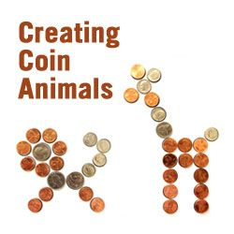  - Practice sorting coins by type using this fun game www.topmarks.co.uk/money/coins-game . For a challenge, you might even try ordering the coins by value.  - Create an animal picture  using coins | Healthy Bodies- to understand what different organs of the body do (Approx. 15 mins)  - With an adult, research major organs (lungs, heart, small/large intestine, brain, stomach, liver) and find out what their important job is in our bodies. Here is a link that has some fun cartoons about each organ that might help you!  https://kidshealth.org/en/kids/center/htbw-main-page.html  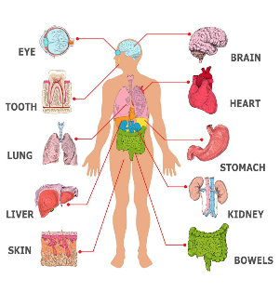  - After researching, can you say a fact about 1 or 2 of the organs you looked at? Tell a family member.
Shared Reading- to explore characters in terms of their actions in situations, personality and appearance and explain why they like/dislike them (As much time as you like )  - Ask an adult at home to read a chosen story to you. You could have a go at reading some of the words and look out for ‘special friend’ sounds and red words.  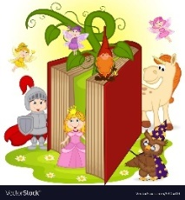  - Choose a character from the story; draw a picture of them and write some words to describe them. You could draw them during a situation in the story and explain their feelings and actions at that time (worried, upset, and angry).  - Discuss with an adult your likes and dislikes about the story. | Money- to understand that money has a value and can be exchanged for goods and services/ to explore ways of paying other than with coins and notes  (As much time as you like )  - Discuss ways to pay e.g. using money and using cards. Discuss the concept of receiving change.  - Set up a role-play shop (toy shop, fruit and veg etc.) to explore paying with cash and paying with card  - Discuss that different countries use different currencies/coins and notes  - Look through catalogues/café menu/online shopping; discuss how prices are represented and the value of various items. You might ask your child to estimate the cost/value of an item. | Healthy Bodies- to understand the need to eat a variety of different foods and can give examples of food we should eat to keep our bodies healthy  (Approx. 15mins)  - Explore the videos in the following link:  https://www.bbc.co.uk/bitesize/topics/zv4cwmn/resources/1  - Make a shopping list with your parents to plan for healthy meals and snacks you might want to make.  - It is also very important to drink enough water each day. Keep a ‘water tracker’ to see if you can reach your target each day. Is it difficult to drink enough water each day? You could use a tracker like this:https://www.bbc.co.uk/bitesize/topics/zv4cwmn/resources/1 or make your own one up – be creative with your design!
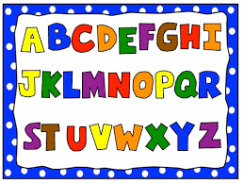  Grammar- recognise a capital letter at the beginning of a name or place and understand and explain why it is there (Approx 10-15mins)  - While you are reading stories, look out for capital letters – are they only found at the start of a sentence? Where else can you find them?  - When you are going out for a walk, look around to see if you can find capital letters used anywhere.  - Have a go at writing you address using capital letters correctly.  - Watch Captain Capital and have a go at the quiz yourself! https://www.bbc.co.uk/teach/class-clips-video/english-ks1--ks2-where-do-you-put-capital-letters/zkbhf4j | Numeracy- to know number bonds for numbers up to and including 10 (e.g. 5+1=6, 2+4=6, 3+3=6, 6+0 =6)  (approx. 10-15 mins per activity)  - Choose a number within 10 and gather that many Lego blocks/stones/pasta pieces etc. Try sharing them out into two groups and record all of the different ways to make your chosen number.  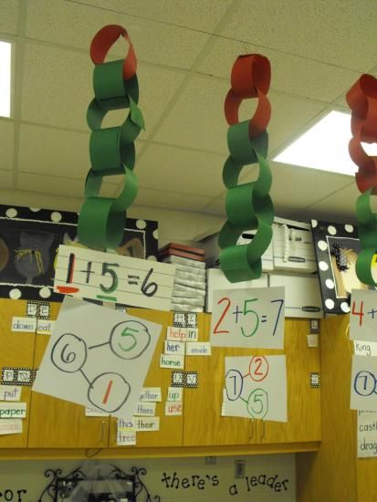  - Sort the teddies into the houses in as many different ways as you can at www.topmarks.co.uk/Flash.aspx?f=WaystoMake  - Make paper chains to show the different ways to make each number (see picture) | Outdoor Learning- to show an appreciation for nature (As much time as you like )  On Thursday 21st May we would have celebrated Outdoor Classroom Day. The theme this year is ‘playful nature’ encouraging us to dress up in nature. To join in and celebrate, you could…  - Make a nature crown out of leaves, flowers and twigs  - Turn yourself into your favourite animal by making a mask  - Access lots more ideas in the grids from Learning through Landscapes available in our Google Classroom  - Be inspired at www.outdoorclassroomday.com/resources/lesson-ideas/
Writing- to hold a sentence/to write a character description /to create a simple fact file (Approx. 10 mins for sentence writing, as much time as much time as you like on Shared Reading/context related writing)  - Select a sentence from your chosen RWI book and have a go at writing it. Remember to say it lots of times to get it stuck in your head before you have a go without looking at it.  - Linked to Shared Reading, write 1 or 2 sentences about a character in your story (perhaps saying what the character did and how they felt).  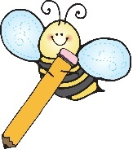  - Linked to Context work on organs in the human body, create a simple fact file or information poster about one (or more) of the organs you researched. Remember to include words and pictures, have a bold heading/s and make it colourful and eye catching. | Sumdog- to consolidate prior learning in numeracy and to access teacher- set activities linked to current learning  (5-10 minutes each day if possible)  - Log-in to www.sumdog.com using the log-in details which were sent via ParentMail on 25/3/20  - Play the games/activities that have been set  - Access the free choice activities to brush up on your mental maths | Music- to make a percussion instrument  (As much time as you like )  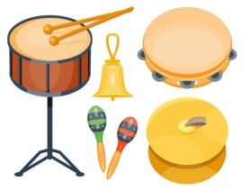  Percussion instruments are those that you shake, tap/hit or scrape to make a noise like a tambourine, maracas or a triangle.  Use junk materials/dried food/natural objects etc. to make your own percussion instrument. Does is shake, tap or scrape? Can you make it play loud and soft? Play along with your favourite song.

Suggested web sites and apps:
Literacy
www.youtube.com/channel/UCo7fbLgY2oA_cFCIg9GdxtQ
(RWI daily lesson)
https://home.oxfordowl.co.uk/ (RWI e-books)
www.teachyourmonstertoread.com
www.letters-and-sounds.com/
www.phonicsplay.co.uk/
www.topmarks.co.uk (Age5-7 games)
www.doorwayonline.org.uk
www.storynory.com
Numeracy
www.topmarks.co.uk (Age 5-7 games)
www.bbciplayer.co.uk (Numberblocks)
www.sumdog.com
Other
www.twinkl.co.uk/offer UKTWINKLHELPS
www.bbc.co.uk/bitesize/
www.bbc.co.uk/teach/supermovers
www.cosmickids.com
www.gonoodle.com

