Newton Primary School Closure Contingency Learning Plan
Primary 6 – 4.5.20 – 15.5.20
Over the following period of time these activities offer your child the opportunity to enhance and practise the skills they have been developing in class as well undertake a variety of differing tasks of their choosing. They also give you an idea of the type of things you can perhaps task your child with should they complete all the tasks on this sheet. There are also relevant and appropriate websites and apps which may be of help.
Numeracy and Maths  Money - Budgeting  You have £20 to spend on creating a healthy meal for 4.  This can be a lunch or a dinner meal.  Think back to the “EatWell Guide” to support planning.  You must include  - Fruit/ Vegetables  - Carbohydrates  - Dairy/Dairy Alternatives  - Protein (beans, meat, fish, pulses)  - Oils/Fats  You can have a look at prices online through supermarket websites:  https://groceries.asda.com/  https://www.sainsburys.co.uk/shop/gb/groceries  https://www.tesco.com/groceries/en-GB/  https://www.marksandspencer.com/c/food-to-order#intid=gnav_food  https://www.aldi.co.uk/c/groceries  What can you create that is within budget?  You cannot go a penny over £20.  Ext: Compare 5 items of your choice at 2 supermarkets. Which supermarket is better value? (Cheapest) |  |  |  | Numeracy and Maths  Money - Offers  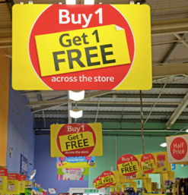  Many shops offer deals on the items they sell. This could be simply a discounted price, or it could encourage the customer to buy more than one product.  Task 1  Find 5 current deals being offered in the supermarkets. As it is unlikely that you can visit stores just now, use the supermarket web pages from the budgeting activity to find some instead.  With your 5 deals, work out how much money you would save from this deal and decide whether it offers value for money or not.  (Sometimes, you might find that the deals are not really good deals at all!) Share and discuss your findings with your family or on Google Classroom.  Task 2  Deal or No Deal:  https://drive.google.com/file/d/11KU2cwdLJmzIrreugXJSI5S0QYbDfKmb/view?usp=sharing  Try out this task in your jotter. For each offer, work out how much money the customer will save and explain whether it is a good deal to suit their circumstances or not. |  |  |  |  |  | Mental Maths  Daily Practise  It is important to continue to have regular mental maths practise, especially your times tables! The key is to do a little bit, as often as you can - even just 10 minutes a day would be great for your brain!  Please make the most of the online subscriptions we currently have to help you with this.  Times Table Rock Stars  https://play.ttrockstars.com/login/82669  Play in the studio to achieve your Rock Status  and challenge your friends (or teacher) to Rock Battles!  Sumdog  https://www.sumdog.com/user/sign_in  Complete weekly challenges, competitions and assessments.  Alternatively, ask someone at home to give you 10 questions to answer that involve multiplication, division, addition and subtraction.
Numeracy and Maths  Division  Get a parent or sibling to write out 10 division sums for you.  Some may have remainders, others way not. How many can you solve correctly?  If you would like a worksheet then please have a look at Twinkl (sign up is free).  https://www.twinkl.co.uk/resource/us2-m-237-four-digit-division-with-remainders-activity  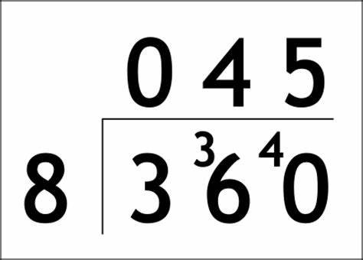  Ext: Create and complete your own Worksheet on  https://www.math-aids.com/Division/ | Reading  Comprehension Questions  https://docs.google.com/presentation/d/1OfYe2w_Eo3EFgEyf3XzFfbu81O_yM08O9Lccl8yMRs8/edit?usp=sharing  On this presentation you will find 3 short extracts to read, each with a set of questions to answer about the text.  Answer these in your jotter or on a piece of paper.  At the end of the presentation, you will find the answers so that you can mark your own work or ask someone at home to mark it for you.  Remember to try to read a text of your choice for at least 20 minutes every day. This could be a book, magazine, webpage, newspaper. |  |  |  | Writing  Instructional  Design a healthy smoothie or healthy snack for your family. Make your creation and write a recipe for it that you can share with your classmates.  Be sure to include:  - a list of ingredients with measurements  - a list of equipment required  - a numbered method (set of instructions) that is written in chronological order.  Inspiration for recipe ideas (don’t just copy one, try to be creative!):  https://www.bbcgoodfood.com/recipes/collection/snacks-kids  Share your recipe, along with photographs of your finished creation on Google Classroom.  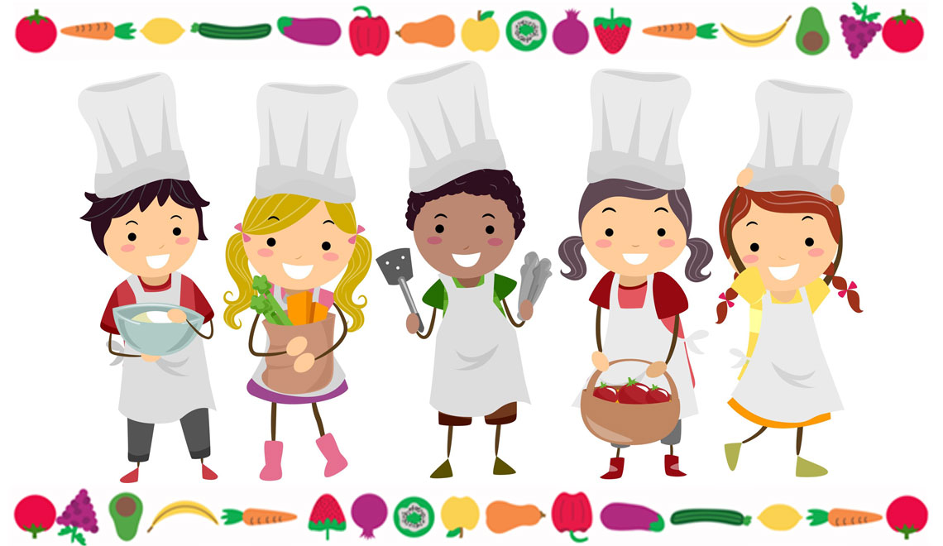
Writing  Poetry  Read about List Poems, see some examples and learn how to create your own by clicking on this link:  https://www.poetry4kids.com/lessons/how-to-write-a-funny-list-poem/  Have a go at creating your own List Poem, based on a topic of your choice. You could choose sport, food, games, film/TV, celebrities...  The links below will help you with rhyming words:  https://www.poetry4kids.com/lessons/rhyming-lists/  https://www.poetry4kids.com/rhymes/ |  |  | Relationships and Sexual Health Education  Lesson 2 - Body Changes  Use the following PowerPoint to learn more about puberty and the changes our bodies go through as we grow up.  You may wish to watch or discuss this with someone in your family and ask them any questions you may have.  https://drive.google.com/file/d/19yVBdlbvjCCbV3_dkolMEH3Q_gzi22Gp/view?usp=sharing |  |  | PE  Increase your heart rate for 20 minutes every day.  - Joe Wicks workouts LIVE every morning at 9am https://www.youtube.com/playlist?list=PLyCLoPd4VxBuxu3sLztrvWFehzv-LnR2c  - Create your own exercise video to share  - Just Dance https://www.youtube.com/user/justdancegame  - Create an outdoor circuit in your garden  - Challenge a friend to complete a set of exercises each day  - Go a run, walk or cycle with your family
Spelling and Grammar  Login to Sumdog and complete the spelling and grammar tasks:  https://www.sumdog.com/user/sign_in  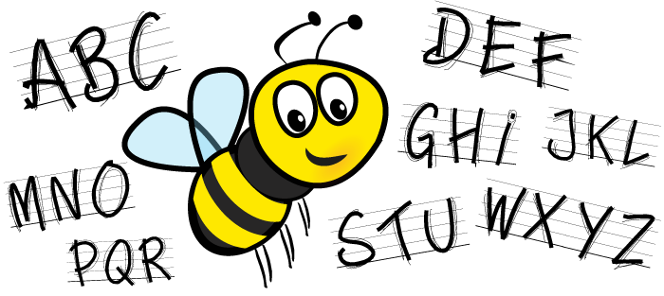  Try Doorway Online Active Spelling Speller 2 to practise tricky words: https://www.doorwayonline.org.uk/activities/speller/ |  | Digital Learning  Online Safety  Explore the ‘Be Internet Legends’ family activity pack:  https://drive.google.com/file/d/19kOvwXrdmZnRzFHRVkDIRiOldV6Iu6T2/view?usp=sharing  This great resource is full of fun activities you can do with your family to discuss and learn more about being safe and responsible online.  When you have completed these activities, you can also explore ‘Interland’, the fun game that compliments the Be Internet Legends resources:  https://beinternetlegends.withgoogle.com/en_uk/interland |  |  |  |  |  |  | Art/Learning Context  You have previously thought about and designed your healthy hero.  Can you use plastic, packages, cardboard, paper (check your recycling bin!) to make a 3D Model of your Healthy Hero.  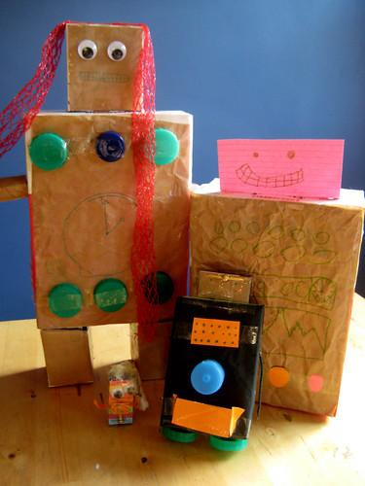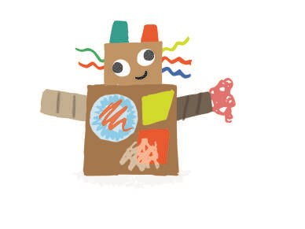  Ext: Take a picture and upload it to Google Classroom or Drive.
FRENCH/SPANISH  Food and Drink  Write down or draw 5 items from each of the 5 main food groups, plus 5 different drinks - this should give you 30 items in total - you can do more if you wish!  Translate each word into french and write it down alongside the english word.  Try to learn the new vocabulary off by heart and teach someone in your family some of the words too.  https://www.bbc.co.uk/bitesize/clips/z3634wx  Ext:  - Find out the items in Spanish too  - Create a quiz to test the knowledge of your friends and family. You could use ‘Google Forms’ to do this. |  | Learning Context - Healthy Heroes  Food Safety  Watch the following video, about food labelling:  https://www.youtube.com/watch?v=mDvtwj_PpN8  Look at the food in your fridge and cupboards at home. Find 5 items with a use by date and 5 with a best before.  Discuss the following questions with someone in your family, you can write your ideas down in your jotter.  - What is the difference between use by and best before dates?  - Why would these dates be helpful when you're shopping in the supermarket?  What kind of foods tend to have use by dates on them? |  |  |  |  |  | Learning Context - Healthy Heroes  Healthy Eating  Plan and design a healthy menu for a whole day, including breakfast, lunch, dinner and any additional drinks and snacks.  Using your new knowledge of the ‘Eatwell Guide’ to consider the appropriate proportions of the different food groups in your menu and current dietary advice.  E.g. Are there enough fruit and vegetables included? Have you included enough to drink?  https://www.nhs.uk/live-well/eat-well/the-eatwell-guide/  https://www.foodstandards.gov.scot/downloads/Eatwell_Guide_Booklet_-_new.pdf  Ext: Why not extend this task to make a menu for a whole week? Or find out how much your menu would cost for the day, using the supermarket webpages?
RME  Judaism  Find out 5 new facts about Judaism that you didn’t know. Read about Kosher food and explore what foods are eaten or avoided in the Jewish faith.  This link may help with your research: http://www.primaryhomeworkhelp.co.uk/religion/jewish.htm#men  Task: Create a poster, a fact file or a presentation to share what you have learned, with a particular focus on food/diet.  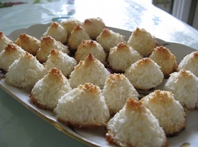  Ext: The following document includes more food related activity ideas linked to Judaism for you to try if you wish, including a fun recipe.  https://drive.google.com/open?id=1xIZ6gB0NhpqlQlphLWOH8hH41sITblnjzO9awDDZYdE |  |  | Music  If you play a musical instrument can you teach a parent or sibling for 20 minutes.  Is there a chord they can learn? Can you focus on breathing, finger position or teach them to read music?  If you do not play a musical instrument have a look at Music with Mylene Klass:  https://www.youtube.com/channel/UCQh2wgJ5tOrixYBn6jFXsXQ  Here there are videos, on rhythm, dynamics, timbre, sing-alongs and more. |  |  |  | Health and Wellbeing/Writing/Art  P6 Buddy Preparations  This task has been left in for another fortnight to give more time for everyone to complete. Please make sure you finish this before you return to school.  On your return to school you will be allocated a nursery buddy that you will help to support during their transition into P1 after the summer holidays.  To introduce yourself to your buddy, create a fact file on 1 A4 page full of information all about you.  It can be made digitally or on paper.  - Include your name  - Include a picture of yourself (we can print this at school if you are unable to - leave a space)  - Include information about yourself that you think a nursery child would be interested to know (think about the questions you would ask to get to know them to help - e.g. favourite food etc) Don’t include personal information, such as your address or phone number.  - Make it as colourful and visual as you can, including drawings or pictures to support your words.  This will be laminated on your return to school so that your nursery buddy can take it home over the summer holidays to share with their family and remember you when they start school in August.

