To Primary 3 and their parents,
These activities offer your child the opportunity to enhance and practise the skills they have been developing in class as well as undertake a variety of differing tasks of their choosing. They also give you an idea of the type of things you can perhaps task your child with should they complete all the tasks on this sheet. There are relevant and appropriate websites and apps which may be of help. We encourage you to assist your child in uploading any work onto Google Classroom should they wish to share it.
Miss Porter and Miss Myles.

LITERACY - Writing  Three hedgehogs receive a most unusual invitation…  Plan and write a story using a story-starter like the one above. Think of a beginning, middle and end to your story before you start writing. Check the link below for more story-starter ideas.  https://twitter.com/alex_t_smith/media  Remember to include a title (sometimes this is easier after you’ve written the story) and provide an illustration for your story, too.  Mild: Underline every capital letter and full stop with coloured pencil.  Medium: Use one exclamation mark and one question mark in your story.  Hot: Use three adverbs (like the ones in the next task -->) | LITERACY - Grammar  Make a game of adverb and verb charades for your family.  - Get 10 small pieces of paper or card.  - On 5 of the pieces write a verb. Remember, a verb is a ‘doing’ word, e.g. dance, sleep, swim.  - On the other 5 pieces write an adverb. An adverb is a word which describes how the verb is being done and usually ends in ly, e.g. happily, excitedly, slowly.  - To play the game, each player takes turns to pick 1 verb card with 1 adverb card (don’t show anyone!). The person then acts out the verb with the adverb and the other players have to guess what is written on the cards.  Try to be creative with the verbs and adverbs you choose. You can do more than 5 of each to make it trickier. | LITERACY - Reading/Talking & Listening  Reading your own writing is a really great skill and can help us improve our literacy.  Read a story you have written to someone in your family, either in real life or by using technology. You could even record yourself reading so you can share it with more than one person!  When you are reading, speak clearly, pause at the end of sentences and you can even use funny voices for the different characters.
LITERACY - Reading  Pick a book in your house and record this information about it:  - Author and title (and illustrator, if there is one)  - Genre  - 3 important characters  - How many pages  - What happens in the beginning, middle and end of the story.  - One thing you liked about it and one thing you would change. | LITERACY- Spelling  Spend 10 minutes on Nessy to warm up your spelling brain! Access Google Classroom to see the spelling word banks and choose a challenge level. Practise your words using active spelling strategies (like the ones in the back of your red jotter) and ask someone in your house to give you a spelling test once you think you’re ready. | LITERACY – Languages  Access this website to listen and read-along to the story of Petit Poulet - Chicken Little.  https://www.thefrenchexperiment.com/stories/chicken-little  You can translate each section into English after listening to it in French. Once you have listened to the story, pick three French words and write them down with their English meaning. This could be the start of your French word bank!
MATHS/GRAMMAR - Sumdog online learning  Complete a variety of reading and maths challenges set on Sumdog. New challenges will be posted every 2 weeks for both Maths and Grammar by your teacher. | MATHS - Time  Make a 24-hour timeline starting and ending at midnight, like this one below. Be creative and make it as clear as possible so that you can keep it and use it to help with future work on telling the time.  Choose your level: you can choose to just have the 12 hour times, or to add 24 hour equivalents underneath for an extra challenge. (A bigger version of this image will be made available on Google Classroom).  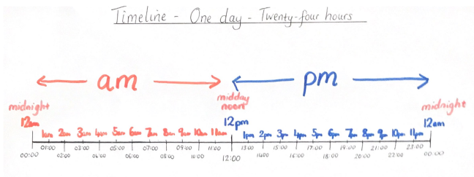 | NUMERACY- Fractions  First, watch this video:  https://www.youtube.com/watch?v=n0FZhQ_GkKw&t=63s  Then, draw 10 different circles. Split each one into a different number of parts. Then shade some in each and record the fraction next to it. Make sure you can say which number is the numerator and which is the denominator.  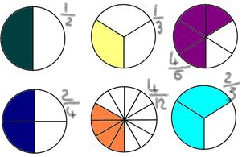
HEALTH AND WELLBEING - Mindfulness  Use your 5 senses for this mindfulness exercise. Sit in your mindful body and find:  - 5 things you can see  - 4 things you can hear  - 3 things you can feel (this could be the breeze, your feet on the floor etc)  - 2 things you can smell.  - 1 thing you can taste (this could even be your tongue). | HEALTH AND WELLBEING - P.E.  Practise your standing long jump.  - Place a starting marker on the floor.  - Stand beside the marker on two feet. Keep your head up, swing your arms and jump.  - Make sure you land on two feet.  - Use chalk or a marker to measure your distance.  - Challenge a partner. Experiment with different techniques and see how you can increase your jump distance. | RME  Research what Ramadan is and which religion celebrates it and summarise your findings into five key bullet points.  This video will give you more information on Ramadan: https://www.youtube.com/watch?v=qFU9Cb0D6lo
CONTEXT- TOYS AND FORCES  Design your dream toy and build a model of it. Record how you made it, explain the process and identify any issues you had and how you overcame them. Evaluate your toy. What forces are used to operate your toy?  For example:  My toy is…  I made it using…  The steps I followed to make it were…  I found it easy/tricky to make because...  Next time I would…  My favourite feature is…  The forces used to operate my toy are... | CONTEXT-TOYS AND FORCES  Watch the BBC Bitesize Clip “Forces around you” -https://www.bbc.co.uk/bitesize/clips/z2y7sbk  Write two column headings: ‘pulling forces’ and ‘pushing forces’ and identify examples of these forces in action outside or at home. Examples may include a door being pushed or pulled, a pushing force when a pen lid is applied to a pen, or a pushing force when the wind blows the tree branches.  Take photos or videos of examples of these forces around you and post to them to our Google classroom. | CONTEXT-TOYS AND FORCES  Watch the BBC Bitesize clip “magnets”- https://www.bbc.co.uk/bitesize/clips/zt642hv  Investigate what a compass is and how it works in relation to magnets. If you have access to a compass (most smartphones have an app that you can install). Record what is the most Northern point in your garden (example, your shed), repeat with Southern, Easten and Western.  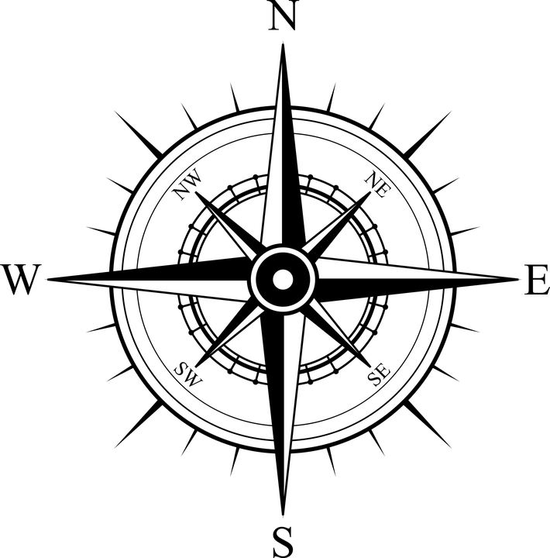

Suggested web sites and apps:
- Maths with Carol Vorderman https://www.themathsfactor.com/
- Literacy with David Walliams https://www.worldofdavidwalliams.com/
- Cooking https://www.jamieoliver.com/features/category/get-kids-cooking/
- Horrible Histories https://www.bbc.co.uk/cbbc/shows/horrible-histories
- Free Children’s Audio Books https://www.amazon.co.uk/Childrens-Books-Audiobooks/s?rh=n%3A69%2Cp_n_binding_browse-bin%3A308724031
- Range of resources available for free from (free 1 month membership available) https://www.twinkl.co.uk/
- Literacy Shed https://www.literacyshed.com/home.html
- Mindfulness https://www.headspace.com/meditation/kids
- Coding http://www.scratch.mit.edu
- NESSY spelling http://play.nessy.com
- TOPMARKS https://www.topmarks.co.uk/maths-games/ (choose from games under the 7-11 tab)
- BBC Bitesize (Choose 1st level Scotland, there are resources for all curricular areas) https://www.bbc.co.uk/bitesize/levels/zgckjxs
- Snappy Maths http://www.snappymaths.com/
- Cosmic Kids Yoga https://www.youtube.com/user/CosmicKidsYoga
- Joe Wicks Body Coach Schools https://www.youtube.com/watch?v=d3LPrhI0v-w&list=PLyCLoPd4VxBuxu3sLztrvWFehzv-LnR2c
- BBC Newsround https://www.bbc.co.uk/newsround/news/watch_newsround

