***Newton Primary School - Closure Contingency Learning Plan - Primary 2***

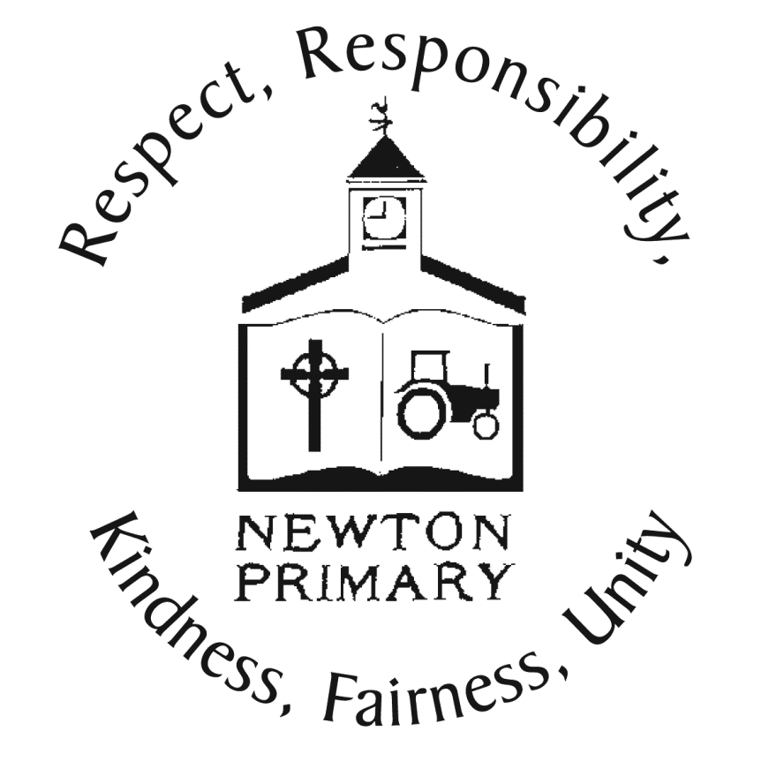

|  |  |  |
| --- | --- | --- |
| Over the following period of time these activities offer your child the opportunity to enhance and practise the skills they have been developing in class as well undertake a variety of differing tasks of their choosing. They also give you an idea of the type of things you can perhaps task your child with should they complete all the tasks on this sheet. There are also relevant and appropriate web sites and apps which may be of help. | | |
| **Literacy – Reading**  The ‘Oxford Owl’ website is a great resource to find a variety of eBooks suitable for your child. It will require a parent/carer to register online, for free, and it will provide access to a wide range of books. In the library you can filter the results by ‘Levels’ then ‘Read Write Inc.’ to select the right level (this would be the colour of book your child was reading in school e.g. green, pink etc.).  We recommend your child reads each eBook three times, as they would at school: once to read the words correctly, a second time with more fluency, and a third time in a ‘storyteller voice’ that shows their understanding of the story.  Link: <https://www.oxfordowl.co.uk/for-home/find-a-book/library-page> | **Literacy - Writing**  Go on a walk with your family in your local area. As you walk, think about the senses of sight, hearing, touch and smell. Use these to write a sentence on each sense. E.g. *I saw a beautiful multi-coloured butterfly.*  (ask your parent/carer to record some of your walk on a digital device to help you remember if needed)  **Extra challenge** – think about adding adjectives to provide more description. Or why not try and write a small paragraph? | **Literacy – Talking and Listening**  Watch and Listen to *‘How to build an igloo – a boy among polar bears.’* <https://www.bbc.co.uk/programmes/p009lv1r>  You may wish to watch it twice. Listen carefully in order to answer the following questions:   1. What is an igloo made from? 2. Why is a boy’s first igloo never easy? 3. How long might it take to build an igloo? 4. Why are the last few blocks important? 5. Why do igloos need overhangs?   You do not need to write the answers down, simply discuss and share with a parent/carer/sibling. |
| **Literacy - Phonics**  The ‘Oxford Owl’ website has lots of free Read Write Inc. Phonics resources to help your child continue learning, including eBooks, practice sheets, Ditty sheets, slideshows, and parent films - but don’t worry if you are not a phonics expert! These activities will help you support your child during this time.  Follow the link – <https://home.oxfordowl.co.uk/reading/reading-schemes-oxford-levels/read-write-inc-phonics-guide/>  Access our **Primary 2 Google Classroom** where you will find differentiated phonics sounds to revise and introduce for your child. | **Literacy – Questions**  Have a look at the video below on questions. <https://www.bbc.co.uk/bitesize/topics/zrqqtfr/articles/z2xdng8>  Questions start with words like; what, where, why, when and who. Question marks are used at the end of a question. Look at the **‘Interesting Image’** saved in our **Primary 2 Google Classroom.** Take your time to look at it carefully, you might need some help and prompting from an adult. Can you think of as many questions as you can about the image? Write down your favourite question and post below the image on Google Classroom – remember your question mark! Some examples are there to help you get started. | **French**  Have a go at practising some Houses and Homes French vocabulary using the website link below. You can listen to stories like ‘Petit Ourson’ or ‘Les trois petits cochons’, learn some rhymes and take part in some activities.    Link:<http://nicurriculum.org.uk/microsite/pl/french/houses_and_homes/index.asp> |
| **Numeracy -** Mental Maths  Log-in to [www.sumdog.com](http://www.sumdog.com) using the log-in details which were sent via ParentMail on 25.3.20  Complete the differentiated challenge set for you.  This challenge will begin on Monday 4th May at 9am, and finish on Friday 15th May at 3pm.  **Extra challenge** – Play some of the games on Sumdog to earn more coins for your home. | **Numeracy –** Angle, Symmetry and Transformation  Remind children about right and left. Ask them to put their right (or left) arm out sideways. Ask them to make a half turn in the direction of their arm and establish that is half a right (or left) turn. Practise by calling out a series of instructions for them to follow. Make a whole turn to the right. Make half a turn to the left. Make a whole turn to the left. Make half a turn to the right. What do they notice about whole and half turns? Establish that, whether they turn a whole turn to the left or the right, they finish up facing the same direction they started in. Also, when making half a turn, whether to the left or the right, the end position is the same. Once you have demonstrated this, ask your children to give similar instructions.  Please look on our **Primary 2 Google Classroom** for some practical activities you can do with your child and a supporting Power Point. | **Numeracy –** Fractions: Halves and quarters of numbers/quantities  Give your child a number which is a multiple of 2 e.g. 2, 4, 6, 8 etc. Get your child to count out this number of objects (Lego pieces, buttons, grapes, pegs etc.) Ask them to split or share equally between two piles.  Do the same for multiples of 4 e.g. 4, 8, 12, 16 etc. Ask them to split or share equally between four piles.  How many are in each pile? Write a sentence to match e.g. one quarter of 12 = 3 or one half of 4 = 2.  **Extra challenge** – If you are confident with halves and quarters, why not try larger quantities?  Or could you split your objects into fifths? |
| **Music -** BBC Music - Bring the Noise!  Why not experiment with some music? Get started with *Play It!* and explore the different elements that make up a song. Play or clap along with the music and then listen back to your own version of songs  *Play It!* contains five songs with more to come soon. You can get musical with *I am a Robot,* *Hands in the Air, Take You Home, Be in the Band, Bring the Noise* and *Spooky World*.  Follow the in-game instructions to explore the three different modes. Follow the link below: <https://www.bbc.co.uk/teach/bring-the-noise/eyfs-ks1-music-play-it-bring-the-noise/z4sq92p> | **Science -** How to Grow a Rainbow  Rainbows are popping up everywhere in windows to spread positivity and for people to spot as they walk by. Grow your own rainbow to hang in your window or add to your collection! Have a look at the bottom of our grid to see how you can make your own.    Check out the link below for a different science challenge or activity everyday: <https://twitter.com/MrsBpriSTEM> | **Health and Wellbeing/IDL**  *Every child has a right to 'a safe place to live'.* Do you think this is the case all over the world?  Listen to the song ***'We've all got rights'*** - <https://www.youtube.com/watch?v=LN_70HXxd5Y>    Think about how you might feel if you did not have a safe place to live.    Why not create a ‘jar of appreciation’ and draw all the things you are grateful for? Use the example to give you some ideas. |
| **Health and Wellbeing – Relationships, Sexual Health and Parenthood**  With your child talk about changes to the body at different stages of life from being a baby to where they are now. For example, has their hair grown, have they got taller? Think about what can they do now that they could not do when they were a baby?  You can watch the video below as a starting point for discussion: <https://www.bbc.co.uk/bitesize/clips/z4tmhyc>  Together, look at pictures of your child at different stages of their life. Can you make a timeline using your photographs and annotate milestones that they have achieved at different stages e.g. crawling, first words, learned to tie shoes etc. | **Health and Wellbeing - PE**  Continue to access Joe Wicks or Cosmic Kids (links below) to keep yourselves fit and active!  If you would like a change, please visit our **Primary 2 Google Classroom** to access some challenges we have chosen for you.  If you would like to try some more challenges, then visit the link below from Youth Sport Trust:  <https://www.youthsporttrust.org/pe-home-learning> | **Health and Wellbeing - Mindfulness**  Do you remember our work on ‘Mindful Moments - Peaceful Pause’ and the importance of pausing for a moment or two as you become aware of your thoughts or feelings? Sometimes the way we feel inside is just like the weather outside. If we are happy and smiling, it is just like a sunny day. If we’re grumpy it is just like our mind is full of those dark clouds, we imagined in our lesson together. Perhaps if we’re angry – we can imagine it is just like thunder and lightning, if we’re sad – it is raining, or if we’re lonely it might be cold and frosty.  Do-BeMindful Homepage - Do-BeMindful.comOver the next two weeks why not draw your own personal weather report using the ***‘Do-BeMindful My Weather Diary’*** which can be found on the **Primary 2 Google Classroom.** Remember we all experience different types of personal weather at different times – that is entirely normal and whatever our personal weather is it is OK to feel that way! |
| **IDL – Houses and Homes**  Discuss the Twinkl Power Point ‘Types of Houses and Homes’ - <https://www.twinkl.co.uk/resource/t-t-2545400-houses-and-homes-description-powerpoint> or find on our **Primary 2 Google Classroom**.  Go for a walk in your neighbourhood and identify different types of houses and homes. If you want to record the different types of houses, then you can make a tally chart.    **Extra challenge** – Can you turn your tally sheet into a bar chart and see which type of home is the most popular in your street? | **IDL – Houses and Homes -** Houses Around the World  Use the link below to download the PowerPoint presentation with photos of the different types of houses found in Chembakolli or find on our **Primary 2 Google Classroom.**  Link - <https://www.actionaid.org.uk/school-resources/resource/chembakolli-housing-and-homes>  Discuss the images and compare similarities and differences.  **Extra challenge** - Have a look at the comparison sheet on our **Primary 2 Google Classroom** and discuss the questions below it. | **IDL – Houses and Homes** - Dream Home  Design your dream home! Be as creative as you like. Think about it carefully and make a plan before you start.  Things you might want to consider:   * What type of house would it be? E.g. semi-detached, a mansion, an eco-home etc? * How many rooms would it have? * What would you have in your dream home - a games room, swimming pool, beauty parlour, science lab etc? * What kind of person would suit living in your dream home? An older person, a family, a scientist, a creative person etc.   If you have Minecraft, why not go on and make your dream home a reality! Or you could build a 3D model using Lego/building blocks you might have at home. |

**Suggested web sites and apps:**

**HWB**

* Cosmic Yoga - <https://www.youtube.com/user/CosmicKidsYoga>
* Joe Wicks PE (Monday- Friday 9am) <https://www.youtube.com/thebodycoachtv>
* Youth Sport Trust Challenges <https://www.youthsporttrust.org/pe-home-learning>
* Go Noodle (for movement breaks and mindfulness) <https://www.gonoodle.com/>

**ICT**

* Scratch Jr. App (details <https://www.scratchjr.org/> )

**Phonics/Reading**

* Ruth Miskin Training (RWI information and resources for parents) <https://www.ruthmiskin.com/en/>
* David Walliams free audio books <https://www.worldofdavidwalliams.com/>
* Audio Stories - <https://www.storynory.com/>
* Alphablocks BBC Iplayer - <https://www.bbc.co.uk/iplayer/episodes/b01cz0p1/alphablocks>
* Oxford Owl (reading/ponics) - <https://www.oxfordowl.co.uk/>

**Numeracy and Maths**

* Topmarks - <https://www.topmarks.co.uk/>
* Sumdog - [www.sumdog.com](http://www.sumdog.com)

**Other:**

* BBC Bitesize – variety of resources for primary aged children -<https://www.bbc.co.uk/bitesize/levels/zgckjxs>
* Twinkl – variety of resources (Use code UKTWINKLHELPS) - <https://www.twinkl.co.uk/offer>
* Learning and Exploring Through Play - <https://www.learningandexploringthroughplay.com/>
* Messy little monster -<https://www.messylittlemonster.com/>
* Red Ted Art - <https://www.redtedart.com/>

