Newton Primary School, Closure Contingency Learning Plan- Primary 1
Monday 4th May- Friday 15th May

Dear P1 Families,

Please note we have made some changes to our provision for phonics on this grid. We feel it would be best to have a focus sound each week, as we would be doing in class, to allow for depth of learning. As such, we have selected a Set 2 sound to introduce and work on each week. We recognise children were, are and will be at different places with their phonics learning and so different levels of follow-up activity may be suitable which we have indicated with 1, 2 and 3 stars. You may feel your child is able to work through each of these, or you may feel sticking at * is most appropriate for your child. If your child finds these new sounds especially challenging, please continue to review Set 1 sounds, oral and word blending with the flashcards provided earlier in the year. We will also post additional supporting resources for each new sound into our Google Classroom. Please also note that, as with all of our learning grid activities, this phonics work is optional and sounds covered will be taught/recapped when children are back in class.

The rest of this activity grid follows the same format as before; the variety of activities will allow your child to build on prior learning and undertake some new planned learning as detailed in our Sharing Learning Leaflet for Term 4. As has been shared previously, we do not wish to give families extra pressure at this challenging time by having a requirement for pupils to complete work at home so please see the activities below as optional suggestions and ideas. We will also be posting additional resources and web links to support the activities to our Google Classroom so please do check in regularly. If you have any issues accessing our Google Classroom please contact our Tech Team at newtontechsupport@stirlingschools.net

It has been lovely to be in contact and to see and hear what your children have been getting up to via our P1 Google Classroom. Please continue to keep in touch, sharing what you’ve been up to and any learning activities. We hope you and your families are staying healthy and keeping well.

Best wishes,
Mrs Russell and Miss Johnstone

Please see grid below

Literacy | Numeracy | Context/Health and Wellbeing/Other
4.5.20-8.5.20 SOUND OF THE WEEK- IR- WhIRl and TwIRl to say, recognise and identify the ‘ir’ sound and to read/write words with the ‘ir’ sound  Watch Read, Write Inc phonics lesson at www.youtube.com/channel/UCo7fbLgY2oA_cFCIg9GdxtQ - the lesson for ‘ir’ will be shown on Tues 5th May at 10am and available for 24 hours  Differentiated follow up activities (using the ‘ir’ Speeds Sound Practice Sheet posted on our Google Classroom)  * Adult to sound out the ‘ir’ words and child to orally blend and say the word  ** Child to sound out and blend to read the ‘ir’ words  ***Adult to say the ‘ir’ word and child to segment into sounds to write the word  Additional follow-up activity ideas will be accessible from our Google Classroom. | Measurement- To put objects in order of size/ to find an object that is ‘longer’, ‘shorter’, ‘heavier’, ‘lighter’ than another and compare the mass, length, capacity of 2 objects  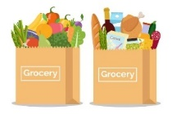  - Shopping Bags – Ask a family member to fill a bag with shopping (a mixture of tins, vegetables, packets etc.). Close your eyes and take out some items then open your eyes to see what you have picked – Can you put these items in order of size/ weight/length? If you take all the items out of the bag could you try and fill 2 separate shopping bags and make one bag heavier than the other? Which items would go in the lighter bag and which in the heavier bag?  - Choose an item in your house, a family member will then ask you to find something heavier/ lighter/longer/shorter than that item. Maybe they could time you to see how quickly you can find something. | Living Things- to participate in growing and  caring for a plant and to describe what a plant needs to grow  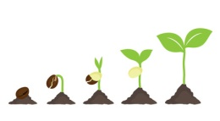  - Plant some seeds (broad beans and cress offer relatively fast results). Caring for an existing plant is good too.  - Watch this video to learn what plants need to growwww.bbc.co.uk/bitesize/topics/zpxnyrd/articles/zxxsyrd  - Make a ‘diary of a plant’- you could draw/photograph and write about what it looks like each day and what you did to look after it.  - Measure your plant every few days using non-standard units (see measurement work)
11.5.20-15.5.20 SOUND OF THE WEEK- EE- What can you sEE?  to say, recognise and identify the ‘ee’ sound and to read/write words with the ‘ee’ sound  Watch Read, Write Inc phonics lesson at www.youtube.com/channel/UCo7fbLgY2oA_cFCIg9GdxtQ - the lesson for ‘ee’ will be shown on Tues 12th May at 10am and available for 24 hours  Differentiated follow up activities (using the ‘ee’ Speeds Sound Practice Sheet posted on our Google Classroom)  * Adult to sound out the ‘ee’ words and child to orally blend and say the word  ** Child to sound out and blend to read the ‘ee’ words  ***Adult to say the ‘ee’ word and child to segment into sounds to write the word  Additional follow-up activity ideas will be accessible from our Google Classroom. | Measurement- Estimate with some accuracy in non-standard units the length of an object and then measure with non-standard units  Estimate the length  - Choose an item from around your house (e.g. TV remote) and choose a non-standard unit of measure (paper clips, hand spans, finger widths, etc). First make a clever guess (estimate) how many of your non-standard units of measure it would take to fill the length of your chosen item; write it down or say it out loud and then measure to check how close you were. Perhaps members of your family could play along too.  - Make ramps for putting toy cars down and again choose a non-standard unit of measure. Estimate how far your car travelled and then measure – have a competition with a family member!  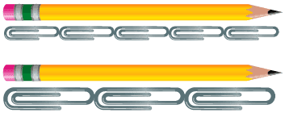  - Play long jump in your garden. Decide on a starting point and see how far you can jump forward. What non-standard unit of measure could you use this time? Estimate then check. | Living things- to name the parts of a plant (stem, root, leaf, flower) and consider the life cycle of a plant  - Watch this video to learn the names of the different parts of a plant  www.bbc.co.uk/bitesize/topics/zpxnyrd/articles/z3wpsbk  - Explore plants in your garden/on your daily exercise, can you spot all the different parts?  - Draw, colour and label a picture of a plant  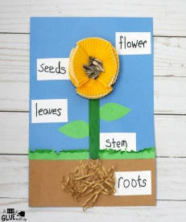  - Watch and learn about the life cycle of a plant atwww.bbc.co.uk/bitesize/topics/zpxnyrd/articles/z2vdjxs
Reading- to apply phonic knowledge to read words and simple texts  There are now more RWI texts available at https://home.oxfordowl.co.uk/books/free-ebooks/. You will need to register to access these but it is free. There are Ditty sheets available on our Google Classroom for those working on simple blending, progressing on to Red, Green, Purple then Pink texts available on Oxford Owl. You may wish to have a go at a few colour levels to work out which is now suitable.  - Select Book. Make predictions based on title.  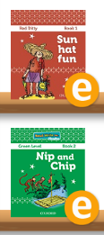  - Practice speed sounds at the beginning of the book  - Practice reading the Speedy Green Words  - Practice any Red Words  - Read through the text  - Discuss the ‘Questions to talk about’  - Reread the same book at least twice to develop fluency | Time- Uses appropriate language when discussing time, including before, after, o’clock, hour hand and minute hand  - Make a daily timetable. Draw a clock face and hands to show what time you are going to get up/have lunch/play in the garden/have dinner etc. When you have finished, ask a family member to ask you questions about your timetable e.g. What are you going to do before you eat dinner? After you get up? Etc.  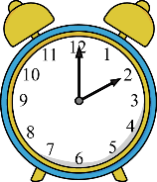  - Spot when a clock in your house shows an o’clock time and read what time it is. What are you doing at this time? | Living things- to show an appreciation for nature and describe things they can do to care for the environment  - Watch this Cbeebies video about the environment www.youtube.com/watch?v=s39DjCdseAA  - With an adult, discuss things that are good and bad for the environment  - Promise to do one thing each day to care for the environment (e.g. turn off the lights when you’re not in the room, recycle cardboard)  - Participate in our Eco Challenge celebrating Newton’s 6th Eco Flag- see Newton Note issued 24.4.20
Non-fiction books- to find simple information and to read simple texts for information  - With an adult, explore any non-fiction books you have. There are some available Free at https://home.oxfordowl.co.uk/books/free-ebooks/. Recap how these are different to fiction.  - Adult might pose a question to research, child to select suitable book to find the information  - Read and explore the book together. You might note down some favourite facts to share with some other family members. | Time- to read digital o’clock times (12 hour only) and represents this on a digital display  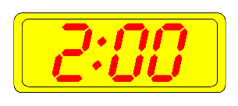  - Look for items and places around your home that display the time on a digital clock. Where did you find the clock? Why do you think a clock was displayed there?  - Draw a picture of one of the digital clocks you find. Is it on the TV/oven/alarm clock? Label where the time is found. | Art and Design- to draw from observation/ to follow step by step instructions  - Draw a picture of a favourite toy, a plant in your garden…anything of your choice. Look carefully at the item as you draw it. Think about size, shapes etc. Maybe everyone in your family could draw the same item. Make it a drawing contest!  - Join in with a step by step Draw Along with author/illustrator Rob Biddulph at www.robbiddulph.com/draw-with-rob
Grammar- match capital letters to lower case letters and know the sounds/names  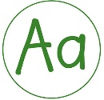  - Play the Mouse House matching game at www.literactive.com/Download/live.asp?swf=story_files/mouse_house_US.swf  - Practice writing the lower case and capital letters on paper/in chalk/with a water gun etc.  - Spot capital letters in books and say its name | Sumdog- to consolidate prior learning in numeracy and to access teacher- set activities linked to current learning  - Log-in to www.sumdog.com using the log-in details which were sent via ParentMail on 25/3/20  - Play the games/activities that have been set and access the free choice activities | 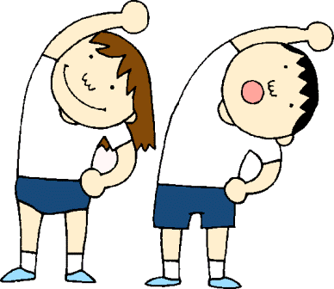  P.E.- to develop my gross motor skills  - Join in with Joe Wicks live PE lesson every morning at 9am (YouTube)  - Set up an obstacle course in your garden which will test different skills like hopping, throwing, dribbling etc.
Writing- to hold a sentence/to write instructions/to make an informative poster  - Select a sentence from your chosen RWI book and have a go at writing it. Remember to say it lots of times to get it stuck in your head before you have a go without looking at it.  - Linked to Health and Food technology, write some simple instructions for something you have made in the kitchen . E.g. how to make a sandwich. Ask someone to follow your instructions  - Linked to context, create a poster showing what plants need to grow. Remember to give it a bold title and use a mixture of words and pictures. | Mental Maths- to count forwards and backwards in 1s to 30, 2s to 20, 5s to 50 and 10s to 100  - Counting forwards/backwards in different voices/characters or with different actions  - Using chalk, make number lines outside. Perhaps a family member could tell you what number to start with and end with and if you are to go up/down in 1s, 2s, 5s or 10s. Then, jump along your number line calling out the numbers as you go.  - Hopscotch – can you make different hopscotches for counting in 1s, 2s, 5s and 10s?  - Pass the ball – throw or kick a ball with a family member and count as you do so. | Health and Food Technology- to participate in food preparation/to demonstrate simple food preparation techniques (e.g. mixing, spreading) and to understand the importance of good hygiene around food  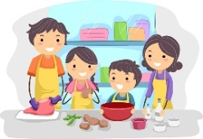  - Help to prepare either a snack or meal at home. You could discuss with a parent first and make instructions for you both to follow. Could you use words such as peeling, slicing, mixing, spreading?  - As you plan to prepare your snack/meal, discuss the importance of hand washing, clean utensils, clean food, tying hair up and wearing an apron with parents.

Suggested web sites and apps:
Literacy
www.youtube.com/channel/UCo7fbLgY2oA_cFCIg9GdxtQ (RWI daily lesson)
https://home.oxfordowl.co.uk/ (RWI e-books)
www.teachyourmonstertoread.com
www.letters-and-sounds.com/
www.phonicsplay.co.uk/
www.topmarks.co.uk (Age5-7 games)
www.doorwayonline.org.uk
www.storynory.com
NEW https://literacytrust.org.uk/family-zone/9-12/book-hopes/
Numeracy
www.topmarks.co.uk (Age 5-7 games)
www.bbciplayer.co.uk (Numberblocks)
www.sumdog.com
Other
www.twinkl.co.uk/offer UKTWINKLHELPS
www.bbc.co.uk/bitesize/
www.bbc.co.uk/teach/supermovers
www.cosmickids.com
NEW www.gonoodle.com

