Accessing Google Drive

Open a new Google tab and type in ‘Google Drive’ in the search bar.  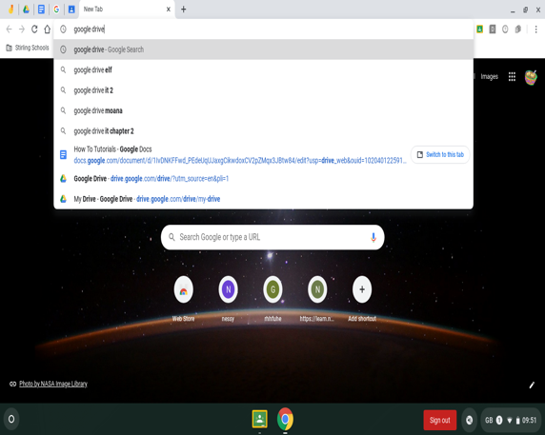 | 2.  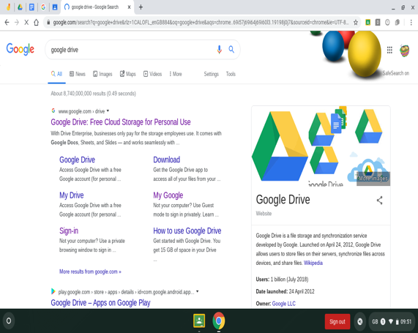  Click on the first result
3.  Click on:  Personal - Go to Google Drive.  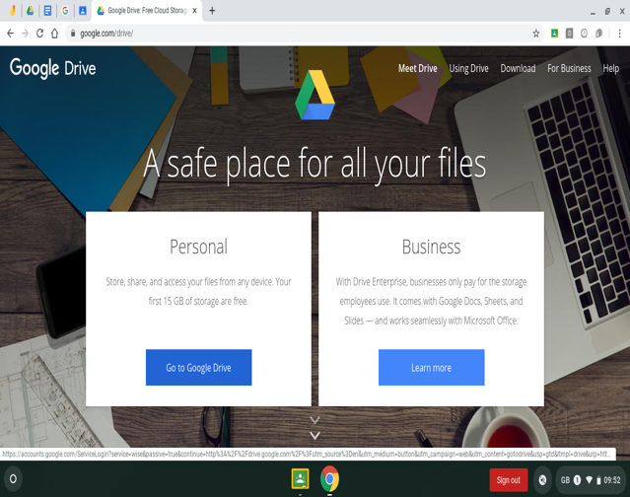 | Log in with your school chromebook login (remember to add @stirlingschools.net).  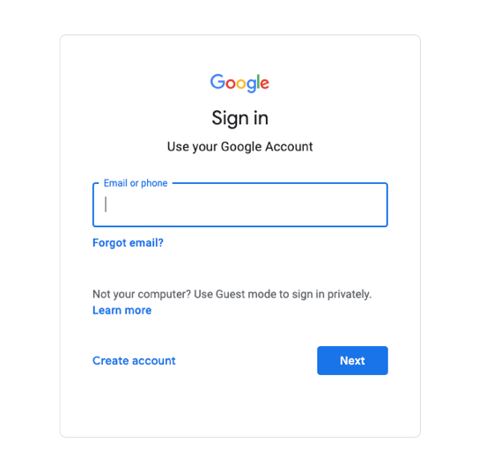
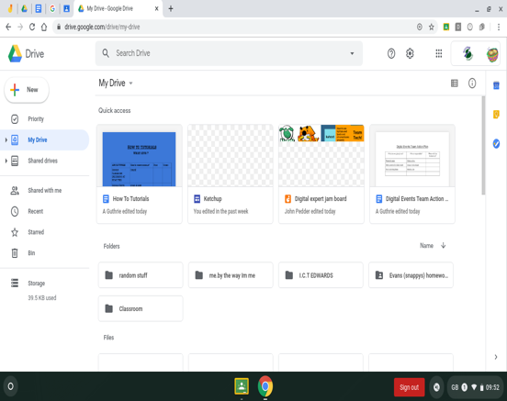
Welcome to your GoogleDrive, where you can create and store a variety of different files types – Google Docs, Google Slides, Google Sheets, Google Drawings etc.

To find a document easily, use the search bar at the top.

