Accessing Google Classroom at Home

Open a new Google tab and type in ‘Google Classroom’ in the search bar.  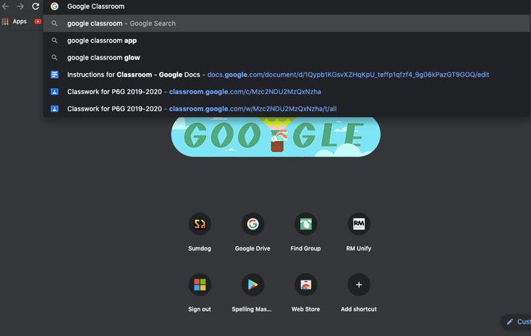 | 2.  Click on this result:  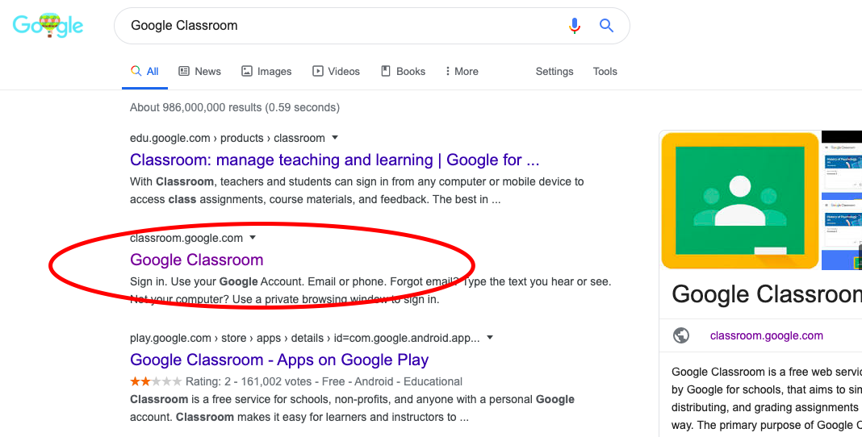
Sign in with your  school chromebook login (remember to add @stirlingschools.net  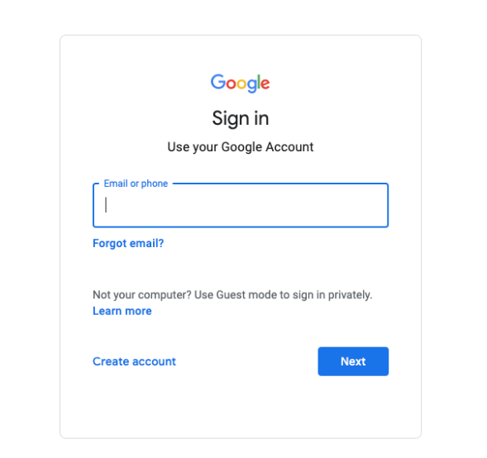 | 4.  Click on your current Classroom.  (to join a class, click the + icon at the top right and enter your class code)  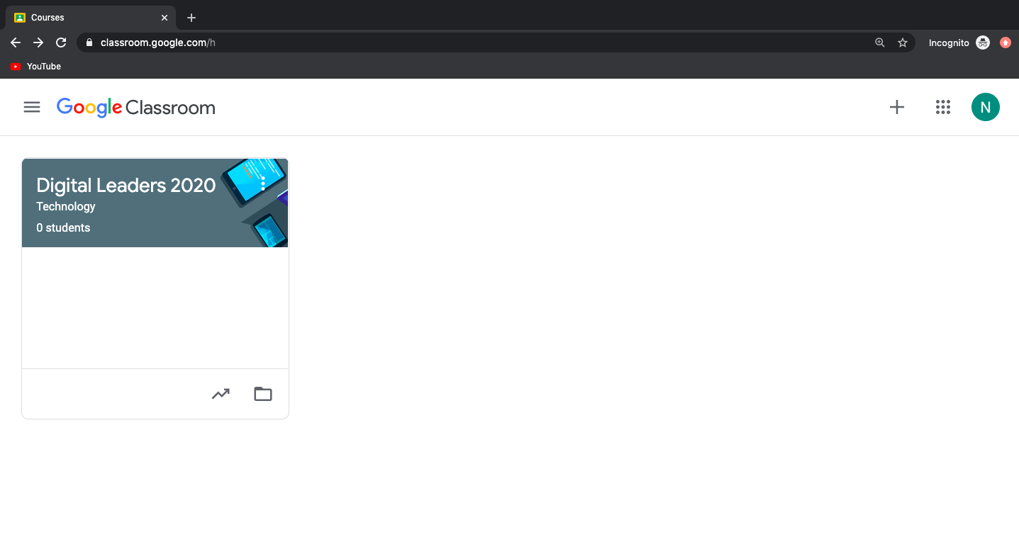
5.
Welcome to your Classroom.
This is the stream, where you will see all announcements and work posted by your teacher.
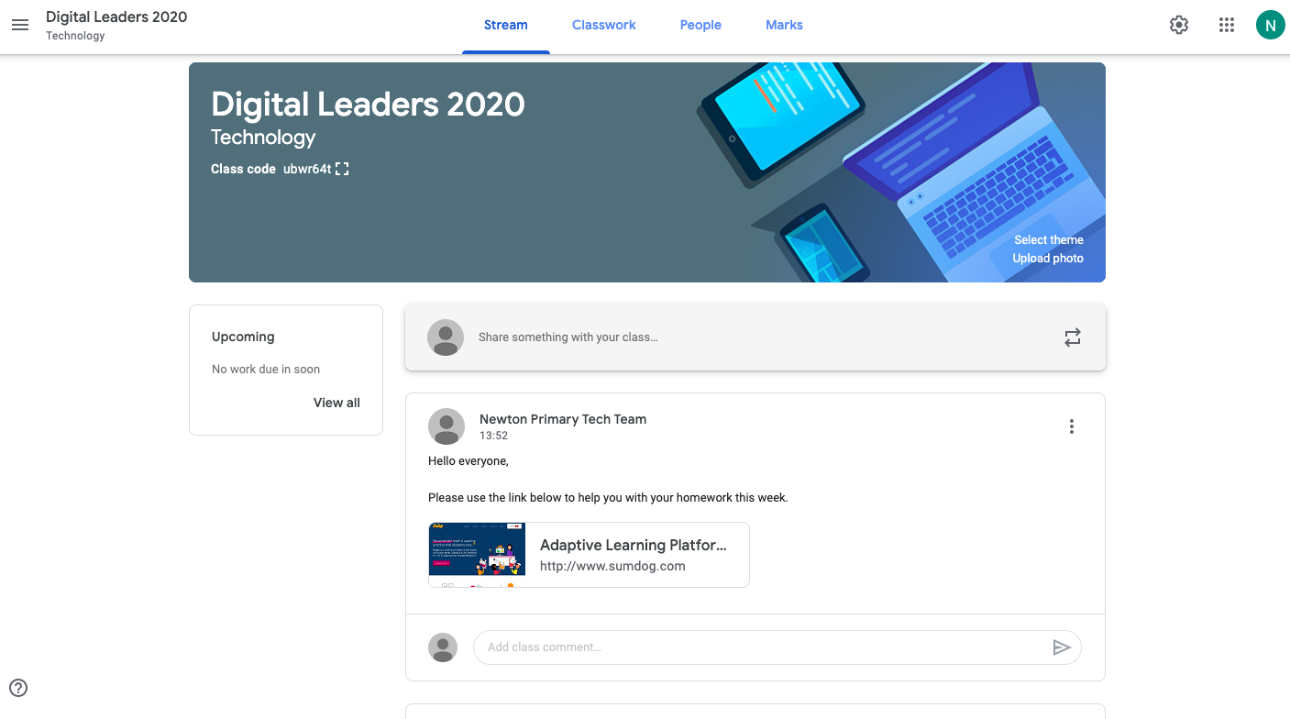
6.
If you click classwork (along the top of the screen), you will be able to easily access any assignments you have been asked to complete.

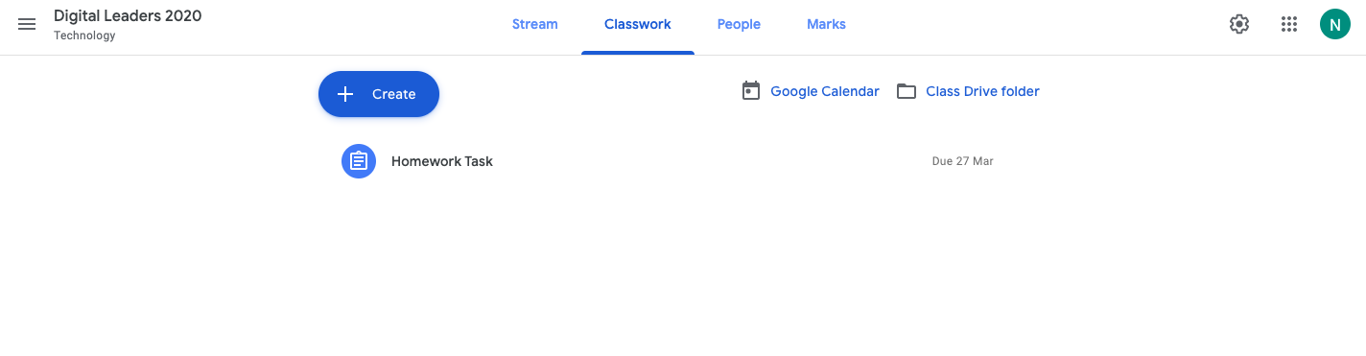

When you have completed an assignment, click ‘hand in’.

