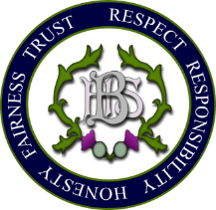
Personal Statement – some things to consider/include:

What are you applying for

Why are you applying for this course/apprenticeship/job

Why does this interest you?

- Show that you understand what’s required to study this course/complete this apprenticeship/do this job.
- Show that you have researched the course/apprenticeship/job.

Why are you suitable for the course/apprenticeship/job?

Do you have any particular skills and experience that will help you be successful in this course/job/apprenticeship?

What have you done that demonstrates your interest in this course/apprenticeship/job
Do your current or previous studies relate to what you have applied for? If so, how?

Have you taken part in any other activities that demonstrate your interest?

Other skills and achievements
Do you have any accredited or non-accredited achievements? Eg Duke of Edinburgh, Young Enterprise, Summer School, FutureLearn

Do you have any other achievements you’re proud of, positions of responsibility that you hold or have held both in and out of school, and attributes that make you interesting, special or unique. Eg Prefectship, Scout leader, etc

