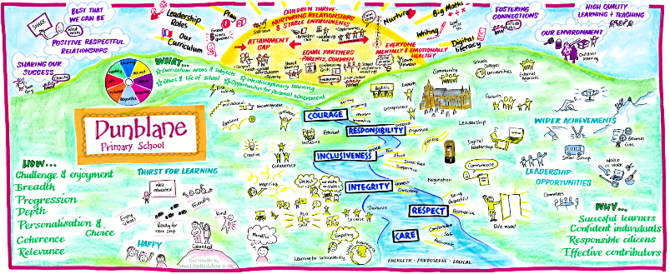
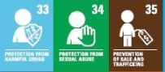
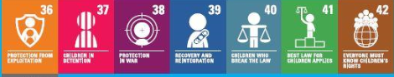
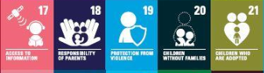
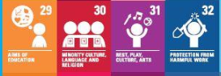
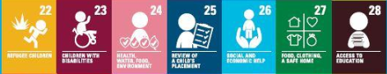
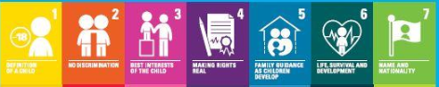
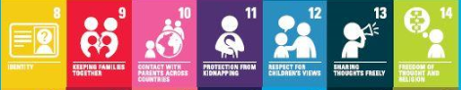
Dunblane Primary School and Nursery
School Improvement Planning 2023/24

“Learning Today, Shaping Tomorrow”
Staff, pupils, parents and members of our community were involved in an extensive and successful consultation process to agree upon a set of values which underpin the life and work of our school.
The following are the 6 agreed values that our community has agreed to uphold:
- RESPECT: To care for ourselves and others by valuing all property, opinions and beliefs.
- RESPONSIBILITY: To treat others as we would like to be treated and accept the outcomes of our actions.
- CARE: To actively show empathy and sensitivity towards each other.
- INCLUSIVENESS: To include everyone in everything we do.
- INTEGRITY: To be honest and have strong moral principles.
- COURAGE: To do things that may take us out of our comfort zone in order to achieve personal growth.

Dunblane Primary School Vision and Aims

Our vision is that every child contributes to our school and its community by being a successful, independent learner, confident individual, effective contributor and responsible citizen.

We will provide a supportive yet challenging learning environment in which we are all capable of continuous improvement. We value highly the contributions of families and the community towards this vision.

Dunblane Primary School and Nursery Class Aims

Our aims were developed through consultation with parents and staff.

We aim to:
- Encourage and empower children to be successful learners by providing a variety of high quality and challenging learning experiences.
- Offer a motivating and relevant curriculum that will provide our children with life skills and support independence, choice and responsibility.
- Promote and embed our values of Respect, Responsibility, Inclusiveness, Integrity, Courage and Care throughout all areas of nursery and school life.
- Develop and maintain positive and effective relationships with children, parents/carers, partner agencies and establishments and the wider community.
- Ensure continuous improvement and positive outcomes for all children which reflect the changing nature of the world around us.
- Foster a sense of pride in Dunblane Primary School and Nursery class, representing them positively in the local community.

Dunblane Primary School Context
In In August 2023 our school roll will be 365 young learners spread across 14 classes from P1 to P7

The school leadership team has 3 PTs, 2 DHTs and 1 Head Teacher

Our attendance rate this past-recorded year has been 97.3%

Self-Evaluation for Self Improvement
Self-evaluation and reflection on our current practice continue to be key features of our work in Dunblane Primary School.
An agreed quality framework within the school ensures that various activities are undertaken for staff and management to reflect on their practice and make improvements where necessary. Our calendar across the year which involves various staff development activities and quality improvement activities ensures that all stakeholders are given a voice in the work of the school including staff, parents and children.
Throughout this past year we have been able to gather views remotely and in person and we will continue to integrate this methodology into our more established practice which includes surveys, interviews and work carried out by the junior leadership team in school. The collation of feedback is then used to plan progress and priorities going forward.
Across 2022 and 2023 session our staff and families have evaluated the school and nursery’s performance against the following How Good Is Our School and How Good Is Our Early Learning Centre Quality Indicators:

1.2 Leadership of Learning
1.3 Leadership of Change
1.4 Leadership and Management of Staff
2.1 Safeguarding and Child Protection
3.1 Ensuring Wellbeing, Equity and Inclusion
3.2 Raising Attainment and Achievement
3.3 Increasing Creativity and Employability

Improvement Planning Overview for Session 2023/24
Following March 2021 and the Scottish Parliament intention to place in law children’s rights we will have those rights as an umbrella that all learning within sits beneath.
Our Standards and Quality Report for session 2022/23 details the progress made in the identified priorities for the year.
Because of self-evaluation the following priorities have been identified:
- To continue to develop the use of digital literacy across school in terms of using data to inform learning and teaching
- To continue to focus on developing a play based approach across school from P1-7
- To further develop Makaton and BSL as our 3rd language in school
- To raise attainment in reading for children within the school but particularly those with barriers to learning.
- To develop children to see themselves as readers and to revisit teaching of reading pedagogy.
- To develop Social Enterprise across our curriculum.

Additional items which came through from self-evaluation:
Developing further our tracking of external achievements for children.
Further involving children in self-evaluation opportunities.
How children influence decisions about their learning.

Dunblane Primary School Improvement Planning Overview 2023/24

National Improvement Framework Priorities | HGIOS 4 & HGIOELC Quality Indicators | Regional Improvement Collaborative Priorities
- Improvement in attainment, particularly in literacy and numeracy.  - Closing the attainment gap between the most and least disadvantaged children.  - Improvement in children and young people’s health and wellbeing.  - Improvement in employability skills and sustained, positive destinations.  Key drivers of improvement  - School leadership  - Teacher professionalism  - Parental engagement  - Assessment of children’s progress  - School improvement  - Performance information | 1.1 Self-evaluation for self-improvement  1.2 Leadership for learning  1.3 Leadership of change  1.4 Leadership and management of staff/ practitioners  1.5 Management of resources to promote equity  2.1 Safeguarding and child protection  2.2 Curriculum  2.3 Learning teaching and assessment  2.4 Personalised support  2.5 Family learning  2.6 Transitions  2.7 Partnerships  3.1 Improving/ensuring wellbeing, equality and inclusion  Specific to HGIOS 4  3.2 Raising attainment and achievement  3.3 Increasing creativity and employability  Specific to HGIOELC  3.2 Securing children’s progress  3.3 Developing creativity and skills for life and learning | - Develop collaborative approaches which build staff capacity to deliver high quality literacy learning experiences for all.  - Work together to strengthen and improve teacher confidence, understanding and teaching of numeracy.  - Work as a collaborative to strengthen the quality of the ELC workforce to support the quality dimension of the expansion.  - Provide professional learning that helps drive forward collaborative leadership at all levels.  - Ensure performance information and improvement approaches support raising attainment for all.
 |  | Children’s Services Plan Outcomes
Some key outcomes are:
- The attainment gap relating to poverty, additional support needs and looked after children and young people is reduced.
- All children thrive as a result of nurturing relationships and stable environments in their own school and community.
- Children, young people and their families are respected as equal partners in decision making and planning.
- Children’s and young people are mentally and emotionally healthy.

Priority | Outcomes for Learners | Impact Measurement | PEF
PLAY  To develop effective and engaging learning experiences for all pupils. | - Learners will lead learning and their interests and views will shape the direction of learning, this will be recorded in Floor books (Both digital and written)  - Learners will experience high quality questioning and challenge within their play.  - Learners will access planned learning opportunities with explicit link to the skills.  - All children will be more engaged and involved in the learning opportunities through staff skilfully observing children to then plan future teaching and learning opportunities.  - Children in Primary 1 and 2 will experience a play based curriculum in the afternoons where the teachers are being responsive to the children’s interests and needs, based on observations and listening to pupil’s voices | - All classes will have floor books that record children’s thinking and evidence opportunities for them to lead learning and shaping the direction of their learning.  - This will be witnessed through planning.  - Soft starts in each class will be carefully planned with a focus on skills being developed.  - Children can talk about the skills and how their learning through play links to the skills framework.  - Google forms will show an increase in staff’s ability to ask challenging questions to further extend individuals learning.  - Detailed observation sheets which support future planning.  - Use of the Leuven scale to show more involvement and engagement with individuals as a result of detailed observations and action plans.  - Strategic overviews being completed retrospectively.  - Detailed observation sheets which support future planning.  - Regular meeting with teachers and SMT to reflect on impact
DIGITAL  - To continue to develop the use of digital literacy across school  - Data in school will continue to be developed in its use. | - Staff to be supported to use Big Maths Data and SNSA data to identify gaps which allow them to target learning communities and staff effectively to close the gap.  - Staff will be required to collate data on impact meetings sheets and compare previous figures and theorise | - Staff will all be measured in their confidence in using the data to identify learning gaps for their learners. Baseline set at beginning of year and revisited.
MAKATON/BSL/FRENCH  - To continue to develop a framework across school for use of Makaton and BSL as well as French which has a progression built in. | - Children will be able to communicate and develop skills in both using Makaton and BSL across the school  - Learning framework in place for staff to follow with materials identified. | - Framework in place to go alongside planning for French/BSL and Makaton to guide staff.  - Termly feedback re use of frameworks  - Staff feedback at the end of the year on using the frameworks
RAISING ATTAINMENT  - PEF  To raise attainment for a group of children who have been identified as having their attainment being impacted by poverty related issues.  - Reading  - To develop pupil’s views of themselves as readers  -To ensure all pupils can see and identify their progress in reading | - Through a focus on strategies techniques and resources attainment in reading will increase across the board.  - 80% of children who are currently behind the curve will see their progress increase by at least 6 months  - Almost all pupils will view themselves as readers  - Reading culture will be fostered  - Reading development across the school, incorporating key elements of literacy work already established within LFS, equality and diversity and Emotion Works.  - Plan for and deliver the successful outcome of becoming a Reading School through the accreditation process allowing us to build a reading culture within DPS.  - Re-launch of school library  - Links with local library- regular class visits, lending programme introduced  - Through a focus on strategies, techniques and resources attainment in reading will increase across the board. Staff and learners will revisit the structure and content of reading lessons, being able to identify the skills and outcomes of an excellent reading lesson.  - Opportunities for family engagement eg library visits, home reading challenges. | - Tracking mechanism across school will show gains in reading from this year.  - Targeted individuals will see an attainment increase in reading and the gap between themselves and others lessen.  - Regular moderation work in house will refocus expectations and agreed outcomes.  - Staff will be confident in the use of data from SNSA and in house tracking to support interventions.  - Progress regularly communicated to class teachers and SMT  - Core reading accreditation will be achieved in year 1.  - A coherent structure for reading initiatives and activities will be in place, providing focused and clear direction.  - Staff will be confident in the use of reading resources and in the planning and implementation of an excellent reading lesson – evaluations term 1 and term 4 will show this.  - Analysis of tracking will demonstrate improvement in reading attainment across the board.  - Learner evaluations throughout the year will show an increase in learners viewing themselves as readers through the conference grids identifying new skills. | $$√$$
Priority | Outcomes for Learners | Impact Measurement
Social Enterprise  All staff will undertake training regarding social enterprise projects and how the Social Enterprise Academy can support us develop employability skills in school.  In year 1 50% of classes will do an enterprise project then the same in year 2. | - 50% of the classes in school in year 1 will undertake a social enterprise project as part of their curriculum.  - Children will have opportunity to learn new skills and apply them within the project.  - Children will have a greater understanding of the skills they have applied in terms of skills for life and 21st century. | - Planning shows 50% classes have undertaken an enterprise project.  - Young learners can identify the skills they used in the projects they took part in. Measured using conference grids within the year.

