Dunblane Primary School and Nursery Class

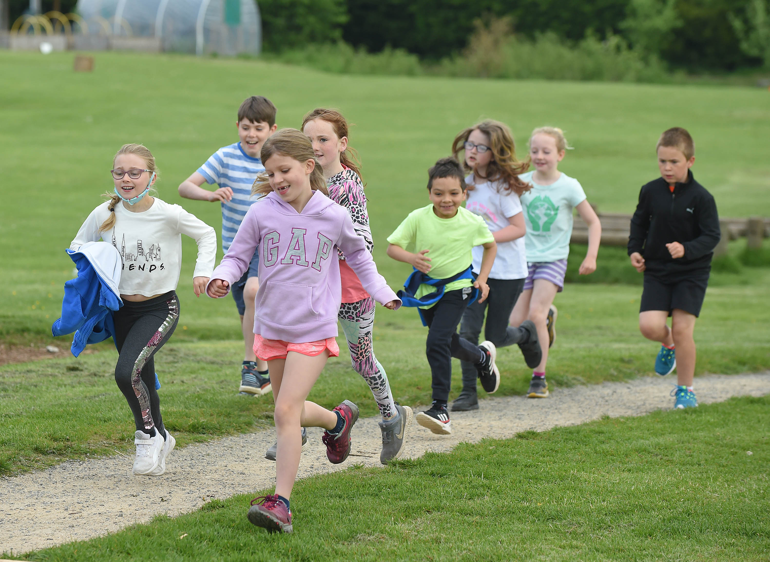
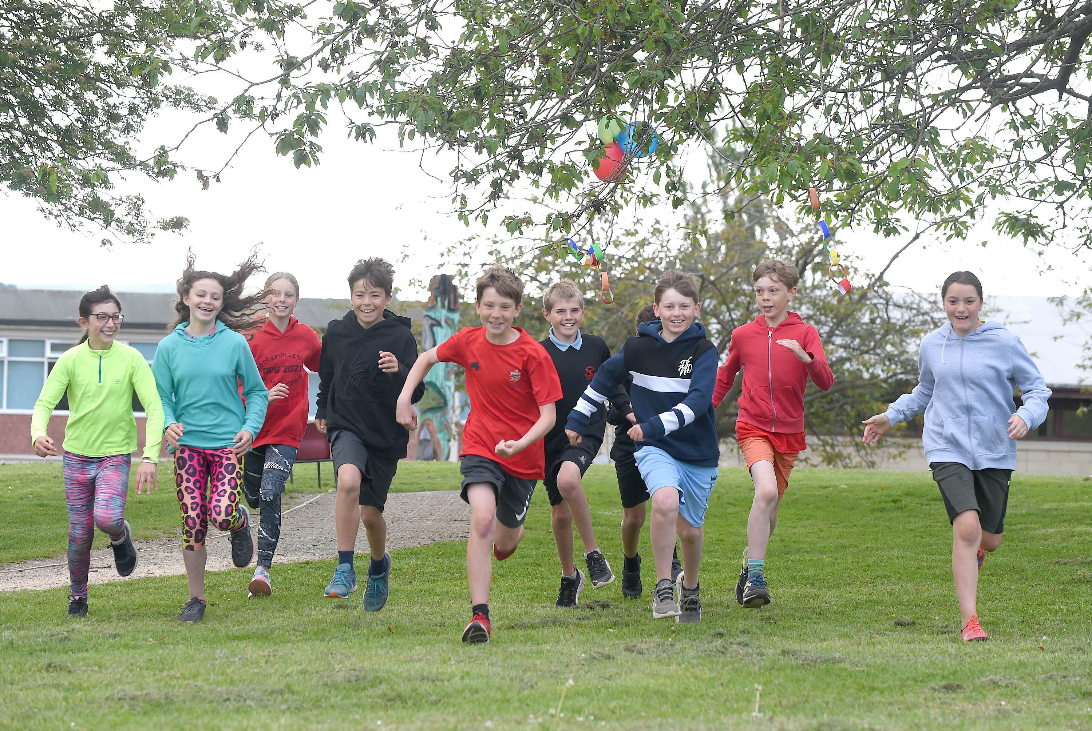

Standards and Quality Report

SESSION 2022/23
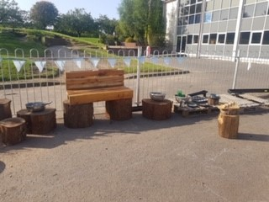
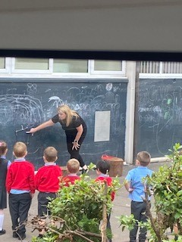
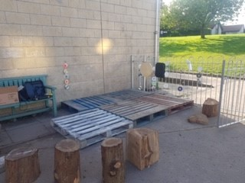

Welcome to our Standards and Quality Report for the school session 2022-23
At Dunblane Primary, we aim to put children at the centre of all we do. We are committed to continuous improvement and meeting the needs of every child. In line with Curriculum for Excellence and Stirling Council, the vision that we have for our school and nursery is one of high achievement, attainment, ambition and inclusion. We strive for excellence and equity in all that we do.

When children leave Primary 7 our aim is that they have become successful learners, confident individuals, responsible citizens and effective contributors.
We are a values based learning community where we take pride in developing all aspects of children’s learning. We are committed to promoting care of the environment and providing children with opportunities to ‘make a difference’ in our local situation. We build effective partnerships with the wider community so that together we can share the important task of preparing our children for the opportunities and challenges of the future so that they can achieve their full potential and follow their dreams.
As a school we promote the values of:
Responsibility Integrity Care Respect Inclusiveness Courage

We believe these values are central to achieving the aims of the school, and are an important part of life at Dunblane and act as a golden thread through all that we do.
The Standards and Quality Report for 2022-23 is a summary of the performance of our school and our nursery with specific reference to the priorities we set ourselves in May 2022. The report also highlights our intended next steps to ensure progress. You will note we have separate documents for nursery and for the school.

Our progress and achievements can only be achieved through of the commitment, effort and joy within learning where children, parents and staff who work very effectively in partnership, ensure the very best learning and teaching opportunities and experiences for all.

We welcome any feedback on our Standards and Quality Report. If you would like to comment please contact the school on 01786 822351 or alternatively email us on dunps@stirling.gov.uk.

As a note for reading as you will often see the phrases all, almost all, most, some etc. Please see below what those words refer to as percentages.

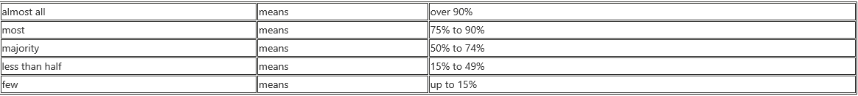

What is included in this report?
In May 2022 we set ourselves the following specific improvement targets for session 2022-2023 and these were:

SCHOOL

23/24 next steps
To review our curriculum in order to ensure we are providing multi faith learning opportunities across all stages
To use pupil voice to create context for learning and review methodology regarding plotting outcomes and experiences
- To revisit the staged intervention approach in school and approaches used re barriers to learning and recording progress

- To continue to support the mental health and emotional wellbeing of our school community
- To focus on developing a play based approach across school from P1-7
- To develop Makaton and BSL as our 3rd language in school
- To continue to develop the use of digital literacy across school in terms of using data to inform learning and teaching
- To continue to focus on promoting gender and race equality across school
- To raise attainment in writing for children within the school but particularly those with barriers to learning
- To continue to embed Learning for Sustainability and develop global awareness through our curriculum

This report aims to outline the impact of our 2022-23 School Improvement Plan, including the impact of our Pupil Equity Funding. It will then go on to indicate the areas which we have identified for our next steps.
Our findings and decisions are based on information and data gathered from:
- The self-evaluation tool, ‘How good is our School 4’, which includes a range of Quality Indicators (QIs).
- Monitoring and tracking of attainment throughout the school.
- Quality assurance evidence, such as observations of learning and teaching and sampling of children’s work.
- Assessment evidence gathered through ongoing class assessments, standardised assessments and teacher judgements on achievement of a level.
- Questionnaires, feedback from and conversations with parents, staff and children either in person or though Google Forms

In the SQR which was constructed at the end of session 2021/22 we identified the following next steps:
School Priority: To continue to develop the use of digital literacy across school
Next Steps:
- Pupil tech team
- SNSA data analysis
- Update school website
School Priority:
- To continue to support the mental health and emotional wellbeing of our school community
- To launch and embed our Positive Relationships Policy, with a focus on gender and race equality

Next Steps
- The Nurturing Approaches Database has continued to be developed in conjunction with EPS and next session will be used to monitor and track identified individual or group wellbeing interventions.
- Child friendly Policy leaflet on nurture to be highlighted and shared.
- Emotion Works will feature in support staff training as well as more information for parents.
- Parents will be required to feedback on our positive relationships policy a year down the line from launch.
- Positive Relationships Policy revisited with staff and pupils in August session 22/23.
- Emotion works will be supported by being embedded in our H and W planning creating a clear framework for delivery for all staff.

School Priority: To continue to develop the use of digital literacy across school

NIF Priority:  - Closing the attainment gap between the most and least disadvantaged children and young people.  - Improvement in attainment particularly in literacy and numeracy. |  | HGIOS4 Quality Indicators and HGIOELC:  3.2 Raising Attainment and Achievement  2.4 Teaching Learning and Assessment
Key drivers for improvement:  - Assessment of children’s progress  - Parental Engagement  - School Leadership  - School Improvement  - Teacher Professionalism |  | Integrated Children’s Services Plan Outcomes:  The attainment gap relating to poverty, additional support needs and looked after children and young people is reduced.
Progress: | PT DIGITAL LED THIS DEVELOPOMENT SUPPORTED BY DHT.  All pupils in P4-P7 have access to their own digital devices for use both at school and at home to support learning.  Planning and policy documents are fully embedded with all staff accessing these.  A tracking system has been put in place by PT to ensure safe and responsible use of equipment, along with a home school agreement for the safe use of devices at home.  Online learning through Google classroom for P3-P7 and Seesaw for P1-2 has been embedded. Google classroom is used to access homework weekly as well as in school learning.  Regular use of devices in class has been supported by the ‘CUBES’ allowing greater connectivity to the network.  Children have had the opportunity to participate in several online meets through the ‘Connecting Classrooms’ project as one example.  P7 transition has been supported very well by the use of online Google meets- with weekly sessions delivered by High School staff online in Term 3.  Parent Council meetings have continued using an online forum and engagement has remained high. Parental consultation and staged intervention meeting have taken place online and engagement has been successful.  Our PT has led staff development sessions on the use of Big Maths, looking specifically at analysing the data. Feedback from staff has been very positive, with the majority reporting an increase in confidence- not only in the regular use of Big Maths as a planning tool but in identifying learning gaps and next steps for pupils.  Our Digital School Award was achieved in November 2021, with the report recommending that Dunblane Primary should be invited to become a mentor school.  The report highlighted that: ‘The whole community of Dunblane Primary School has a very clear vision for digital technologies in learning, thanks to detailed yet concise policy and planning embedded in the SIP. The core documents are overtly underpinned by local and national guidance and it is evident that the school has carefully researched prior to constructing their plans. Collaboration across and between personnel is also evident, capitalising on rich, school based expertise and experience. The documents submitted as supportive evidence by Dunblane PS were amongst the best I have reviewed in validations to date. The strategy and policy documents were well articulated and informative.’
Impact: | A group of staff and pupils met with an assessor from Digital Schools Scotland and shared the School’s digital journey. They fed back on impact of the use of digital technology for both pupils and staff.  The report highlighted:  ‘Dunblane PS has a very strong sense of community and this is reflected in their digital culture. Technologies are successfully implemented to provide creative and engaging lessons. Learners feel empowered and well supported by an effective combination of effective teaching and opportunities to become more independent. Learners felt that they were encouraged and motivated by their teachers. They were able to describe multiple apps to support and enhance learning. They were articulate and confident in their descriptions of actions fostering online safety. They spoke knowledgably about the risks and benefits of social media, especially regarding TikTok and You Tube channels. Teachers described digital technology " as a game changer" especially for those learners with ASN, dyslexia in particular. Accessing the curriculum was far easier if such learners were provided with appropriate digital tools. Moreover, teachers felt technologies helped the school establish an inclusive ethos. Reluctant writers became more motivated and engagement with technologies has been transformational for one particular group who were now volunteering to contribute to a newsletter. Coding, starting at nursery level, was evident and the whole community was proud of the achievements to date. The school is not, however, complacent and has clear plans to continue this successful progress.’  ‘Staff spoke confidently about their digital journey to date and were able to cite multiple examples of individual and collective progression. Decisions pertaining to future digital development took account of the school's context and ambitious aspirations for learners and teachers. CLPL and pedagogy are identified as key factors in continuous improvement of digitally supported learning and teaching. Teachers are enthusiastic about their delivery of lessons, enhanced by creative application of digital technologies. The shared vision for the school is proactive and ambitious, recognising the challenges and opportunities created by blended learning. The school team wish to futureproof their engagement with digital technologies and consciously review their policy and practice to achieve such.’  ‘Targeted CLPL for digital technologies to enhance learning and teaching continues to ensure effective and appropriate delivery. Teaching staff have embraced all opportunities to develop their skillsets and knowledge. Young Digital Leaders are encouraged to apply their digital skills as tutors and guides for others ( including peers, younger learners and adults) Teaching staff have welcomed and valued the contribution of key members within the school team who provided effective, in house CLPL.’  ‘The digital culture in Dunblane PS is very strong, with all stakeholders offered opportunities to benefit from the technologies implemented within and beyond the school gates. The school Twitter account, SeeSaw and Google Classroom provide daily opportunities to communicate with families and celebrate wider achievement. These platforms have been welcomed and embraced by parents seeking information and feedback for learners.  Transition models have been developed and are heavily based upon digital technologies - from nursery transition through to S1 transition. The school team are excited by and enthusiastic about the progress made to date. They are confident that these already successful models can be developed to further enhance learner experience. This desire for continuous improvement was prevalent throughout the validation.’  ‘Use of digital technologies to deliver the curriculum within Dunblane PS is creative and purposeful. Implementation of planning for digital technologies is effective across the school and the team have successfully embedded technologies in their day to day learning and teaching. The school is engaged in a very productive project through the Connected Classrooms initiative, which included linking with a scientist in Nepal. Opportunities to directly engage in real and relevant conversations around the globe are very powerful. Learning and teaching has more immediate meaning and relevance which can be highly motivating. Weaving curricular areas together, be it through STEM based activities or otherwise, can help learners understand the connectivity of effective education. Transfer of skills therefore becomes easier and more frequent. Teachers are already seeing the benefit of this and one staff member exemplified the general attitude; " we are ready to go further. It's such an exciting time."  ‘The group explained that all contribute to self-evaluation. This very collaborative approach to development of digital technologies across the curriculum ensures that all stakeholders have the opportunity to express ideas and concerns, influencing policy and practice. Indeed, young Digital Leaders known as the Tech Team have the opportunity to directly and remotely support learners and teachers. This will become an expectation and specified role over time.’
Next Steps: | Pupil tech team  SNSA data analysis  Update school website

School Priority:
- To continue to support the mental health and emotional wellbeing of our school community
- To launch and embed our Positive Relationships Policy, with a focus on gender and race equality

NIF Priority:  Improvement In Children and Young Peoples Wellbeing | HGIOS4 Quality Indicators and HGIOELC:  3.2 Raising Attainment and Achievement  3.1 Ensuring Wellbeing Equity and Inclusion  2.2 Curriculum  3.1 Leadership of Learning
Key drivers for improvement:  Assessment of children’s progress  School improvement  Teacher Professionalism  Performance Information  School Leadership | Integrated Children’s Services Plan Outcomes:  Improve health and wellbeing outcomes for our most vulnerable children and young people.  All children thrive as a result
Progress
PT HEALTH AND WELLBEING LED THIS DEVELOPMENT SUPPORTED BY DHT RESPONSIBLE FOR NURTURE
Positive Relationships Policy
The Positive Relationships Policy, with the Nurture Principles embedded at its core, has been launched to the school community. This incorporates anti-bullying, diversity and equality, restorative practice and nurture principles.
This policy has been embedded throughout the year with all staff launching it within their classrooms and in the playground in Term 1, as well as receiving training on restorative practices.
Parent guidelines have been created and shared. A pupil friendly version is being developed with the Junior Leadership te Principles of Nurture:
The final two principles have been rolled out across the school with staff development sessions taking place for each (Children’s Learning is understood developmentally and Language is a vital means of communication)
EMOTION WORKS INFO
An Authority wide nurture video, developed by Educational Psychology, highlighting effective practice, has been launched within the ‘ASN matters’ forum, with pupils and staff from Dunblane Primary contributing to this.
am and will be shared next session, further reinforcing the launch process this year.
Staff worked collaboratively to create a ‘whole school approach to nurture’ document and briefing note for staff handbook, highlighting features of effective practice at DPS.
Children across the school have reflected on each of the principles, creating child friendly language to be displayed in classrooms as well as reflecting on what each of these 6 principles look and feel like in our setting.
The Junior Leadership Team led self-evaluation through focus groups of children to reflect on our nurture journey. A sample of views gathered are highlighted below:
‘The school cares about our needs
We can talk to someone, people will listen to us if we are upset
We can take time out in hub or calm corner in our class if we need to
We do wellbeing webs so adults can check in on us and chat to us about our wellbeing. Our calm code helps us to talk about how we are feeling
Buddies help our P1s to settle in
Conferencing grids help us talk to our teacher about our learning
We have worry boxes/calm boxes
Emotion works has really helped us to think about our feelings
We know that our voices will be heard. We know this because we sometimes help to make decisions about our school.
We learned about the rights of the child and we think they are met in school
We do lots of things to look after each other in school
We share our learning with others and celebrate things we are doing well
We have the hub which people can use at break and lunch if the playground is too much or if we need a quiet break
The way we celebrate when people are doing the right thing or making good choices is much better than what we used to do with traffic lights. Now everyone gets praised for doing the right thing.’
The Junior Leadership Team reflected on our nurturing approaches using ‘Maslow’s Hierarchy of Needs Wellbeing Triangle’. Pupils identified ways in which Dunblane Primary meet each of the five levels under the headings: ‘physiological needs, safety needs, belongingness and love, esteem and self-actualisation’ Pupils reflected particularly on: conferencing girds, pupil participation through the sustainability squad, JLT, buddying, clubs, house captains, Emotion Works, the Hub, calm corners/calm code/calm boxes, positive relationships, the Young Leaders of Learning programme amongst other examples.
A Youth worker has completed weekly sessions with groups of P6 and P7 children, focussing on mental health and wellbeing- specifically focussing on transition and peer relationships. Children and parents have reflected positively on these sessions and pupils have engaged well.
A grant was secured for additional wellbeing resources to continue to develop use of the Hub (school wellbeing space). This space has been used successfully this year, supporting playtime and lunchtimes, Seasons for Growth groups, collaborative learning, targeted wellbeing work, mental health youth worker and school counsellor.

Impact
Nurture
See pupil reflections above
Consistency of approaches to restorative practice in class and playground
Staff feedback:
Staff survey highlights:
All staff feel that they understand the ethos and values around nurture well or very well.
All staff feel they know and understand the nurturing principles well or very well
All staff feel they can implement the principle so f nurture into their practice well.
Staff were asked to reflect on what Dunblane Primary looks like as a nurturing school. A sample of responses highlight:
‘Relationships between staff and pupils are positive. Individual pupils are supported in a variety of ways
The children know the school values and see evidence of them in practice
Positive language, open/non-threatening body language, strong transitions, safe spaces, understanding the young people’s needs
The Hub in action, restorative practices, safe spaces throughout the school and in classrooms
Calm codes, calm corners, emotions works, language used when communicating with children, calm boxes, sensory room
Using different techniques to check in with children- whiles class, individually
Growth mindset, use of positive reinforcement
Identifying and using regulation strategies
Emotion works learning
Supporting smooth transitions- year to year, daily
Recognising behaviour as a form of communication, check-ins daily’

Emotion Works
Through data gathered we can see clearly that our children across school have had an increase in the number of emotion words they know and understand, the number of regulation strategies they can identify, the number of triggers that they understand and how their body and behaviours communicate their emotions to them.
For example:
As an average number across school the children at the beginning of the year could identify 39 regulation strategies when they were feeling dysregulated. At the end of the year we had an average of 106 strategies being identified.
At the beginning of the year an average across all sages was 69 triggers identified but at the end of session children could identify 174 triggers and apply how to support themselves with that using the regulation strategies noted above.
We conducted a highly successful sharing of the learning event to develop the understanding and awareness of emotional regulation into the school community. We had a 96% turn out of family members to share their children’s learning with them. Below is some of the feedback we received:
“I have had the pleasure of learning all about the cogs recently but P6 have made it come to life beautifully for me. I am elated, proud happy glad and amazed at this learning.”
“I understand now the different trigger points and associated emotions and it’s great that I can identify them also. I am happy proud impressed and interested.”
The school has been highlighted for a Bronze award in their work on Emotion Works and we have been featured in a film showcasing good practice.
Positive Relationships Policy
Launched in August of last year. Staff and pupils are all aware of the policy and a parent and pupil friendly version was distributed to support everyone in the application of it across school.

Next Steps
The Nurturing Approaches Database has continued to be developed in conjunction with EPS and next session will be used to monitor and track identified individual or group wellbeing interventions.
Child friendly Policy leaflet on nurture to be highlighted and shared.
Emotion Works will feature in support staff training as well as more information for parents.
Parents will be required to feedback on our positive relationships policy a year down the line from launch.
Positive Relationships Policy revisited with staff and pupils in August session 22/23.

School Priority; Continued awareness raising of Learning for Sustainability within the frame of Global Goals making links to diversity and equality.
Continue to embed skills framework related to employability and creativity in DYW and promote work on Social Enterprise
NIF Priority:  Improvement in Employability Skills and Sustained, Positive School Leaver Destinations for all Young People. | HGIOS4 Quality Indicators and HGIOELC:  3.2 Raising Attainment and Achievement  3.1 Ensuring Wellbeing Equity and Inclusion  2.2 Curriculum  3.1 Leadership of Learning
Key drivers for improvement:  Assessment of children’s progress  School improvement  School Leadership  Teacher Professionalism | Integrated Children’s Services Plan Outcomes:  Improve health and wellbeing outcomes for our most vulnerable children and young people.
Progress:
All stages planned context linked to SDG5 – Gender Equality which all learners engaged in.
Women in STEM google meets for P4-7 Focus SDG
All staff undertook two sessions regarding awareness raising with The Black Curriculum looing at unconscious bias and considering teaching practice and language.

Impact:

Staff across all stages considered environments and how we represented with particular reference to diversity and equality.
Staff considered language use in the smallest of scenarios to begin with and use of resources to ensure more of a balanced and inclusive approach

Next Steps:

All stages to plan context linked to SDG10 – Reduced Inequalities using book as stimulus for session 22/23 August term using literacy as the vehicle

School Priority: Continued Awareness Raising and development of LFS
NIF Priority:  Improvement in employability skills and sustained positive school leaver destinations for all young people | HGIOS4 Quality Indicators and HGIOELC:  1.3 Leadership of Change  2.2 curriculum  2.3 teaching learning and assessment  1.2 leadership of learning
Key drivers for improvement:  School improvement  School Leadership  Teacher Professionalism  curriculum | Integrated Children’s Services Plan Outcomes:  Improve health and wellbeing outcomes for our most vulnerable children and young people.  The attainment gap relating to poverty, additional support needs and looked after children and young people is reduced.
Progress
This aspect of SIP was led by JH acting PT LFS
Children in nursery to P3 have had the skills of creativity, empathy, curiosity, problem solving, and effective communication introduced to them and linked to their play scenarios.
PT delivered CAT sessions on sharing good practice and integrating the global goals across learning
P1-7 have all planned contexts with clear links to SDGs in term 3
Baseline of staff views on what LFS means to them.
CAT session delivered by PT focussing on sustainable development education and interdisciplinary learning
IDL challenges planned across P4-7 in term 3
All playgrounds across school have developed their outdoor spaces to integrate open ended play scenarios with a focus on problem solving, curiosity and creativity which in turn leads to development of effective communication and empathy within large groups of children.
All classes have been spending a much larger percentage of time outdoors for their learning.
Across N-P3 the global goals explorers have been introduced to all children.
Within the nativity this year children had the chance to showcase their learning re food journeys linked to SDGs.
Began work on connecting classroom work following successful bid and this will be spent on purchasing resources for gender equality as part of the project. Cluster of local school formed with JH coordinating. FH and CA other two PTs supporting this work.
Partner school identified in India and virtual work has begun between the cluster locally and the school in India. The school is called Bhavans Rajaji Vidyashram in Chennai. We have worked in partnership with network schools in Stirling: St Ninians and Raploch
P1-3 and P4-7 have all had virtual meetings with the class teacher in Chennai.
JH led INSET input on Connecting Classrooms and supported staff to plan their context for Term 3 around India whilst incorporating SDGs and global citizenship working alongside promoting and celebrating diversity work. This will be a first for DPS as a whole school context for learning in session 21/22 term 1.
Most classes in DPS took part in the initiative Wee Flags For Change with families also making their own pledges. Other schools in Stirling were encouraged to take pat also.
Numeracy outdoor learning progression planners have been introduced.
P1/2 playground area developed and extended over the year to encourage experimental play and skills development.
We have an eco group which explore actions we can take as a school to reduce our carbon footprint. This year we received our new green flag.
Contexts undertaken in school increasingly linked to SDGs (Sustainable Development Goals)
Pupils take part in climate change events throughout the year such as the Youth climate summit.
P5-7 have enjoyed a virtual Q and A with local Climate change author Neil Kitching.

Impact
Learners across all stages take part in outdoor learning. Some classes learn in the outdoors more than indoors however outdoor learning across the school has increased.
Two class teacher have taken lead on this within the year developing leadership skills.
All staff using numeracy planners for learning outdoors.
All class charters which we create at the beginning of the year are based on children’s rights. We worked in partnership with Raploch Primary School for this.
Children’s voices have been heard across the school in terms of being involved in planning the outdoor areas as well as choosing the country we would wish to be linked with.
Children across the school have supported other stages in the process of growing and sustainability.
Developed good partnerships with local schools.
JH herself has been a shining light in supporting work across the authority as well as on a national stage and developing her leadership skills.
Staff have been sharing practice with each other through a framework of support which had been created for them.
JH with a clear lead on LFS has supported staff exceptionally well as a role model, team teacher and resource manager for them.
DPS work on LFS has been shared across Stirling networks and nationally through magazines such as the GTC magazine.

Next Steps
Continue to develop our diversity work making links to social justice and the rights of the child
Develop literacy bags for outdoor learning
Develop more reciprocal partnerships
Linking the characteristics/skills to the children learning across the board.
Develop holistic assessments to assess the characteristics.
You Tube video delivered to staff on next steps for LfS over session 20/21 by Miss Hutton.
https://youtu.be/G2TkBa9h6zs

Video to support outdoor numeracy learning delivered to staff.
https://youtu.be/O2gWc0LbzeE
Video to support staff link context to Global Goals.

https://youtu.be/WzdtsjbmhQE

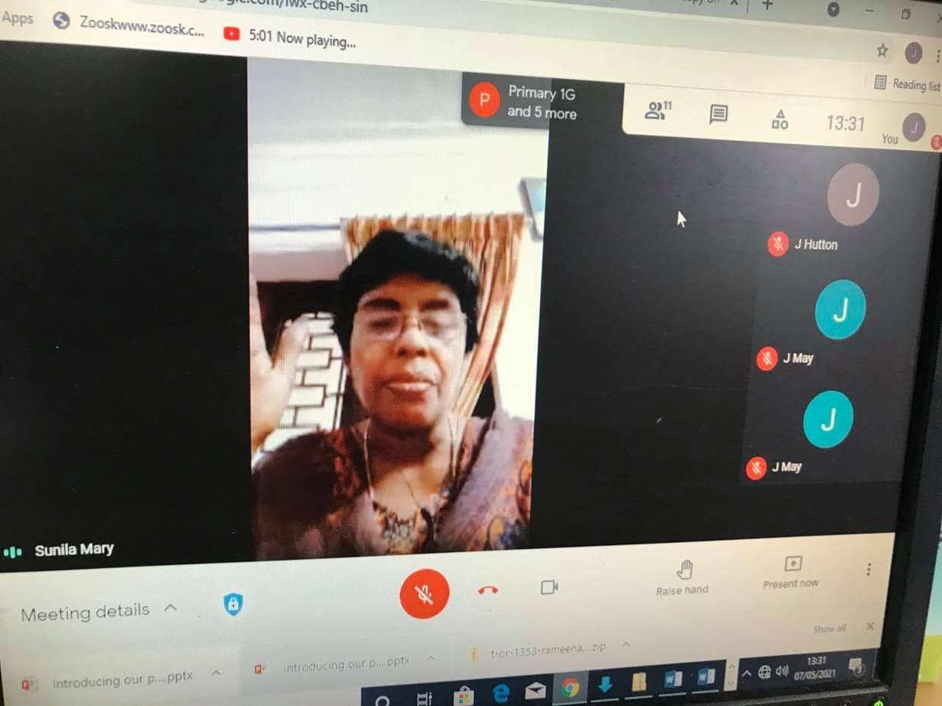
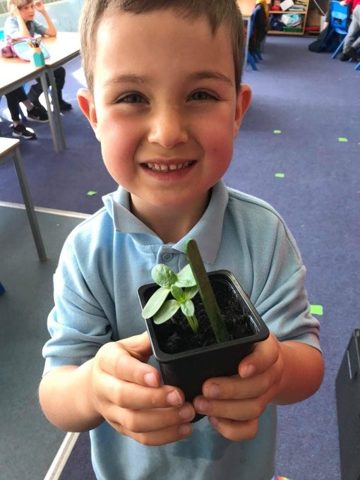

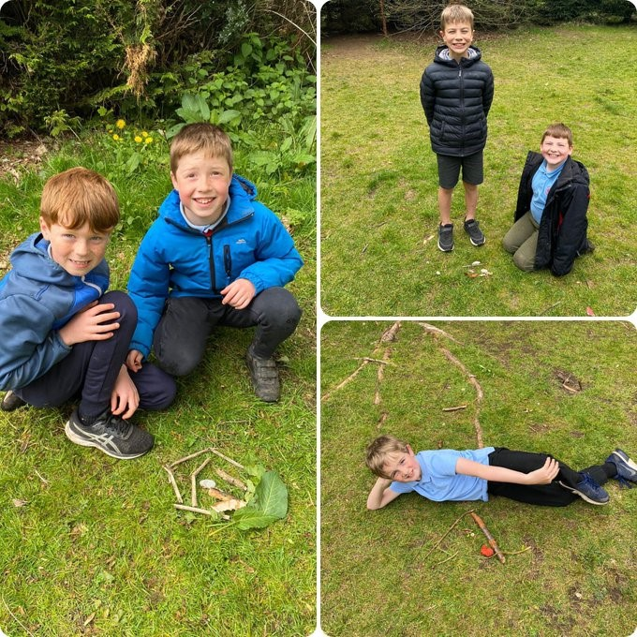

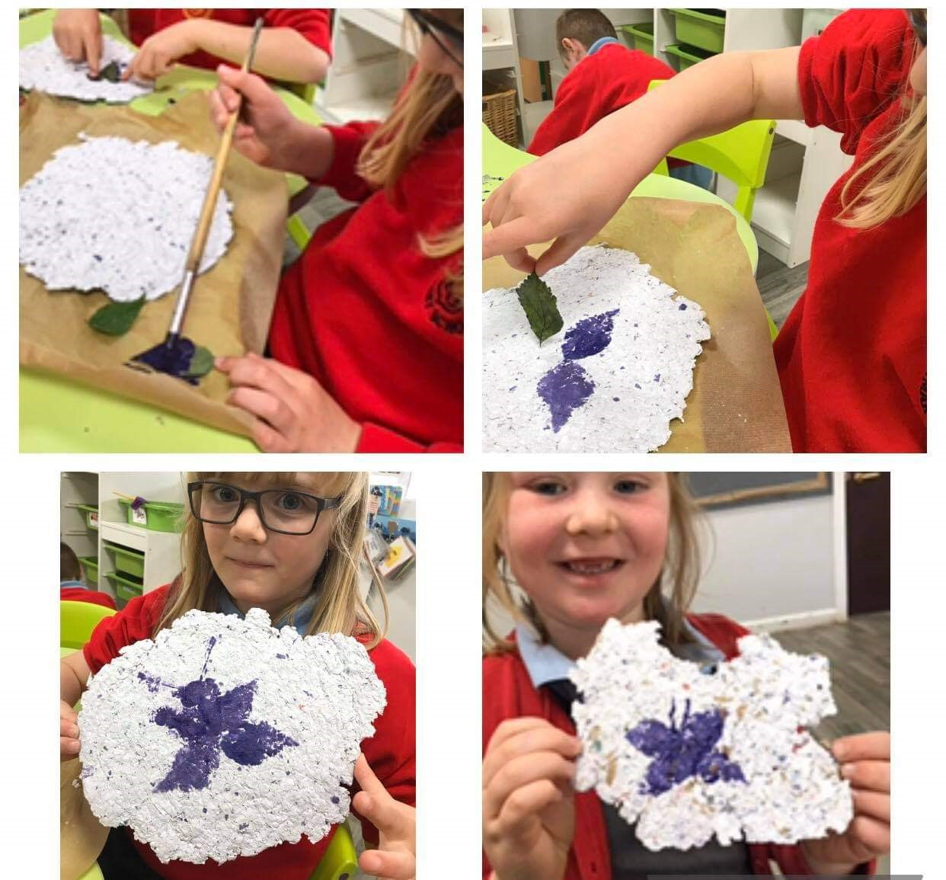

Progress and Impact of Pupil Equity Fund
Pupil Equity Funding is money that we as a school are awarded to help provide children with the best possible opportunities in their learning.it is there to help the school support children who experience barriers to their learning and who might be falling behind or not getting the same chances in their education because of their family experiencing poverty or other financial difficulties. This is referred to as the poverty related attainment gap. We here at Dunblane Primary School have not identified a poverty related gap when analysing our attainment figures but we do have a number of children who experiences barriers to learning.
We use the Scottish Index of Multiple Deprivation as a statistic tool to identify children who may fall into the poverty related gap. The SIMD ranks data from most deprived ranked 1 to least deprived ranked 10. This of course is not an exact measure and cannot simply be used in isolation to known knowledge of the school community itself. Our school data looks like this:

SIMD 10-8 | SIMD 7-5 | SIMD 4-3 | SIMD 2-1
69% | 11% | 18% | 2%

Last year the school was allocated £14,098 of additional funding through the Pupil Equity Fund. In discussions with staff and SMT as well as views sought throughout the year from parents, the following priorities were identified:
- The emotional health and wellbeing of our children, as well as a targeted group of children who are the most vulnerable in terms of returning to full time education following Covid.
As a result of these priorities the school identified the following interventions:
- Continued employment of additional support for learning assistants to undertake individual support for targeted learners allowing them to have the capacity to engage in learning in class and out with class to support their needs.
Although the impact for these children can also be seen through the SQR itself in areas of health and wellbeing, nurture and Emotion Works specific impact for these children is noted as:
Progress
DPS won a national competition on showcasing the knowledge of children through a TV programme called Coggle Box.
PT has inputted within HT meetings regarding the project and rollout of it.
PT is now an ambassador for Emotion Works and supports staff across Scotland on methodologies.
Staff have a knowledge now of the impact of nurture and the outcomes associated with supporting the principles in their classes.
Staff and management tracking wellbeing across school using differing tools and targeted approaches for individuals.
In our health and wellbeing survey of parents 73% of those who responded believed the school to be proactive in building positive relationships and supporting each child as an individual and that we made children feel safe, healthy, active, nurtured achieving respected and included.
All classes aware and using Emotion Works regularly in practice with all children familiar with and using the language associated with emotions and identifying them.
Children can be heard and have successfully demonstrated use of language of emotions in challenging situations. See the graphs below which serve as a snapshot of impact across the school following baseline assessments and follow ups at the end of the year.
Impact
All classes aware and using Emotion Works regularly in practice with all children familiar with and using the language associated with emotions and identifying them.
Children can be heard and have successfully demonstrated use of language of emotions in challenging situations. See the graphs below which serve as a snapshot of impact across the school following baseline assessments and follow ups at the end of the year.

The number of regulation strategies trebled for P2H. The initial number was 3 and the final number was 9.

The number of emotion words doubled from 6-12 from the initial to final baseline assessment.

The number of regulation strategies for P3M doubled from the initial baseline to the final baseline. This increased from 164-372.

The number of emotion words for P3/4 doubled from the initial baseline to the final baseline. This increased from 158-320.

The number of identified regulation strategies almost doubled from the initial to the final assessment for P3M. They increased from 68-128.

There was a 5 X increase in the number of regulation strategies P4A could identify from the initial baseline to the final baseline. This increased from 40-203.

The number of emotion words trebled from the initial to final assessment for P5HG. This increased from 153-514.

There was more than a double increase in emotion words identified by P6/7 from the initial to the final assessments. This increased from 155-400.
In our health and wellbeing survey of parents 73% of those who responded believed the school to be proactive in building positive relationships and supporting each child as an individual and that we made children feel safe, healthy, active, nurtured achieving respected and included.
In the same survey 82% of those who responded said that children felt included and engaged and that we understood and valued diversity and challenged discrimination.
Targeted wellbeing interventions for individuals, have been measured using the Warwick Wellbeing Scale. Data has shown that all children improved or maintained their wellbeing scores:
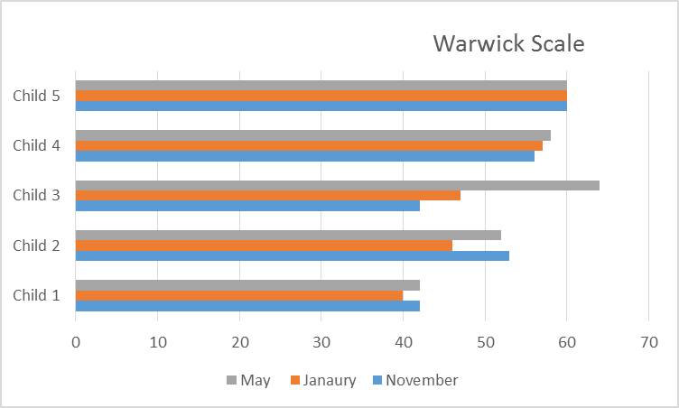
This was completed for individual pupils at three points over the session to measure the impact of specific HWB/Nurture interventions including: anxiety programme, individualised curriculum with targeted supports in place to engage the children their learning and wellbeing, resilience programme, targeted Emotions Works support, using the 5 point scale as a tool to support regulation and ‘calm’ boxes with tools to support regulation. As the data shows, overall almost all these pupils showed an increase in scores over the session in their Warwick wellbeing scales.
Alongside this, data gathered shows an overall trend in increased or sustained attendance patterns and less frequent intervention from senior management regarding behaviour. This highlights that nurture/wellbeing interventions in school as well as working in partnership with agencies and parents has had a positive overall effect on these young learners’ ability to more effectively regulate their emotions and develop strategies to manage these.

Overall in school with the exception of a child with a particularly high needs level we have seen in children:
Better self-regulation through the capacity to verbalise thoughts and feelings.
Better conflict resolution through restorative conversations
Improved resilience in relationship challenges.
Improved capacity to clearly communicate thoughts and feelings to others lessening the anger felt at times.
Increased engagement in tasks for most of the children across the school.

Wider Achievements
Over the course of the year it has not been possible for children and families to participate in the events which we would normally detail in this section. However the following has occurred across school:
- P7 pupil’s artwork chosen to create a bench for the community to enjoy within the Holmehill area in Dunblane. https://dunblane.info/1697-holmehill
- Dunblane Primary School won the national competition run by Emotion Works and is currently showcased on their website https://www.emotionworks-recovery.org.uk/multi-competition-winner/
“This very popular winner in the larger project category really did take a unique spin on sharing their learning about the cogs! As many of you know, we use the idea of wearing ‘coggles’ to help us look at things through an Emotion Works lens. Lots of schools take on this idea and make their own fantastic versions of coggles like the ones shown here. It was an absolutely inspired idea by Principal Teacher and HWB lead at Dunblane, Rachel Aylott, to come up with the idea of ‘Cogglebox’ to encourage children to view a selection of TV programmes, movies and adverts using Coggle vision!”
- Police Scotland Officers supported learning about bullying and hate crime from P4-7.
- P7A created their own newspaper which was distributed to all families at various points throughout the year
- We had 2 winners and 2 runners up for the Halloween Short Story entries which the Co-op were running for Halloween.
- All children took part in fundraising activities for Children In Need
- LFS The school and families were encouraged to take part in Transform Our World, Youth Climate Summit. Some of our work was highlighted in the National celebration of the week and you can see the video here: https://youtu.be/ph34Yld8-WE.
- Miss Hutton has also been approached to share the planning and development of LFS across our school with our colleagues in Stirling Council but even wider across other local authorities.
- Virtual parent focus groups regrading self-evaluation have continued throughout the year.
- Whole school took part in Book Week in March
- Walking bus reinstated for school pupils with the support of parents in the community
- Various children’s work shared with school community with some making a real impact for many people in terms of mental health during lockdown. One particular example was a P7 pupil’s poetry which got big reactions from the community during This Is Me Week.
- Burns celebration delivered virtually this year against all odds.
- P7 and P1 managed a full and safe transition programme with P7s celebrating heavily the end of their time in DPS
- All children contributed to a survey to see what they would like in the field to spend grant money awarded by the national lottery. Trim trail fitted in June 2021

