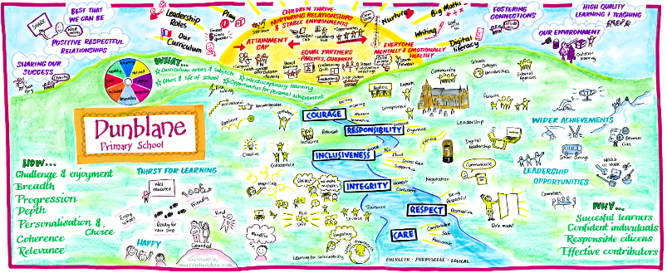
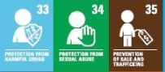
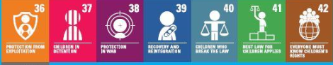
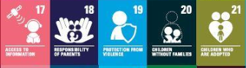
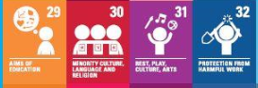
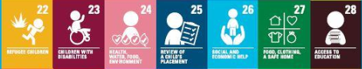
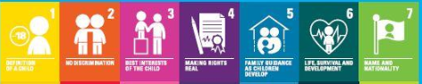
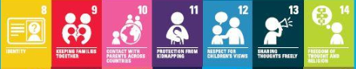
Dunblane Primary School and Nursery
School Improvement Planning 2021/22

“Learning Today, Shaping Tomorrow”
Staff, pupils, parents and members of our community were involved in an extensive and successful consultation process to agree upon a set of values which underpin the life and work of our school.
The following are the 6 agreed values that our community has agreed to uphold:
- RESPECT: To care for ourselves and others by valuing all property, opinions and beliefs.
- RESPONSIBILITY: To treat others as we would like to be treated and accept the outcomes of our actions.
- CARE: To actively show empathy and sensitivity towards each other.
- INCLUSIVENESS: To include everyone in everything we do.
- INTEGRITY: To be honest and have strong moral principles.
- COURAGE: To do things that may take us out of our comfort zone in order to achieve personal growth.

Dunblane Primary School Vision and Aims

Our vision is that every child contributes to our school and its community by being a successful, independent learner, confident individual, effective contributor and responsible citizen.

We will provide a supportive yet challenging learning environment in which we are all capable of continuous improvement. We value highly the contributions of families and the community towards this vision.

Dunblane Primary School and Nursery Class Aims

Our aims were developed through consultation with parents and staff.

We aim to:
- Encourage and empower children to be successful learners by providing a variety of high quality and challenging learning experiences.
- Offer a motivating and relevant curriculum that will provide our children with life skills and support independence, choice and responsibility.
- Promote and embed our values of Respect, Responsibility, Inclusiveness, Integrity, Courage and Care throughout all areas of nursery and school life.
- Develop and maintain positive and effective relationships with children, parents/ carers, partner agencies and establishments and the wider community.
- Ensure continuous improvement and positive outcomes for all children which reflect the changing nature of the world around us.
- Foster a sense of pride in Dunblane Primary School and Nursery class, representing them positively in the local community.

Dunblane Primary School Context

Self-Evaluation for Self Improvement
Self-evaluation and reflection on our current practice continue to be key features of our work in Dunblane Primary School.
An agreed quality framework within the school ensures that various activities are undertaken for staff and management to reflect on their practice and make improvements where necessary. Our calendar across the year which involves various staff development activities and quality improvement activities ensures that all stakeholders are given a voice in the work of the school including staff, parents and children.
Throughout this past year we have been able to gather views remotely even through closure periods and we will continue to integrate this methodology into our more established practice which includes surveys, interviews and work carried out by the junior leadership team in school. The collation of feedback is then used to plan progress and priorities going forward.
Across 2020 and 2021 our staff have evaluated the school and nursery’s performance against the following How Good Is Our School and How Good Is Our Early Learning Centre Quality Indicators:
1.4 Leadership and Management of Staff
1.5 Management of Resources to Promote Equity
2.7 Partnerships
3.1 Ensuring Wellbeing, Equity and Inclusion
3.3 Increasing Creativity and Employability

Improvement Planning Overview for Session 2021/22
Following March 2021 and the Scottish Parliament placing in law children’s rights we will have those rights as an umbrella that all learning within sits beneath.
Our Standards and Quality Report for session 2020/21 details the progress made in the identified priorities for the year. As a result of the year we have been through due to Covid closure we will be continuing to embed, carrying forward and introducing new aspects of the work planned for last year into next session.
As a result of self-evaluation and the impact of Covid 19 the following priorities have been identified:
- To continue to embed nurture principles across the school
- To continue to support the mental health and emotional wellbeing of our school community
- To continue to develop the use of digital literacy across school
- To launch and embed our Positive Relationships Policy, with a focus on gender and race equality
- To raise attainment in writing for children within the school but particularly those with barriers to learning
- To continue to embed Learning for Sustainability and develop global awareness through our curriculum

In session 2021/22 although we appear in a very confident place regarding Covid 19 at present the improvement plan will be flexible enough to take on board any necessary changes which need to be delivered.

