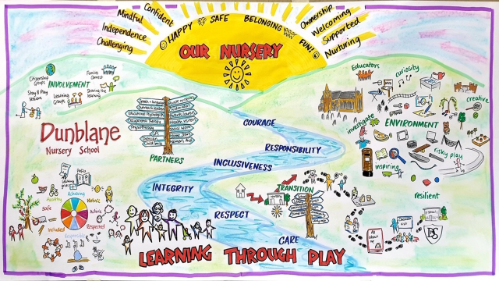

Nursery Priorities for session 2020-2021
- Through the period of change in management structure and 1140 expansion delivery, children’s needs remain at the centre of curriculum design and development. Children will continue to be offered rich and exciting play & learning opportunities, both indoors and out and within their community in order to learn skills and secure progress.

- Children show consideration for themselves and for others through building positive relationships and having built up strategies to support them in different situations

- The use of data to ensure Individual children’s needs are met and data is used to support the formation of targeted groups.

This year has been a year of different adaptation at Dunblane Primary School nursery class. We implemented 1140hrs while also adhering to National guidance and risk assessments in response to COVID 19.
15 children from the school nursery and 4 children for PVI whose nursery was closed regularly attended the nursery hub from the 5th of January until the 22nd of February. During this lockdown the nursery class were delivering a service to children they knew well with a consistent environment and adults they knew well. All children who accessed the Hub were happy and settled during their sessions because of the consistency within the nursery. Here are some comments from parents whose children accessed the Hub -
“Hope you and all at the nursery are keeping well and a huge thank you for the wonderful care Isla has been receiving during her sessions.” Parent using our service from PVI.
“She has started nursery great, its good it’s quiet and lets her get a change to know people.” January Start child using hub.
For children learning at home we continued to use Seesaw as our main form of communication with parents during the lockdown period. All parents accessed Seesaw. A survey 2 weeks into lockdown showed that 100% of our parents said that communication between nursery and home during lockdown was good. All parents had access to Seesaw and all engaged in some form of online learning, while most engaged with the online daily activities. The activities included universal learning targeted under 3 core areas – Literacy, Numeracy and HWB which included a daily live video and follow up tasks always with a familiar educator. Targeted learning was also planned for, for each individual child. They received 3 activities per week directly linked to their own, individual learning grids. In addition to this we provided activities linked to Mindfulness, stem, global goals and transition. Survey Monkeys following the lockdown period showed -
Almost all of our parents (90%) said that their child was motivated by the activities on offer remotely.
Almost all (95%) of the parents said that the activities were at the right level for their child.
Almost all (95%) felt that there were enough activities set on a weekly basis.
During the lockdown parents were asked if there were any specific interest or areas of home learning they would like the nursery to cover. Responses included – weather, animals, planet earth, fun science experiments, human body and these were then covered remotely.
Parents were also asked ways in which we could improve our home learning. Almost all comments were positive and included –
“I think you are all doing an incredible job.”
“Very well organised and planned!! Well done.”
On this survey parents suggested regular Google meets for the nursery children, in line with the school and also recorded voice messages when commenting on Seesaw. This allowed children to hear the voice of the Educator. The nursery made these positive changes. The nursery offered weekly, themed Google meets linked to the children’s interests. On average 15 children, who were learning at home regularly attended the Google Meets along with the children in the Hub. Once child said to another child on the Google meet – “I thought I would never see you again.” This highlighted to the educators the importance of the children meeting virtually.
Almost all (95%) of the children said that they liked the learning they were receiving learning at home and that they liked to see the educators on the computer.
Children were consulted on the things they liked to do over the last few weeks and things they would like to do more of. The nursery used this information when future planning.
Support for children who accessed other agencies such as SALT and ASN Outreach, their remote support continued. Resources and door step support was offered to a few of our families. The nursery also did twice weekly Fare share food deliveries for families who requested this within the community.
Staff’s views around the care and education for children in nursery during the lockdown were sought. These were collated in the following Wordle –

This tells us that staff felt the lockdown period was successful and the children’s experiences and learning continued at home.
The return to nursery was smooth with all children settling back well. Staff referred to this as being like a party – “Children were so happy to be back in nursery, seeing their friends”. Good communication between home and nursery continued and calls were made to all families during the first week back. The call included discussing the child’s general wellbeing, learning targets and current interests to aid future planning.
Nursery Priority: Children show consideration for themselves and for others through building positive relationships and having built up strategies to support them in different situations
National Improvement Framework Priority  - Improvement in children and young people’s health and wellbeing  Care Inspectorate Quality Indicators  - 5.1 Children’s wellbeing and rights.  Realising the Ambition  - Section 3 What I need to Grow and Develop  National Standard  - Criteria 2 – Development of children’s cognitive skills (Health and wellbeing) |  | HGIOELCC Quality Indicators & HGIOELC  - 3.1 Ensuring wellbeing, equity and inclusion
Integrated Children’s Services Plan Outcomes
- All children thrive because of nurturing relationships and stable environments in their own school and community.
- Children and young people are mentally and emotionally healthy
Progress: | 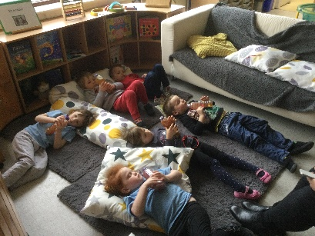  - Mindfulness is fully embedded within the nursery and most children are able to talk about Mindfulness, what it is and how we use it to support their mental well-being. Some children are able to talk about the benefits of mindfulness.  The children were able to tell the educators that –  “Mindfulness makes people feel nice.”  “It makes us feel happy.”  “It helps us stay calm”  “When you relax it gives you more energy.”  “Mindfulness is relaxing.”  This demonstrates that some children have a sound knowledge of what they can do to be mindful and the benefits of it.  - All staff completed the Do-Be Mindful staff training and most staff have reported that they use one or  more of the techniques at home to support them with their mental wellbeing. All staff participate in  the mindful sessions alongside the children when in nursery. One staff members said - “I usually  practice a little mindful meditation before bedtime, this has had a positive impact on the quality of  sleep I get”  - All families were given information about Mindfulness in  the form of a leaflet. Following consultation with parents a PowerPoint presentation was produced which showed  Mindfulness in action at nursery and this was shared with all  families. All families were given a Mindfulness Molly bear and mindfulness activities to encourage mindfulness at home. One parent shared with nursery staff- “The other day I found Aurora  lying outside on the grass with Molly on her tummy practicing her mindfulness!”  - One family requested additional mindfulness activities during the lockdown as the child was finding it  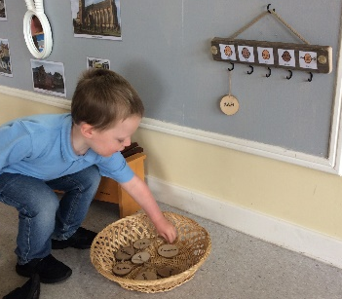  hard to focus on a task for any periods of time.  - Children have a choice to use the calm code to sign in at the start of a nursery session. This gives the child a focus in the morning if they struggle to separate from parent/carer. It can be the start of a discussion between the educator and the child and an opportunity for them to support the child if required. Most children can now independently use the calm code to talk about how they are feeling.  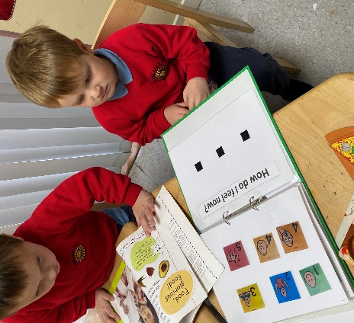  - The calm code is also part of the nursery Fix It Folder which is used during restorative conversations with children and educators. Most children can identify their emotion and give a reason why they feel this emotion. The calm code being part of nursery life has helped individual children who can struggle to  self-regulate. Almost all children know the purpose of the Fix it Folder and most are able to use this with  adult support to resolve conflict.  - Both nursery cohorts have an identified calm space for children to access. Both cohorts also have  happy boxes. The children identified what resources they would like in the happy boxes. An  individual child has his own happy box and this is used on a daily basis. One child spontaneously  created his own happy box to take home.  - All staff participated in Equality and Diversity training held by Education Scotland. This raised  awareness of appropriate language to use and made staff think about the language they use. Staff  did activities with the children to raise the children’s awareness of the roles different sexes can do.  The nursery did an audit of their resources and are starting to purchase a wide range of diverse  Resources such as books, dolls, puzzles and generic plasters.
Impact: | - Mindfulness has given children and educators an opportunity throughout the day to have  some quiet, down time. The benefit of this is that it encourages a calm, kind and  compassionate culture within our nursery setting.  - Survey Monkeys were conducted throughout the year to gauge if children were talking and using Mindfulness at home. Parents were asked if their child spoke about Mindfulness at home.  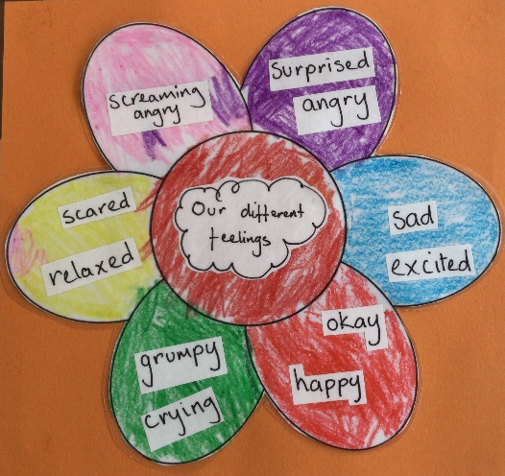  In September the survey showed that 27% of our children spoke about Mindfulness at home. By March 2021 this has increased to 83%. This data shows that our children are becoming more aware of Mindfulness.  - As part of the whole school COVID recovery plan the nursery participated in the Emotion Works programme. Emotion works is an educational programme designed to help develop children’s  emotional literacy and wellbeing. In September the nursery completed a quick emotion work  assessment along with the quick regulation strategy assessment. The results showed that children’s emotional vocabulary increased from 4 emotion words to 13 words.  Words in September 2020 4 Words Words in March 2021 13 words  Happy Sad Grumpy Tired Screaming Tried Angry Curious Scared Relaxed Grumpy Crying Happy Okay Sad Excited Surprised
Next steps: | 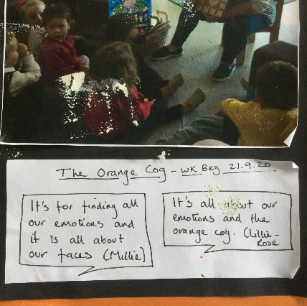  - Ensure that our new cohort of children are involved in the creating of new happy boxes and calm areas which are relevant to them.  - The component model section of the Emotion works programme, where different coloured cogs are introduced to the children will be part of our nursery settling in programme, the impact of this will be reviewed each year.  - The quick emotion works assessment and the quick regulation assessment will be sued in September and April each year and the impact will be evaluated.  - Emotion works will continue to be used and referred to in school.  - Permanent emotion works display is visible in the nursery at all times.  - To continue to purchase equality and diversity resources.

- Nursery Priority: Through the period of change in management structure and 1140 expansion delivery, children’s needs remain at the centre of curriculum design and development. Children will continue to be offered rich and exciting play & learning opportunities, both indoors and out and within their community in order to learn skills and secure progress.

National Improvement Framework Priority  - Improvement in children and young people’s health and wellbeing.  Care Inspectorate Quality Indicators  - 1.3 Play and learning  - 2.1 Quality of the setting for play and learning  - 2.2 Outdoor play and learning  Realising the Ambition  - Section 3 What I need to Grow and Develop  - Section 4 Children’s work - The importance of play |  | HGIOELCC Quality Indicators & HGIOELC  - 2.2 Curriculum
Integrated Children’s Services Plan Outcomes

National Standard
- Criteria 2 – Development of children’s cognitive skills (Health and wellbeing
Progress: | - In August 2020 staff were consulted on the vison and ethos they wanted for the nursery class.  Again in March 2021 we revisited this with staff. Here are what staff said to represent our pedagogy  and ethos  These 2 wordle’s tell us that at the heart of our vison, pedagogy and ethos are our children. As a team  we are striving for a responsive play based inclusive environment for all our children and families to  grow and thrive.  - Due to the COVID restrictions our nursery environment was split into 2 cohorts and time was spent  ensuing that there was an equal balance of resources in the 2 indoor and outdoor cohorts. An environmental audit took place in October/November 2020. This was to look at further developing the environment to ensure we were using a broad range of materials and resources to provide children  with enough choice. From this an action plan was created to adjust and make improvements to the  nursery environment to support and meet children’s needs. This lead to the redesigning of the nursery environment to maximise the positive experiences for the children. Rest areas were established in both cohorts and most children access this quiet rest area at some point during their day. Additional,  consistent signage was added to the nursery floor which encouraged independence and promoted  choice as part of our LIFT journey.  - As a result of the audit, changes were also made to the outdoors. Using Realising the Ambition and Adventures with Alice the nursery environment was adapted. We defined different areas and provided more choice to the children outside. Staff and children were consulted and open ended resources  were purchased such as the 3D geometric shapes, small world resources, additional loose parts,  measuring resources, books with a focus on nonfiction and diversity. Further resources were purchased with a focus on insuring Literacy and Numeracy are alive during natural resource play.  We had a nursery teacher for 6 weeks and she felt that there were many different opportunities for  open ended play. As a result, she asked if one of our Senior staff members could talk about our outdoor area at a Pledge to Play conference. 102 participates from across the local authority took part. She particularly wanted photographs of the pipes with water, the willow arch and the sandpit / mud kitchen. She said “I think Dunblane has developed their garden really well from what was essentially a tarmac  yard”.  Here is feedback we received from those who attended this part of the work shop  Staff completed a self-evaluation exercise linked to 3.3. With regards to the 1140 changes one staff  member said “The staff made changes to the environment, that are inspired by the Adventures with  Alice programme. Provocations are provided to spark the children's curiosity and imagination. Open  ended questioning are used by the staff team to support children's own ideas and thoughts during  group times and various activities and staff scaffold the children's learning.”  - More loose parts play, malleable experiences, art and construction are embedded in our daily  opportunities for the children to explore and investigate. During COVID restrictions we did a virtual  sharing the learning presentation for our families about what learning and exploration look like in our nursery. We focused on the 3 core areas of the curriculum along with loose parts, curiosity and STEM  which gave our families an inside view of learning which is taking place for their children. Families  found this worthwhile and we received positive feedback-  “Thank you for all the great information provided in this curriculum email.”  “It was lovely to see photos and hear about all the different activities in nursery.”  “I found it really helpful to have all the areas of the curriculum explained, showing how this is taught in nursery and how this can transfer to home.”  “It also helped to understand some of the things that Cameron talks about at home!”  “Thanks for this. It all looks great - a fun and enriching environment for the children. Anna is really enjoying nursery. We will continue to support her learning at home. “  - Almost all children self-select during play with a wider choice of loose parts and natural resources during their nursery session.  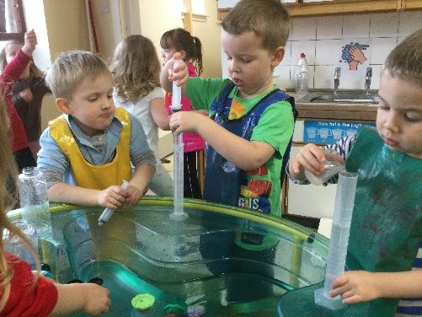  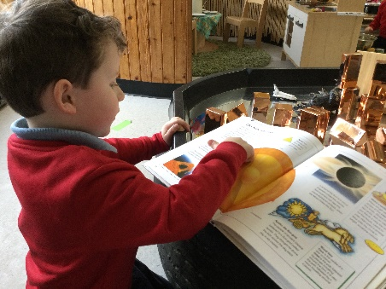  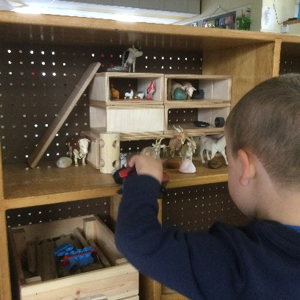  - Through consultation with the children we asked what they enjoy at nursery or if there was anything  they didn’t enjoy. Here are some of the voices of our children,  Likes -  “Playing outside and seeing my friends.” “Eating Lunch and playing.” “Playing inside and outside and  reading stories. “Playing with the water, playing with the playdoh and going outside.” “Everything!”  “Playing in the house corner, with food in the kitchen. Putting the bees on at the number. “  Dislikes-  “No”, “nothing “Nothing bad at nursery.” “Rolls at lunchtime.” “Can’t think. “ “We can’t mix, I miss the bee group.” “Missing mum.”  This information tells us that our children feel that the environment and resources are appropriate for  them.  - Throughout this period of change we ensured that we have a clear communication system for our  parents. Seesaw has been used as a method of sharing play and learning within the nursery and at  home. We now have our own nursery mobile and landline allowing families and partners to call us  directly. Recently we have been trialling a block of online learning journals to further develop our links  with home and share the children’s learning more frequently with families. From consultation with our families we plan to move forward with learning journals online as recent data has shown that our  families, children and team feel this platform provides the most individual and relevant information  about a child, their needs and learning and progression.  Comments from families about the learning journal pilot included,  “I am able to log in and see  everything I feel the online  journals are great way forward.”  “Easy to use and add our own observations to, lovely to see  pictures and understand the link to curriculum.”  Some comments from our team  about the learning journey pilot included -  Less time consuming. Links to the curriculum. Educators can easily  access all children’s journals  and add observations. Can track  next steps. Can pull reports from  data. They are easier, more efficient and less time consuming. Children can be a more active part of  their learning and often help you document their learning. We can access it from home if we need to.  Outside agencies can have access to the children they work with meaning all work is in the same place  and instantly uploaded. There are so many benefits I can't even name them all!
Impact: | - A survey monkey took place in October 2021. Most (83%) of our families agreed that the nursery extended hours offered by the 1140 expansion suited their lifestyle and child’s needs. Comments included – “Great for those that need them.” “Allows me to work and my child to attend nursery.” The 17% who disagreed wanted a service 5 days per week 9AM – 3PM. This information was passed onto out link officer who advised that Stirling Council will be conducting a parent’s/families consultation around 1140hrs.  - In the same survey families were asked the strengths and next steps of the 1140 journey. Some comments included-  “Provide better flexibility for families.” “” Additional hours have supported their learning and development. “The strengths are how well my child’s teacher communicates with me after each class.”  - We asked our families to describe the 1140 expansion delivery and have created a Wordle below to capture the words used. This shows us that families felt positive about the 1140 expansion.  - In March both parents and staff were asked to describe the nursery team. Parent’s words to describe the staff team -  Staff’s words to describe the staff team  This information tells us that during the delivery of 1140hrs and COVID recovery period staff have the right skills, knowledge and values to support the children and families.
Next steps: | - Building work linked to 1140hrs did not take place in August 2020 due to COVID and limited resources. The nursery staff created working spaces using a cupboard for the administrator and painted and upgrade the Principles office space. This allowed the admin to have a comfortable space to work in. The nursery also utilised the annex space. This included painting the area and adding resources to use this as a break out space for our children. Building work will now be taking place between July – September to upgrade the nursery in line with 1140hrs  - Stirling Council will be conducting a parent’s consultation around 1140hrs and we have shared with the parents views. We will promote this consultation and encourage our parents to participate.  - Following on from a google document created from parents in response to our self-evaluation of 3.3 a parent made it apparent to us that they don’t understand some of the terminology used such as Risky Play. We will raise awareness to parents about what risky play is and how it can be encouraged at home.

Nursery Priority: Individuals Needs are meet. Data is used to support the formation of targeted groups.
National Improvement Framework Priority  - Improvement in attainment, particularly in Nursery and Literacy.  Care Inspectorate Quality Indicators  - 1.3 Play and learning  - 1.2Personisied planning and support  - 3.3 Quality assurance and improvement  Realising the Ambition  - Section 2 Being Me- Starting strong  - Section 4 Children’s work - The importance of play |  | Quality Indicators & HGIOELC  - 2.3 Learning, teaching and assessment  - 2.4 Personised Support
Integrated Children’s Services Plan Outcomes
- Improving outcomes for children
National Standard
Criteria 1 ; Staffing, leadership and management
Criteria 2 ; Development of children’s cognitive skills health and wellbeing
Progress: | - Lift  All staff received training and have gained experience in using baseline assessments linking to our LIFT programme in order to identify the communication and language needs and developmental stages of our children. As a result, our educators are able to offer timely interventions and interactions to support and challenge individuals in making progress within language and communication development. Tools such as Keyword assessments, Renfrew vocabulary word finders and teaching children to listen rating scales have  been used to plan next steps for our learners and have provided data to allow us to make informed  decisions on the interventions required. All children have completed an understanding, listening and  talking assessment using assessment tools or holistically during play.  Our environment is now using only board maker symbols to label spaces and resources During a survey  60% of our families said they would like to learn more about LIFT and further developing their children’s communication and language skills through a parents group.  - Personised Support /Targeted Interventions  In January 2021 we evaluated 2.4 (HGIOELC- Personised support) as a team, with other agencies, families  and children to ensure children needs are being met and inform improvements required.  This pie chart is a response from our agencies telling us they believe we are effective at meeting individual’s needs  - Observations of Learning / Learning Folders  A quality assurance process demonstrated our learning folders did not have a consistent approach  to record learning and progression for our children in March 2020. In August, as a team we reviewed  the content of our learning folders for individuals and changed the layout ensure significant learning  was documented and the folders had an easy to understand process for any reader. We consulted  with our parent’s curriculum group on the changes and this influenced decision. Our families asked  for a parent’s guide to be inserted into each folder for the areas learning grid and learning groups to  offer an explanation to readers about these sections. A discussion with all staff to obtain views took  place. Our folders were then renaming- Learning folders emphasising the value of learning and  progression within to all. This then lead to an audit of the quality of observations within the learning journals on ensuring individuals needs are being met. With the support from our Early Years Teacher  we worked on training sessions with the team to enhance our methods and knowledge of using observation and holistic judgements of a child’s progress are meeting individual’s needs. As a result of this, all staff felt motivated, they increased in confidence when documenting children’s individual learning  and planning targets. Our families felt involved in their children learning intentions and found the  changes impacted on the easy of understanding their own child’s next steps thus increasing parental engagement and communication around learning and progression. From a survey to parents 100%  agreed they are involved and know their child’s learning and development next steps and have been consulted in making them. After this changed parents /team said  Parent – “This is a massive improvement from previous journals, and it should be very helpful  especially in these times of limited contact.  Shirley DHT- “I agree that these are much clearer and easier to see exactly what is each child learning.”  - Tracking and Monitoring progression  During impact meetings educators reflect on children’s progress and development. This session we  have used a new system for tracking directly linking to our Stirling’s Play and Learning Framework  where children’s achievements have been collated. Educators have been taking a closer look at observations and progression using the play and learning framework and as a result, next steps for individuals are made clearer. Also next steps for our whole learning environment have become clearer  with the data imputed then producing quantitative overviews of our learning across the 3 main  curriculum areas. As a result of these graph we were able to identify gaps in writing development and numeracy for some children, and we have reviewed our spaces to create further learning opportunities and experience in these areas.
Impact | - Lift  Child’s understanding of spoken words and listening skills are differentiated within the environment. Children receive communication at a level which is appropriate for them through play and adult and child interaction, this has resulted in a steady progression in language development. Timely interventions for some children have impacted their communication and language skills with progress being made over time. Terrific talkers intervention group has had 8 children who were not on track in listening and talking and now 90% of the children are on track, this shows us the children has progressed during the time of this intervention. Some children are transferring the skills they have developed during the interventions and using them in spontaneously during play and learning experience.  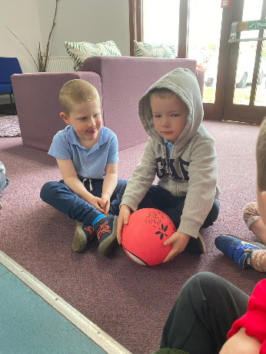  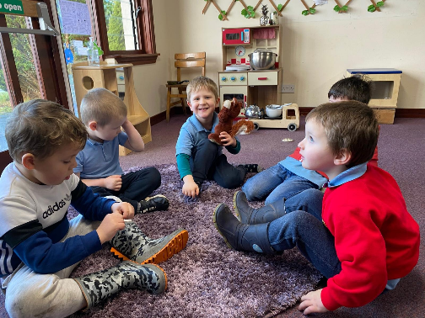  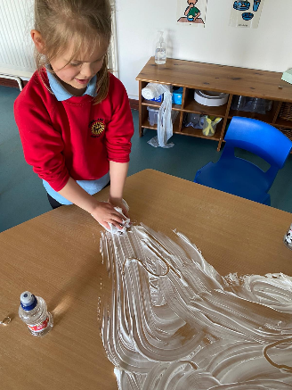  Some children who require challenge have taken part in a story telling group and read, write inc group and this has resulted in one child blending sounds and reading unknown word. The others in the groups have developed skills in rhyming, identifying sound names and formatting letter sounds again these skills are being transferred into their play. Home links has been established and resources have been shared to further develop skills with their family. Parent’s commented  “I have noticed a big difference at home with rhyming and writing. “  “Smaller groups work well for learning.”  - Personised Support / Targeted Interventions  As a result of universal, targeted and enhanced support and interventions through play we have seen improved outcomes for most children across the curriculum  - Observation/ Learning Folders  Most Children assess their learning folders on a regular basis to revisit experience. Parents and children have opportunities to discuss learning linked to their child’s individuals targets at intervals through the year and there has been an increase of parent engagement on Seesaw our on line platform with 98.14 %of our families connect, and 94.44 % of families seeing and/or commenting on learning.  Educators have expressed increased confidence in viewing and making observation through play and observations are individual to the learner.  - Tracking and Monitoring Progression  Most of our families completed a survey which told us 100% felt included and part of the process of learning and progression with their child.  Impact of progression is recorded above with most children making clear progression over time within literacy, numeracy and health and wellbeing.
- Continue to use assessments and the play and learning framework to inform targeted groups and next steps for individuals, consider consistency of delivering interventions virtually if we are in lockdown again.
- Take a closer look at securing children progress and achievements to further provide the best outcomes for children and families in Dunblane Primary Nursery.
- Continue to develop writing development experience and numeracy within our environment both indoors and out.
- A trail period of learning journals on line has further increased approach to tracking and monitoring children’s progress and added to our opportunities to share learning and progression with our families. Continue to use this platform and develop our digital skills with online learning journals
- Make further progress with the Lift programme in supporting children’s language and communication development
- Introduce a communication and language parents group to explore the benefits of the LIFT programme with families.
- Develop observation methods to further enhance adult and child interaction

