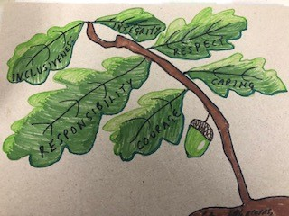
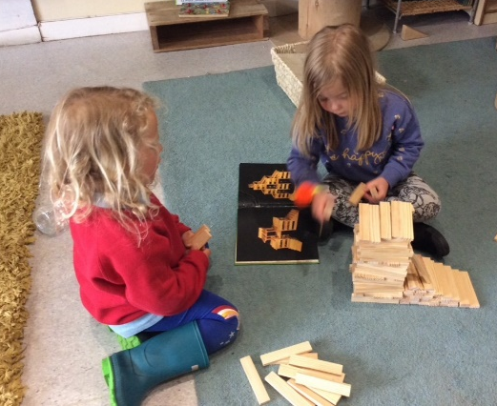
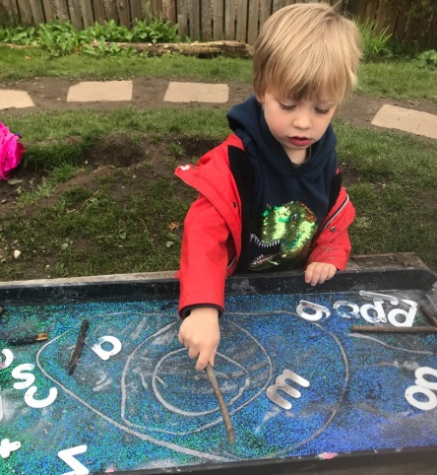
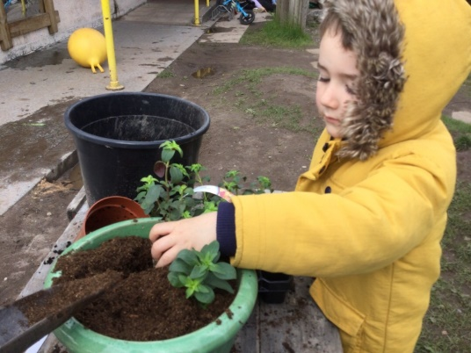
PROLOGUE
This year has be a year of new beginnings and adaptation at Dunblane Primary School nursery class. We implemented 1140hrs while also adhering to National guidance and risk assessments in response to COVID 19, while, throughout upholding our vision and values at the centre of our delivery.
Our curriculum has been focused on learning through play. Learners are empowered to be successful through quality learning experiences, offering opportunities that will provide our children with life skills, supporting their independence, choice and responsibility. Relationships are at the heart of our practice with children, families, partners and our community in Dunblane.

Continuous improvement and reflection throughout the academic year has challenged and supported our delivery ensuring we are working towards positive outcomes for all our learners and families. We have consulted with all stake holders on our next steps to improve which are highlighted within this year’s improvement planning.

The nursery service changed for a period during a national lockdown, only offered a limited provision to some children and for most, remote learning commenced
This session, similar to the school, the nursery will have a focus on skills for writing development as our attainment in Writing is slightly lower than in other curricular areas, this will be a focus and developed through play and learning experience for the children to access.
At this point we are still working with nursery bubbles following Scottish Government guidance and local authority risk assessments.
In session 2021/22 although we appear in a very confident place regarding Covid 19 at present the improvement plan will be flexible enough to take on board any necessary changes which need to be delivered.

Key Priority: HGIOELCC:3.2 Securing children’s progress Quality Framework Care Inspectorate: -5.2 Children’s progress and achievement

NIF Priority: Improvement in children and young people’s health and wellbeing  National Standard:  4.1 The setting uses relevant nation self- evaluation frameworks to self-evaluate and systematically identify strengths and areas for improvement.  5.2 Parents and carers are supported to engage in their child’s learning and development. | Realising the Ambition: sections 6 Putting pedagogy into practice
Integrated Children’s Services Plan Outcomes
Improving outcomes for children with care experience, disabilities, and in need of protection
RIC: Improving the health and wellbeing of children and young people

Outcomes for Learners: High expectations are for all children and our learners are achieving.

Key Actions |  | Priority Leader | Milestones Dates | Evaluation/Analysis of Progress and Impact  Mkl;nlk
- To continue to support the mental health and emotional wellbeing of our school community through children continuing to develop their sense of self and recognition of emotions having an impact on themselves and others.(Emotion Works and Do be Mindful)  - Lift interventions support progress through universal, targeted and enhanced strategies to improve outcomes for learners  - Develop knowledge in using Stirling’s play and learning framework to inform needs and next steps for learners  - Impact meetings and Play and learning framework tracking and monitoring database measure progress for all children in communication and language development, mathematics and health and wellbeing.  - Collaborative working with children, families, and partners is used to improve our setting and secure improved outcomes for children and families  - Digital learning journals are established to offer reflection of clear progression for children.  - Emotional Works assessments are in place for all new children and part of our settling in process.  - Ensure equity for all  - To embed Learning for Sustainability and develop global awareness through our curriculum |  | Communication Champion and Staff team  Play Champion  SMT  All staff  SMT and team  Health and Wellbeing lead and team  Global Goals Led | Ongoing

Key Priority: HGIOELCC:2.3 Learning teaching and assessment Care Inspectorate Quality Framework:1.3 Play and learning

NIF Priority: Improvement in children and young people’s health and wellbeing  National Standard:  2: Development of children’s cognitive skills and health and wellbeing | Realising the Ambition: section 4 :child’s work – the importance of play
Integrated Children’s Services Plan Outcomes:
Improving mental health and emotional wellbeing

RIC: Improvement in attainment in literacy and numeracy for children and young people
Improvement in curriculum developments, learning and teaching to support employability skills and sustained positive destinations.
Outcomes for Learners:
Children are motivated and inspired, curious and creative during play.
Interactions and warm relationships are evident during planned and unplanned play opportunities. Children are making progress over time through play and learning experiences

Key Actions |  | Priority Leader | Milestones Dates | Evaluation/Analysis of Progress and Impact  Mkl;nlk
- Ensure positive relationships and attachments are at the centre of our practice  - With a key focus on writing within literacy development, build on opportunities for children to experience planned and spontaneous play to develop pre-writing skills required  - Our play champion will lead on launching Stirling’s pledge to play  - Baseline assessments are used after settling in period to obtain understanding of children’s prior knowledge and developmental stage, for example, emotion works baseline, key word assessment  - Children participate in decision making in our setting and are agents of their own learning  - Planning is responsive to the needs and interest of our children, through play opportunities children are inspired to explore and develop curiosity and enquiry.  - Develop a shared ethos to risky play experiences within our team and with our families and partners  - Adventures with Alice volume 2 with be used to enhance play and learning opportunities for our children  - Article 31 of the UNCRC will be embedded in our practice- The right to play, we will raise awareness of this across of nursery community with all stake holders  - Build PEEP and family connect groups in our communities to meet family’s needs  - Improve Adult Child Interactions(ACI) through peer learning and observations together using digital technology  - Build relationship through system leadership with our trio and learning communities to share best practice and learning together  - Children benefit from universal, targeted and enhanced interventions  - Launch Positive Relationships Policy, with a focus on gender and race equality |  | All Staff  Literacy Lead and staff team  Play Champion  All key workers  All Staff team  Curriculum Lead and Staff  SMT  Play Champion  SMT  PECE  SECE | Aug 21  Ongoing  From Aug  Settling in periods  Oct-  Ongoing  Ongoing  Termly  Ongoing  August onwards

Key Priority: HGIOELCC:2.1 Quality of the setting for play and learning Care Inspectorate Quality Indicator 1.5: Management of Resources
NIF Priority: Improvement in children and young people’s health and wellbeing  National Standard:  Criteria 3 – Physical Environment | Realising the Ambition: section 5.3& 6.3 and throughout under ‘spaces’
Integrated Children’s Services Plan Outcomes
Improving outcomes for children with care experience, disabilities, and in need of protection
Improving mental health and emotional wellbeing
RIC: Improvement in literacy and numeracy for children and young people
Improve the health and wellbeing of children and young people
Outcomes for Learners:
Children are interested and motivated during play and learning. Children are agents in planning for their learning environment. Children develop a sense of self and belonging in their nursery environment and community.
Key Actions |  | Priority Leader | Milestones Dates | Evaluation/Analysis of Progress and Impact  Mkl;nlk
- Our environment supports children’s interests and learning  - Through LIFT strategies the nursery environment supports language and communication  - Our children, families and team are involved in resource selection, purchasing and fundraising  - Our environment reflects the culture and religion of our families and others.  - Nurture principles are embedded in our ethos and our environment indoors and outdoors reflects this.  - Focus on Nurture Principle : language is a vital means of communication and Children’s Learning is Understood Developmentally  - Development of adventure trolley will be used as a resource to enhance free play during forest sessions  - Resources purchasing reflect other areas requiring development within our improvement plan, for example, focus on writing development and learning journals online.  - To develop the use of digital literacy across school community extending play and learning experiences for children and families. |  | SMT  Communication Champion  SMT  All Staff  SMT  All Staff  Forest Lead  SMT  Digital Lead | Ongoing  Aug- Oct  Ongoing  From Aug  Dec  Ongoing  Oct- Dec

