



My Personal Plan

Insert Child’s Photo

**Child’s Name:** **D.O.B:**

**Start Date:**

Insert KWs Photo

Keyworker:

**Dunblane Primary Nursery**

**Dunblane Primary Nursery**

**Personal Plan**

We want to ensure we work effectively with our parents / carers in order to meet your child’s needs. An important first step in this process is completion of your child’s personal plan. This will help us to gather information on your child’s health & wellbeing and development & learning.

Our Key Workers will keep a personal learning journal for your child which will document significant moments or learning during their time at nursery. This journal belongs to your child and we encourage you / your child to access regularly and / or contribute to it by adding to the journal or sharing special things to be added, e.g. photos, tickets from a special event etc...

Any information you give us will be used to support your child during their transition to nursery and then on an ongoing basis to ensure your child’s needs are met. If your child needs extra support with any aspect of their health or development appropriate plans will be put in place.

Please ensure you inform us of any changes which may affect your child’s personal plan. Information in this plan will be reviewed as required or on a minimum 6 monthly basis.

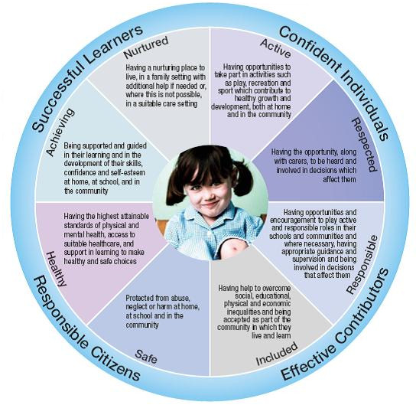



**Why have a Personal Plan?**

These guidelines has been compiled to clarify the requirement for ELC providers to provide a **Personal Plan** for individual children, in accordance with The Social Care and Social Work Improvement Scotland (Requirements for Care Services) Regulations (2011). Although plans are sometimes referred to as a care plan it is important that we all adopt the common language of ‘Personal Plan’.

More importantly these guidelines make clear our responsibilities as ‘Duty Bearers’ of children’s rights, in line with the United Nations Convention on the Rights of the Child (UNCRC). We wholeheartedly believe that children have the right to the best possible; care and support, education, play, protection, health and help when they need it. We also strongly advocate that the best interests of children should be the top priority when planning (article 3, UNCRC).



These guidelines fully incorporate Getting it Right for Every Child

(GIRFEC) paperwork and the Scottish Government Health and Social Care Standards (H&SCS) which have five overarching principles.

**Health and Social Care Standards - Principles**

**Health and Social Care Standards - Five Headline Outcomes**

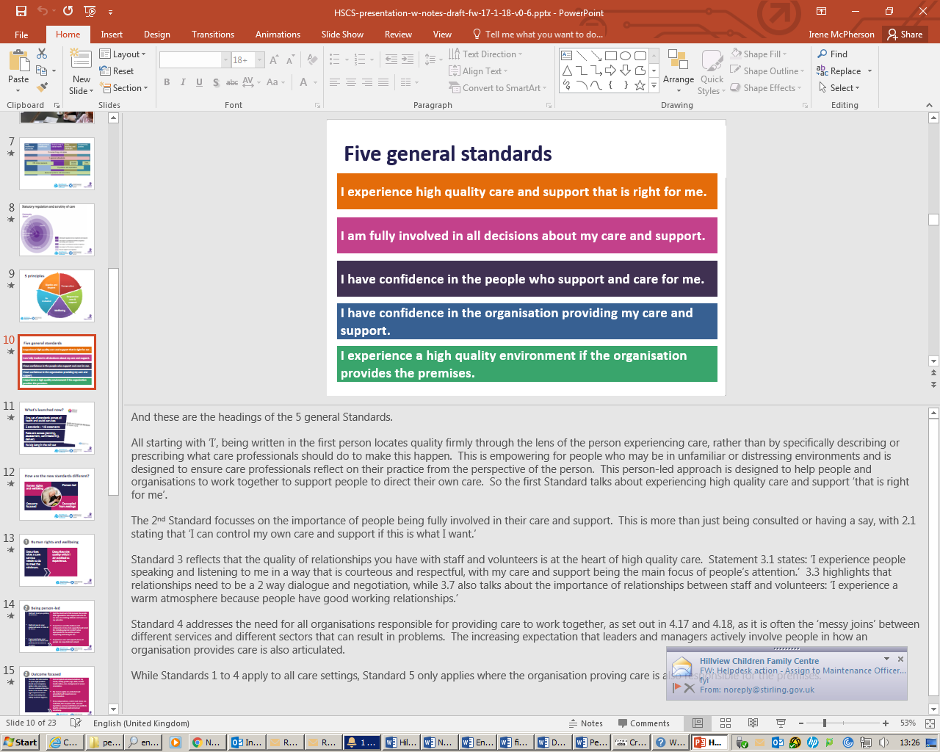

Contents

**Section One: Core Information and ‘All About Me’**

1a: IAF Form 1 Version 3.0: Child / Young Person and Family Core Information

1b: ‘All About Me’

1c: Emergency Contact Information

1d: Agreements / Consents

1e: Child’s Chronology

**Section Two: Personal Learning Plan (PLP)**

2a: Settling In / Transition Document

2b: Overview of Key Care, Support and Learning Needs

2c: Development and Learning Records

**Section Three: Additional Support** (added if / when required)

3a: Incident and Accident Reports

3b: Medication Form

3c: Other Forms

3d: IAF Form 2A - Version 3.0: Wellbeing Observations and Assessment

3e: IAF Form 3 - Version 3.0: My World Assessment

3f: IAF Form 4 - Version 3.0: Child / Young Person’s Action Plan

3g: Paperwork for TAC meetings

IAF Form 5 - Version 3.0: Report for Child / Young Person’s Meeting

IAF Form 6 - Version 3.0: Record of Child / Young Person’s Meeting

3h: All Other Correspondence / Information

**Section Four: Review**

**Section One**

**Core Information and ‘All About Me’**

1a: IAF Form 1 Version 3.0: Child / Young Person and Family Core Information

1b: ‘All About Me’

1c: Emergency Contact Information

1d: Agreements / Consents

1e: Child’s Chronology

**1a: Child / Young Person and Family Core Information** (GIRFEC Form 1)



|  |  |  |  |  |  |  |  |
| --- | --- | --- | --- | --- | --- | --- | --- |
| **First name: Surname:**  **Other names: Known as:** | | | | | | | |
| **Date of Birth:** | | | **Gender:** | **F** | **M** | |  |
| **Nationality:**  **First Language:** | | | | | | | |
| **Parents Details:** | | | | | | | |
| **Mother:** | **Address:** | **Telephone:** | | | | **Occupation:** | |
| **Father:** | **Address:** | **Telephone:** | | | | **Occupation:** | |
| **Previous Address:** |  |  | | | | | |
| **Do both parents have contact with child?**  **Detail if no** | | | | | | | |
| **If birth parents do not have parental rights please specify who does?** | | | | | | | |

1. **Personal Details**

**2. Members of Household**

| **Forename** | **Surname** | **DOB** | **Gender** | **Place in Family/ Relationship** | **Employment Status/**  **School** |
| --- | --- | --- | --- | --- | --- |
|  |  |  |  |  |  |
|  |  |  |  |  |  |
|  |  |  |  |  |  |

**3. Non-Resident Parents**

|  |  |  |
| --- | --- | --- |
| **Name & Relationship to Child** | **Address** | **Tel. No.** |
|  |  |  |
| ***Rights and Responsibilities:*** |  |  |
| **Contact Arrangements with Child** |  | |
| **Shared Residence Details** |  | |
| **Name & Relationship to Child** | **Address** | **Tel. No.** |
|  |  |  |
| ***Rights and Responsibilities:*** |  |  |
| **Contact Arrangements with Child** |  | |
| **Shared Residence Details** |  | |

**4. Additional Languages**

|  |  |  |  |  |
| --- | --- | --- | --- | --- |
| **Language(s) spoken at home by pupil:** |  | | | |
| **Language(s) used by family members to child:** |  | | | |
| **Is an interpreter required for meetings?** |  |  | **Which language(s)?** | |
| **Can child speak/understand (aurally) in English, Home language or another language? (Give details)** | | | | |
| **English** | **Speak: Y/N** | | | **Understand (aurally): Y/N** |
| **Home Language (name)** | **Speak: Y/N** | | | **Understand (aurally): Y/N** |
| **Other Language(s)**  **(name)** | **Speak: Y/N** | | | **Understand (aurally): Y/N** |

**5. Health Details**

|  |  |  |  |  |
| --- | --- | --- | --- | --- |
| **Name of Professional** | **Address** | **Telephone** | **Email Address** |  |
| **Health Visitor:** |  |  |  |  |
| **GP Name:** |  |  |  |  |
| **Other:** | **Address** | **Telephone** | **Email Address** | **Purpose** |
|  |  |  |  |  |
|  |  |  |  |  |
|  |  |  |  |  |

**6. Education Details**

|  |  |  |  |
| --- | --- | --- | --- |
| **Current Establishments** | **Stage/Year** | **Start Date** | **Sessions Attends** |
|  |  |  |  |

**7. Previous Educational Establishments**

|  |  |  |  |
| --- | --- | --- | --- |
| **Establishment** | **Address** | **Start Date** | **End Date** |
|  |  |  |  |

**7. Additional Information**

|  |  |  |  |
| --- | --- | --- | --- |
|  | **Y** | **N** | **Details** |
| **Child/ Family Social Worker** |  |  |  |
| **Is child a Looked After Child (LAC)** |  |  |  |
| **Is child Looked After and Accommodated?** |  |  | **If Yes, who is carer and what is their relationship to child?** |
| **Is the child on Staged Intervention?** |  |  | **Stage:**  **Reasons for Staged Intervention:** |

**1b: All About Me**

This section is framed under the GIRFEC wellbeing indicators to allow us to gather relevant information which will be used to identify your child’s key care and support needs and allow us to put appropriate plans / actions in place to ensure your child’s needs are fully met.

|  |  |  |  |
| --- | --- | --- | --- |
| **SAFE** | | | |
|  | **Y** | **N** | **Details** |
| Does your child have a basic awareness of safety e.g. trapping fingers, climbing, road sense etc… |  |  |  |
| Is your child able to ask for help? (if non-verbal what are the signs to look out for?) |  |  |  |
| Is your child able to express feelings & emotions? (if non-verbal what are the signs to look out for?) |  |  |  |
| Is there anything in particular that scares or upsets your child? |  |  |  |
| How can your child be comforted? | **N/A** | **N/A** |  |
| Does your child have any difficulty with vision?  *Please provide further information on how best support your child* |  |  |  |
| Does your child have any difficulty with hearing?  *Please provide further information on how best support your child* |  |  |  |
| Does your child have any physical difficulties?  *Please provide further information on how best support your child* |  |  |  |
| Does your child have any difficulties expressing themselves or following instructions? |  |  |  |
| Do you have any concerns about your child’s self-esteem and / or confidence? |  |  |  |

|  |  |  |  |
| --- | --- | --- | --- |
| **HEALTHY** | | | |
|  | **Y** | **N** | **Details** |
| Does your child have any diagnosed medical conditions? |  |  |  |
| Would you describe your child as being in good health? |  |  |  |
| Does your child take any medication on a regular basis?  *A separate, more detailed form will need to be completed if medication is to be given by nursery staff.*  Must be reviewed every 3 months |  |  |  |
| Does your child have any allergies, intolerances and/or medically prescribed diet?  *A separate, more detailed form will need to be completed to detail emergency action / medication required and/or details of medically prescribed diet.* |  |  |  |
| Does your child have any special dietary needs and / or preferences? |  |  |  |
| Does your child regularly attend the dentist? |  |  |  |
| Healthy Start Vitamins  Are you aware of which vitamins your child needs? |  |  |  |
| Are your child’s immunisations up to date? |  |  |  |

|  |  |  |  |  |
| --- | --- | --- | --- | --- |
| **ACHIEVING** | | | | |
|  | **Y** | **N** | **Details** |  |
| Has your child had their 13-15 month and / or their 27-30 month check by the Health Visitor? |  |  |  |  |
| Have you and/or health visitor identified any concerns with your child’s development? |  |  |  |  |
| Have any assessments been carried out in relation to this? |  |  |  |  |
| Does your child have any diagnosed additional support needs? |  |  |  |  |
| Does your child require support with toileting?  (e.g. wears pull ups, stands/sits, uses potty/toilet)  *Please provide further information on how best support your child* |  |  |  |  |
| Does your child find coping with new situations challenging?  *Please provide further information on how best support your child* |  |  |  |  |
| Does your child communicate verbally?  *Please provide further information on how best support your child* |  |  |  |  |
| How they act when angry, hurt, excited?  *Please provide further information on how best support your child* | **N/A** | **N/A** |  |  |

* Individual nurseries may want to ask parents / carers to complete a strengths and difficulties questionnaire (SDQ), for children 3 years old and above, and / or use other relevant assessment tools to gather development and learning information.

|  |  |  |  |  |
| --- | --- | --- | --- | --- |
| **NURTURED / ACTIVE** | | | | |
|  | **Y** | **N** | **Details** |  |
| Does your child have a special comforter? |  |  |  |  |
| What is the best way to comfort your child? (e.g. cuddle, pat back, wipe face, give them space etc…) | **N/A** | **N/A** |  |  |
| Does your child have any specific interests? |  |  |  |  |
| Does your child take part in any organised activities / clubs etc? |  |  |  |  |
| Has your child developed particular skills or talents e.g. dancing, music, sports … |  |  |  |  |
| Will your child require a sleep whilst at nursery?  *If yes, a sleep plan should be put in place* |  |  |  |  |

|  |  |  |  |  |
| --- | --- | --- | --- | --- |
| **RESPECTED / RESPONSIBLE / INCLUDED** | | | | |
|  | **Y** | **N** | **Details** |  |
| Do you have any personal beliefs or preferences that we need to be aware of? |  |  |  |  |
| How would you describe your child’s personality / dispositions? | **N/A** | **N/A** |  |  |
| Can your child dress / undress independently? |  |  |  |  |
| Can your child feed themselves independently? |  |  |  |  |
| Does your child respond to rules & boundaries? |  |  |  |  |
| Have you received your child’s Book bug bags at:  Baby?  Toddler (1-2 years)?  3 years old? |  |  |  |  |
| Do you read to your child? |  |  |  |  |
| Are you a member of the local library? |  |  |  |  |

|  |
| --- |
| **Please detail below any additional information which will help us to meet your child’s care, wellbeing and learning needs.** |
|  |

**It is Parent / Carers and Keyworkers responsibility to update this Personal Plan on a ‘needs must’ basis. The plan should be routinely reviewed at least every 6 months.**

**1c: Emergency Contact Information** (in addition to parents / carers**)**

As part of our duty to ensure that your child is safe, it is **essential** that you let us know if anyone other than yourself, or the adults listed below will be collecting your child from nursery. In the best interests of your child, you should be aware that we will refuse to allow unknown adults to collect your child. If there is anyone who is legally restricted from contact with your child, please let us know and make sure that we can identify them should they come to the nursery.

Anyone collecting or dropping off your child **must** be aged 16 years or over. If someone under 16 arrives to collect your child, we shall refuse to allow them to collect your child and shall contact you or one of your emergency contacts.

In line with our duty of care, if we have any concerns about the wellbeing of any adult presenting to collect your child, for e.g. if we suspect they may be under the influence of alcohol or drugs, we will refuse collection and call an emergency contact. We are also duty bound to report such concerns to the relevant authorities.

|  |  |  |  |
| --- | --- | --- | --- |
| **Other Emergency Contact Details**  **1 2 3** | | | |
| **Emergency Contact Name:** |  |  |  |
| **Address:** |  |  |  |
| **Relationship to Child:** |  |  |  |
| **Authorised to collect child from nursery?** |  |  |  |
| **Home telephone number:** |  |  |  |
| **Mobile Number:** |  |  |  |
| **Work Telephone No(s):** |  |  |  |

It is important that you let us know if your child will not be attending nursery. If your child is absent unexpectedly, and we have not heard from you, we will contact all emergency contacts.

*Please make sure you have read the Unexpected Absence from Nursery Parent’s Guide.

**\*Please ensure all contacts are kept up to date\***

**1d: Agreements / Consent:**

**CHILD’S NAME: ______________________________ DATE: ___________________**

|  |  |
| --- | --- |
| **Agreements / Consents** | |
| **Suncream**  At nursery your child will spend significant time outdoors, it is therefore essential that, during periods of warm / hot weather, you ensure your child is adequately protected e.g. protective clothing / sun cream.  I agree to apply sun cream (as required) to my child before they attend nursery.  **Signature: _______________________________**  If your child attends for an extended day, nursery staff will re-apply sun cream at lunchtime  I agree to provide sun cream for nursery staff to apply (extended day children only).  **Signature: _______________________________**  In the occasional event that you have been unable to apply sun cream to your child, nursery staff will use nursery sun cream to protect your child.  I give permission for staff to apply nursery sun cream to my child.  **Signature: _______________________________** | |
| **Face Paint**  There may be occasions when children have the opportunity to have their face painted.  I give permission for my child to have face paint applied.  **Signature: _______________________________** | |
| **Outings**  There may be occasions when children will be accompanied by staff on local outings on foot e.g. a local walk.  I give permission for my child to participate in local outings.  **Signature: _______________________________**  Note: Individual consent will be sought for larger outings or any outing involving transport. | |
| **First Aid**  If your child has an accident whilst at nursery they may require First Aid.  I give permission for a First Aider or other suitable adult to provide basic first aid.  **Signature: _______________________________**  If your child has an open wound whilst in nursery a first aider may be required to use antiseptic wipes to clean the wound and / or apply a plaster to protect the wound.  I give permission for the use of antiseptic wipes:  **Signature: _______________________________**  I give permission for my child to have a plaster applied.  **Signature: _______________________________** | |
| **Emergency Medical Treatment**  In the event of an accident we will administer First Aid only. If further medical treatment is deemed necessary, medical help will be sought.  I consent to any necessary medical or surgical treatment which a medical officer regards as necessary for my child. (Parents are always contacted in cases of emergency).  **Signature**: _____________________________________ | |
| **Toothbrushing**  I would like my child to participate in daily toothbrushing programme.  **Signature**: _____________________________________ | |
| **Illness**  I agree to keep my child at home if they are unwell and adhere to relevant exclusion period for infectious illnesses (e.g. 48 hours for sickness / diarrhoea).  **Signature:** _____________________________________ | |
| **Nursery Handbook**  I confirm I have received a copy of the nursery handbook and agree to read and speak to staff if I have any queries.  **Signature**: _____________________________________ | |
| **Unexplained Absences**  Unexplained absence can cause concern. To avoid any cause for concern, regarding unexplained absence, we ask that you let us know if your child will be absent.  I agree to inform the nursery if my child will not attend any planned session(s).  **Signature**: ____________________________________ | |
| **Use of Images (Data Protection)**  During the nursery session, a large number of activities take place and we would like to be able to record these on digital images (photos and / or video). We see this is a key part of documenting learning and celebrating achievement.  **Please add your initials to each box to give consent for use of images as described:** | |
| Image to be used as part of nursery wall displays / planning / documentation gg |  |
| Image to be used within children’s journals |  |
| Image to be used on the nursery website |  |
| Image to be used on the Facebook page (closed group for nursery users only) |  |
| Image to be used on nursery / Stirling Council Twitter feed (public account) |  |
| Image to be used in nursery / Stirling Council publications e.g. newsletters, leaflets, reports |  |
| Image to be used in training presentations (in-house, local & national) |  |
| Image to be used in local community celebrations e.g. within local library |  |
| Image to be used in external media, e.g. Stirling Observer press release |  |
| Image to be included in photos / videos captured by professional visitors |  |
| Image to be included in group nursery photographs (when applicable) |  |
| Image to be included in annual individual photographs (when applicable) |  |
| Named work to be displayed on (internal) walls e.g. coat pegs, drawers, displays etc… |  |
| I give permission for my child’s images to be used where I have initialled above  **Signature**: _____________________________________ | |
| I agree that I will not share any photos captured at nursery events via Social Media.  **Signature**: ___ __________________________________ | |

|  |
| --- |
| **Use of Information (Data Protection)**  It is important the parents / carers are kept informed about nursery events and progress. To reduce the amount of paper and printing required, for environmental and cost efficiency, where possible we will communicate via email and / or text messages. |
| **Mobile phone number(s) to be used for emergency communication purposes:** |
| **E-mail address(es) to be used for communication purposes:** |
| Please sign to give consent for using your contact details (e.g. phoning you, sending an email or texting your mobile phone) to inform you about nursery events and information (NB We do not require consent to contact you about our statutory functions such as personal support issues about your child for instance, academic progress, attendance monitoring, etc.)  **Signature**: _____________________________________ |
| **Sharing Information**  A key part of identifying a child or young person’s needs is collecting and sharing relevant information with services and agencies who may have knowledge of that child or young person. Stirling Council work closely with other professionals, for example; Health Visitors, Social Workers, Speech Therapists, to promote the highest possible standards of health and well-being.  I give permission for information regarding my child / family to be shared between nursery and relevant professionals.  **Signature:** _______________________________  I agree to nursery requesting a copy of my child’s 13-15 month, 27 month and pre-school assessments and / or other relevant information from my Health Visitor.  **Signature: _______________________________**  ***\*Please note no permission is required when sharing information in line with Child Protection / Safeguarding.*** |

|  |
| --- |
| **Religious / Cultural Diversity & Gender Equality**  We are a non-denominational nursery i.e. we are not affiliated with any religion.  Curriculum for Excellence and national policies and guidance encourages us to promote diversity and equality, including gender equality. We will therefore have a variety of resources and books available to all children within nursery.  We may at certain times of the year learn about different festivals and celebrations such as Christmas, Easter, Eid, Diwali, Chinese New Year etc.  I give permission for my child to learn about / celebrate religious and cultural festivals, from a Scottish and wider world perspective.  **Signature:** _____________________________________ |

**If you wish to change add / remove consent at any time please speak to nursery staff to update.**

|  |
| --- |
| **Data Protection: Privacy Statement** |
| The information collected in this form is used by Stirling Council / the nursery to exercise our statutory duties in relation to Early Learning and Childcare (ELC) and funded childcare places.  The Council has duties under the Education (Scotland) Act 1980, the Standards in Scotland’s Schools etc. Act 2000, and the Children & Young People (Scotland) Act 2014*.*  The purposes of collecting information through the personal plan include:  - to ensure a child is given appropriate provision to meet their needs  - to have relevant contact details and consents as required  - to form the basis of the child’s school record when they transition to school  - to allow the setting and the local authority to monitor and plan for ELC provision  - to allow the Scottish Government, as part of the ELC census, to monitor and plan for ELC provision (names and full addresses are not shared)  - to allow, in the future, the information to be linked to other data such as social work, education or health data to consider the effects of different ELC provision on a child’s outcomes and to allow school education functions to be exercised in a way designed to reduce inequalities of outcome.  The information collected will be kept by Stirling Council / the nursery on file and / or computer whilst your child attends a funded childcare place.  If your child moves on to a Stirling Council school, relevant information will be retained on a system called SEEMiS which is used to store information about pupils attending our schools.  If your child moves onto a school out with the Stirling Council area, relevant details will be passed on to them.  Some of the information collected here will be shared with the Scottish Government to improve the ability to monitor ELC rates and analyse these by children’s characteristics in order to identify specific groups for targeted support and improve the outcomes for children and reduce inequalities. Names and full addresses  are not shared with the Scottish Government.  You have rights in relation to personal data processed about you and your child, including a right of access to personal data, and a right to object to processing.  For further information about this, please see: [www.stirling.gov.uk/dataprotection](http://www.stirling.gov.uk/dataprotection) |

|  |
| --- |
| **Declaration & Signature:** |
| * It is important that the information you give in this plan is as full and accurate as possible. * All of the information you give will be treated as strictly confidential, however we may at times have to share with your Health Visitor and/or GP or other relevant professionals to ensure it is accurate. Information you give will be stored in a secure file and on computer. * If your circumstances change, or there are any changes to the information you give at the time of completion, it is very important that you inform the us **ASAP** in order that they have up to date details.   **I confirm that I agree to my data being stored / shared according to the privacy statement.**  **I confirm that to the best of my knowledge, all of the information provided by me in this plan is accurate.**  **I confirm that I fully understand the information I have been asked to provide, and have sought clarity on anything I was unsure of.**  Parent / Carer’s Signature: …………………………………………….. Date: …………………………….. |

**1e: Child’s Chronology**

Can be located on SEEMIS

**Section Two: Personal Learning Plan (PLP)**

**2a: Settling In / Transition Document**

**2b: Overview of Key Care, Support and Learning Needs**

**2c: Development and Learning Records**

Information in this section of the plan should evidence and / or link to records of child’s development and learning, which may include; settling in, learning journal, reflection points, my year of learning, assessment information and learning goals. It must include information about child’s development needs and / or learning goals and evidence progress over time.

* Information gained at personal planning meeting and during settling in should inform initial learning goals for child.
* This section should have a contents list added to identify development and learning records included in plan and / or signpost to the location of further records.

I know where to find records of my child’s development and learning and am aware of my responsibility to consult with the nursery about my child’s care, wellbeing and learning needs, which includes attending personal planning meetings at least every 6 months.

Parent / Carer Signature: ___________________________________ Date: _____________________

**Getting it right for every child**

**SHANARRI Pathway - Wellbeing Indicators**

|  |  |  |  |
| --- | --- | --- | --- |
| **Possible Lines of Progression…** | | |  |
| **SAFE:** | | | |
| Amber | Green |  | **Educators Observations** |
|  |  | * Separates from parent or carer. * Engage positively with parent/carer on collection. * Can be comforted by adult; will seek out adult for comfort or help. * Indicate when happy/distressed etc. through smiles/noises/tears * Makes good eye contact * Develop confidence in communicating with adults/peers * Understand that some things are not safe. * Listens to and responds appropriately when advised that things are not safe. * Returns and separates well from parent or carer * Renews relationships built with keyworkers and staff member * Recalls and spontaneously adapts to familiar environment |  |

|  |  |  |  |
| --- | --- | --- | --- |
| **HEALTHY:** | | | |
| Amber | Green |  | **Educators Observations** |
|  |  | * Displays a range of emotions appropriate to situation. * Demonstrate some control over emotions independently. * Develop a positive awareness and sense of self. * Developing an awareness of respect for own body. * Developing independence with personal toileting routines. * Demonstrates a sense of humour. |  |

|  |  |  |  |
| --- | --- | --- | --- |
| **ACHIEVING:** | | | |
| Amber | Green |  | **Educators Observations** |
|  |  | * Plays purposefully in a number of ways - Adult Initiated/Solitary/Parallel/Co-operatively. * Interested/engaging in what the nursery has to offer. * Curious about/sustaining interest in particular activities. * Is aware of / anticipates /follows nursery routines. * Joins in with group activities. * Able to engage and communicate with adults/peers. * Seeks out particular child/children. * Developing independence with personal dressing routines. * On return is able to recall and reflect on previous learning * Continues to confidently engage in experiences and activities * Continues to engage and communicate with adults / peers |  |

|  |  |  |  |
| --- | --- | --- | --- |
| **NURTURED:** | | | |
| Amber | Green |  | **Educators Observations** |
|  |  | * Experience love, emotional warmth and attachment. * Receive a level of physical care to stay clean, warm and physically active. |  |

|  |  |  |  |
| --- | --- | --- | --- |
| **ACTIVE:** | | | |
| Amber | Green |  | **Educators Observations** |
|  |  | * Moves around nursery activities/areas with confidence * Developing Gross motor skills: (Bikes, scooters, large blocks) * Developing Fine motor skills:(Building blocks, puzzles, crayons) * Learning to move and control body parts and share space. * Is aware of /participates in opportunities to develop skills and friendships outside of nursery i.e. opportunities with family, friends, community links. |  |

|  |  |  |  |
| --- | --- | --- | --- |
| **RESPECTED:** | | | |
| Amber | Green |  | **Educators Observations** |
|  |  | * Responds to praise, encouragement and attentiveness. * Shows respect for others (Give space and time to talk) * Shows respect for others regardless of differences. * Shares in the excitement of a cultural diversity. * Builds relationships with wider circle of children |  |

|  |  |  |  |
| --- | --- | --- | --- |
| **RESPONSIBLE:** | | | |
| Amber | Green |  | **Educators Observations** |
|  |  | * Attend nursery regularly. * Learning to grow, nurture and understand where living things come from. * Join in with simple recycling tasks. * Aware that rights are linked to responsibilities.(e.g. Play/tidy away) * Takes responsibility for own actions. * Understands that some behaviour is not acceptable. * Is able to apply nursery values to their play and learning * Supports younger children in modelling routines |  |

|  |  |  |  |
| --- | --- | --- | --- |
| **INCLUDED:** | | | |
| Amber | Green |  | **Educators Observations** |
|  |  | * Feel valued at home/nursery/community. * Be encouraged to explore and make choices to develop learning and interests and share this with others. * Opportunities to offer thoughts ideas and opinion through learning i.e. consultation, learning groups, target groups |  |

**My Well- Being Summary**

Summative

Reflection

Settling in

Achieving

Healthy

Included

Responsible 

Respected

Active

Nurtured

Safe

**Key**

Summary

Well - Being Indicators

Practicing

Consistently

**2b: Overview of key care, support and learning needs.**

**Child’s Name: Key worker: Initial date of overview:**

**Settling: Toileting: Allergy: Medical condition: Dietary: Social / emotional / behavioural: Other:**

Key Worker Signature: Date: Parent / Carer Signature: Date:

Key Worker Signature: Date: Parent / Carer Signature: Date:

|  |  |  |
| --- | --- | --- |
| Overview of key care, support and learning needs | Plan - How will needs be met? (Strategies / Actions to be taken) | Signpost to other relevant information, for example, other plans or paperwork. |
|  |  |  |

**2c: Development and Learning Records**

Information in this section of the plan should evidence and / or link to records of child’s development and learning, which may include; settling in, learning journal, reflection points, my year of learning, assessment information and learning goals. It must include information about child’s development needs and / or learning goals / next steps and evidence progress over time.

* Information gained at personal planning meeting and during settling in should inform initial learning goals for child.
* This section should have a contents list added to identify development and learning records included in plan and / or signpost to the location of further records.

**Our children all have individual learning folders which are stored in their trays.**

**Here you will find**

1. **Our learning grids**

**2. Our assessment Information**

**3.Our My year of learning Summative reports Section Three: Additional Support** (added if / when required)

Information and procedures required to meet any additional support needs (ASN), including; medication / allergies, significant development and learning needs, diagnosed conditions, child protection and care experienced or looked after children (LAC). Where relevant, GIRFEC and Staged Intervention procedures should be put in place to ensure that a Team Around the Child (TAC) is in place and supporting the child to meet desired outcomes. Some additional supports may be short term, for example, bereavement or injury. Short term plans should be put in place to meet these needs.

3a: Incident and Accident Reports –All completed form in here – currently pages for ech individual are found in the Incident/ Accident folder in our staff kitchen

3b: Medication Form(s) - All completed form in here – currently pages for ech individual are found in the medication folder in our staff kitchen and a copy will be in here too.

3c: Other Forms

All forms 3d- 3g are in individuals own files in a red folder with our GIRFEC paperwork

3d: IAF Form 2A - Version 3.0: Wellbeing Observations and Assessment

3e: IAF Form 3 - Version 3.0: My World Assessment

3f: IAF Form 4 - Version 3.0: Child/Young Person’s Action Plan

3g: Paperwork for TAC meetings

IAF Form 5 - Version 3.0: Report for Child / Young Person’s Meeting

IAF Form 6 - Version 3.0: Record of Child / Young Person’s Meeting

3h: All Other Correspondence

3a: Incident and Accident Reports

3b: Medication Form(s)

3c: Other Forms

3d – 3g: IAF Forms 2A-6 (if required)

3h: All Other Correspondence / Information

**Section Four: Personal Plan Review**

Personal plans **must** be reviewed at least once within a 6 month period, or earlier if circumstances change.

|  |  |
| --- | --- |
| * Has any of the core information or ‘all about me’ information changed? |  |
| * Is there anything that needs updated in relation to your child’s health for example, changes in medical needs or allergies? If so, have the relevant forms been updated? |  |
| * Is there anything that needs updated in relation to your child’s feeding, sleeping or toilet training? |  |
| * Is there any change to your family circumstances that we need to be aware of? |  |
| * Do you feel that you are being involved and consulted in your child’s learning at nursery? * If not - how can we improve this? |  |
| * How do you feel your child is progressing? |  |
| * If your child is receiving additional help, do you feel support has been given at the right time and that your child is progressing because of the support? |  |
| * What are your child’s main areas of learning that you would now like us to focus on? |  |
| Any other comments / notes: |  |

Parent / Carer Signature: …………………………….……..

Educator Signature: …………………………….…….. Date: ……………………..

*If any updates are recorded here Keyworker must update **Overview of Key Care, Support and Learning Needs.**