Our Monthly News | August 2020
Welcome Back  A warm welcome back to all our children and families. We have been amazed at just how well all the children have returned and/or settled into nursery routines. Working in our small bubbles has offered opportunities for us to revisit relationships and has supporting the additional nurture we all need after the lengthy break.  Covid-19 Procedures  Ensure your child is using hand sanitizer on entry each day.  Remember to social distance from other adults at drop off and collection times.  Survey Monkey/ Parent groups  Thank you to all who completed our recent survey monkey, We are gathering your data and will use this to inform.  For families or carers who said they would like to volunteer for a parent group, can you now please email  dunblanenu@stirling.gov.uk  Let us know which group you would like to be involved in.  The parent groups include- Curriculum group, Gardening group, Fundraising group and Families connect group.  We know it’s hard when our families can’t come in and see what we are doing at nursery. Here’s a sneaky peek into our bubbles – we have been so busy.  No pictures added to the website newslteter | oUR learning focus  During our first term our context for learning is  ‘Our gentle Journey’. We have reintroduce the calm code and are learning to identify their emotions. We are exploring how we each feel and are beginning to understand ways to help and support our needs. Our introduction to Emotions Work Recovery Programme has got off to a positive start, with a current focus on getting to know each other and relationship building. The children are continuing to develop and understand the importance of hygiene routine and practices with support. The children have had lots of fun during together times and we are focusing this around community building experiences for example learning our peer’s names through rhymes.  Your child may be able to share this with you at home, here is a link to a favourite song used in across the nursery. ‘Higility Piglity Bumblebee’  https://www.youtube.com/watch?v=MmfdmAD0AG8  What is the calm code?  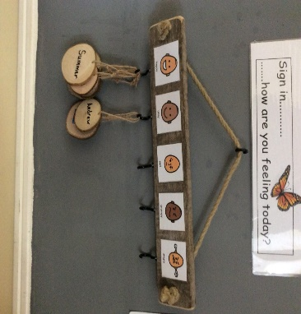  The calm code is a 5-point scale visual system that can help to organize a person’s thinking when working through difficult moments, particularly those that require social understanding. It is a visual way of our young learners to demonstrate how they feel and recognizing their own and the emotions of others. The children use the calm code to sign in each day and tell us how they are feeling We talk to the children about each staged and together are planning self-regulation strategies.  INTRODUCING mINDFULNESS AT HOME  The children and staff have been practicing mindfulness regularly during our nursery sessions. During these mindfulness your children have voiced feelings of happiness, calm and quiet. Mindfulness sessions are making a positive impact on the nursery environment increase children engagement and concentration skills.  We would love to introduce some of the learning to you to use at home.  Here is a few ideas you can try.  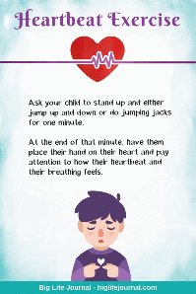  https://positivepsychology.com/mindfulness-for-children-kids-activities/  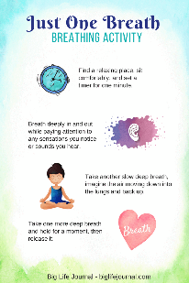  If you have any other mindfulness tips you already use at home we would love to hear about them. Please share your mindfulness stories or tips by emailing us on  dunblanenu@stirling.gov.uk
Our Gentle Journey | August 2020
rEMINDERS  As part of our COVID19 Risk assessment we must ensure all areas are well ventilated. With this in mind we request you bring a cozy jumper along to nursery each day. As the temperatures outside fall the playroom could become a little cooler than normal and some children may benefit from an additional layer.  Please bring a label water bottle to nursery for your child to use through the session. A snack and lunchtimes we will continue to provide milk and water to drink. Our team will support your child to refill their bottle as required.  Please ensure all your child’s belongings are clearly labelled.  If you have your child’s learning folder at home can you please return it soon.  Introducing 4pm Snack  During the nursery day the children receive morning and afternoon snacks along with Lunch. For children who are staying on after 4 pm there is an optional additional snack around 4.15 pm. This snack would need to be provide by yourselves and we ask it is a healthy options for your child until tea/dinner time at home. Please label your child’s snack stating it’s for 4pm.  Seesaw – A tool for Communicating to Parents  Seesaw is a simple way for educators and children to record and share what's happening in nursery. It is also a tool for parents to share pictures with the nursery showing learning beyond nursery. Once we have parental permission for children to be on Seesaw children will be issued with a QR code. This will allow parents to access Seesaw using the Seesaw Class app. | Upcoming events  We are looking into the possibility of hosting our curriculum evening virtually. At the moment we do not have a date for all meetings, however bear with us please.  Nursery curriculum evening – A presentation will be sent out week beginning 28th of September. We will share our Nursery improvement plan and our intentions of how we plan to share learning via seesaw.  Curriculum group meeting – Proposed date would be Friday 18th of September at 11AM  Garden group virtual meet - TBC  Fundraising group virtual meet –TBC  Information for Parents  We are now operating in 2 small bubbles as the caterpillar group have now joined the butterflies. The child appear happy to be back in the main nursery playroom. Thank you for your cooperation and patience during this time of change. It is our intention to continue to use the annex as a learning space for small focus groups throughout the year.  You will shortly be issued your child’s nursery contract, please can you sign and return this. This is an essential document as part of the 1140 expansion.  Our care plan are currently under review and we may require parent/carers to complete a new copy to ensure we have all the information we need about your child. Apologies if you’re new to nursery and have just completed paperwork. This new system should cover all we need to know and will be reviewed every 6 months with your child’s key work.

