The Wallace Monument Group

Dunblane Nursery

May-June 2017

The Wallace Monument Group

26.4.17

As part of our context on ‘building’ a small group wanted to do an in-depth study of a building that captured their collective interest. To engender the group spirit, they have a welcome song and they follow and at set routine to reinforce the sense of being key member of a purposeful group.

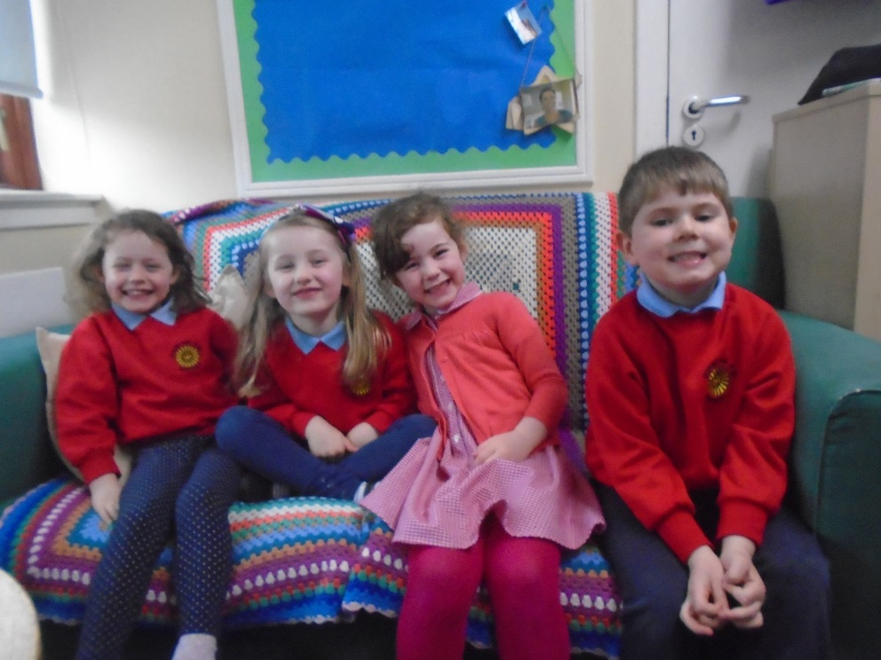

*I value the opportunities I am given to make friends and be part of a group in a range of situation**HWB 0-14a*

Initally the group were asked to close their eyes and were taken on a virtual walk through Dunblane, picturing all the buildings and bridges that they pass on a regular basis. Each child then gave a description of their favourite building and the others had to try to guess. Anna said, “You get flowers here.” The next clue was, “It is quite small.” The group thought of tesco and Marks & Spencer, but they weren’t right. It was tricky! We couldn’t guess, so Anna told us it was the Secret Garden florist down the High Street.

Discussion moved on to various types of buildings, and buidlings the children knew well and why they would like to learn more about them. Options included:

Lauren “Wallace High School, because I don’t know about it.” Anna “Dunblane Hydro.” John “Castles. The view outside from the castle from the top.”

The children decided to go away and think about the options and do some research before voting for the Wallace Monument at that the following meeting.

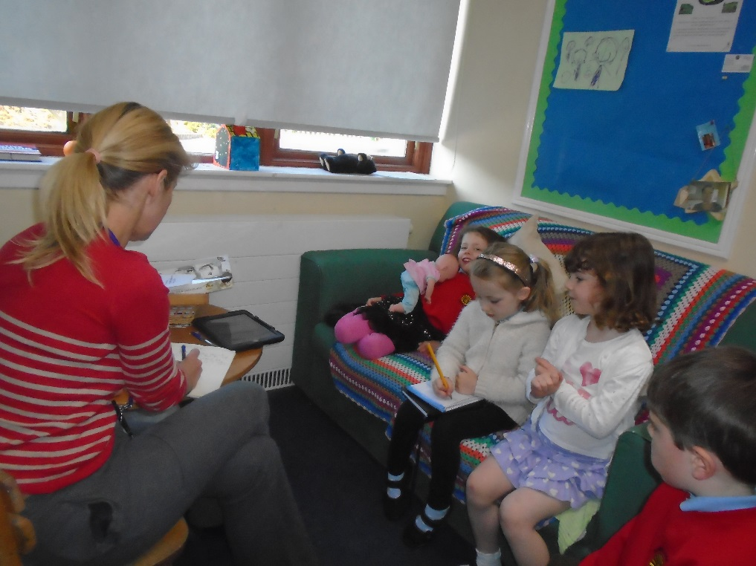3.5.17

The vote took place:

John “The Wallace Monument because it has twisty, turny stairs.”

S “I saw the Wallace Monument yesterday on my way home from the shops. One day from the Gruffalo Park I went up to the Wallace Monument, but I didn’t go inside it. I think it’s for parties or for people to explore”

Lauren “I think the Wallace Monument is to celebrate St George’s Day.”

Anna “It’s an old church.”

*In everyday activity and play, I explore and make choices to develop my learning and interests. I am encouraged to use and share my experiences.**HWB 0-19a*

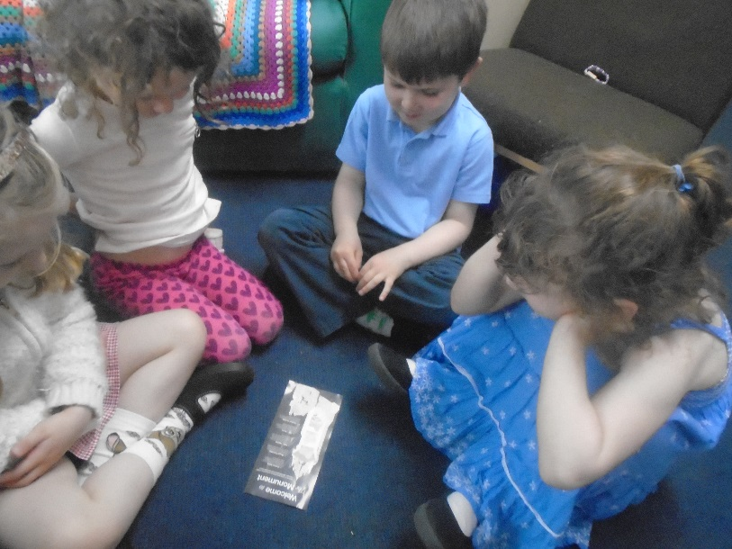10.5.17

Our third meeting was very exciting as John had been to visit the Wallace Monument with his daddy. He brought back a leaftet to share with the rest of the group, and aswered lots of questions.

John “We went up and down on a bus. At the bottom there’s a big door.”

Lauren “It looks like a little door but it’s huge. I’ve been.”

John “We climbed up the stairs which was boring ‘cos there were loads of stairs. Round and round. There were actually four rooms on top of each other.”

Lauren “Why are the stairs so twisty turny?”John “Maybe, cos it’s so big and fat.”

Lauren “I think it’s so tall and the stairs have to be twisty turny.”

The group learnt that the word for twisty turny stairs is:

**spiral staircase**. *As I listen and take part in conversations and discussions, I discover new words and phrases which I use to help me express my ideas, thoughts and feelings. LIT 0-1010a*

Anna “Why do they have pointy bits at the top?”

John “Maybe because it’s to burst a hot air balloon?”

S “It might be a roof. To make it look like a castle so everyone likes it?”

John “Like Rapunzel’s Tower!”

After studying John’s leaflet, the group decided they’s like to draw the monument and selected pastles to work with.

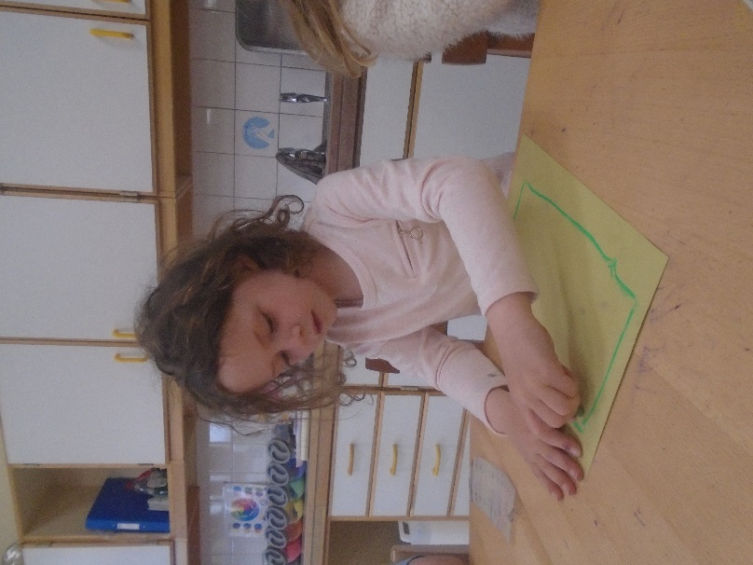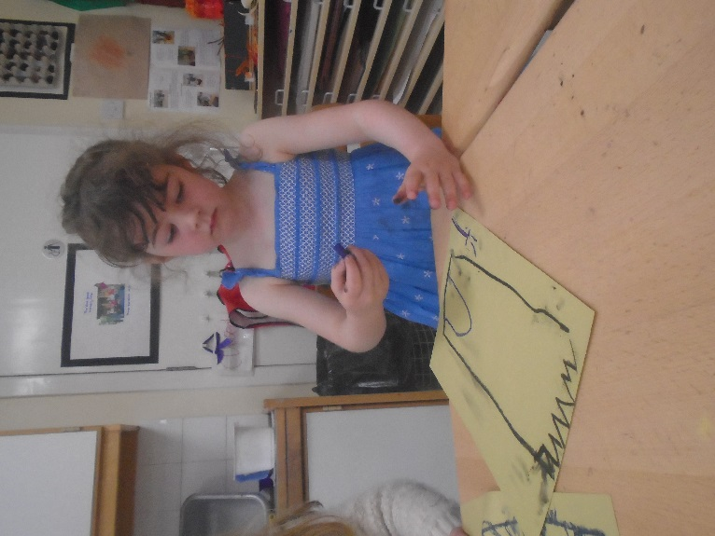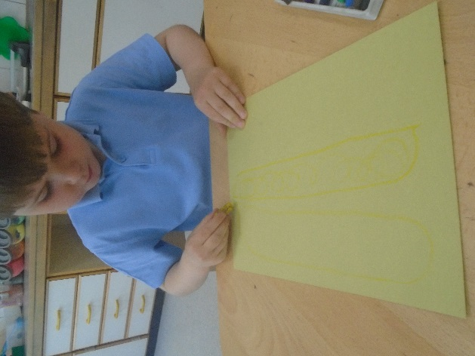

*I have the freedom to discover and choose ways to create images and objects using a variety of materials. EXA 0-02a*

17.5.17

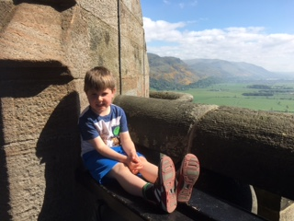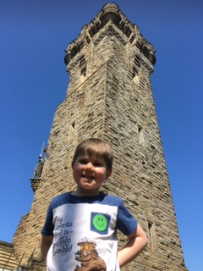John shared these picture of his visit to the monument with the group:

“I was sitting on a bench at the top of the Wallace Monument. It was good.”

Then the group watched a video of poppy petals being thrown from the top of the Wallace Monument yesterday. This was to mark the deaths of soldiers in a battle a long time ago.

Lauren “Wow, that’s all the petals.”

After watching the video we had more questions to research:

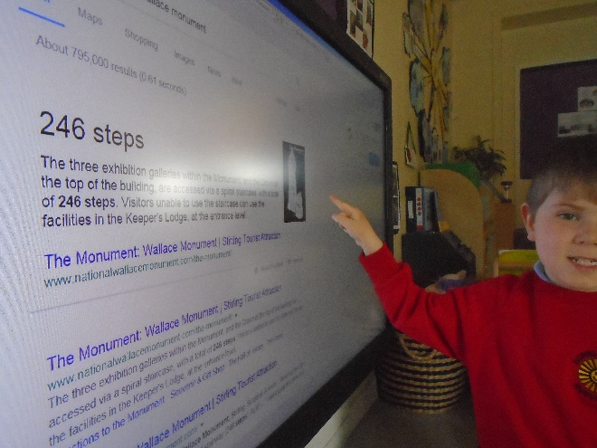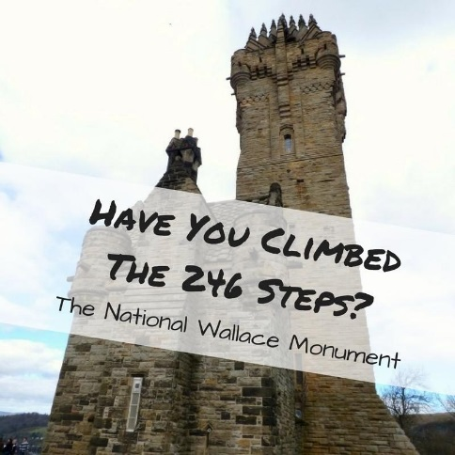Lauren “How was it made?”

S “Why is it so tall?”

John “How many spiral steps are there?”

Each group member took a guess (Anna was off):

Lauren “150”

John “151”

S “1000”

John’s answer was the closest!  *I am developing a sense of size and amount by observing, exploring, using and communicating with others about things in the world around me MNU 0-01a*

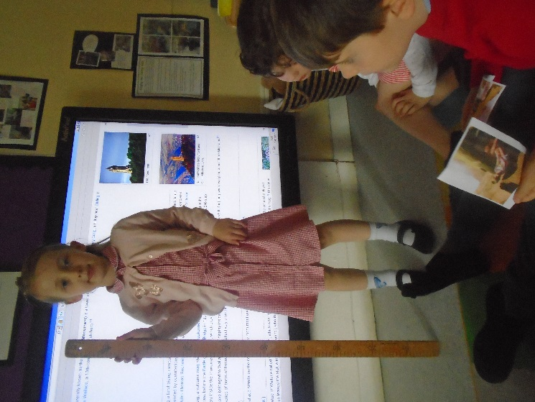The group wanted to know how high that was.

We used the internet to find out that the tower is 67m high. The children then used the metre stick to measure the highest part of the nursery.

It was just over 3m high, so the Wallace Monument is a LOT taller than nursery! *I have experimented with everyday items as units of measure to investigate and compare sizes and amounts in my environment, sharing my findings with others.**MNU 0-11a*

Lauren now wants to explore what is in each of the three rooms.

John wants to “Make a twisty turny spiral staircase.” But he needs to think of things that are round.

Lauren suggested “What about pipe cleaners. We can curl them round our fingers?”

S would like to look at “Why was William Wallace a prince.”

The group decided to vote again next week when Anna is back to agree what to explore next.

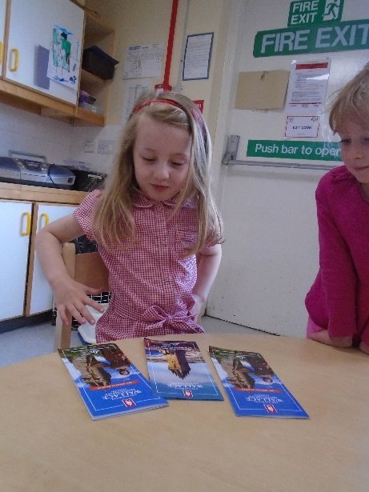24.5.17

This week S brought in some photos she had taken of the Wallace Monument:

“Why did you take pictures from outside the building?” Lauren

“We couldn’t stop on the road ‘cos it was too busy.” S

“Why is that picture close and that one far away?” Anna

“We used zoom on the camera to make it closer.” S

After discussion the group decided they’d like to draw William Wallace the following week. S said he had a crown, a cape and a sword. Anna told us he was tall.

7.6.17

We had a week’s break because of Sports Day, but everyone was still keen to draw William Wallace. S had brought in some leaflets.

“I’ve got William Wallace to draw a picture. I got them from the library.” S

“I think that’s the real William Wallace with a beard and a cloak. Look how big the sword is!” Lauren

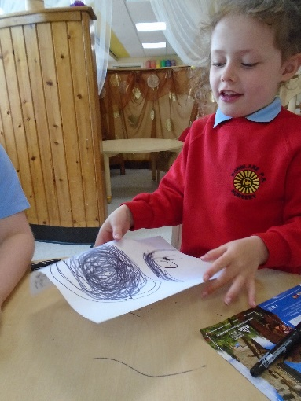Each child then drew their representations.

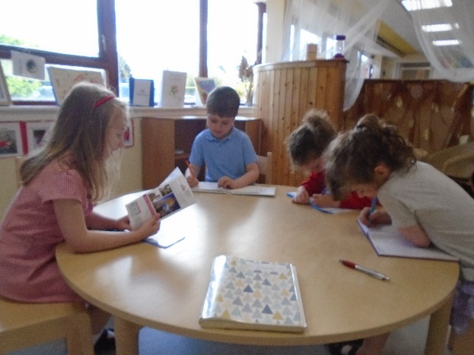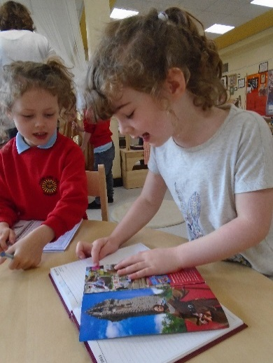

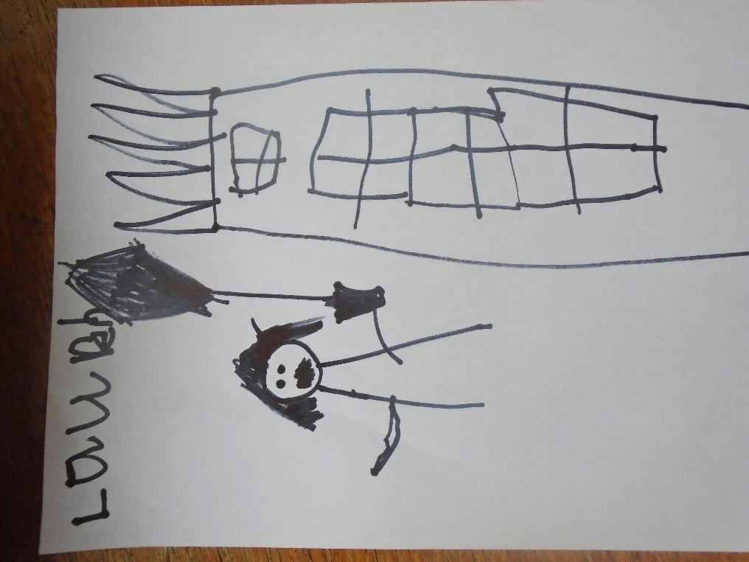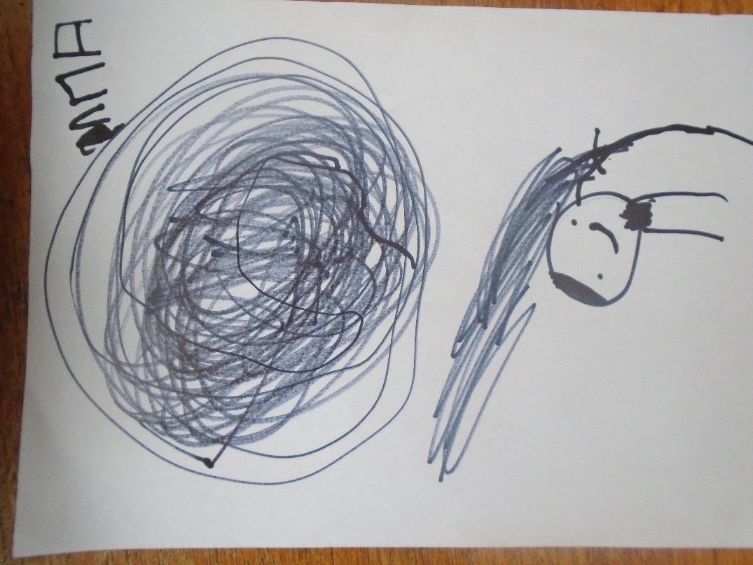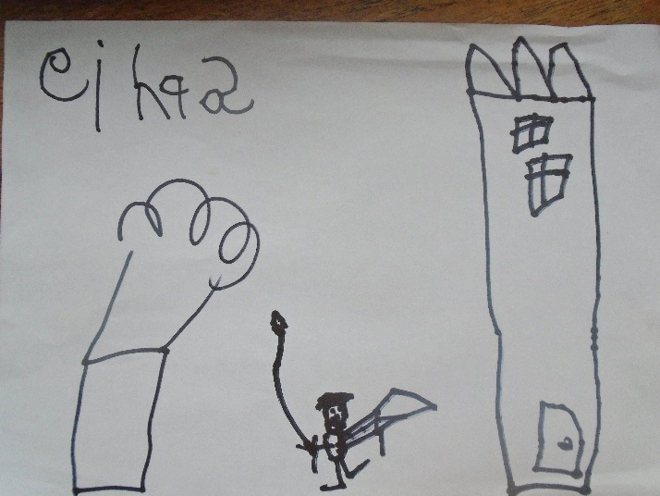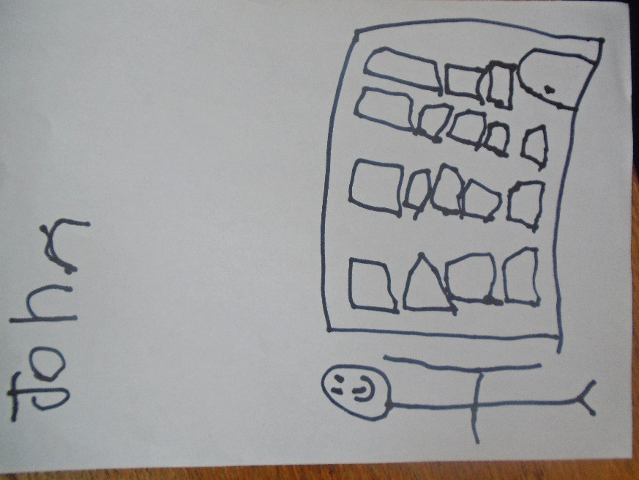

14.6.17

Finally we got round to making spirals! First we used Lauren’s suggestion and twisted pipe cleaners around our fingers.

Then our student showed the group how to cut spirals from paper.

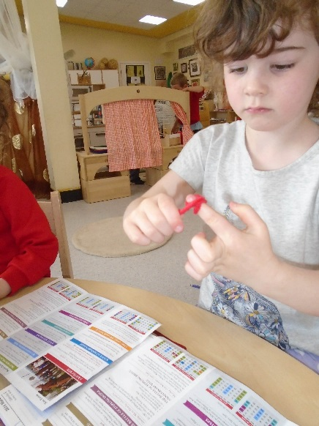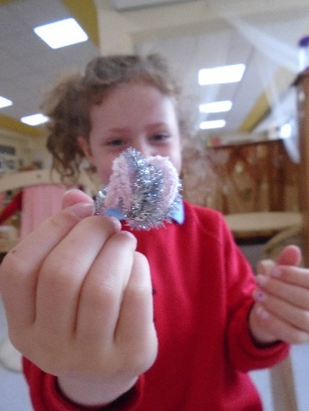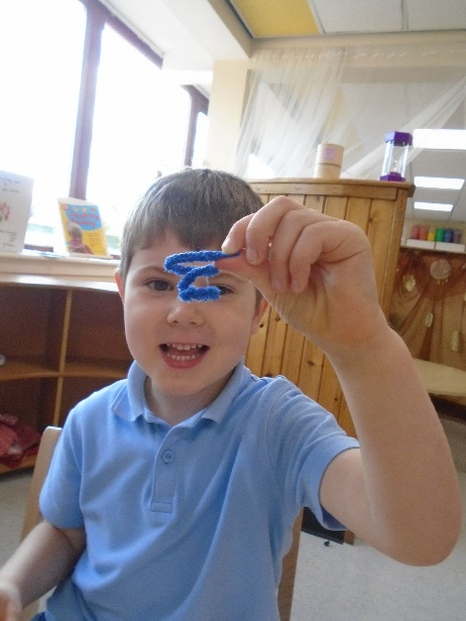

“This is the spiral staircase” ~Anna

**Experiences and activities:**

* Listening, talking & discussing with respect
* Exploring leaflets, photographs & the internet to research (collectively and independently)
* Drawing with a variety of materials
* Learning new vocabulary
* Watching video clips
* Presenting findings and personal experiences to a group
* Estimating (number of stairs), height
* Using everyday materials and references to get a sense of scale (height of the monument)
* Experimenting, by trying several different ways to make a spiral
  + Cutting paper and twisting pipe cleaners

“This is the spiral staircase” ~Anna

**The learning group considered:**

* Sharing ideas and interests and working in a group.
* How important it is to listen to others and follow rules allowing opportunities for learning.
* How revisiting and recalling previous learning helps us remember and retain learning
* How to use leaflets, the internet and video clips for research
* How to select and source appropriate materials for creative purposes.
* How some materials can change shape as we manipulate them.

**Curriculum for Excellence Experiences & Outcomes**

* *I value the opportunities I am given to make friends and be part of a group in a range of situations. HWB 0-14a*
* *In everyday activity and play, I explore and make choices to develop my learning and interests. I am encouraged to use and share my experiences.* *HWB 0-19a*
* *As I listen and talk in different situations, I am learning to take turns and am developing my awareness of when to talk and when to listen LIT 0-02a*
* *I listen or watch for interesting information and I use this to make choices or learn new things LIT 0-04a*
* *To help me understand stories and other texts, I ask questions and link what I am learning to what I already know LIT 0-07a*
* *Inspired by a range of stimuli, I can express and communicate my ideas, thoughts and feelings through activities within art and design.* *EXA 0-05a*
* *I have experimented with everyday items as units of measure to investigate and compare sizes and amounts in my environment, sharing my findings with others.* *MNU 0-11a*
* *I am developing a sense of size and amount by observing, exploring, using and communicating with others about things in the world around me*
* *MNU 0-01a*