School Travel Plan
Updated June 2016
Dunblane Nursery and Primary School
January 2015
- INTRODUCTION
What is a School Travel Plan?
A school travel plan is a live working document which sets out how the school and community promote safer, active and sustainable travel to school, with the main emphasis being on reducing the number of children being driven to and from school. The JRSO group were responsible for writing this Travel Plan. Below they have stated why we are writing the plan –
“To get people walking safely to school.” Katy
“To encourage people to walk to school.” Georgia
Aims of the Dunblane School Travel Plan
- To encourage pupils and staff to walk, cycle or scoot to school.
- To ensure that everyone in the community is aware of safe routes to walk or cycle to school.
- To provide everyone with safe cycle and walking routes to Dunblane Primary School.
- To reduce the number of cars which park in inappropriate places around the school.
- To raise awareness of the benefits of walking, cycling or scooting to school.
It helps the world.
It is healthy and fun.
It keeps you healthy
Why should we
It is fun to walk with your friends and join the walking bus.
Walk to school? By JRSO
It makes the roads safer.
It takes a while to walk and you have time to chat with your friends.

- SCHOOL DETAILS
School Address Dunblane Primary School
Doune Road
Dunblane
Perthshire
FK15 9AU
Telephone: (01786) 822351
Email: dunbps@stirling.gov.uk
Website address: http://www.dunblaneprimary.ik.org/
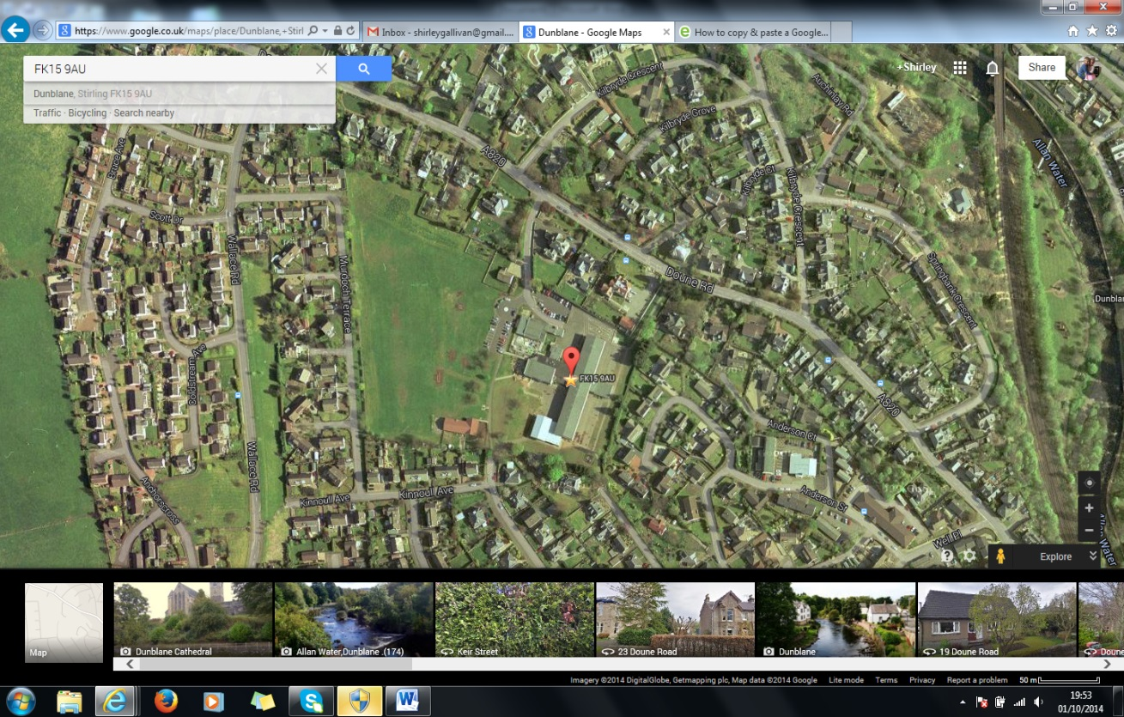
Contact Name for Travel Plan : Shirley Gallivan and the school JRSO team.

The school is set in extensive grounds consisting of garden and soft and hard play areas, together with an adventure course and multi sports area. Also on campus is Kid’s Club (out of school care) which serves all of the Dunblane Community. It operates from 8-9am and again after school from 3:15 – 6pm. There is a cycle rack outside the Kids Club (5) and a cycle rack in the senior playground.
The building is over 51 years old, having been built in 1963.
The school currently has 17 classes and morning and afternoon nursery classes. The present school roll is 487. The school has a morning and afternoon nursery class. 40 pupils attend the nursery. The nursery school operates from 8.30am to 11.40am and the afternoon session is 12.30pm - 3.40pm. The school nursery offers and extended day so children can also be picked up at 12.30PM and dropped off earlier at 11.40AM. The nursery has 1 Senior Early Childhood Educator and 3 Early Childhood Educators.
STAFF
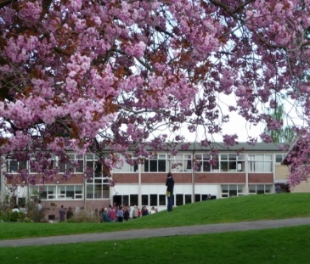
There are three members in the Senior Management Team. The Head teacher is Mrs Sally Kennedy. There are two Depute Head teachers, Mrs Sarah Starrs and Mrs Shirley Gallivan. The school has 3 principal Teachers. There are 16 full time teachers and 5 reduced class contact teachers. The school has 7 Support for Learning Assistants. The school also has 2 clerical staff, a janitor, 4 catering staff and 4 cleaners.
- LOCATION AND DESCRIPTION OF SCHOOL
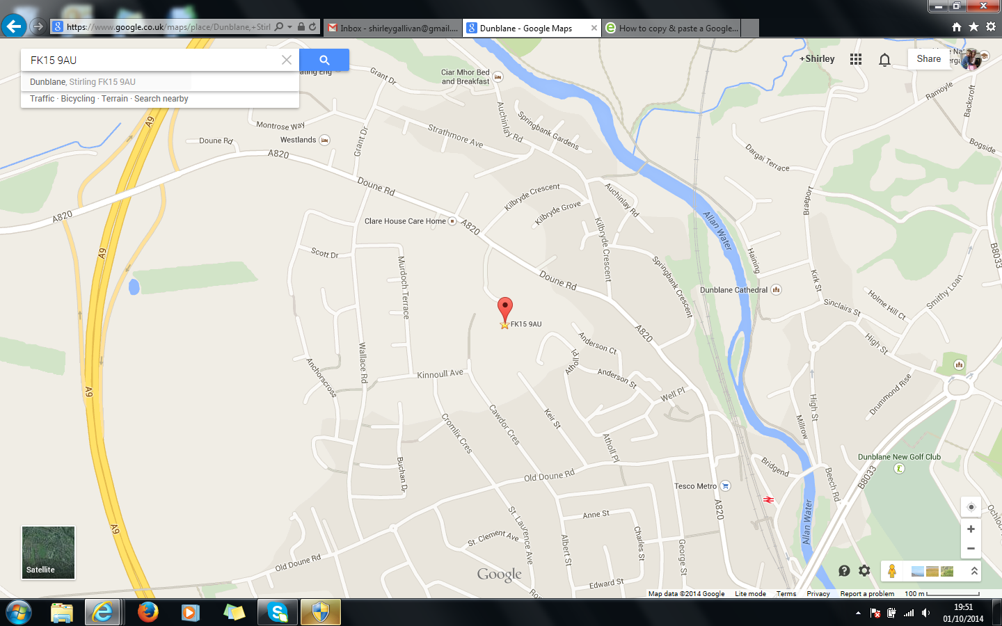
Dunblane Primary is situated near the outskirts of the City of Dunblane and serves the community west of the River Allan.

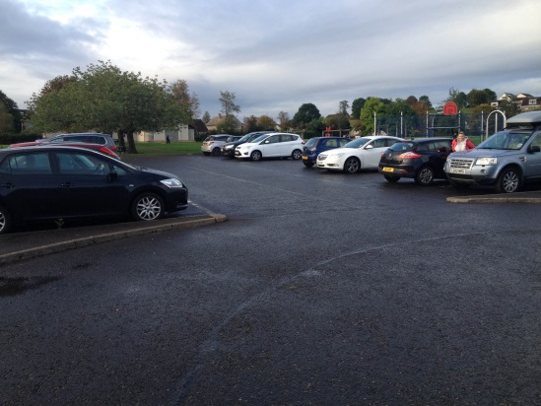
The school has 1 main entrance for cars. This is from the main Doune Road and the staff car park (1) and visitors car park (2) are accessed from here (3). When approaching this entrance there is a sign which clearly states that cars, other than staff, are not allowed to use this gate between the stated time. (4)
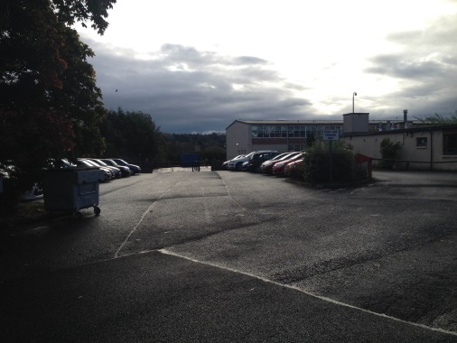

2. Visitors car park
1.Staff car park
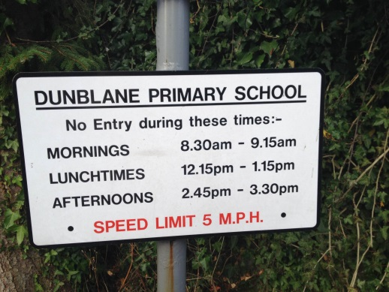
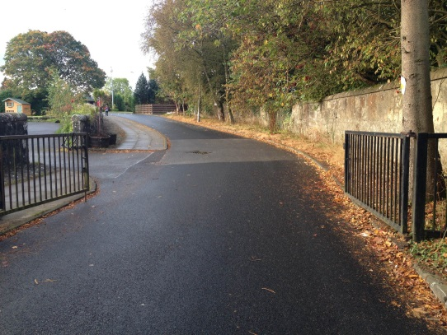

4.Restrictions
3.Main entrance for cars

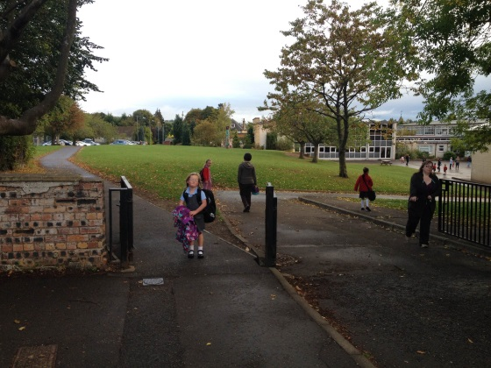
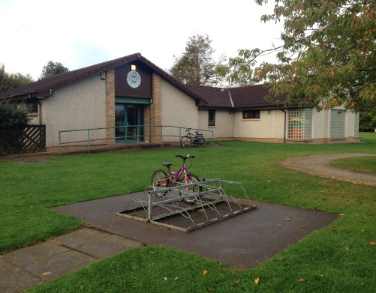
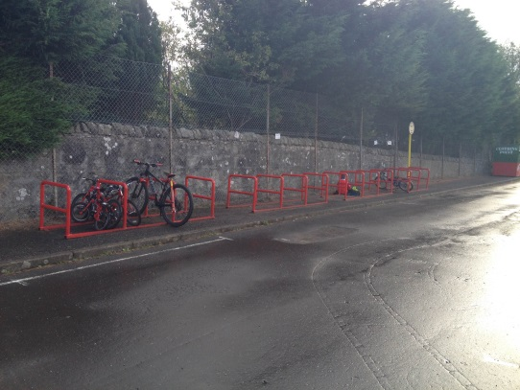
There is also an entrance for pedestrians on the Doune Road. A bike rack is located close to this entrance (5). The other entrance which is accessible by foot, bike and scooter is that from Cawdor Crescent which is a residential area (6). There are issues with parents not showing considerate parking. There is also a cycle rack close to this entrance (7).
7. Bike rack outside the Kids Club.
5. Bike racks close to Doune Road
6. Cawdor Crescent Entrance
The school was completely refurbished to a high standard in 1998 and has a purpose-built nursery and games Hall. The school operates from 9am – 3.15pm. Morning interval is from 10.30-10-45am and lunch time is from 12.15 – 1.15pm.

- THE CURRENT TRAVEL SITUATION
On Wednesday the 9th of September all the pupils at Dunblane Primary School and its nursery class participated in the Hands Up Scotland Survey which shows how pupils normally travel to school. The results are shown below.
Hands Up Survey September 2014 –
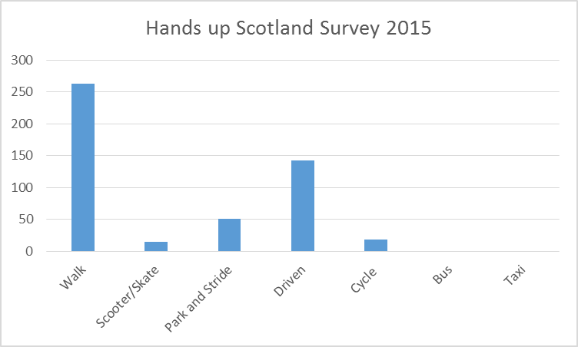
Actual numbers –
Walk Driven Scoot Bus Cycle P & S Taxi 263 143 15 0 18 51 0

During Walk to School month in October we used the living street travel tracker. Every day pupils recorded how they travelled to school. Analysing the above graph and the travel tracker results it shows us that most pupils at Dunblane Primary School walk to school. However a large percentage of pupils are driven to school. Since last session more children are using park and stride. We aim to work together to reduce this number.
- EXISTING PRACTICE TO PROMOTE SAFER, ACTIVE AND SUSTAINABLE TRAVEL TO SCHOOL.

- Walk to School Month in October
- 2 cycle racks in the school grounds
- Cycle training through Bikeability.
- School Crossing Patrol located on the Old Doune Road. They work from 8.30AM – 9AM and from 3PM – 3.45PM.
- JRSO Citizenship group was formed and they had visits form the Community police about road safety.
- Campaign – JRSO’s considerate parking discussions with the parents
- Newsletter termly about considerate parking.

- TRAVEL ISSUES
Travel and transport issues faced by the pupils and parents at Dunblane primary School –
- Parents work and don’t have time to walk to school with their children.
- Busy roads on many popular walking routes to school particularly the Old Doune Road and the Doune road.
- The School car park is small for the number of cars dropping pupils off.
- Walking paths are unsafe as they are covered with leaves, mud and puddles. This can be dangerous when wet and slippy.
- Cromlix Crescent and Cawdor Crescent are busy with cars dropping off and picking up.
- Parents are worried about their child’s safety as they have to cross busy roads with no lollipop person.
- 70% of the pupils at Dunblane Primary School attend the Kids club which starts at 8AM.

- OUR OBJECTIVES
OBJECTIVE | TARGET
Reduce the number of cars driving to the school at the beginning and end of the school day and encourage more pupils to walk to school. | Reduce the number of pupils travelling by car by 15% (from 143 to 122 pupils)
Encourage more cycling or scooting to school in order to increase the number of pupils cycling to school. | Increase the number of pupils who cycling and scoot to school by 15% (from 18 to 21)
Promote the take up of ‘Park and Stride’ | Increase the number of pupils who take part in park and stride by 10% (from 51 to 56)
Encourage parents to consider where they are parking to avoid congestion and residents to be able to leave their drive during drop off and pick up times. | Reduce the number of residential complaints from 5 last session to 0.

- ACTION PLAN – UPDATED JUNE 2016
Action Point | How will we achieve it? | Responsibility and date to be completed | How will we know it has been achieved?
Encourage pupils to walk to school | -JRSO group to do a presentation at assembly about the benefits if walking to school  - Set up a school walking bus every Wednesday with 5 different routes. Advertise this initiative around the school and on website. Talk about it regularly at assembly. JRSO pupils to attend parents evening, promoting the walking bus.  -Identify in a leaflet safe walking routes to the school and share this via parent mail.  -Participate in walk to school month – October and May use the Living Streets Travel Tracker with a certificates for the winning class. This will be used in October and May  - Lollipop person to continue to help pupils across the road on the Doune Road.  -Create a school traffic subgroups to address the concerns regarding the busy roads on the Old Dolune Road and Doune Road | JRSO Group. Road Safety week 17th – 21st Nov.  Distributed during health  fortnight.  Meetings in April & June. Minutes available with action points. | More pupils are walking to school and this will be evident in the Hands up Survey and the travel tracker.  Termly JRSO newsletter.  Completed leaflet emailed to all parents and displayed around the school.  Travel Tracker website  Safe ways to cross on both these roads.  Reduce the volume of traffic going to DHS
Pupils to keep safe when walking and cycling to and from school | -JRSO group to do a presentation at assembly before the clocks change about being seen in the dark  - Have a Be Safe Be Seen day where pupils wear bright clothes.  -As part of the curriculum pupils will be education in how to walk safely to school and reminded of the green cross code.  - JRSO pupils will go into the nursery and infant classes to support the delivery of this.  -Zebra crossing on the Old Doune Road close to Wallace road due to the volume of traffic going to the High School.  - A zebra crossing at the chicanes on Wallace Road. A drop off zone at the grass area on Wallace Road would be useful with a 15 minute parking zone for parents walking younger children to school. A roundabout on Wallace Road at either Anchorscross or Coldstream Avenue would allow traffic to turn and reduce the traffic on the Old Doune Road.  - Zebra Crossing on the Doune Road close to the entrance of the school gates.  -Identify and promote appropriate park and stride places for the High School pupils to avoid traffic on the OLR.  Identify appropriate park and stride places for Dunblane Primary School pupils to avoid traffic on the OLR.  - JRSO group to email companies to receive free high vis products and distribute them.  -Police in during health fortnight to talk to p1-4 pupils about road safety.  -Magic Road Safety Show for nursery and p1-3 pupils during health fortnight | Assembly close to clocks changing  Road safety week 17th- 21st Nov.  Health Forthnight every year.  June 2015 | Pupils are seen to be wearing bright clothes and reflectors  Included in HWB planners  A reducation in the volume of traffic on the ORD and Doune Road.  Zebra crossing in 2 places – Doune Rd and ODR  50% of pupils have high Vis products to use when walking to school.
Encourage pupils to cycle or scoot to school | -Produce a safe walking route map for scooting and cycling to school.  -Add scooter racks to the school playground.  -Hold a scoot to school Week where children are encourage to scoot.  - Use Give Me Cycle Space which is a Cycling campaign to encourage more children to cycle to school. It aims to create high levels of driver awareness around child cyclists to make the roads around schools more cycle-friendly.  - Continue to use Bikeability within the school  - Continue to work closely with recycle a bike who provide safety checks on the children’s bikes before they conduct Bikeability. | June 2015P5’s during health fortnight.  Annually for P5’s April  Recycle a bike in April annually | More pupils are scooting and cycling to school
Encourage families to park and stride to school. | Create a map and identify suitable places to be able to park and then walk to school. Share this via parent mail.  -Create a leaflet which include maps identifying safe walking, cycling, scooting and park and stride routes. | May 2015 met to discuss this with Bridget Clarke. | More pupils are parking and then walking to school
Encourage parents to be responsible road users and think of others when parking | -Purchase triangular signs which will be put out every morning and night stating that this is an unsafe place to park.  -JRSO group to talk to parent who have parked in an unsafe places  -Regular articles in school and JRSO newsletter about being responsible road users.  -School car park not be accessed between 8.30 -9.15AM, 12.15 – 1.15PM and 2.45 – 3.30PM  -Staff members to be distributed car park badges so they are easily identified. | May 2015 – Janitor only letting staff cars into the school.  Badges distributed May 2015 | No complaints by residents about inconsiderate parking.  Parents not coming into the school during these times.

The travel plan will be updated in June 2016.
- Signatures
_____________________________ (Head Teacher)

______________________ ( Eco - committee representative)

______________________ ( JRSO representative)

