Dunblane Primary School Nursery Class
Evaluating our Year
2015-16

As part of the Nursery Improvement Plan for 2015 – 16 two main Quality Indicators were identified to be addressed.
These were:
- Maximise positive language and literacy opportunities in order to improve learning experiences for children.
Together the nursery team worked on the above priority and measured the impact this had on the children.
Library visits
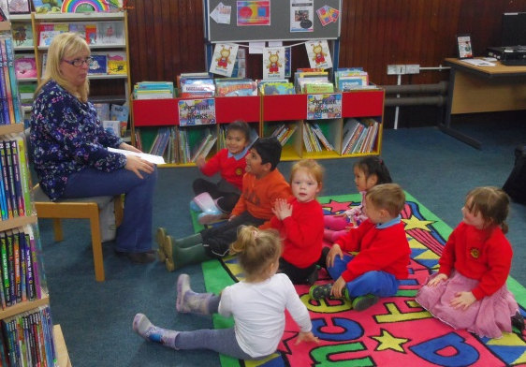
94% of children at the nursery experienced one or more visit to the local library. For most of the children this was beneficial as they accessed books for pleasure and to extend their learning. There were opportunities for all children to listen to stories being read by someone from the library and opportunities for questions were given. All of the children attending, morning and afternoon children, were able to listen to the full story and then browse for books of their choice. The afternoon children generally are the young children, received the book bug session. All children were engaged for the full session which comprised of short stories, songs, puppets and rhymes.
The 3 children who did not access the library were all 2 year olds within our nursery. They did not access the local library as we do not yet have buggies for transport.
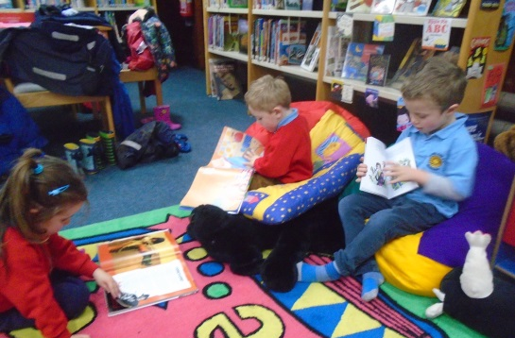
Dunblane Primary School Nursery class have had a display space in the library for 2 months of the year. This is used to celebrate the children’s work and achievements. One display linked to stories and the other was about families. Opportunities for the public to add comments were offered but none were received.
Creating literacy rich environment
Within the nursery a ‘Literacy Rich’ environment has been created. Books can be found in all areas of the nursery and link well to the context, activities & displays.
Lending library
The nursery class created a lending library for all children. This comprised of a wide range of books. Most children accessed the lending library at least once. The Majority children accessed the lending library 3 or more times. Children could be heard recommending books to their friends and sharing reasons as to why they might enjoy it. Children were often the instigators of borrowing and selecting the books and could be heard asking their parents for another book. 8 children regularly accessed the lending library and it became part of a nursery routine. The books were refreshed twice a term and children were involved in the selecting of these new titles. The families have shown respect to all the books borrowed. This is also evident in the nursery.
Reading workshop
On Thursday the 19th of November a reading workshop was held for all nursery parents. The session was not well attended. On reflection the wording ‘workshop’ may have put parents off attending and future events would be called ‘sharing the learning’. Evaluations showed that all parents found the session informative and useful. (See Appendix 2 for evaluation).
Transition – Paired reading
The transition process started in term 3 with Primary 6 pupils coming to participate in paired reading sessions with the nursery children. The impact of this was that the nursery and Primary 6 pupils were comfortable taking on the role of the buddy. This reinforced what the nursery staff were working on with the children – good sitting, good listening and the layout of a book.
Terrific talkers
10 children benefitted from a small language group. The main activity was listening and responding to stories. The children were developing their skills in turn taking, listening to others, asking and answering questions. Progress was made by all children developing their confidence and ability to listen for longer periods of time.
Next Steps
- 100% of children will visit the local library for 1 session by Christmas. In terms 3 and 4 individuals will be identified for future visits based on individual needs and interests. Such as the benefit from the walk to the library, listening to stories, browsing for books and based on what the library has on offer.

- Continue to use the local library display space for 2 months of the year. The nursery will advertise this more to parents using the school website, notice boards and providing information slips. Rather than lifting the display from the planning wall the nursery will use a gallery approach. This will be more child lead and they will be more involved in how this looks.

- Continue the lending library and ensure that all new parents are aware of this facility. This can be highlighted at the curricular evening in September. Introduce a weekly session in the nursery where children share the book they have borrowed and talk to a small audience about the book. This should encourage more children to want to participate in accessing the lending library.

- Continue to keep a spread sheet of borrowers and track children who are not using the library and try to address this.

- Extend the variety and challenge in the books which we offer. The school library books and reading scheme can be used.

- Parents will continue to be involved in their child literacy development. At the curricular evening in September pointers on how parents can support their child will be shared along with the leaflet used at the workshop this session.

- To improve learners experiences through a shared understanding of high quality provision and how learning commitments can contribute to this.
Staff development
The nursery team had 3 new members of staff start during this session. 4/5 staff are using the Stirling Council Vantage programme to book onto relevant courses. All staff attended network meetings, courses and in total the nursery staff attended 23 courses through Vantage. All staff completed appropriate evaluation forms and highlighted their next steps and impact.
All staff had an area of responsibility within the nursery.
Collegiate working
Regular meetings in the nursery have been opportunities for staff to share good practice and to ask for advice. Specific time was set aside at in-service days and after work meetings to look in detail at Building the Ambition. Sections 1, 2 and 3 were looked at in detail as a staff in the November and February in-service days.
During recent PRD meetings all staff commented on feeling part of a team. All staff members feel that they can ask any other colleague for advice, guidance or clarify.
Mary Kinnaird re-established the Cluster nursery meetings which have taken place twice this session. Dunblane nursery class is also part of the council’s improvement trios with Croftaime and Acrewood nurseries. These have been useful connections to share good practice and to particulate in quality dialogue.

Monitoring
Quality Assurance observations are planned for in the nursery monitoring calendar. Observations of staff take place and professional dialogue between staff informs their next steps.
An Induction Folder was created this session to support new staff starting at the nursery. This ensured all staff were given the appropriate information which was the same for everyone.
Sharing good practice
Mrs Mary Kinnaird has been asked by the council to share the planning process used at the nursery as this was seen to be good practice. She has been involved in creating guidance linked to what makes good planning. This will be shared with other staff within the Authority at future in-service days.
Throughout this year 8 different nurseries have been advised to come to visit the nursery class to see good practice.
Next Steps
- To plan for sections 4-8 Building the Ambition to be looked at in detail in session 2016-17.
- Peer reviews to be formally introduced in the Quality Assurance calendar and to be a critical friend.
- Using time off the floor should occasionally be used to visit other establishments.
- Alison McKeown to be put onto Vantage.
- As a next step for the improvement trio’s, staff from the nursery will visit the other establishments.

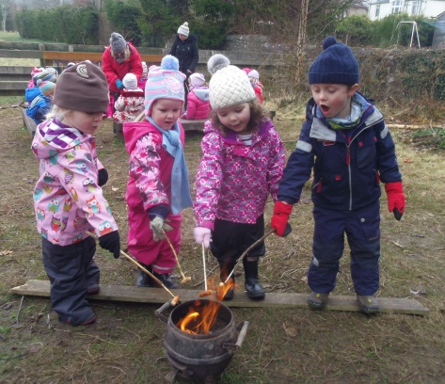
Proud moments this session
Forest Schools
All Nursery children and primary 1 children have experienced the forest schools programme for 2 –4 terms. The impact that this has had on our children has been fundamental in building emotional resilience, taking risks in a safe environment and supporting imagination and problem solving skills.

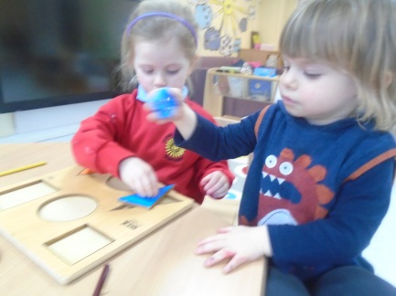
Inclusion of 2 year olds
This has been the nurseries first year where we have provided care & education for 2 year olds. We have had four 2 year olds who have attended afternoon sessions. All our 2 year olds completed an individual transition programme which included home visits.

Parental partnership
We are continually seeking parental views. A recent questionnaire demonstrated that parents are very happy with the service we provide.
This year our parents have supported us with several successful fundraisers, allowing us to buy the children gifts at Christmas and the end of term and making improvements to our environment, i.e. the cloakroom.

Environment – Purposeful resources
The nursery environment is continually being improved and this year we have been lucky enough to secure funding allowing us to buy some additional furniture and resources; however we are great believers in using non-commercial resources giving the children the opportunity for open ended and imaginative play.

Outdoor Area
The outdoor area of the nursery has been used to support children with the transferring of skills. For example using tools as safely inside as out, developing gross and fine motor skills, developing negotiation skills and working together.

Dance Programme
All children have had the opportunity to participate in 2 blocks of dance session lead by Mrs Alison McKeown. The children were expressively moving to music, developed spacial awareness and their ability to follow instructions. Some children presented their dance to parents and parents were invited to join in a group dance with all staff and children at the end of the ’Pentathlon’.

