√ One class will have responsibility for using the litter pickers across the week (not sharing the equipment). The Hi Vis jackets can be worn.
√ The litter pickers can do their duties at break time and afternoon break (not lunch time).
√ Class teachers have responsibility to rota the children in their class each day to complete the jobs. Litter pickers should be wiped down with disinfectant wipes at the end of the day.

Week Beginning | Class
22nd February 2021 | P4-7 Hub
1st March 2021 | P3/4
8th March 2021 | P2/3
15th March 2021 | P1/2
22nd March 2021 | P6/7
29th March 2021 | P5/6
19th April 2021 | P4/5
26th April 2021 | P3/4
3rd May 2021 | P2/3
10th May 2021 | P1/2
17th May 2021 | P6/7
24th May 2021 | P5/6

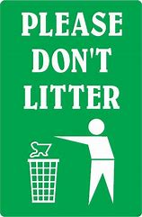
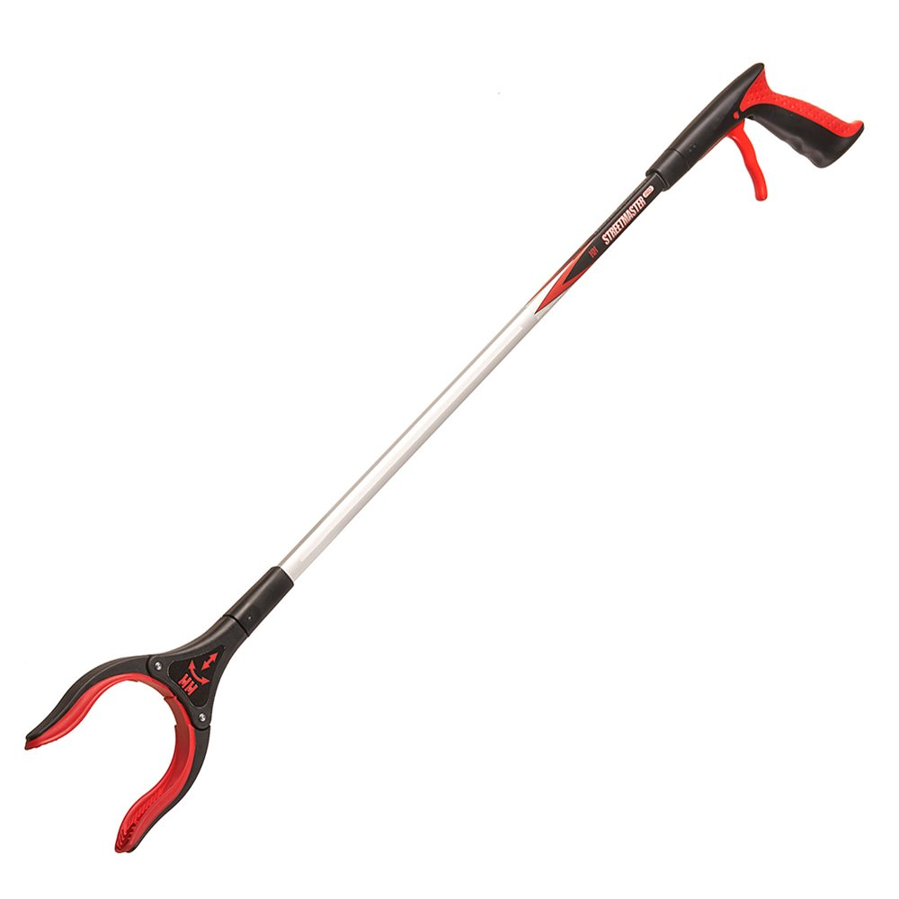
Our Vision
We Care for Each Other
We Care for Ourselves
We Care for Our Environment

