Stirling Schools- Learner Guide to Google Meet
What is Google Meet?
Google Meet is an interactive online video conferencing platform which will allow you to participate in online live learning with your teacher. You access Google Meet through your Google Classroom(s).

How will Google Meet be used?

The recordings will be shared on the Google Classroom for 21 days. The school needs your parent’s permission or, if you are aged 12 and over, you need to give your own consent. If you do not want to be recorded in the live lesson you can watch the recording later which will be posted on the Google Classroom.
Participating in lessons using Google Meet
If you are not comfortable with being on camera to speak with your teacher, let him or her know using an email or private message in Google Classroom, so that other arrangements can be put in place.

Using Google Meet is inviting someone into your home. You need to think carefully about the view from your web camera and how you are set up at home for learning online. Here are some top tips:

- Be dressed suitably - no pyjamas - get dressed as you would be happy to be seen outside of your home.
- Sit somewhere with your back towards the wall. This will reduce how much of your home is in the camera frame. When blurred background becomes available please switch this on.
- Turn the TV and other distractions off. Try to find a space which is quiet.
- Let other people in your home know when you are attending a live recorded lesson on Meet.
- If you have some headphones, use them. You might need to change the meeting settings after you plug-in your headphones. This will work even better if they have a microphone. Help here
- Choose somewhere with good light but don’t have your back towards a window if you can avoid it. Too much light can make it difficult for others to see you on your camera.
- Have your device on a table rather than on your knees. If you don’t have a table, use cushions under your device to make yourself more comfortable.
- Have some paper/jotters handy with a pen or pencil so you can write notes if you need to. You could also type your notes on a Google Doc.
- You must not make your own recording of a Google Meet.
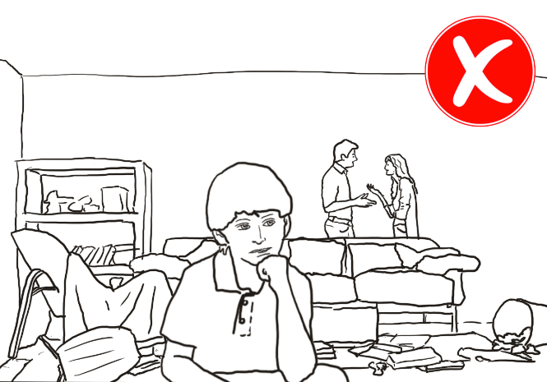 | 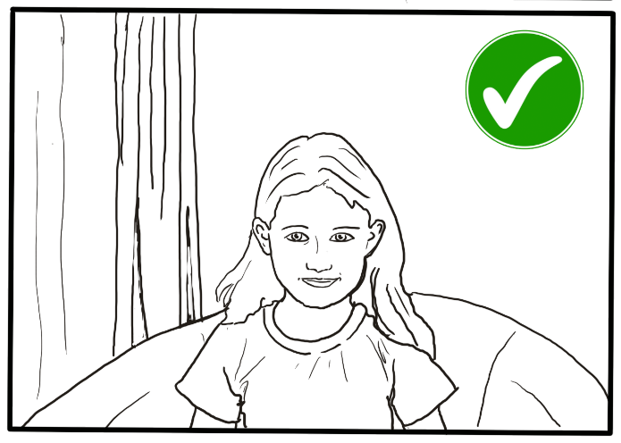
Connecting to a Google Meet lesson
Your teacher will set a time for your meeting in Google Classroom. This is also where you will find the link for the meeting when it starts. Your teacher will be the first person in the meeting room and will be the last person to leave it.
Tips for Meet
- Visit your Google Classroom to get the meeting link just before the meeting is due to start.
- Go to the meeting link.
- Mute your microphone before you enter the meeting. You can also switch off your camera if you wish.
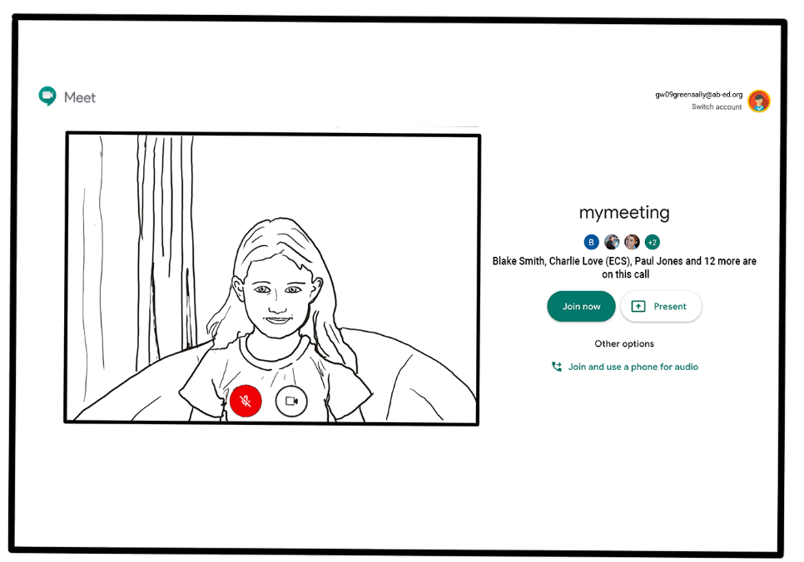
- Click Join now to enter the Google Meet. Don’t click Present.
- Once connected, listen carefully to your teacher. You can use the chat to ask questions or unmute your microphone and ask your question. You should mute your mic again after you have asked your questions.
- In your Meet, be kind and considerate of other people. The Meet is just like being in school and you need to behave appropriately. Your teacher may remove you from the meeting if you don’t do so. If you are removed from a meeting, the headteacher or another member of senior staff may discuss this with you and your parents/carers.
- Remember that the meeting is being recorded. The REC in red on the top left of the page tells you that recording is happening.
- When the Meet is finished, disconnect by clicking the red “hang up” button.

Remember to check Google Classroom after the meeting for any assignments that your teacher has set for you.

Acknowledgement
Thank you to Aberdeen City for sharing their advice.

