Reading | Writing | Talking and Listening
To celebrate Outdoor Classroom Day 2020, please read this text: https://drive.google.com/file/d/1wgKivoi5qG6tYWzv RUf9w0nOsNB2QoT5/view  After the extract you will find some comprehension questions.  At the end of the question pages, you will find the answers so that you can mark your own work.  Remember to try to read a text of your choice for at least 20 minutes every day. This could be a book, magazine, webpage, newspaper. | Make a book of your own. Most of you should know how to do this. If not follow these simple instructions: https://www.youtube.com/watch?v=OFWcSnRIAmc  In your story try to include all of these:  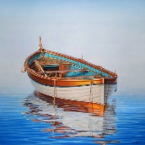  · Good openers  · Connectives  · Alliteration  · Similes  · Adjectives  Remember to give your book a title. | Fact or Opinion  Click on the link below and watch the video to learn about facts and opinions. You’ll find some activities to do at the bottom of the page.  https://bbc.co.uk/bitesize/articles/zn4d  Linking to what you have just learned, try debating these topics with your family:  - If animals could talk, would it change the world?  - Can you ever tell a lie for a good reason?  - What five words best describe you?
Writing | Literacy  P5/6  Home Learning Grid | Reading
We have been doing work in class about Jimmy the peacock.  Choose your favourite bird and use books, internet, documentaries etc. to research your bird. Share your information. You could write a book, create a fact file, create a PowerPoint, or make your own documentary style programme.  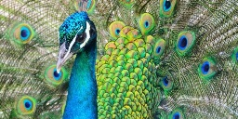 |  | Read a newspaper or magazine article.  Highlight the key information from the text.  Write a summary of the article using the following success criteria:  - Identify key events.  - Use own words to recap.  - Make it short and concise (quality over quantity).  - Ensure it makes sense to the reader.  - Retell in chronological order.
Spelling | Talking and Listening- Family Interview | Writing
Use the spelling activities grid and spelling words posted in google classroom to complete three spelling activities of your choice.  Using a dictionary find any words you do not know the meaning of. Use them in a sentence of your own.  Choose a challenge word from the dictionary (a word you don’t know). Identify the meaning and try to use it in conversation with your family. Did they notice your new vocabulary? | Choose a member of your family to interview.  Ask them questions about when they were little.  You could ask things like:  · What was their favourite game to play?  · What was their favourite TV programme?  · What did they like/dislike about school?  · Where did you live?  Make up some questions of your own. | It is still very important to wash your hands regularly.  Can you write a set of instructions for how to wash your hands properly?  You may wish to use this video to remind you or the different steps.  https://www.youtube.com/watch?v=bQCP7waTRWU  Remember to include lots of high level VCOP.

Whole Number | Place Value | Perimeter and Area
Research the distance from the Earth to the Moon and other planets, e.g. it is about 384 403 km to the Moon.  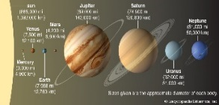  Record the information in both digits and in words (three hundred and eighty-four thousand, four hundred and three kilometres) and write the distances in order. | 356,728  Look at this number. Can you write it out in words? How many ways can you describe this number? Examples include “the three represents three hundred thousand”, “the six equals six thousand”, “10,000 more would be 366,728”.  Challenge yourself by repeating this process with bigger numbers. | Use what you have learned about area and perimeter to do some measuring outside. Find the perimeter/ area of a slab, your front garden, garden shed, sandpit, decking etc. Don’t worry if you don’t have a tape measure, you could measure using your feet by stepping heel-toe or find a couple of sticks and use them. Just remember to include your units at the end. E.g the perimeter of my shed is 12sticks and the area is 8 sticks. (ensure the sticks are the same length!)
Problem Solving | Maths and Numeracy  P5/6  Home Learning Grid | Outdoor Times Tables
What’s My Number?  1 2 3 4 5 6  7 8 9 10 11 12  13 14 15 16 17 18  19 20 21 22 23 24  25 26 27 28 29 30  31 32 33 34 35 36  1. The number is odd, 2. It is a multiple of three, 3. It is smaller than 7x4, 4. Its tens digit is even, 5. It is the greater of the two possibilities. Now make up your own clues for another number |  | Choose a times table, challenge yourself to one you think you need the most practice with.  Go outside and collect sticks or stones and order them into multiples of your chosen times table.  Here is an example: -  II  II II  II II II  II II II II  II II II II II
Scale Drawing | History of Maths | Money
Design your bedroom.  Your bedroom is 6m by 5m. Draw a scale drawing (1cm=20cm) and consider the size of your bed/ wardrobe/cabinets/desk/etc. Your drawing will be 30cm x 25cm.  Try changing the layout of your bedroom. Would everything still fit? Could you add some other furniture in? | Explore a historical number system.  Explain how it works and explain how it has developed.  What has it impacted on today?  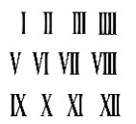  Ideas could include, Roman numerals, early forms of money, Tally Marks.  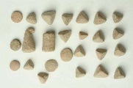 | Ben has eight coins in his pocket.  How much money might he have?  What is the highest possible amount?  What is the lowest possible amount?  If he has £1.32 what coins might he have? Is there more than one answer?  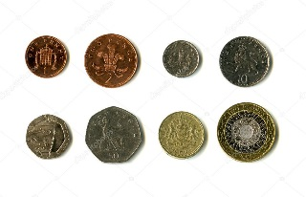  Try creating your own coin challenge using six or ten coins.

Health and Wellbeing – Dance Moves! | Art and Design- Make a Sampan | IDL- WW2 Family Research
Invent 8 dance moves that get you on your feet and your heart pumping e.g. star jumps, sliding left or right, power stance, clapping, spinning, etc. Now choose your favourite song and for every beat change dance move. How many combinations can you come up with? Can you create a dance routine for the whole song?  Take a picture or video of your routine! Have fun! | 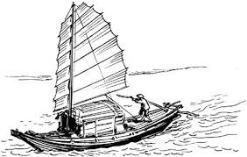  We have been learning about sampans in our class novel ‘The House of Sixty Fathers’ by Meindert DeJong. See if you can make a sampan that floats using anything you like – paper, tinfoil, plastic... Test your boat.  How many pennies can it hold?  Can you improve it? | Talk to your grandparents or great-grandparents and find out if they experienced the Second World War or if they know someone in your family who did. What did they do? Were they soldiers on the front? Were they helping the war effort in factories on the Home Front? Were they evacuees? Find out as much information as you can to get an idea of what it was like to live through the war.  Create a biography of their experiences for your WW2 Fact File.
Music- Tuneful Glasses | Other Curricular Areas  P5/6  Home Learning Grid | Modern Languages- French Cities
Have a go at creating a simple tune by exploring pitch and rhythm using household items.  Watch the RSNO’s ‘Challenge 2- Tuneful Glasses’ https://www.youtube.com/watch?v=ymPlqw-nTjA&feature=emb_logo  Can you create a simple well-known tune like Old McDonald or Twinkle Twinkle Little Star?  Why not record or perform your tune for a family member.  Please remember to ask your parents’ permission prior to using anything! |  | Identify a city in France. Research the area and create a guidebook to highlight some of the key information for visitors. You may wish to include:  -landmarks -shopping centres  -beaches -museums  -transport -restaurants  Useful websites might include:  https://www.lonelyplanet.com/france  https://www.kids-world-travel-guide.com/france-facts.html
Health and Wellbeing- Circuit Training | IDL- WW2 Propaganda | Health and wellbeing- You’re A Star!
Set up a circuit in your home or in the garden. Try to include running and jumping activities. Give yourself one minute at each station. Record how many of each activity you manage. Repeat this everyday – see if you can improve your results each day.  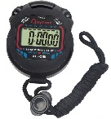  Activities might include: • Shuttle runs • Star jumps • Throw and catch a ball | Watch this short video on propaganda during WW2: https://www.bbc.co.uk/teach/class-clips-video/history-ks2-how-propaganda-was-used-during-world-war-two/zr77wty  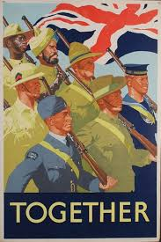  Create your own motivational poster about something you are passionate about.  Can you persuade and encourage others  to join your cause? | You are awesome and it’s time to remember why!  Finish each of these sentences. Try to include three examples in each.  I was proud when I…  I am talented at…  I have fun when…  I am looking forward to…  Ask someone else to answer the same questions about you and compare your answers!

