Reading | Writing | Talking and Listening
Consider what types of books you enjoy reading.  What makes you choose them? Create a poster about your preferences. You may want to include:  -If books are fiction or non-fiction.  -Authors you like and why?  -The overarching theme of books which interest you?  -Types of illustrations you like?  -What catches you eye when looking at different books? | Make a book of your own. Most of you should know how to do this. If not follow these simple instructions: https://www.youtube.com/watch?v=OFWcSnRIAmc In your story try to include all of these:  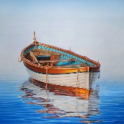  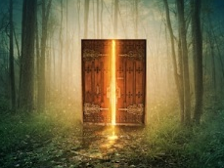  · Good openers  · Connectives  · Alliteration  · Similes  · Adjectives  Remember to give your book a title. | Copy this link into your browser and watch Authors Live with Michael Rosen as he shares his love of poetry and rhymes in this fun-filled and very funny event:  https://www.scottishbooktrust.com/authors-live-on-demand/michael-rosen  Choose a favourite moment from one of Michael’s  poems and create a still image of that moment.  Add notes to say what the character is saying, thinking, feeling, or take a digital photo and annotate it or add speech and thought bubbles.
Writing | Literacy  P6/7  Home Learning Grid | Reading
We have been doing work in class about Jimmy the peacock.  Choose your favourite bird and use books, internet, documentaries etc. to research your bird. Share your information. You could write a book, create a fact file, create a PowerPoint, or make your own documentary style programme.  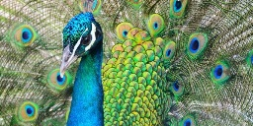 |  | Read a newspaper or magazine article.  Highlight the key information from the text.  Write a summary of the article using the following success criteria:  - Identify key events.  - Use own words to recap.  - Make it short and concise (quality over quantity).  - Ensure it makes sense to the reader.  - Retell in chronological order.  - Include sequencing words e.g. meanwhile, next, lastly.
Spelling | Talking and Listening- Family Interview | Writing
Use the spelling activities grid and spelling words posted in google classroom to complete three spelling activities of your choice.  Using a dictionary find any words you do not know the meaning of. Use them in a sentence of your own.  Choose a challenge word from the dictionary (a word you don’t know). Identify the meaning and try to use it in conversation with your family. Did they notice your new vocabulary? | Choose a member of your family to interview.  Ask them questions about when they were little.  You could ask things like:  · What was their favourite game to play?  · What was their favourite TV programme?  · What did they like/dislike about school?  · Where did you live?  Make up some questions of your own. | It is still very important to wash your hands regularly.  Can you write a set of instructions for how to wash your hands properly?  You may wish to use this video to remind you or the different steps.  https://www.youtube.com/watch?v=bQCP7waTRWU  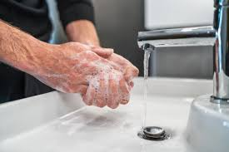  Remember to include lots of high level VCOP.

Whole Number | Data Handling | Perimeter and Area
Research the distance from the Earth to the Moon and other planets, e.g. it is about 384 403 km to the Moon.  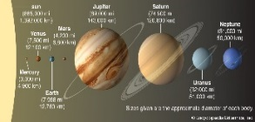  Record the information in both digits and in words (three hundred and eighty-four thousand, four hundred and three kilometres) and write the distances in order. | Choose a product advertisement you have seen on television or in a magazine e.g. shampoo, toy, sweet.  Create a questionnaire to gather feedback on the product.  Think carefully about what questions you will ask.  Imagine the company will be using the information to find out how well the public like this product or things that could be altered/ changed. | Use what you have learned about area and perimeter to do some measuring outside. Find the perimeter/ area of a slab, your front garden, garden shed, sandpit, decking etc. Don’t worry if you don’t have a tape measure, you could measure using your feet by stepping heel-toe or find a couple of sticks and use them. Just remember to include your units at the end. E.g the perimeter of my shed is 12sticks and the area is 8 sticks. (ensure the sticks are the same length!)
Money | Maths and Numeracy  P6/7  Home Learning Grid | Shape
Choose a meal your family eats on a regular basis and list the ingredients. Estimate the cost of each ingredient and total the cost of the items.  Check your estimations using an online supermarket website. List the exact costs and total them.  What was the difference between your estimated cost and exact cost?  What is the cost of the meal per person? |  | Create a picture of a robot which is made up of a variety of regular and irregular 2D shapes.  List the different shapes you used.
Scale Drawing | History of Maths | Problem solving
Design your bedroom.  Your bedroom is 6m by 5m.Draw a scale drawing (1cm=20cm) and consider the size of your bed/ wardrobe/cabinets/desk/etc. Your drawing will be 30cm x 25cm.  Try changing the layout of your bedroom. Would everything still fit? Could you add some other furniture in? | Explore a historical number system.  Explain how it works and explain how it has developed.  What has it impacted on today?  Ideas could include, Roman numerals, early forms of money, Tally Marks.  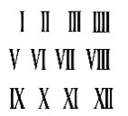  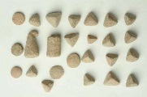 | Ben has eight coins in his pocket.  How much money might he have?  What is the highest possible amount?  What is the lowest possible amount?  If he has £1.32 what coins might he have? Is there more than one answer?  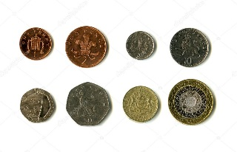  Try creating your own coin challenge using six or ten coins.

Drama- Character Portfolio | Art and Design- Ariel Landscape Art | IDL- Research
An unusual character arrives on the Isle of Harold.  Create a portfolio about him/ her.  Include things such as their career, medical information, family, places they have lived, skills they have etc.  Draw a picture of your character to include in their portfolio. | Using Google Maps, explore the satellite images of different sections of Scotland:  https://www.google.co.uk/maps/  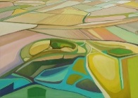  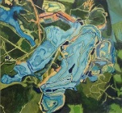  Create a piece of aerial landscape art for your chosen section. Type ‘aerial landscape art’ into Google images to look at lots of examples. You can complete in a medium of your choice. E.g. oil pastels, paint, pencils, pens, crayons etc. | Research the terms reduce, reuse and recycle.  Write a definition for each.  Explain how they differ from each other and when you might use each.  Consider why are each of them are important.  Create an information poster to relay the information you have found to others.  Remember to ensure it is eye catching, clearly presented and includes text and images.
Music- Tuneful Glasses | Other Curricular Areas  P6/7  Home Learning Grid | Modern Languages- Spanish Cities
Have a go at creating a simple tune by exploring pitch and rhythm using household items.  Watch the RSNO’s ‘Challenge 2- Tuneful Glasses’ https://www.youtube.com/watch?v=ymPlqw-nTjA&feature=emb_logo  Can you create a simple well-known tune like Old McDonald or Twinkle Twinkle Little Star?  Why not record or perform your tune for a family member.  Please remember to ask your parents’ permission prior to using anything! |  | Identify a city in Spain. Research the area and create a guide book to highlight some of the key information for visitors. You may wish to include:  -landmarks  -beaches  -shopping centres  -museums  -transport  -restaurants  Useful websites might include:  https://www.spain.info/en_GB/  https://www.lonelyplanet.com/spain
Health and Wellbeing- Plan your own circuits | IDL- Scottish Landmarks | Health and wellbeing- You’re Star!
Plan your own circuit session. Include 6 different stations. Use exercises that target a variety of different muscles.  Use a stopwatch or ask someone to time you completing each exercise for 1 minute. Record how many repetitions of each exercise you complete.  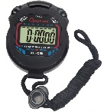  Repeat the same circuit session at a different time. Can you increase the number of repetitions from last time? | Identify a Scottish Landmark.  Research facts about the landmark e.g. Why is it important? Where is it located? How old is it? Who is linked to it? How often is it visited?  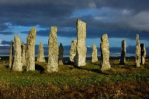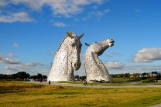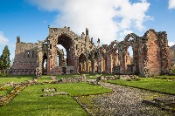  You could present your findings as PowerPoint, video, fact file. | You are awesome and it’s time to remember why!  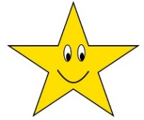  Finish each of these sentences. Try to include three examples in each.  I was proud when I…  I am talented at…  I have fun when…  I am looking forward to…  Ask someone else to answer the same questions about you and compare your answers!

