Scottish Wars of Independence Homework Grid
January – April 2018
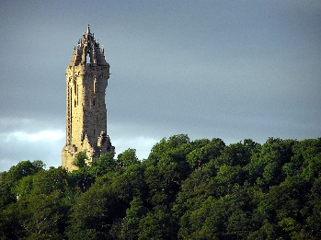
Make a model of a famous Scottish castle, building or monument using any materials you wish. | Create a time-line of the Scottish Wars of Independence. | Design a leaflet for the Wallace’s Monument.
Research facts about the Auld Alliance. | Make a PowerPoint about Robert the Bruce. | Research what a child’s life would be like 700 years ago and compare it to your own life.

