Castleview Primary School Parents and Carers

A huge warm (virtual!) welcome to Castleview Primary from the Parent Council. We are sure you will love being part of our community.

Our role is to provide a voice for all the parents and carers of the school for matters that are important to them. Part of our role is to work with the school to help decide on key priorities, communicate with parents to hear their views and try and make links with the wider community.

Currently we have three parents on the council but would love to welcome more. Stuart McCusker is our Chairman and is dad to Liam who is in Rainbow Class. Gillian MacAuley is our Secretary and is mum to Megan who is in Red Class. Sally Stovell is our treasurer and is mum to Daisy who is also in Rainbow Class. If you are interested in becoming part of the Parent Council please let the school know.
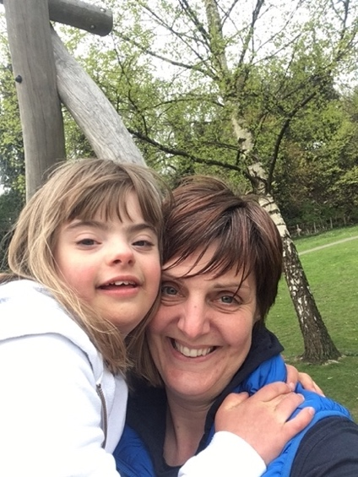
Stuart and Liam
Gillian and Megan
Sally and Daisy
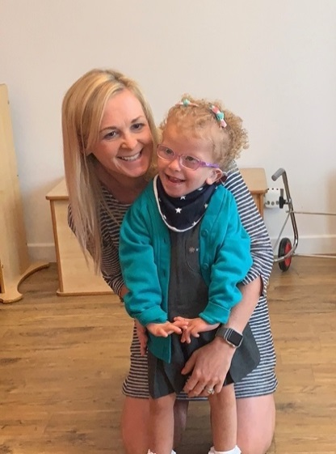

We have a Facebook page that we use to share information, help build our community and gauge the views of our Parents and Carers. We would love for you to join us on there. You can follow this link or just search for Castleview Primary School Parents and Carers:

https://www.facebook.com/groups/246822320456109

We look forward to times when we can arrange an event and welcome you properly.

Stuart, Gillian and Sally

