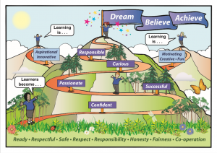
Callander Primary School
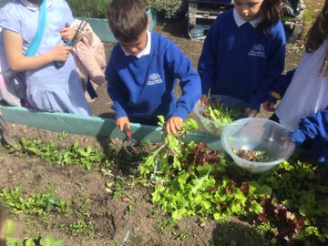
Learning at Home Policy

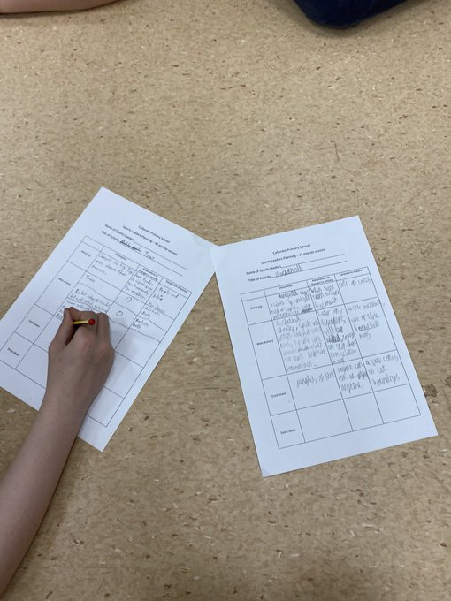
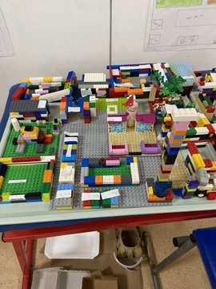
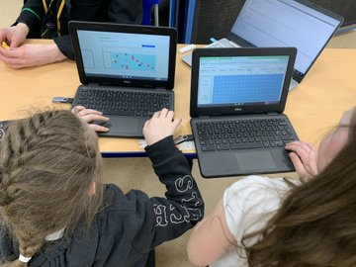

POLICY
Callander Primary School – Learning at Home
“Research shows that learning at home can have significant immediate and longer-term impacts on children in different ways. These include a child’s early learning, later achievements, nurture, resilience, wellbeing, social mobility and skills for life.” Education Scotland, 2022
At Callander Primary, we recognise that parents are involved in this process by supporting their children at home with reading together, writing and counting as well as a variety of different activities.
At Callander Primary, we understand that parents may also have questions regarding homework. Questions may be:
- I don’t have much time to complete homework activities with my child, can my child have less homework to complete?
- Can my child have more homework to complete?
- Can we have more information and knowledge regarding the content of homework and the expectation of the class teacher?
- How much help should I give my child in completing homework activities?
To answer these questions and as a result of surveys and discussions regarding homework with parents, children and staff, we have developed the following policy and approaches to offer reassurance and to support learning at home.
Parents and staff recognise the following core purposes of homework:
- Additional practice of work undertaken in class.
- Development of a school / home partnership in learning. We want to encourage parents to engage in the homework activities, helping and supporting the learning process. We recognise that homework may be a product of parent and child working and as such is marked accordingly.
- To provide further opportunities for children to experience some choice in the way they learn. Homework can provide opportunities for children to show a creative approach to independent learning.
- To provide opportunities for children to develop and deepen their understanding of particular concepts.
- We acknowledge that homework must not be “catching up” on uncompleted class activities unless by prior arrangement with parents.
- We understand that homework provides an extension of learning from the classroom however we also recognise that many families and learners are committed to other activities in the evenings and as such homework is always at the discretion of parents/carers.

- No learner in our school will be punished for incompletion of homework tasks. Teachers expect that learners will attempt some homework activities each week but that the number of tasks/ activities undertaken will be determined by parents.
- All staff are keen to support learners with homework and as such we run Homework Clubs on Wednesday lunchtimes for all learners. If parents are unable to support their children with homework activities in any week, they can send a note into the class teacher.
- Homework will be issued in a variety of different ways by class teachers. Particularly in the early years, children should be encouraged to read and go over sounds and numbers each night. As children move through the stages, learners will be given the opportunity to self manage their tasks over a period of days.
- Homework will be shared via our online platforms:
- Seesaw – Primary 1 and 2
- Google Classroom – Primary 3-7
Where requested, children can be provided with a jotter to complete homework tasks also.
- Some parents may prefer to have the opportunity to complete homework activities over the weekend when there is perhaps more free family time. Teachers will be sensitive to this and will provide the homework activities where appropriate, for the following week. This allows parents and learners to begin thinking about the tasks if they choose to do so.
- The school app will be used to provide information on common homework themes and supports throughout the school for home and family learning where appropriate.
- Homework will be marked by the class teacher (teacher assessment) or it may be self or peer assessed.
- Self and peer assessment can only take place effectively when learners have a very clear understanding of the criteria or expectation for homework. In order to reflect on the learning undertaken, learners must know the standard of work which is expected of them and as such teachers spend time discussing the success criteria for activities ie. How will learners know that they have successfully achieved. Through this knowledge they can reflect on what they and their peers have done well and how they could make their work even better.
- Many classes, particularly in the senior stages of the school, will engage in peer assessment of homework where learners are encouraged to look at other children’s homework and provide constructive feedback on how they have done. Peer assessment involves learners in giving positive and constructive comments on the learning activities of one of their classmates. The development of effective peer and self assessment is an ongoing process which requires to be modelled in the class.
“Independent learners … are able to engage in self reflection and to identify the next steps in their learning. Teachers should equip learners with the desire and capacity to take charge of their learning through developing the skills of self assessment.”Assessment Reform Group 2012

Homework at Callander Primary will be based on the Four Contexts of Learning and will use the following format:
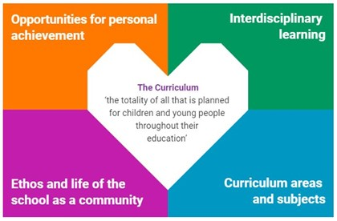
Each week there will be homework set for specific curriculum areas and subjects (blue section). There will also be opportunities for additional learning to be undertaken over a longer period of time at home based on the other sections (orange, green and pink sections).
As stated above it will be each family’s decision regarding the quantity of home learning to be undertaken each week.
If a piece of homework is required to be undertaken that relates to a follow up tasks in class, this will be highlighted on the grid. For example, if a child is asked to read to a certain page in their reading book this may be because further prediction work is going to be undertaken in class.
- In addition to homework, where appropriate, class teachers may also remind parents of future whole school or class events by recording this on Seesaw, Google Classroom or the school app and Facebook pages or by sending letters home.
- If your child is absent from school due to a family holiday homework will not be issued. If you wish your child to complete a holiday diary or Power Point we would be happy to share it with your child’s class on their return.

Further support regarding home learning can be found below:
https://education.gov.scot/parentzone/learning-at-home/home-learning-environment/
The following extract is taken from Parentzone, part of Scottish Government’s advice for teachers and parents:
Showing an interest in homework and talking to your child really helps them to learn. With support and encouragement, children find it easier to get into the homework habit, take more responsibility and learn how to organise and manage their time.
Homework is learning that children do for themselves, perhaps with the support of parents or other family members such as grandparents or older brothers/sisters.
Children can find homework interesting and fun – or dull and annoying. However, doing homework is important – it makes a difference to learning. Knowing how to get involved in ways that work for you and your child can really help.
When children are younger, parents may be actively involved in helping them learn specific things such as spelling and counting. As your child progresses through school, the things they learn will become more complex and homework may become more demanding…
We all know that homework can be a source of tension and argument in the home for a number of reasons. Even if you do not know much about the subject, you can offer support in different ways:
- show an interest in what they are doing and encourage them to talk about it
- ask them to explain the things you don't know about
- listen to what they are saying
- give praise by acknowledging their successes
- try not to compare them negatively to others – either older or younger brothers and sisters or other children in their class - this will discourage rather than motivate
- if they need support, encourage them to think about how they can find answers for themselves, this will help them more than doing the work for them
- they shouldn't need to spend all their time on school work*
Encourage them to have other interests. A balance of leisure activities, time with friends and family as well as school work is important.
If you have any further questions or queries regarding learning at home please contact your child’s class teacher or the school office.

Policy drafted by Class representatives group: December 2011
Shared with staff and parents: April 2012
Published on school website April 2012
Revised: November 2017
Republished on school website and school app: November 2017
Revised November 2022
Republished on school website and school app: January 2023

