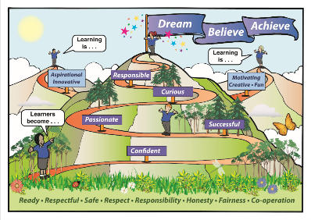Callander Primary Home Learning Leaflet

If your child is well but unable to attend school because they are having to self-isolate for a longer period of time then please use the following to support their learning at home:

• Completion of the week’s homework tasks set by your child’s class teacher (these can be accessed via their Seesaw or Google Classroom account)

• Completion of Home Learning activities which can be accessed via your child’s Google Classroom or Seesaw account.

• Interdisciplinary activities for example cooking, sewing, craft, outdoor activities etc.

If your child is well but unable to attend school because they or someone in your household are isolating and awaiting results from a Covid test (usually around 1-3 days) then please use the following to support their learning at home:

• Completion of the week’s homework tasks set by your child’s class teacher (these can be accessed via their Seesaw or Google Classroom account)

• Interdisciplinary activities for example cooking, sewing, craft, outdoor activities etc.

Online learning resources:

As well as accessing the class work set for your child by your child’s class teacher. Your child can also access the following activities online to further support their learning:

<https://spec.stirlingschools.net/primary-hub/primary-learners>

<https://www.bbc.co.uk/bitesize/primary>



Logging on issues?

If you or your child cannot log into your child’s Seesaw or Google Classroom account please contact Mrs Starkey or Mrs Harvey who will be able to assist:

[starkeyt50s@glow.sch.uk](mailto:starkeyt50s@glow.sch.uk)

or

[harveyc50s@glow.sch.uk](mailto:harveyc50s@glow.sch.uk)