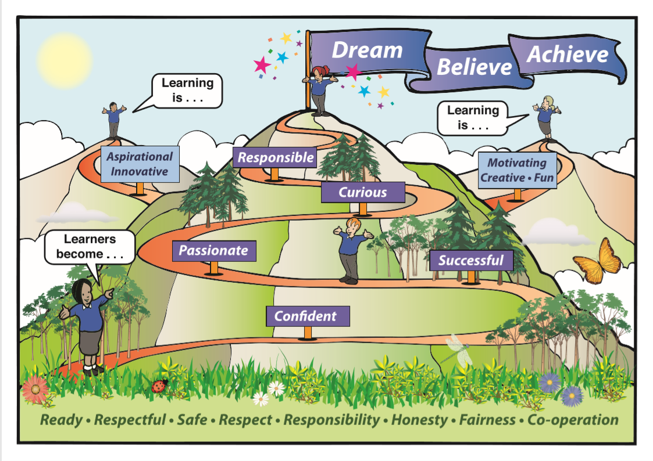

Callander Primary School
Returning to School in August 2020:
Advice and Guidance for Parents and Carers

Dear Parent Carers,
I hope that you and your family are well. I am now able to share the arrangements in place for the 2020-21 school session. Your child should know who their teacher(s) will be next session from the letter within the pack you have received in June, and school staff have created welcome videos for the children to watch on our Facebook page:
“Callander Primary Staff and Parent link.”
Staff will also be meeting to share pupil information ahead of the children’s return to school.
As stated by the Scottish Government, all children are to return to school in August on a full time basis from the week beginning the 10th August. For this first week we will have the following timetable:
Monday 10th and Tuesday 11th August - Staff Development Days
Wednesday 12th – P2-7 pupils return 9am. Primary 1 pupils starting at 9.30am. Please see below for specific information for Primary 1 children.
In order to keep everyone safe there will be new routines and procedures in place which are explained in more detail throughout this guide.
Unfortunately at this time parents and carers will only be able to come into the school building by appointment only. Please telephone the school office to arrange a suitable time. The only exception to this is parents of children attending our Autism Provision or if a parent has to come and collect a child due to illness.
If someone in your household is showing symptoms of coronavirus or self-isolating. Please contact the school at the earliest opportunity and follow NHS Inform guidelines.
If you are concerned that your child or a member of your household has been in contact with someone with Covid-19, please contact the school at the earliest opportunity and follow NHS Inform guidelines.
PLEASE DO NOT SEND YOUR CHILD TO SCHOOL IF THEY ARE DISPLAYING OR HAVE BEEN IN CONTACT WITH SOMEONE DISPLAYING THE FOLLOWING SYMPTOMS:
- Fever
- Continuous or new cough
- Loss of sense of taste or smell

If your child becomes unwell or displays these symptoms in school we will contact you to collect your child immediately. You MUST then contact NHS 111 for further guidance. Please do not send your child back into school until you have been told to do so by the NHS.

Operational arrangements
The arrangements outlined below are those currently in place and will be reviewed regularly. Any changes to these arrangements will be communicated to parents, carers and children in advance. However please be aware that a change may have to be implemented at very short notice. The full risk assessment is available on our school website.
Start and end of the school day
In order to ensure we maintain physical distancing as much as possible we have made changes to the key routine at the start and end of the day:
- We will be introducing specific drop off and collection points for children and parents to use.
These new routines will allow us not to have too many children coming into school through the same door at the same time.
The table below shows the drop of and pick up / collection points.
Class | Drop off/Collection location | Parent Waiting Area
P1 Mrs Dempster/Mrs Robb | Old Nursery garden | Old Nursery Garden
P1s of P1/2 Miss Parker/Miss Gardiner | Primary 1 ramp door | School Field/bottom of the stairs at Primary 1 ramp
P2’s of P1/2 Miss Parker/Miss Gardiner | Side ramp door | Gated area of playground
P2 Mrs Bell | Side ramp door | Gated area of playground
P3 Mrs Scott | Side ramp door | Gated area of playground
P3/4 Mr Titterington | Side ramp door | Non - gated area of playground
P4 Mrs Wallace | Side ramp door | Non gated area of playground
P5 Ms Muir | Dining hall door in back playground | Back playground next to pavillion
P5/6 Mrs McQue | Dining hall door in back playground | Back playground next to pavillion
P6 Mrs Peedle/Mrs Robb | Dining hall door nearest to kitchen in back playground | Back playground next to pavillion
P7 Miss Rennie | Main entrance of school | School field
Autism Provision | Main entrance of school | School hall
It is essential that children are brought to the correct drop off points to avoid overcrowding. It is essential that parents socially distance 2m from each other when waiting to drop off / collect their children.
The children’s teacher will collect / direct the children from and to the correct areas. The children do not need to line up at 9am. They should remain in their drop off area until collected by their teacher at 9am. A small number of families may be affected by two different drop off and collection points. We have worked hard to minimise this but apologise for any inconvenience this may cause.

There will also be a one - way system within school and the class teachers and school staff will practice this with the children on their return to school in August. Videos of the one- way system and the drop off and collection points will be uploaded to the school Facebook page for families to watch together before the children return to school. The link for these videos is below:
https://www.youtube.com/channel/UCL6KodPSlRWPP8U_dKkUM5Q

Arrangements for Primary 1 children for Wednesday 12th August
On Wednesday 12th August we would like to invite all new Primary 1 children and their parents to join us at 9.30am. This will allow the rest of the school to get settled and it will be less busy in the school grounds.
Unfortunately we cannot allow parents to come into the school building to drop their children off so instead we plan to hold a welcome activity on the school field from 9.30am so parents can bring their Primary 1 child to school, help them settle into the games, take a photo etc. and then leave the children in the care of their Primary 1 teacher. We hope that this is a welcome compromise and will give parents the same opportunities to help their child become familiar with their new school on this first day. Once the children have all arrived and settled the Primary 1 teachers will then lead the children into their P1 classrooms to enjoy the rest of their day.
If it is raining on Wednesday 12th then we will ask parents to drop their children off at the Primary 1 ramp and the children will be collected by their teachers from there to take part in some indoor welcome activities.
We would also kindly request that Primary 1 parents take a note of the menu choices for school lunch so we can order the correct choices for each child on arrival. The menu is attached to the bottom of this guide. Alternatively you may wish to provide your child with their own packed lunch.
Health and Safety
Children will not have to physically distance from other children in their class but they will still be required to remain physically distant from other classes and large groups. All adults in school must keep 2 m distance from the children unless administering first aid or offering comfort. In which case appropriate PPE is worn by staff.
There are facilities for hand sanitising at every entrance to the building and every classroom and enhanced cleaning materials and hand washing provision is also available in each classroom and toilet.
- Please support your child to learn how to wash and importantly, dry, their hands effectively. This should help protect hands.
- If you have concerns about increased handwashing causing your child’s skin to become sore, you may wish to supply a hand-wash or hand-cream for your child at the start of term. This must be clearly labelled with their name and will remain at your child’s table throughout the school day.
- Increased handwashing stations and protocols will be in place. This will include when a child enters/leaves a room or changes activity.
- There is currently no requirement for children or staff to wear face coverings except in cases where personal care is being undertaken (e.g. support with toileting). They may however do so if they wish.
- First aid and any required medication will continue to be administered. Staff will wear PPE at this time.
- There will be increased ventilation with door and windows open. Children should come to school with appropriate warm clothing.
Cleaning
- Increased cleaning activities will take place before, during and after the school day.
- We have protocols in place during the school day to regularly clean touch points and resources across the school.
- The school environment has been developed to ensure ease of more regular and deep cleaning.
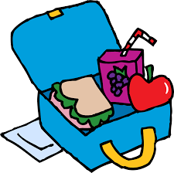 Play and lunch
Play areas will be zoned and staffed to support physical distancing between classes and break times will be split across the school. The table below shows how we will stagger playtimes and lunchtimes across the day. This will ensure children still have access to their usual amounts of playtime and lunch time whilst being able to keep within their class groups.
Class | Playtime | Area | Lunchtime | Area
P1 | 10.30am | Gated playground | 12.00pm | Gated playground
P1/2 | 10.30am | Gated playground | 12.00pm | Gated playground
P2 | 10.30am | Non - Gated playground | 12.00pm | Non - Gated playground
P3 | 10.30am | Back playground | 12.00pm | Back playground
P3/4 | 10.30am | Back playground | 12.00pm | Back playground
P4 | 10.55am | Gated playground | 12.00pm | Zoned field area
P5 | 10.55am | Gated playground | 12.15pm | Zoned field area
P5/6 | 10.55am | Non gated playground | 12.15pm | Gated playground
P6 | 10.55am | Back playground | 12.30pm | Gated playground
P7 | 10.55am | Back playground | 12.30pm | Non gated playground
Autism Provision | 10.30am | Gated area | 11.45am | Gated area
To ensure children have time to eat and time to play over the course of lunchtime, lunch for all classes will be taken within classrooms with school lunches delivered by our catering team. A new menu has been created by the catering team which will take the form of a “grab bag” style packed lunch. The menu is at the bottom of this guide. Alternatively children may bring their own packed lunch to school each day.
Classes will be cleaned following lunch. Universal free school meals will continue to be delivered for all P1-3 pupils. Packed lunches from home must be brought into school in either a throw away bag or in a plastic box that can be wiped down. Pupils should bring these with them in the morning and store at their table in class.
Home lunches are not currently recommended in line with guidance on minimising the number of journeys between different settings.

Healthy Drinks and Snacks
We actively encourage children to drink water throughout the school day. A drinking bottle needs to be plastic and very clearly marked with their name. This is to allow it to be wiped down on arrival and before departure. The children’s water bottles will be kept at their table in class. Children may like to bring a snack to eat at break. We would encourage healthy snacks. The water fountain will not be accessible at this current time.

Uniform
Uniform gives a sense of identity and belonging in line with our school ethos and values. In line with current COVID guidance clothing worn to school should be easily washed and children to wear clean clothes to school each day. We also wish to minimise changing clothes while at school on return to school we recommend the following uniform modifications:
- Polo shirt and sweatshirt as normal
- Comfortable trousers or shorts (suitable for outdoor learning and outdoor PE sessions e.g. tracksuit bottoms, leggings)
- Comfortable shoes suitable for outdoor learning and outdoor PE sessions.
- Waterproof jacket / coat suitable for outdoor learning.
- We ask that long hair is tied back.
We will not be asking pupils to change into indoor shoes during this different approach or get changed for P.E..
Due to the increased ventilation, with windows and doors being open, we ask that children do come to school appropriately dressed.
Jackets and home packed lunches will remain with children at their place in their classroom. We are asking children not to bring school bags into school during this time. This also includes toys. If your child requires the support of a transitional object (eg. a teddy), please contact a member of the Senior Management Team to discuss an alternative arrangement (such as a photograph).

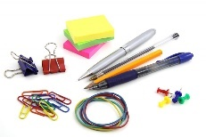 Learning and Teaching, Classroom organisation and stationery
One of the first aims of next session is to reconnect with our staff, children and families. We are looking at this using the 3 R’s – Re - imagine, Re - design and Re-grow. There are a number of priorities this session and our School Improvement Plan has been adapted appropriately to reflect the challenges we may face in the coming year.
Each child will have their own special seat and table within their class. Each child will also be given an individual supply of all stationery required all neatly packaged up for them in individual packs. This packs will remain in school. Pencil cases and other stationary will not be required, and these should remain at home.
If school resources are sent home e.g. reading books these will need to be quarantined for 72 hours on their return to school. This means there may be a slightly slower turnaround of reading materials etc. than in the past.

Parental Communications and Emergency contact details
It is essential, as always, that we have the most update to parent/carer contact details for the children. If your telephone number or address has changed please ensure you let us know immediately.
To support physical distancing and communicate as efficiently as possible we will continue to share key information and updates via our school and nursery Facebook pages, our school app and via email.
During this time parents/carers will only be able to visit the school office by appointment only. If you wish to arrange an appointment or would like to speak to a member of staff then please phone 01877 331576 or email starkeyt20s@glow.sch.uk.
Blended learning
The Scottish Government has asked schools to develop plans for blended learning. If at any point this model has to be put in place due to an outbreak of COVID-19 then parents/carers should refer to the following guidance:
The approach to learning taking place part time in school and part time at home is termed ‘blended learning’. At Callander we are working on our model in collaboration with colleagues across the McLaren Learning Community. The model will maximise learning and teaching in class to equip children with the skills they need to work from home. As we welcome learners back to school in August we will be focusing on literacy, numeracy and health and wellbeing. The learning at home aspect of blended learning will involve a range of approaches including digital and online learning and experiential learning opportunities. Learners will be consolidating and expanding on what they have learned in school. We plan to use the Google Classroom and Seesaw platforms to ensure consistency and clear communication about learning between home and school.
If pupils had to attend school on a part time basis we would be using the 50% model. This model involves 50% of children attending for part of the week. In practical terms each class has been split into two groups - Group A and Group B. The groups will attend school on a two - week rotational timetable.
During a Week 1 timetable Group A will attend all day Monday, Tuesday, and Wednesday morning whilst group B will attend all day Thursday and Friday.

During a Week 2 timetable Group A will attend all day Monday and Tuesday whilst Group B will attend Wednesday morning, all day Thursday and Friday.

Within the pack you received in June you have a separate letter confirming which group your child /children have been allocated.
The content of this guide was written in collaboration with all Head teachers in the McLaren Learning Community and is in line with local and national guidance as of 30.7.2020. If changes are necessary a new guide will be issued with changes highlighted in red.
As always, we will continue to be guided by Scottish Government and Health guidance. All of the arrangements in place are subject to change and I will be in contact should changes be required.
Kind Regards

Tanya Starkey

TRAYS | MONDAY | TUESDAY | WEDNESDAY | THURSDAY | FRIDAY
Week 1 | Choice of Cheese, Ham or Tuna Sandwich  Fruit  or  Yogurt | Cheese and Onion Pastry Roll  Chocolate & Mandarin sponge cake  or  fruit | Beef burger Roll  Or  Vegetarian burger roll  Fruit  or  Yogurt | Choice of Cheese, Ham or Tuna Wrap  Berry Flapjack  or  fruit | Choice of Cheese, Ham orTuna Sandwich  Fruit  or  Yogurt
Week 2 | Choice of Cheese, Chicken, or Tuna Sandwich  Pear and Ginger Sponge cake  or  Fruit | Choice of Cheese, Ham or Tuna Wrap  Fruit  or  Yogurt | Cheese and Tomato Pizza  Oattie Biscuit  or  Fruit | Choice of Cheese, Ham or Tuna Roll  Fruit  or  Yogurt | Choice of Cheese, Ham or Tuna Sandwich  Cupcake  or  Fruit
Week 3 | Choice of Cheese or Tuna Roll  Fruit  or  Yogurt | Chicken Burger  Vegetarian Burger available  Carrot cake  or  Fruit | Choice of Cheese, Chicken ,or Tuna roll  Fruit  or  Yogurt | Choice of Cheese, Ham or Tuna Sandwich  Jelly and Ice Cream  Or  Fruit | Choice of Cheese, Ham or Tuna Wrap  Fruit  or  Yogurt

Week 1, 2 & 3 AUG 2020 Primary Menu
All pack lunches to be provided with a 4oz fruit /salad pot and a small carton of milk.
The fruit/salad pot will include eg chopped apple / cucumber sticks, chopped pear / carrot sticks, mandarins / celery sticks

