Reading Activities
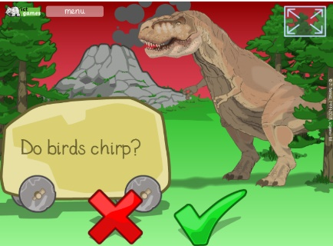
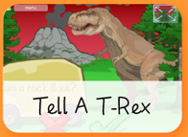
1. A range of reading tasks with a range of difficulties can be found on www.ictgames.co.uk
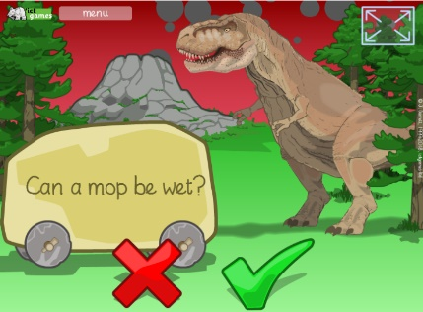
www.ictgames.co.uk/literacy.html
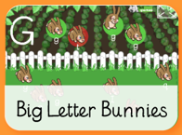
2. Identifying capital letters from lowercase letters
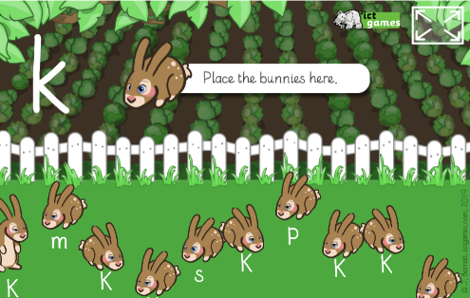

http://www.ictgames.co.uk/literacy.html

2. Play rhyming games
Say ‘into the pot goes’ while pretending to place objects/ drawings that rhyme into a pot (for example, a bat, a hat, a cat, a mat). Do this with your child and then see if they can do it independently.
You can turn this into a game by throwing in words that don’t rhyme, and asking your child to catch these ones out. For example, a cat, a hat, a bird – this last word shouldn’t go in the pot!

3. Play phonics word games
Play simple phonics word games based on the sounds your child is learning and has learned at school.
Start off using just the speech sounds and then immediately say the word. For example, you could say, ‘At the shop I will buy a /m/ /a/ /p/ – map, a /b/ /e/ /d/ – bed, a /d/ /u/ /ck/ – duck.’ Then, trying just saying the sounds and asking your child to work out and say the whole word.

4. Sound it out
If your child gets stuck on a word, try phonics first. Get your child to say the letter sounds (e.g. ‘c’ ‘l’ ‘a’ ‘p’) and then blend them together to hear the whole word (clap); this is called blending. If they are really stuck then it’s best to tell them the word and move on. If the book is at the right level then this should not happen too much.

5. Get them involved!
When you’re reading with your child, try to keep them actively involved in the words and the story. Clap out syllables or chunks in words and names to help with reading longer words: pel-i-can! Sep-tem-ber! Or point out that some words are made up of two words (for example, wind and then mill makes windmill).
You can have lots of fun with reading by making it an interactive experience. Encourage your child to join in with phrases, sound effects, and actions to make story time a shared experience. It’s great for bonding, and talking, acting, and re-telling will all help to develop your child’s reading.

6. Take turns to choose and read books. When it’s your turn model lots of expression, and maybe actions if appropriate. Sometimes make a mistake to see if they notice. They could help you correct yourself, and it’s a good chance to emphasis it’s ok to make mistakes as long as you do your best to put it right.

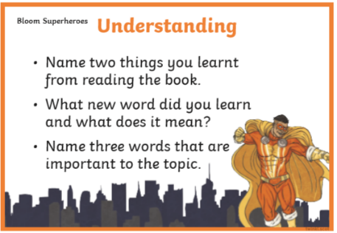
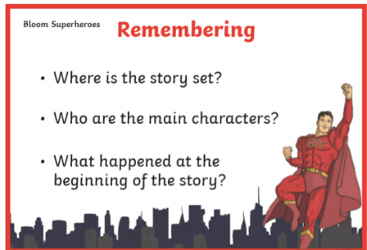
7. Asking questions whilst reading together can help to build your child’s interest and comprehensions skills. Perhaps ask your child to choose one or two questions from a selection before you read the text together. This can work well for fiction and non-fiction texts. You can find some good examples of guided reading questions on www.twinkl.com like these ‘Bloom Superhero’ questions. Don’t forget however that simple ‘what?’, ‘who?’ and ‘where?’ questions can be just as helpful in helping children to focus and draw information from the text.

8. Don’t be afraid to re-read
It’s tempting to think that your child should always be reading new books and changing their books as regularly as possible. While your child will benefit from reading widely, reading the same book more than once is important too.
As well as giving your child the opportunity to encounter the same words and phrases enough times to remember them, re-reading helps children to the think again about the ideas in the book. Maybe they will notice something they missed the first time? Having old favourites that you go back to again and again helps develop a love of reading.

9.
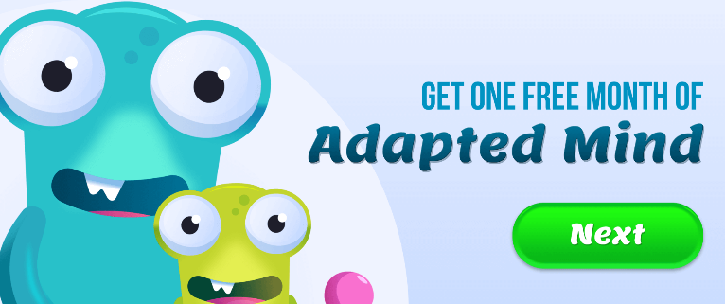

www.adaptedmind.com

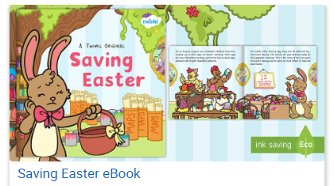
10. Ebooks can be quite motivating for young readers and www.twinkl.com have a nice selection. These colourful stories allow children to turn the page with realistic sounds that are fun, and provide ample opportunities for questions and discussion.

Spelling Activities
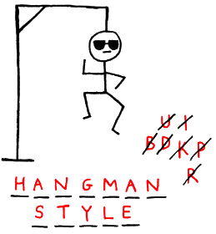
1. Play Hangman using the spelling patterns in your IEP.

2. On the www.ictgames.co.uk website you can read a word, then type it into the computer. It has a lowercase keyboard! There are a range of spelling difficulties available.
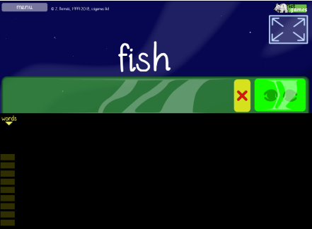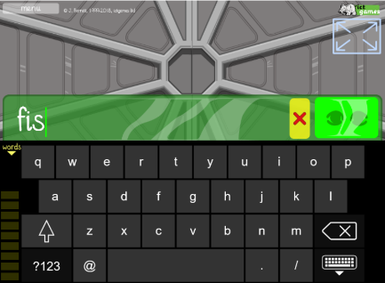
http://www.ictgames.co.uk/literacy.html

2. Write or ask an adult to scribe for your spellings in the following way:

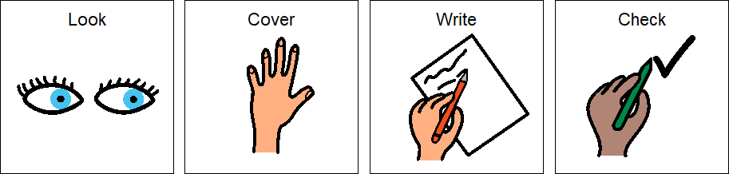

3. a. Play Bingo
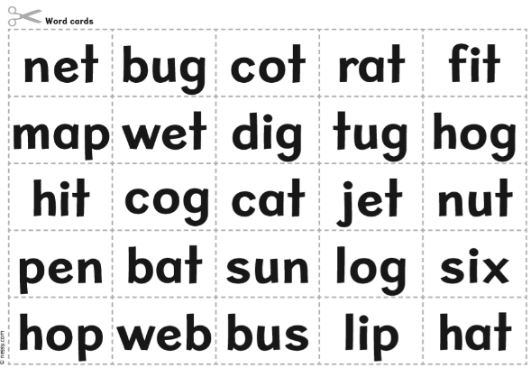
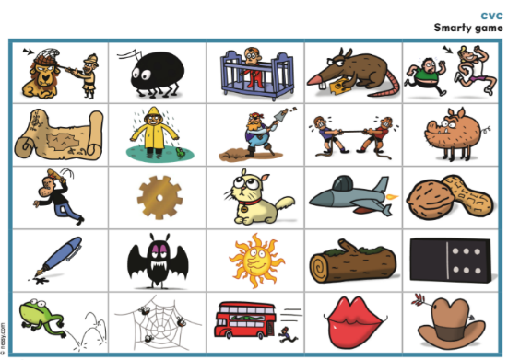
b. Cut out all the pictures, turn them over and play matching pairs.

We can email copies on request.

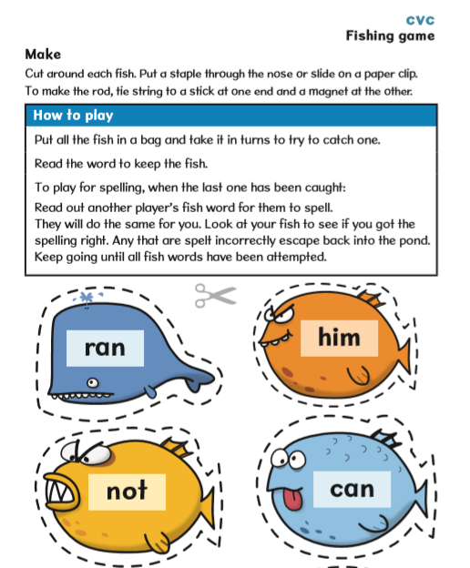

4. Draw your own fish and add your spelling words, or we can email copies on request.

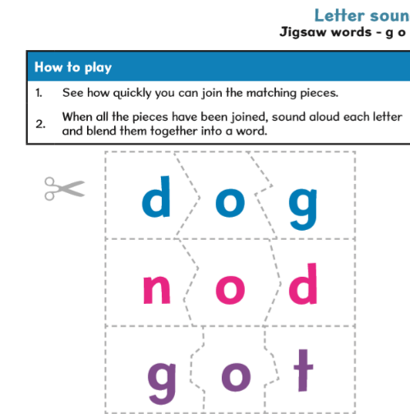

5. Make jigsaws with spelling words and then put them back together:

6. Hiding spelling words around the house can turn learning into a fun word hunt. Perhaps race with your child (or encourage a sibling) to collect as many words as possible in a given time. The second part of the challenge is to then read all the words you have found. Some children may not appreciate the competitive element of this. In this case they could get points for reading everyone’s cards, or simply find them all themselves.

Handwriting
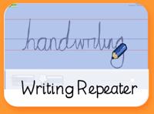
1. www.ictgames.co.uk has an online screen where you can model how to form letters. It will then play back the writing you have done, so you can see your work. We are working on all letters that start in the same place, and are formed clockwise:
c, o, a, d, g, q
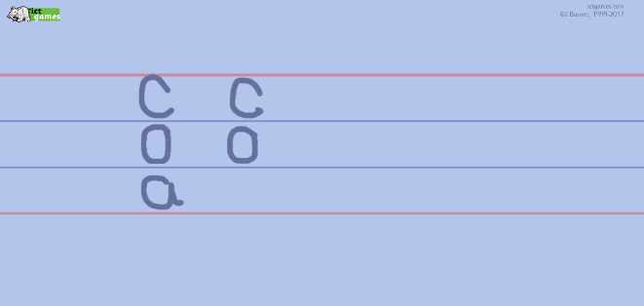
http://www.ictgames.co.uk/literacy.html

Sentences
1. Reading and ordering words on www.bbcbitesize.co.uk
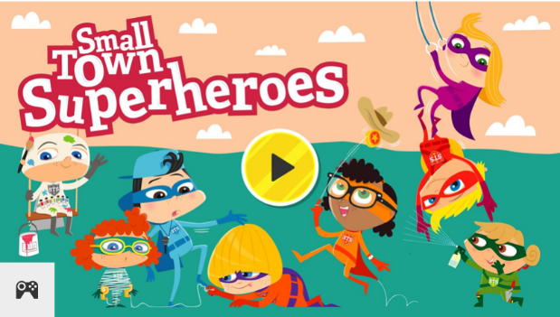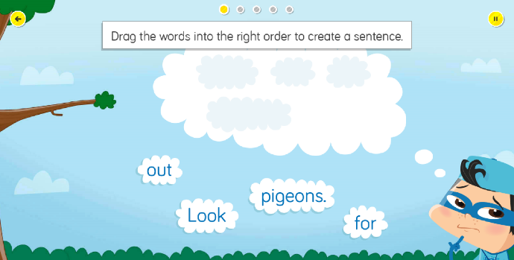
https://www.bbc.co.uk/bitesize/topics/zd63xyc/articles/zncgvk7
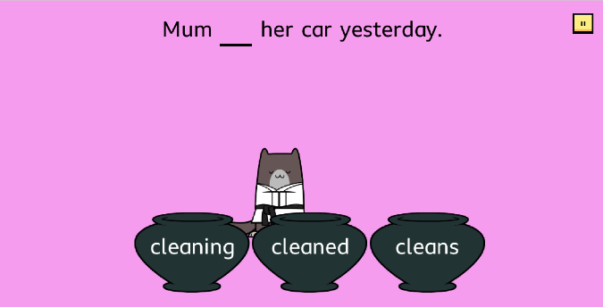
2. Karate Cats on www.bbcbitesize.co.uk

3. Re-ordering sentences
Read a simple book. Write short sentences for each page. Cut up the words. Let your child re-order them. Perhaps they could choose to illustrate one or more of the sentences making a simple book of their own.

4. Perhaps and your child could stretch a sentence together. All you need is some paper and pens, or a white board for this activity.
Begin with a very simple sentence such as
The dog barks.
If you write these words individually on slips of paper, you can then add to the sentence with new words, rather than rewriting the sentence each time.
Prompt your child, or take it in turns, to add a new word or phrase that relates to who, what doing, where and maybe why or when.
‘where?’
The dog barks outside the door.
‘when?’
The dog barks outside the door in the night.
‘why?’
The dog barks outside the door in the night to wake up her owners.
Alternatively, you can stretch a sentence by adding adjectives (describing words)
The hungry dog barks outside the old door in the stormy night.
It may be fun, and a bit more challenging also to play this as a memory game and just do it verbally. Remember just to go at your child’s pace, especially as they get used to the activity.

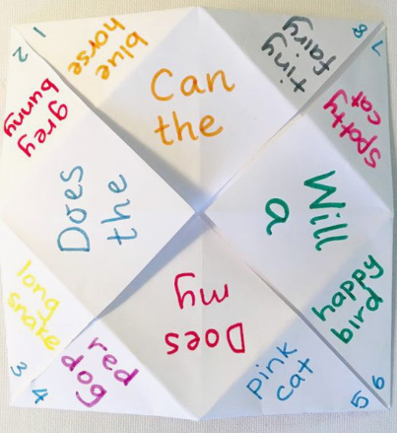
5. A fun way to explore sentence building together could be to make a traditional ‘cootie catcher’ with your child. If you can’t remember from your own childhood, YouTube has some short film demonstrations of how to fold your ‘cootie catcher. You could then have some fun choosing and adding ‘who’, ‘doing what’ and ‘where’ words to explore a variety of different sentences. Equipment required otherwise, is just paper and colourful pens.

Talking and Listening
1.A great way to get your child’s imagination going is to build stories together. Taking turns to tell a story helps children to listen and wait for their turn, whilst giving them time to think of ideas. Pictures and words on cards or slips of paper can help with ideas.
You can take turns to start a game if that is appropriate. Some children, however will find it much easier to take over if an adult has started already and a strong sentence to begin with is very helpful.
e.g. One day a young boy called Fred was walking in the woods. Suddenly he stopped and looked up. He couldn’t believe it, right above him was a gigantic…
At this point the next person takes over and adds their ideas. This may just be one sentence or a bit more depending on the child. Be ready to prompt and encourage with ideas.
You could always finish with an illustration from your story.

2. Play the Listening game
This is a lovely simple game that can be played inside or out and the results can vary more than you might think. Find a nice spot to sit together. The ‘rules’ are easy. The adult can begin by saying “I’m going to count to 20 in my head while you close your eyes and just listen – no talking. When the time’s up, you can tell me everything you heard while you were listening. Then we’ll swap and you’ll count while I listen”.
The point of the listening game isn’t to find out who hears the most. It’s really about taking time to pay attention to what’s happening around you. And then sharing it with each other.

Maths
Left, Right, In front of and behind.
- Draw around your hands or cut out paper hands. Drive a toy car or walk a small toy to your left or right hand.
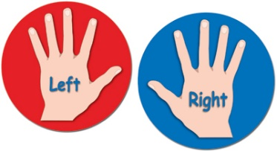
- Q: Where is the Lego man?
A: On the right.

- Play location games. Jump in front of the settee, hop behind the door, lie in the bed, stand on the right of the chair etc

Left, Right, up and down.
- Q: How can Steve get to the lion? A: Up 2 tins!
Q: How can Steve get to the crocodile? A: Up 2. 1 left.
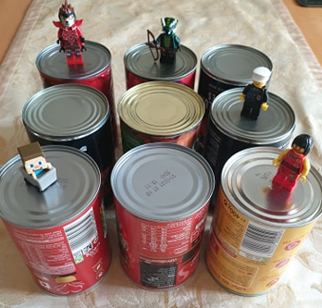

- If you have a tiled floor in your kitchen or bathroom you could repeat with different toys, or yourself if they are big enough. A chess board or draughts board could be used.
Left, Right, forwards, backwards.
- Repeat the above activities explaining these words can also be used.
Turning ¼, ½ and ¾ turns.
(You can call it 2/4 turns to begin with if that makes more sense!)
- Go on a hunt around your house. Look for things that turn. (Clocks, taps, door handles, bottle tops, dimmer light switch etc)
- You could mark North, East, South and West on paper on the floor and make a compass.
Play jump on North. Sit on South. Hop on West etc to learn the compass names. Simon says star jump on etc
- Stand in the middle of the compass.
Point to a direction. Always go clockwise to begin
Give instructions like this:
Point to South. Turn a ¼ turn. Where are you pointing now?
- Try different start points. Take turns to give and follow instructions.
Repeat the activity on different days using lego men, soft toys etc to reinforce the ideas.
- Play true or false. Move a lego toy, and say how much it has moved. Where you telling the truth?
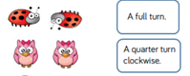
- Dance with Hip Hop Granny to learn left, right and turn words.
https://www.bbc.co.uk/sport/av/supermovers/42626760

- Clockwise and anti-clockwise
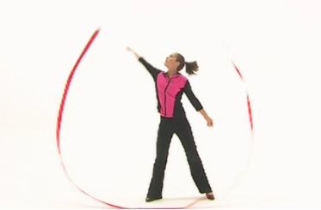
https://www.bbc.co.uk/bitesize/clips/zjyb9j6

Symmetry
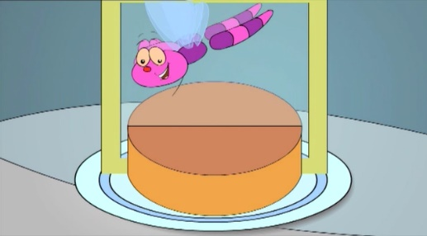
https://www.bbc.co.uk/bitesize/clips/ztpyr82
- Go on a symmetry walk around the house. Find things that are symmetrical. (Maybe a mixing bowl, vase, lamp, spoon, handle on cupboards etc)
- If you have a mirror put it on objects/ pictures to see if they are symmetrical or on your face to see what happens.
- Paint on paper. Fold the paper. See how it is the same on both sides.
- Draw half a picture ask your child to copy the other side.
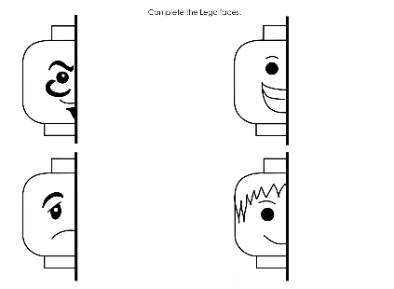

- Build something symmetrical with Lego together.
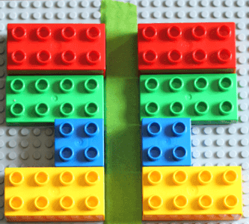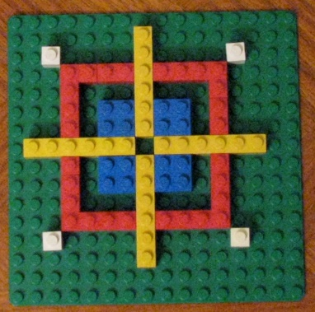

Measuring
- If you have a ruler go around the house looking for things that are longer or shorter than the ruler and make groups. If a ruler isn’t inspiring, try a toy! You model the ruler!

- Repeat looking for things that are longer, shorter or about the same as the ruler/ toy.

- Find some toys, furniture anything really! Count how long they are in Lego bricks, DVD boxes, DS game cartridges, sheets of toilet roll etc. (Use anything you have that’s the same length.) The doll is 13 Lego bricks, the book is 18 Lego bricks, the pencil is 2 and a bit Lego bricks….

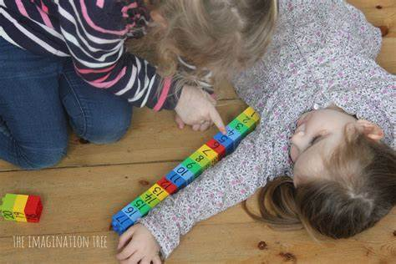

- Measure the same item with different things.
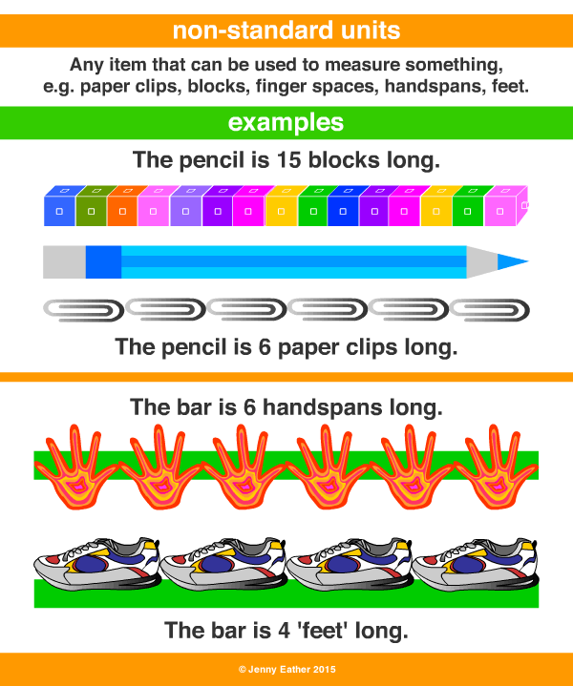

- Measure your family’s hands and feet in the same unit to compare sizes. Prove who has the biggest and smallest hands.

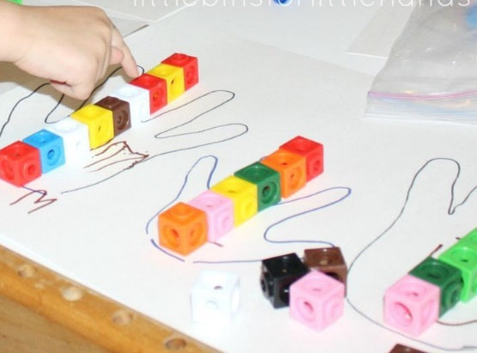

- Think about measuring everybody’s height, or a large toy. Choose a good thing to measure in. (It’s easier to measure a big thing with a bigger object like tins. This would take longer with Lego bricks)
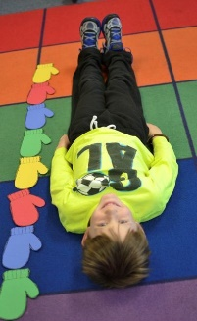

- If you have a ruler find some items that are whole cm long, so you don’t have to discuss mm to begin with! There are lots of worksheets online to print if you have a printer.

Number
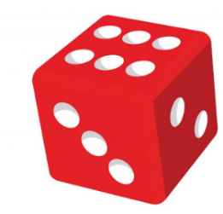
- Number bonds -The game ‘pig’ is great fun and very good for developing number bond retention. It’s very simple and only requires paper, pen and a dice.

- Choose a target number – 50 is good but you might want to start off with 30 just to practice the rules.
- The player 1 rolls the dice and rolls again adding the numbers together. At this point they can choose to keep rolling and adding on each number rolled as they go, or they can bank their score by writing on the score sheet.
- The winner is the first person to roll and add up to 30. Sounds easy for player 1, however, if you roll a 1 at any time you lose your whole score for that turn and score 0 on the score sheet!
- The player 2 takes a turn when either player 1 decides to bank their score or rolls and one and scores nothing!

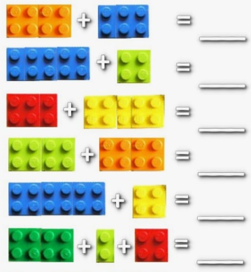
- Addition and subtraction – don’t forget good old Lego for very simple addition and subtraction.

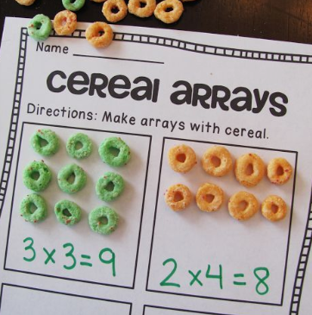
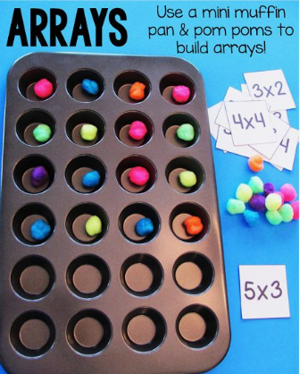
- Multiplication – Arrays are a pictorial representation to help children understand times tables. You can get creative and make them from all sorts of things around the home.
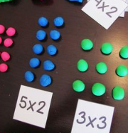
They can be especially helpful in pointing out the communicative nature of multiplication, so it is worth turning your array around and seeing how 2x4 (2 sets of 4), is the same as 4x2 (4 sets of 2).

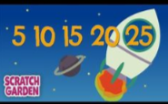
- Skip counting - Learning to skip count and having a good knowledge of multiples can help children immeasurably with multiplication and division later on. Scratch garden on YouTube has a large selection of educational songs including their ‘Counting in...’ series. It’s good fun and covers counting in 2,5, and 10s as well as many others.

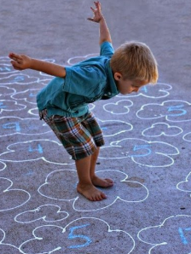
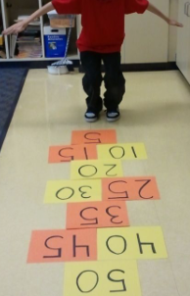
You can also make large number cards/shapes for the floor to encourage skip counting. Using the 5 times table, write the multiples of 5 to 50 and then ask your child to count out their steps e.g. what is 5 times 5? Standing on 0 to start they can then count out 1,2,3,4,5, landing on 25. This works well with chalk and an outside space as well.

‘

