Home Learning activities and ideas April 2020.

Firstly I hope you all enjoyed Easter. We have loved hearing and see how the pupils have got on through your posts on the Facebook page. Everyone looks like they have grown.
As we enter a new term at home we want to ensure you we are still very much thinking about our Callander AP community and are available to answer any questions and discuss learning or concerns.
We will begin to make calls to our families to check-in and discuss any individual learning or support that may be useful. Please remember to send updated contact info to daviesk20s@glow.sch.uk if you haven’t already done so.
Keep an eye on the Facebook page for information, videos, learning ideas and stories.

Take care and keep in touch,
Mrs Davies.

Literacy learning opportunities  Here are some literacy opportunities that you can support your child to engage in. They have been designed a chosen to embrace everyday play and experiences which can support the child’s understanding and learning in the broad area of literacy. This can encompass communication, interaction, joint- attention, reading, phonics, mark-making. | Communication  - Cooking  - Playing in the garden  - Playing with toys  - Chasing games  - Taking turns – toys, ipad, on play equipment  - Out for a walk  - Looking at pictures together  Plus many, many more everyday activities that your child enjoys engaging in. Play alongside your child, narrate the activity using simple key words and signs if you know them.  For example cooking: Key words could include – stir, pour, more, cook, oven, hot, cold, ingredient names.  Remember to give your child time to process if asking questions or giving instructions. If you can make the activity visual using real objects, pictures or drawings this can support their understanding of expectations and order of activities. | Letter recognition/Phonics  There are lots of fun and engaging ways to explore letters. We are focussing on the letter sounds rather than letter names at the moment as this enables pupils to gain pre-reading skills.  In school each day we watch, listen to and sing phonics songs. Then in our 1:1 learning session the pupils explore letter recognition and phonics with an adult. This can be printed letters, written letters, wooden or glitter letters – whatever it may be that engages the pupils. I have included some website with nice ideas to make it more fun and interactive. | Reading  - Share favourite stories snuggled on the couch, before bed, in a tent. Where ever takes your fancy.  - Listen to and watch stories on youtube, audible, bbc iplayer. Julia Donaldson’s animated stories are a firm favourite at school.  During reading, looking at books or pictures as your child simple  Who, what, where questions related to the story and easily accessible through pointing to the pictures. Pause, wait for answers and model the reply if your child doesn’t after some thinking time.  You can also create matching activities which enable children to demonstrate early reading skills. See pages below.
Mark-making and letter formation
- Scribble freely using lots of different writing materials: chalk, pens, paint, water on the slabs outside with a paintbrush.
- Trace over line patterns, shapes, letters – there are lots of creative ways to do this for example in sand or foam with your finger or stick.
- You can make the letters out of dough, let it dry and use them to explore the letter shapes.
- Draw together.
Encourage correct pencil grip whenever possible but don’t get too hung up on it. Enjoyment and engagement are more important initially.
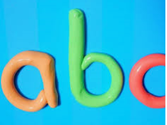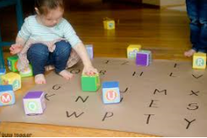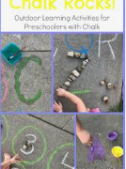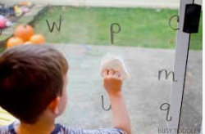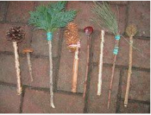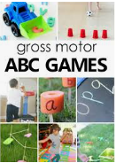

Numeracy learning opportunities  Here are some numeracy opportunities that you can support your child to engage in. Numeracy is very accessible through everyday interaction/experiences from counting amounts to money, measure and shape. Hopefully some of the ideas in the table will give you inspiration and understanding of how a seemingly everyday experience is your child employing their developing numeracy skills. | Number recognition  You can do this in a number of ways.  - Use the number grid from the previous pack to point to numbers and say them or cut them up and use as flash cards or to order.  - You could hide numbers around the room to find, name and order.  - Write numbers outside with chalk and erase with water as you find and correctly identify them.  Try not to be tempted to rush ahead and learn too many numbers. Quite often pupils can learn the names and order of numbers without having grasped what this means in a practical sense. I would suggest going no further than numbers to 30 for pupils in our class. Start with numbers 1-5, then 1-10, then 1-15, etc. You will find which numbers your child was working within in their latest IEP. I can send you a copy if you don’t have it | Counting amounts  This is a great activity to do alongside number recognition and is skill for life, learning and work.  Take advantage of everyday opportunities such as  - Cooking, dinner or snack time. How many do you want? How many do you have? You can have 2 etc  - Collect amounts of objects – stones in the garden, lego bricks, and favourite toys.  - Notice numbers and amounts while out and about – count cars, trees, family members, fingers and toes. | Shape & Colour  Can be fun to explore as one activity or separately.  - Go on a shape hunt – find real objects of certain shapes (street signs, wheels etc) or hide cut out shapes in a bag or around the garden to find and name.  - Similarly with colour – how many colours can you find and match in the garden for example.  - Can you match 2D shape to shape? Or match colour to colour.
Everyday learning opportunities
Watch your child play. Think about the opportunity there might be to model numerical language to them or the skill that they might be employing. Could you count with them, name the shapes found on their toys or ask them what colours they can see?

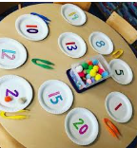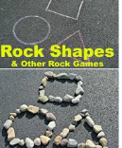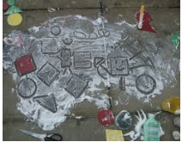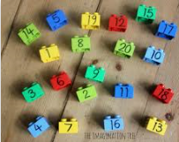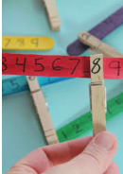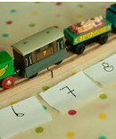

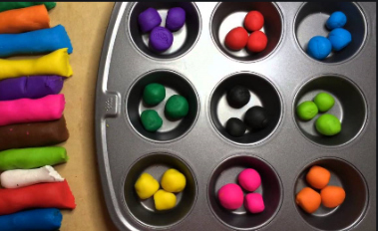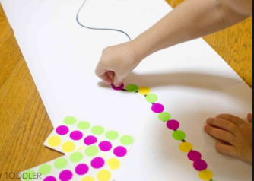  Pincer grip activities.  Encourages you to use thumb and fore finger to grasp and place. Endless ways of doing so and can be taken into maths, literacy and everyday life skills  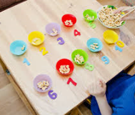 |  | 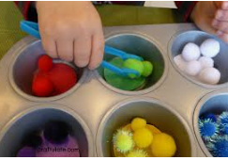  Tong transfer activities are good for concentration, hand strength and grip.  Again there are many ways of achieving this. Use kitchen tongs or large tweezers, pick a material that is achievably picked up in tongs and is fun, and select containers to transfer them between. Again this could incorporate numeracy and literacy by matching letter to letter or correct amount to number  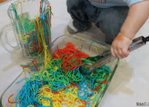 | 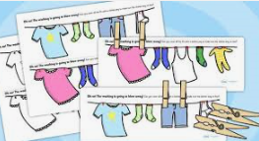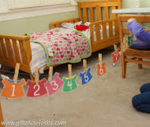  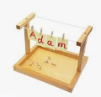  Peg/washing line activities.  This incorporates both using two hands to achieve the activity and pincer grip.  This first picture is a printable we use regularly in school.  The other pictures are fun ways to incorporate literacy and maths skills. No need for a printer – you can just draw or write them.  Bonus is you could get some help to get the washing out in the sunshine.
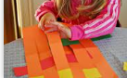  Paper weaving – encourages you to employ both hands to achieve the task. This is quite a tricky activity. | Fine motor activity ideas.  If you come up with any novel ideas that your child enjoys please do share on the facebook page. Any questions please ask.

Gross motor activity ideas.  Gross motor activities are great for calming or alerting pupils, readiness to focus on a task, regulating the sensory system and they give you the coordination, strength and muscle tone to attend to fine motor skills such as doing zips and buttons and using writing materials. We engage in gross motor activities every day at school.  What are gross motor skills?  Gross motor are physical skills which require whole body movement. These movements involve large muscles of the body which are used for core stability.  Why are gross motor skills important?  These muscles are important for everyday activities such as standing, walking, running, jumping, sitting etc. They also include hand-eye coordination skills which are important for activities such as throwing and catching, playing and swimming.  The development of gross motor skills enable children to perform every day functions as mentioned above which then allow other skills to develop. Without the development of gross motor skills it is more difficult to gain fine motor skills (drawing, cutting, and writing) which support children to engage in a number of self-help skills such as dressing, eating, and independence during play and learning.  Gross motor at home.  Think obstacle courses, den building, running, scooting.  Chasing games, copy me dance offs. Most importantly have fun and enjoy your time together. | 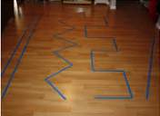  Walk and balance along the line trail. | 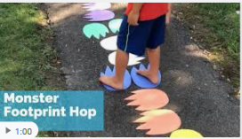  Jump the monster trail. | 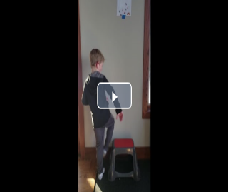  Jump or step up and down uses a range of muscles and gives feedback through the feet. | 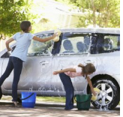  Get involved in household jobs to work those muscles.  - Car washing  - Sweeping  - Pushing pram or wheelbarrow  - Carrying appropriately weighted items  - Raking grass cuttings.
 | 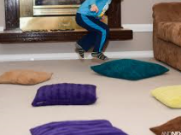  Jumping indoors where allowed, on the trampoline or on and off the garden steps etc. | 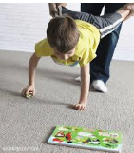  Wheel barrow walking games. | 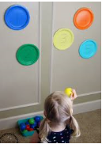  Throwing at a target or to each other.

Life-skill learning opportunities
In our current situation we aren’t always rushing out the door, we don’t have too many places we need to be or go. With this in mind, now could be the perfect time to develop more life-skills and independence.
Take time to:
- Dressing skills
- Eating and drinking independently
- Opening packets
- Asking for help and desired items
- Learning to follow and plan and stop activities
- Join your child at play
- Demonstrate skills to them
- Revisit daily skills and activities often
- Help them to develop their independence.

Below is a grid with areas of skills development to consider working on. The list is not exhaustive of all the skills your child can or will develop and nor is it mandatory to their success. It is there to highlight the different areas of life-skills that our children can be supported to explore and gain. When our pupils are supported to learn a skill through modelling and often physical support to engage the long term goal is to continue to support the child to a point in which they can undertake the task as independently as possible. Initially they will need a high level of support. Don’t be tempted to rush, take it at their pace and slowly work towards independence if and where possible.

Skills area | Why is the skill important? | What can you do? | Ideas and activities
Executive Functioning Skills | Executive functioning skills are those which we use to organise ourselves. They are the skills needed to plan for you day and while undertaking a task.  Executive functions skills are very complex and can be extremely difficult to develop. The following are some ways to begin to develop such skills. | - Use of visuals to plan day  - Developing ability to cope with timing and stopping activities when time us up  - Use of visuals to complete a task | Create a simple visual plan for the day using photos or symbols. Cover them, tick them or turn them over as you work through the day.  When playing a game or taking turns use a timer. Refer to the timer as it runs out and support your child to stop when it is finished.
Practical Living Skills | Any activity that supports daily living such as buying items, cooking, home care etc. Developing these skills promotes independent life-skills and are also a great way to engage in fine and gross motor activities. | One of the best ways to support your child to develop these skills is to involve them in everyday activities around the house. | - Preparing snack, lunch or dinner  - Washing the dishes  - Doing the sweeping or hoovering  - Play shops – exchange money for snacks at home
Personal Care | These are skills required to follow personal hygiene routines and can also encompass skills to promote good mental health such as following a sensory diet for calming and alerting. | Similarly to practical living skills by involving your child in preparing for and undertaking hygiene practices you can teach them how to independently complete such tasks. Not having to rush out the door could create time to practice dressing skills. By exploring which activities engage and or calm you child you can begin to create a ‘bank’ of activities to access when they feel overwhelmed and anxious or disengaged. | - Hand washing and tooth brushing every day.  - Breathing activities – model big slow breaths in and out to you child when calm, make a game of it and they may be able to copy.  - Squeezing, massage and deep pressure can be soothing and help to calm when feeling overwhelmed – not every individual will respond to this. You would need to explore what did and didn’t work for your child.  - Putting socks and shoes on and off.  - Being able to take off clothes then being able to put on clothes.  - Wiping your own nose or bottom.
Self-Advocacy | Is about children learning how to get their needs met effectively. They need to know how to ask, who to approach for help, and how to say no. | Give you child simple decision and choice to make throughout their day. This can be either with concrete objects or through use of visuals for example.  You can also model the language need to ask “help” “want bubbles”. | - Giving choice of foods, toys, activities etc. Either use the real object for example show you child two toys and ask them to choose which one or use visuals such as pictures or symbols for your child to make a choice.  - When playing or if your child is trying to get your attention/wants something model the language needed. Ask them do you need help? Or simply say help and then help them achieve whatever it is they need support with.  - Bubble play for example: blow the bubbles, pause, say more bubbles and blow again. Model ‘want bubbles’ and pause… allow time for your child to gesture or say they want more.
.

Websites to explore:
http://www.veryspecialmaths.co.uk/ - Les Staves specialises in math skills for pupils with additional support needs. This year Mrs Higginson and I were lucky enough to attend an information sharing session with Les himself. Les is a very inspirational practitioner and he has the ability to see the mathematical skills involved in everyday tasks that we all participate in.

https://do2learn.com/games/learningames.htm - has some fun songs and interactive games to explore life skills and safety.

https://www.learning4kids.net/list-of-sensory-play-ideas/ - lots of great fun sensory activities.

Search: ‘massage and deep pressure for kids’ on google for some excellent resources and explanations of how to undertake deep pressure and the benefits it can have to your child.

