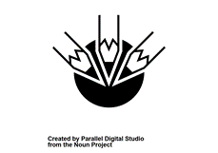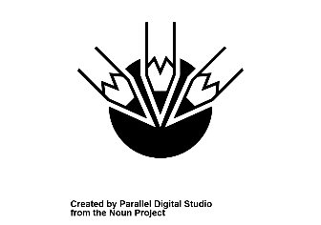 T

**This Is How We Teach Writing:**  TT

**During specific sessions, the Colourful Semantics, Read, Write, Inc, Weekly Handwriting lessons,**

**following may be used: Weekly Big Writing Lessons, Talk 4 Writing sessions, Weekly Spelling lessons, VCOP activities**

**Using the following Emergent writing/fine motor activities, ICT, rhyming activities, whole class, in strategies/resources groups and individual, Paired Writing, clear focus on Tools for Writing, Writing for**

**a Purpose, the use of Environmental Print, Modelling Writing, Scaffolding Writing,**

**the use of Word Banks/Pyramids/Planning pages, Clear Criteria Shared, a variety**

**genres (personal, functional, imaginative) Editing, Use of Mixed Media, Up -**

**levelling, Highlighting Key Concepts**

**This Is How We Assess Writing:**

* **Daily, ongoing informal observation.**
* **Through focused observation of VCOP criteria using appropriate highlighters for each area.**
* **Application of skills across all curricular areas.**
* **AiFL approaches – Peer/Self-assessment, 2 stars and a wish etc.**
* **Formal termly assessment using the Benchmarks and Roz Wilson Writing Criteria**
* **Formal assessment through Read, Write, Inc.**

**Daily, informal observations**

***Callander Primary School: A Framework for Writing***

A protocol as endorsed by staff in 2017 and reviewed in 2018 for establishing clear approaches to teaching and assessing Writing.

**Callander Primary School**



***Callander Primary School: A Framework for Writing***

A protocol as endorsed by staff in 2017 for establishing clear approaches to teaching and assessing Writing.

**Callander Primary School**



**We ensure that all learners are supported and challenged in Writing by ensuring:**

* **Differentiation of: groupings, appropriate resources, planning and questioning, expectations, criteria**
* **Regular and focused informal and formal assessment.**
* **Clear professional dialogue and action points determined through Impact Meetings.**
* **Support for Learning targeted support via: Fresh Start, ICT usage, Clicker 6, use of SLA.**
* **High expectations are shared at all times.**



**We promote Writing in our classrooms when timetabling allows by:**

* **Celebrating Success through Writing displays.**
* **Providing real contexts and writing for a purpose.**
* **Through play contexts and IDL contexts.**
* **Reading/modelling pieces of writing/stories with particular strengths.**
* **Providing quality writing materials and resources.**
* **Literate rich displays in classrooms.**
* **Consolidating VCOP skills through Soft Start activities/Daily challenges.**
* **Making links with Book/Author of the Month.**