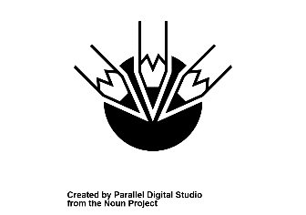 T

**This Is How We Teach Numeracy:**  TT

**During specific sessions, the Daily Number Talks, Numicon, Arrays, Rekenreks, Rigour Maths,**

**following strategies/resources Daily 10, TJ, Big Maths, Sumdog, Mindset Mathematics, You cubed, SHM**

**may be used: maths starters, Stages of Early Arithemitcal Learning, Base 10, number fans, 100 square big boards, interactive games**

**This Is How We Assess Numeracy:**

* **Daily, ongoing informal observation.**
* **Through focused observation of strategy based problem solving.**
* **Application of skills across all curricular areas.**
* **AiFL approaches – Peer/Self-assessment, 2 stars and a wish etc.**
* **Formal termly assessment using the Benchmarks, TJ and Twinkl assessments**
* **Holistic assessments of transferable skills in a variety of contexts**

**Daily, informal observations**

***Callander Primary School: A Framework for Numeracy***

A protocol as endorsed by staff in 2017 and reviewed in 2018 for establishing clear approaches to teaching and assessing Numeracy.

**Callander Primary School**



***Callander Primary School: A Framework for Numeracy***

A protocol as endorsed by staff in 2017 and reviewed in 2018 for establishing clear approaches to teaching and assessing Numeracy.

**Callander Primary School**



**We ensure that all learners are supported and challenged in Numeracy by ensuring:**

* **Differentiation of: groupings, appropriate resources, planning and questioning, expectations, criteria**
* **Regular and focused informal and formal assessment.**
* **Clear professional dialogue and action points determined through Impact Meetings.**
* **Support for Learning targeted support via: Plus One, Power of Two, use of SLA.**
* **The use of Numeracy Progressive Planners, Maths Hub, SNSA and Benchmarks.**



**We promote Numeracy in our classrooms when timetabling allows by:**

* **Interactive and changeable wall displays to reflect current contexts.**
* **Providing real contexts and the use of Numeracy to develop life skills.**
* **Through play contexts and IDL contexts.**
* **Providing quality numeracy materials and resources.**
* **Celebrating all aspects of Numeracy through a STEM focus week.**
* **Consolidating mental agility skills and sharing strategies through daily Number Talks and our YouTube channel.**
* **Family Learning workshops.**
* **Providing opportunites for learners to participate in cluster and LA events.**