CALLANDER PRIMARY SCHOOL AND NURSERY
SCHOOL IMPROVEMENT PLAN 2019-2020 Vision, Values and Aims
Callander Primary School and Nursery continues to be committed to providing the highest quality learning and teaching environment for all our learners. We have a clear focus on developing the skills of successful learning, confidence, responsibility and the ability to contribute effectively in a variety of settings. We firmly believe that the development of these skills is best achieved through effective partnership working. We are a community which aims to reflect and review practice in order to set an agenda of continuous improvement where effective learning and teaching are at the heart of everything we do.
As a learning community we have adopted the following motto:
Dream, Believe, Achieve
This encapsulates our desire for all learners to have a passion and enthusiasm for learning and an ability to challenge and drive their learning forward.
We have also adopted the following values:
Honesty Respect Co-operation Fairness Responsibility

and following consultation with the children this session we have also identified the following school rules:

Ready Respectful Safe

The motto, core values and rules have a high profile within the school and nursery community and underpin all that we do and explicitly link with the United Nations Convention on the Rights of the Child. We strive to be a vibrant learning community where continuous improvement is at the heart of teaching and learning, achievement and support for pupils. Our aims are linked to Stirling Council priorities and the National Priorities and Legislation for Education. The work we do will reflect Stirling Council’s Mission Statement “Improving Life through Learning”

Callander Primary School’s aims are:
To raise standards of attainment and achievement by
- Promoting the personal growth of children and adults so that all can achieve their full potential.
- Providing a happy, nurturing and safe environment where all are valued and respected.
- Promoting the important partnerships within the whole school community, and to develop the skills necessary for pupils to become active and responsible citizens.
- Equipping pupils with the skills and attitudes necessary to adapt in a changing society, by encouraging creativity, enterprise and ambition.

From the Improvement Plan 2018-2019 the following has been undertaken:
- The nursery has developed a language rich environment to including symbols and the use of Makaton.
- The use of Read, Write Inc. within P1-3 and Reflective Reading in P3-7 has continued with the introduction of parent / child workshops.
- The development of an approach to writing using Talk 4 Writing strategies including a whole school approach to handwriting and presentation has been introduced.
- The development of “Number Talk” with a focus on mental agility has been introduced.
- A robust whole school approach to developing learner conversations and learners identifying their next steps in learning has been introduced.
- Nursery planning, assessment and moderation has been improved by developing staff skills in using progressive pathways to plan coherent contexts and embedding learning intentions and success criteria
- The communication environment within the Autism Provision including the introduction of the Good Communication Standards has been developed including the introduction of Makaton.
- Progression pathways for a third language, Spanish, for second level have been developed for McLaren Learning Community.
- Moderation and assessment of numeracy and literacy through the development of valid and reliable evidence to determine achievement of a level at P1, 4 and 7 has been established.
- Two of the nurturing principles have been explored with teaching staff in led by two staff who have been trained as nurture ambassadors,
- Nursery parental engagement has increased by developing opportunities for health and wellbeing through healthy walks.
- Learners independence within the Autism Provision has been further developing through a life skills approach to learning.
- Approaches to monitoring children’s participation and engagement in all aspects of school life has been established.
- Strategies to support children’s levels of stress and anxiety through the introduction of Growth Mind-set alongside the “kitbag” approach have been introduced
- A whole school digital learning strategy has been developed.
- The school curriculum map to include a focus on food technologies has been further developed.
- Understanding of Autism within school including wider school and community engagement has been improved.
- Individual learning records based on milestones documentation have been introduced to the children in the Autism Provision
- Digital learning has been further developed through the introduction of coding from Primary 3 to Primary 7.

In carrying out all aspects of work, we:
- Conduct our business with integrity, impartiality, fairness, tolerance and mutual respect
- Encourage all stakeholders to embrace the school values.
- Value diversity, promoting social inclusion – in an environment where everyone is welcome
- Seek progress through partnership, working closely with people with whom we share a common purpose

Self Evaluation Used to Inform Planning

At Callander Primary School we recognise the importance of the evaluation and planning cycle and have clear procedures in place to support robust self-evaluation, leading to clearly defined improvement priorities. Our self-evaluation processes include:

- Quality assurance throughout the session.
- Evidence of pupils’ learning.
- Analysis of data – attendance, exclusions, teachers’ professional judgements, holistic assessments, standardised assessments.
- How Good is Our School 4 Quality Indicators used by staff for self-evaluation.
- School improvement consultation carried out with pupils, parents and staff.
- A full review of last year’s School Improvement Plan.

.School and Nursery Priorities
This session, 2019 / 2020, the school will focus on 3 strategic development priorities.

- Improvement Priority 1 - To improve the attainment of all pupils, especially in reading, writing and numeracy
- Improvement Priority 2 - To improve the skills of children; including Skills for Work.
- Improvement Priority 3 - To improve children’s health and well-being through early and effective intervention - through multi-agency partnerships; developing the Health and Well-being curriculum, and interventions to reflect Getting It Right For Every Child and the nurturing principles.

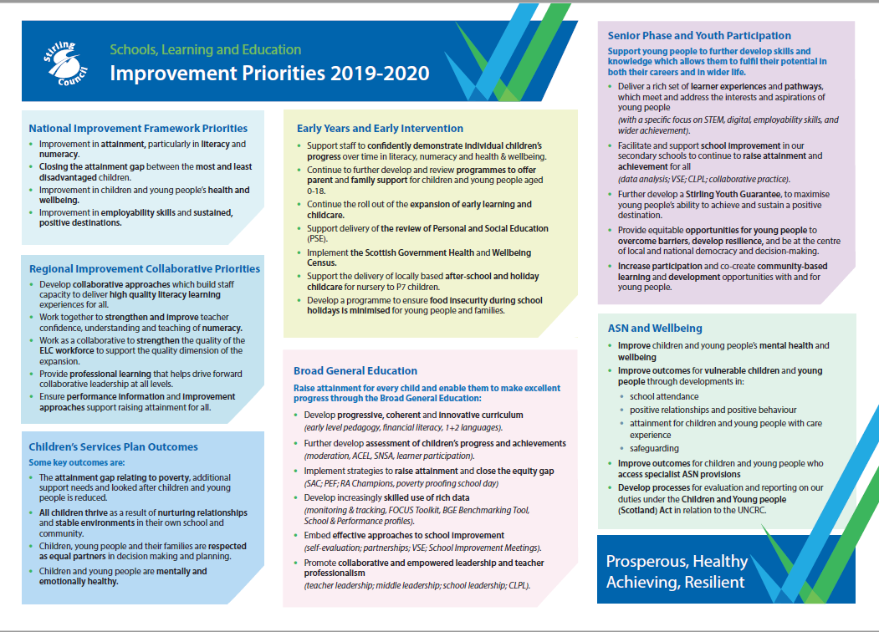

Improvement Planning Overview | Callander Primary School Improvement Plan

National Improvement Framework Priorities | HGIOS 4 & HGIOELC Quality Indicators
- Improvement in attainment, particularly in literacy and numeracy.  - Closing the attainment gap between the most and least disadvantaged children.  - Improvement in children and young people’s health and wellbeing.  - Improvement in employability skills and sustained, positive destinations.  Key drivers of improvement  - School leadership  - Teacher professionalism  - Parental engagement  - Assessment of children’s progress  - School improvement  - Performance information | 1.1 Self-evaluation for self-improvement  1.2 Leadership for learning  1.3 Leadership of change  1.4 Leadership and management of staff/ practitioners  1.5 Management of resources to promote equity  2.1 Safeguarding and child protection  2.2 Curriculum  2.3 Learning teaching and assessment  2.4 Personalised support  2.5 Family learning  2.6 Transitions  2.7 Partnerships  3.1 Improving/ ensuring wellbeing, equality and inclusion  Specific to HGIOS 4  3.2 Raising attainment and achievement  3.3 Increasing creativity and employability  Specific to HGIOELC  3.2 Securing children’s progress  3.3 Developing creativity and skills for life and learning

Improvement Priority | Outcomes for Learners | Impact Measurement | PEF
- To improve the attainment of all pupils especially in reading, writing and numeracy.  - Closing the attainment gap between the most and least disadvantaged children.  HGIOS 4/ HGIOS ELCC: 2.3, 2.4, 2.5, 3.2 | - Learners receive high quality learning and teaching in reading, writing and numeracy.  - All learners make very good progress from their prior levels of attainment in reading, writing and numeracy with a target of between 80 and 90% in reading and writing and numeracy at P1, 4 and 7.  - Nursery children will further develop their vocabulary and knowledge of language  - Learners within the Autism Provision will further develop their communication skills. | - Assessment information including professional judgement, standardised assessments and evidence of learning.  - Tracking & monitoring data.  - Analysis of qualitative and quantitative data to identify targeted children.  - Measurements of improvement specific to each targeted intervention.  - Quality assurance measures including effective planning, observation and moderation.
- Improvement in children and young people’s health and wellbeing.  HGIOS 4/ HGIOELCC: 2.6, 2.7, 3.1, | - Learners feel safe and included through our nurturing principles.  - Learners emotional and physical wellbeing needs are met enabling them to access learning.  - Families will have an increased understanding and knowledge of additional support needs.  - Learners will be given opportunities to access a range of extra-curricular activities and will have wider achievements recognised. | - Measurements of improvement specific to each targeted intervention.  - Views and feedback from pupils, parents and staff.  - Analysis of qualitative and quantitative data to identify targeted children.
- Improvement in employability skills and sustained, positive destinations.  HGIOS 4/ HGIOELCC: 2.2, 2.3, 3.3 | - Learners will experience enhanced learning and teaching opportunities through the use of digital and food technologies.  - Learners within the Autism Provision will develop key life skills and competencies.  Learners are developing an understanding of the link between skills and employability. | - Observations, learning conversations and pupil’s reflections on their skills development.  - High level feedback from our partners supporting food technologies

Improvement Planning Action Plan | Callander Primary School Improvement Plan

Improvement Priority
To improve the attainment of all pupils especially in reading, writing and numeracy.
Closing the attainment gap between the most and least disadvantaged children.
HGIOS 4/ HGIOS ELCC: 2.3, 2.4, 2.5, 3.2
Outcomes for Learners:
- Learners receive high quality learning and teaching in reading, writing and numeracy.
- All learners make very good progress from their prior levels of attainment in reading, writing and numeracy.
- Nursery children will further develop their vocabulary and knowledge of language.
- Learners within the Autism Provision will further develop their communication skills.
Key Actions | Priority Leader | Milestone Dates | PEF | Evaluation/ Analysis of Progress and Impact
To improve attainment in reading across the whole school by using practitioner enquiry methods to develop the following:  Reading:  Nursery:  - To develop the new nursery setting as a language rich environment to include Makaton.  - To develop staff confidence in planning motivating and enriching approaches to play and learning focusing on language, thinking, creativity and curiosity  School and Autism provision:  - Staff to work towards Gold Level Reading Schools Framework with support from Regional Improvement Collaborative to develop a comprehensive reading culture  - Read, Write Inc. and Reflective Reading further developed through the introduction of support staff and parent workshops  - Moderation approaches for reading using adapted criteria and Benchmarks.  Writing:  School , Autism provision and nursery:  To improve attainment in writing across the whole school by establishing a nursery and school approach which will include the following:  - Further development of an approach to writing using Talk 4 Writing strategies to support holistic assessments  - To embed a whole school approach to handwriting  - To develop whole school approach to spelling using “Wrap Around” spelling from P3-7.  Numeracy and Mathematics :  To improve attainment in numeracy across the whole school by using practitioner enquiry methods to develop the following:  School, Nursery and Autism Provision:  - A robust whole school approach to planning and teaching numeracy and maths focusing on fluidity of groups  - Staff confidence in using a variety of resources including Numicon to support effective teaching of numeracy.  - Staff confidence in assessing numeracy from nursery to Primary 7 by developing holistic assessments.  - A robust approach to “Number Talks” with a focus on mental agility across all classes.  - Staff confidence in P1 and 2 to develop conceptual understanding of maths with support from the Regional Improvement Collaborative.  Curriculum:  School, Autism Provision, Nursery:  To improve attainment in in all areas across the whole school to develop the following:  - a robust whole school approach to including learners in evaluating and identifying the school improvement priorities.  - A robust whole school approach to further developing learners understanding of their progress and their next steps in learning.  - To develop robust systems to analyse available data to raise attainment.  Nursery:  - To introduce approaches to moderation of learning within pre-birth to 3 and Early Level learning within the nursery.  - To introduce Family Learning Workshops focusing on Literacy and Numeracy.  Autism provision:  - To develop, review and implement planning formats and cycles which meet the individual needs of our learners and are reflective of the small steps and learning experiences our pupils engage in.  - Development of a range of evaluation strategies which contribute to improvement of teaching and learning practices across the provision.  Learning Community:  - To introduce progression pathways and relevant resources for a third language, Spanish, for second level. (McLaren Learning Community)  - To expand and build on moderation and assessment of numeracy and literacy through the development of valid and reliable evidence to determine achievement of a level at P1, 4 and 7.  - To introduce and implement a Learning Community approach to science. | Louise Heron (SECE)  Nicola Almass (SECE)  Sheena Muir (PT)  Anna Gardiner(CT)  Tanya Starkey (HT)  Sheena Muir (PT)  Louise Scott (PT)  Louise Scott (PT)  Allison Bell (CT) /Gemma Dempster (CT)  Clair Harvey (DHT)  Tanya Starkey (HT)  Marina Brunella (PECE)  Nicola Almass (SECE)  Kirsty Davies (PT)  Tanya Starkey (HT)  Hayley Cleland (HT Thornhill Primary) | By June 2020  BY June 2020  By December 2019  By December 2019  By December 2019  By December 2019  By December 2019  By December 2019  By October 2019  By June 2020  By November 2019  By January 2020  By December 2019  By October 2019  By November 2019  By November 2019
Future Plans
- To develop whole school approaches to developing parental engagement in literacy and numeracy.
Improvement Planning Action Plan | Callander Primary School Improvement Plan

Improvement Priority
To improve the health and wellbeing of all children through early and effective intervention, through close multi-agency partnerships and developing interventions to reflect Getting It Right For Every Child and the nurturing principles.
HGIOS 4/ HGIOELCC: 2.6, 2.7, 3.1,
- Learners feel safe and included through our nurturing principles.
- Learners emotional and physical wellbeing needs are met enabling them to access learning.
- Families will have an increased understanding and knowledge of additional support needs.
- Learners will be given opportunities to access a range of extra curricular activities and will have wider achievements recognised.
Key Actions | Priority Leader | Milestone Dates | PEF | Evaluation/ Analysis of Progress and Impact
School, Autism Provision and Nursery:  - To focus on 2 of the nurturing principles in collaboration with our school Nurture Ambassadors,  - To develop a whole school Positive Relationship Strategy.  - To develop a whole school approach to positive behaviour management including a launch of an alternative to Golden Time and a refreshed anti bullying strategy.  - To develop and improve Parent/Carer knowledge of additional support needs including nurturing approaches.  Autism Provision:  - To develop learners independence by further developing staff understanding of the SMARTS approach.  Nursery:  - To develop staff confidence in planning motivating, enriching approaches to play and learning focusing on relationships, connections and wellbeing  Learning Community  - To develop and implement an innovative approach to transition for Primary 7 learners moving on to McLaren High School | Pam Wallace (CT)  Clair Harvey (DHT)  Clair Harvey (DHT)  Pam Wallace (CT)  Kirsty Davies (PT)  Marina Brunella (PECE)  Andrew Clark (HT Doune PS)/Hayley Cleland (HT Thormhil and KIM PS) | By February 2019  By December 2019  By April 2020  By January 2020  By December 2019  By June 2020
Future Plans
- To focus on embedding nurturing principles across whole school.

Improvement Planning Action Plan | Callander Primary School Improvement Plan
Improvement Priority

To improve children’s skills including developing skills for employability.
Improvement in employability skills and sustained, positive destinations.

HGIOS 4/ HGIOELCC: 2.2, 2.3, 3.3
Outcomes for Learners:
- Learners will experience enhanced learning and teaching opportunities through the use of digital and food technologies.
- Learners within the Autism Provision will develop key life skills and competencies.
- Learners are developing an understanding of the link between skills and employability.
Key Actions | Priority Leader | Milestone Dates | PEF | Evaluation/ Analysis of Progress and Impact
School, Autism Provision and Nursery:  - To develop learner’s creativity and problem solving skills through the introduction of maker space opportunities as part of classroom contexts  - To develop computational thinking coding and robotics skills across the school  Autism Provision:  - To develop and embed partnership working within our school community and wider context which has a positive impact on the skills for life, learning and work of our pupils e.g. High schools, Active Stirling, Parents, Community links | Tanya Starkey (HT)  Lesley Rennie (CT)  Andrew Craven (CT)  Julia Gilbert (PT) | By October 2019  By June 2020  By January 2020
Future Plans
- To develop whole school approach to incorporating World of Work, digital learning and food technologies through learning contexts

