**School Improvement Planning Overview – Pupil Equity Fund**

**School: Braehead Primary**

**Session 2020 - 2021**

**PEF Allocation: £34, 069**

|  |
| --- |
| **National Improvement Framework Policy** |
| * **Closing the attainment gap between the most and least disadvantaged children** |
| **Contextual analysis (identify the gap and barriers to learning** |

|  |
| --- |
| Since the Covid 19 pandemic, children’s learning has been reliant on home engagement. We have identified many barriers to home learning including wifi, access to devices, increased use by all family members for work and learning, increased stress and anxiety and lack of parental confidence. During this time of uncertainty and change we are planning for recovery. We plan to build on our nurturing approaches and to develop our digital strategy to support our children and families.  Our school roll is projected to be 333 for next session, with 13 classes across P1-7.  From data gathered in session 2019-2020, 50% of children are in Quintile 2 this is based on 19% living within decile 3 and 32% within decile 4. 6% of our school population live in Quintile 1 as compared to 14.5 % across Stirling. 10 % of our children live in Quintile 5. 6% of children are registered for free meals as compared to Stirling level of 9.2%. Since the Covid 19 pandemic 1 family has requested to be registered for emergency free meals. Almost all these children are in deciles 2-4. Local intelligence suggests that some children would be entitled to free school meals but families are not claiming. This may be due to stigma or lack of understanding. There is a concern that many of our families would be classed as working poor and may not be aware of funding they may be entitled to. Since the Covid 19 pandemic, our HWB Officer has been supporting many of our families and there is a better understanding throughout the community of poverty with situational poverty becoming more prevalent. The community have set up a shop called “The Heart of Braehead” to support families at this challenging time. They also provide weekly shopping supplies to families in need who have been identified by the school, and are delivered by school staff every Friday.  At the end of February our attendance was 95% which is slightly below Stirling average of 95.1%. However this figure was calculated for a whole school year and not just up to February.Attendance has been stable over the last few years at around 95%.73% of the children whose attendance and late-coming is being monitored due to being below 90% have increased or maintained attendance so far this year. Analysis of attainment information demonstrates that there is an attainment gap relating to attendance of around 20% in reading, writing and numeracy for children whose attendance is below 90% in comparison to those whose attendance is higher. There is a gap of around 2% between average attendance rate and attendance of children who live in Quintile 1.  Although we are in line with national attainment trends, we identified a downward trend in reading and writing. For both Listening and Talking and numeracy, we are in line with national attainment trends but below Stirling attainment. In P4 and P7 we are on an upward trend whilst P1 remains the same. Our Raising Attainment Champion undertook a project to assess engagement with mathematics in his P7 class. 71% regularly accessed either the classroom or Sumdog. The remainder (2 pupils) accessed the learning infrequently i.e less that one engagement per week. 19% of accessed neither.  There is a small gap between attainment of children in all curricular areas who are registered for FSM as compared to children who are not. Improvement outcomes for pupils within SIMD 1-5 pertain to providing a consistently nurturing and secure environment. Across the School we have implemented a Universal approach to develop Nurturing principles. Alongside this staff and children were trained in the 5 point scale. |

These figures are based on engagement with the SeeSaw App from P1 to P6 and Google Classroom in P7.

**Home Learning during School Closure Term 4 2019 – 2020**

|  |  |  |  |  |  |  |  |  |  |  |  |  |  |
| --- | --- | --- | --- | --- | --- | --- | --- | --- | --- | --- | --- | --- | --- |
| **Classes** | **P1B** | **P1H** | **P2B** | **P2H** | **P3B** | **P3H** | **P4B** | **P4H** | **P5** | **P5/6** | **P6** | **P7B** | **P7H** |
| **Engagement** | **30%** | **33%** | **55%** | **70%** | **20%** | **69%** | **25%** | **48%** | **24%** | **67%** | **30%** | **54%** | **65%** |

Due to the Covid 19 pandemic from 23 March 2020, home learning has been the main method of engaging children in learning. Recognising the potential limits on the availability of digital technologies, we provided home learning opportunities on our website and through paper copies at our local supermarket.

**Achievement of Curriculum for Excellence Levels 2019 - 2020**

Due to Covid 19 our latest figures were recorded in February. I have re-submitted these predictions for Term 4.

|  |  |  |  |  |  |  |  |  |  |  |  |  |  |  |  |
| --- | --- | --- | --- | --- | --- | --- | --- | --- | --- | --- | --- | --- | --- | --- | --- |
| **Reading** | | | | **Writing** | | | | **Listening and Talking** | | | | **Numeracy** | | | |
| **P1** | **P4** | **P7** | **S3** | **P1** | **P4** | **P7** | **S3** | **P1** | **P4** | **P7** | **S3** | **P1** | **P4** | **P7** | **S3** |
| **E** | **1st** | **2nd** |  | **E** | **1st** | **2nd** |  | **E** | **1st** | **2nd** |  | **E** | **1st** | **2nd** |  |
| 83 | 85 | 84 |  | 81 | 91 | 75 |  | 85 | 84 | 77 |  | 85 | 85 | 80 |  |
| 85 | 84 | 84 |  | 85 | 84 | 75 |  | 88 | 89 | 77 |  | 85 | 88 | 80 |  |
| 85 | 84 | 84 |  | 85 | 84 | 75 |  | 88 | 89 | 77 |  | 85 | 88 | 80 |  |

**SIMD**

Our school has a broad catchment and the diversity is spread across all 10 deciles of SIMD. 6% of learners live in SIMD 1 and 2 and are challenged with aspects of poverty that influences prospective learning. Closing the attainment gap between the most and least disadvantaged children is our aim and part of the national Improvement Framework. 50% of the school population live in deciles 3 and 4 and this indicates that these families have potential barriers that could impact on attainment. 29% of families live in decile 7-10.

|  |  |  |  |  |  |  |  |  |  |  |
| --- | --- | --- | --- | --- | --- | --- | --- | --- | --- | --- |
| **SIMD at October 2019** | **Decile 1** | **Decile 2** | **Decile 3** | **Decile 4** | **Decile 5** | **Decile 6** | **Decile 7** | **Decile 8** | **Decile 9** | **Decile 10** |
| **% of pupils** | **2%** | **4%** | **19%** | **32%** | **2%** | **11%** | **1%** | **19%** | **7%** | **3%** |

**Attendance/Exclusions**

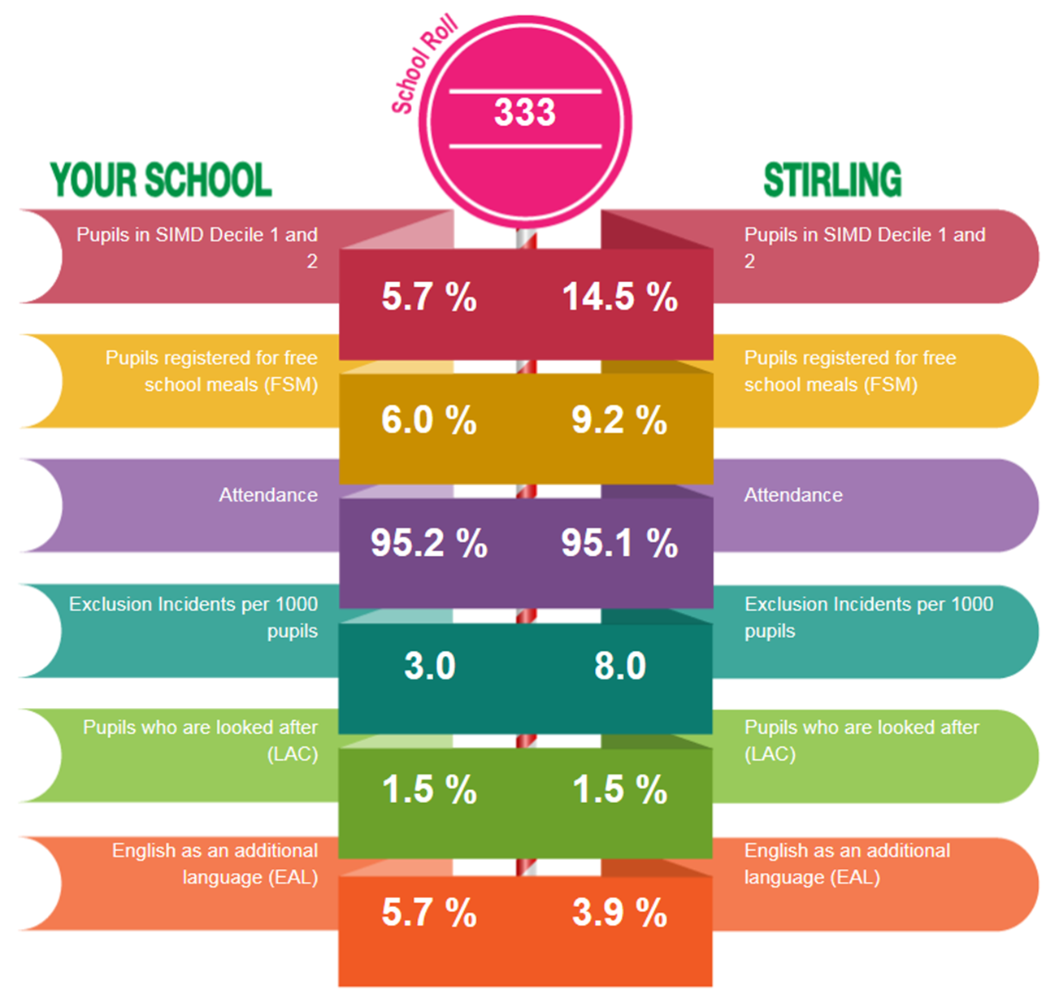

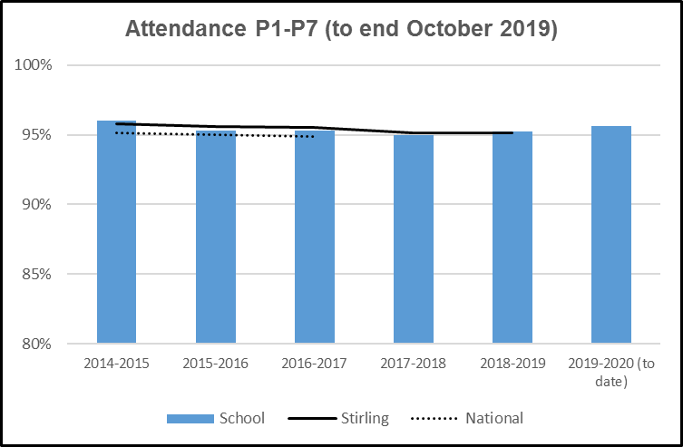

**Exclusions**

|  |  |  |
| --- | --- | --- |
| 2017-18 | 2018-19 | 2019-20 |
| 0 | 0 | 2 |

In Braehead PS attendance is consistently high and is equal to

Stirling Council average. Where there are specific attendance

concerns, we engage with the families to support and improve

attendance and late-coming.



|  |  |  |  |  |
| --- | --- | --- | --- | --- |
| **Identified gap/barrier** | **Outcome for Learners** | **Impact Measure** | **Intervention** | **Cost** |
| ***Linked to barriers identified through analysis of data and illustrated in contextual analysis.*** | ***What change do you want to see for learners? How much change? Who are the target group? By when?*** | ***How will you know the change is an improvement?*** | ***What do you plan to do?*** |  |
| Emotional regulation  In a survey conducted during the Covid 19 pandemic, 40% of parents surveyed did not feel confident supporting their child’s emotional wellbeing.  Children may suffer a lasting impact due to the effects of the pandemic. These may include parental relationship conflict, domestic abuse, alcohol or substance misuse and the mental health needs of parents.  Scottish Government | Children and their families are able to recognise and verbalise their emotions. | * Pre and post wellbeing survey * Increased emotional vocabulary through pre and post vocabulary assessment * Reduced number of behaviours caused by emotional irregularity. | * HWBO to develop with targeted families and children * Purchase Emotion Works * Whole staff training * Monthly review of progress * Analysis of data * Universal and targeted interventions planned through Braehead Young Workforce * Play Therapy with identified children * Talking Mats – Train the Trainer | £21,800 HWBO  £1250 Emotion Works  £5000 Play Therapy |
| Gaps in Numeracy  In a parental survey Only 40% of parents felt they knew ways of supporting their child with numeracy.  Our Raising Attainment Champion conducted a practitioner enquiry to measure the impact of child confidence in numeracy and parental engagement to support their child’s numeracy using Sumdog.  Out of a group of 9 with SIMD 1-3, 6 responded. All 6 felt more confident supporting their child’s home learning, recognising the value of the Sumdog App with children in engaging at least once a week. | 90% of P1 children will achieve Early Level numeracy  90% of P4 children will achieve First Level numeracy  85% of P7 children will achieve Second Level numeracy | * Base line assessment for all learners * Tracking and Monitoring meetings * QA of planning and practice * Focus Groups | * DHT support EY numeracy and developmental planning * Support blended learning through Sumdog to improve motivation and fluency * The Play and Learning Framework and new adapted numeracy planners will support engagement and progression. | £700 - Sumdog |
| Engagement in Learning  Our Raising Attainment Champion conducted a practitioner enquiry to measure the impact of child confidence in numeracy and parental engagement to support their child’s numeracy using Sumdog.  Out of a group of 9 with SIMD 1-3, 6 responded. All 6 felt more confident supporting their child’s home learning, recognising the value of the Sumdog App with children in engaging at least once a week. | All classes will show an increased level of engagement from home. | * Tracking and monitoring of home learning engagement * Analysis of Sumdog figures * Audit of parental opinion on blended learning * Pre and post audit of staff and parents digital skills and confidence * HWBO to track progress of identified families. | * To encourage all P4 to P7 children to engage with Sumdog for at least 30 minutes a week. * Teacher, peer and parental feedback will encourage improvement in learning and motivation to take part. * Provide motivating contexts through improved curriculum design * Improved digital skills of staff, parents and children to support blended learning and reduce barriers | £700 Sumdog  £21,800 HWBO  £4200 I-pads |
| Residential Entitlement  100% feedback from children and parents demonstrated the positive impact of the residential experience. | * All children are entitled to a residential experience. * P7 children will meet children from other schools who will be attending Bannockburn High which will support their transition | * Feedback from pupils * Feedback from staff * Feedback from parents | * Bannockburn Learning Community agreed to jointly reduce the cost of the P7 transitional residential experience. | £1000 |
|  |  |  |  | Total £33,950 £99 left |