

**P5M’s Braehead Primary Rainbow Races and Fit Fortnight Home Learning Grid**

|  |  |  |
| --- | --- | --- |
| See the source image**Literacy – Spelling**  Choose the level of **spelling words** with the rule ‘ous’ and ‘ious’ suited to your own level of challenge. Practise the words using LCWC and then write a sentence for each word. First think of the sentence in your head then up-level it to make it as interesting as you can.  You can also practise spelling words on [www.doorwayonline.org.uk/activities/speller](http://www.doorwayonline.org.uk/activities/speller)  There are a variety of word lists to choose from with a variety of spelling rules to work through. There is also a list of 1200 common words to practise. | **Literacy – Writing**See the source image  The Covid-19 crisis has changed all our ways of living. We are living through History right now. In the last grid we suggested that you could begin to make a **Time Capsule** to record how you and your family are feeling. Here are the last 3 tasks to complete it.   1. My Community – what am I doing to stay   connected with others.   1. Special Occasions – have you celebrated any special occasions during this Covid crisis? 2. Interview your parent/carer   You can use the sheets attached to help you.  **Write out your own instructions** for the  ‘How to grow a rainbow’ experiment using the Science experiment template attached. | Get caught Reading!! - Carlton Road Academy **Literacy – Reading**  **Letters from your teachers -**read what we have been doing to keep busy in ‘Lockdown’.  **Comprehension**: Read the ‘Daily News’ article and answer the questions. Choose which level you want to do – tricky or trickier?  **Keep reading!** Pick and choose from the many different free e-books in the ‘free e-book library’ on [www.oxfordowl.co.uk](http://www.oxfordowl.co.uk). Log in and access for free.  Any books you do read then please remember to record in your ‘First Minister’s Reading Challenge passport’ or if you don’t have that then a piece of paper will do so you can add it in at another time. |
| Literacy clipart literacy numeracy, Literacy literacy numeracy ...**Numeracy and Maths**  In addition to practising your times tables you should be linking these facts to **division**. Eg) if you know 2 x 6 = 12 and 6 x 2 = 12 then you should learn that 12 ÷2 = 6 and 12 ÷6=2  You can use the ‘Division wheels’ sheets attached to test yourself.  There are challenges set for you on ‘**Sumdog**’ too | Literacy clipart literacy numeracy, Literacy literacy numeracy ...**Numeracy and Maths**  **Adding and subtracting 9.**  What is the strategy you use to quickly add or subtract 9 to a number? One of the ways to add 9 is to add 10 then take 1 away.  Choose which level of challenge you want to do on the attached sheet and if you want to extend yourself then make up some of your own. You can use the 100 square to help you.  **3 and 4 digit column subtraction** -see the attached sheets to practise subtracting. Remember you ALWAYS take away from the digit on the top row. | Literacy clipart literacy numeracy, Literacy literacy numeracy ... **Numeracy and Maths**  **Fruit Kebab Problem Solving**  You have a selection of fruit- strawberries (s) , grapes(g), raspberries (r ) and pineapple (p).  You have to make fruit kebabs.  Each fruit kebab must have 4 pieces of fruit but they **don’t** need to be a different piece of fruit.  Eg) you could make s s g g or s g s g  How many different ways can you make a fruit kebab?  Try to solve this in a logical way so you do not repeat yourself. |
| Health and Wellbeing Month at Xiros - Xiros**HWB**  **Rainbow skewered fruit kebabs –** use the attached sheet to help you if needed or just make your own colourful Rainbow fruit kebab or fruit salad. Enjoy!  **Healthy eating rainbow task –** Using the attached sheet to help ,draw as many different fruits and vegetables as you can for each colour of the rainbow. (eg: red- strawberries, raspberries, tomatoes) Try to think of as many as you can. Ask an adult for ideas or if you can look up the internet to see if you can find any unusual ones you have not heard of before. | Using creativity in careers interviews | Ideas 4 Careers**Creativity**  **Grow your own rainbow** using the scientific process called the capillary action. Use the attached sheet to help you. |  |
| **HWB**Health and Wellbeing Month at Xiros - Xiros  Take part in our Health and Wellbeing challenges as part of our Fit Fortnight. Our challenges can be accessed by clicking on the link below  <https://tinyurl.com/Health-Challenge-Grid> | Using creativity in careers interviews | Ideas 4 Careers  **Creativity**    **Fit Fortnight**    Let’s get creative for fit fortnight!    Here are some challenges that could earn you some house points.    Could you…     * Create a house song or chant and perform it for your teacher. * Design a house poster or winning certificate for our rainbow races. * Create a team mascot. * Build your own obstacle course for your family. * Make your own medal. * Research the Olympics.     You could be creative by using recycling, pens, paint, or natural materials you find on your walks!    Each task you submit will earn you 1 house point.    Good luck! | **Outdoor / Active**4 Ways to Spend More Time Outside | SUCCESS  Rainbow Races  Take part in our rainbow races. Don’t forget to share your participation photos with your class teacher via our Seesaw and Google Classroom apps. The house with the most participation wins the house cup!  Click on the link below to access our activities.  <https://tinyurl.com/Braehead-Rainbow-Races> |

Remember that you can use Sumdog  and TTRS at anytime too.

**Spelling:**

**ous / ious**

The key to this spelling pattern is knowing when to include the ‘i’ and when to omit it. Sometimes it is sounded (as in ‘various’) but there are other important words where it is silent ( religious). Remember ‘i’ should ALWAYS be used between a c and ous.

|  |  |  |
| --- | --- | --- |
| ous / ious | ous / ious | ous / ious |
| famous  nervous  jealous  various  curious  furious | dangerous  enormous  generous  previous  serious  glorious  precious  anxious | glamourous  marvellous  disastrous  victorious  seriously  previously  suspicious  malicious |

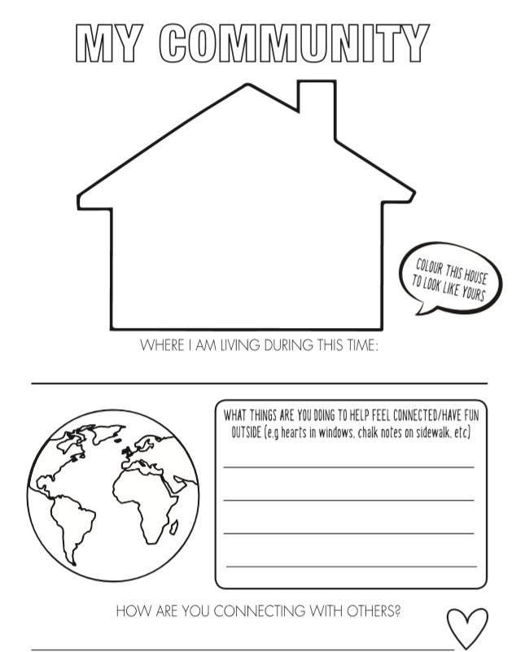 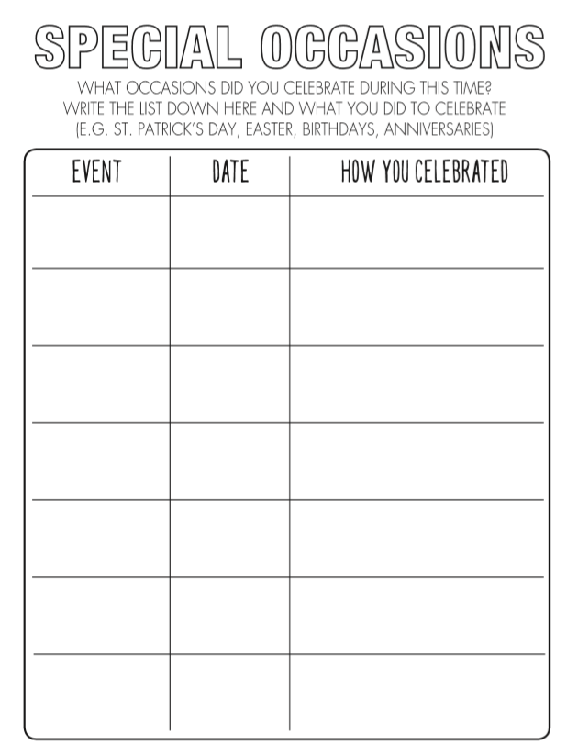

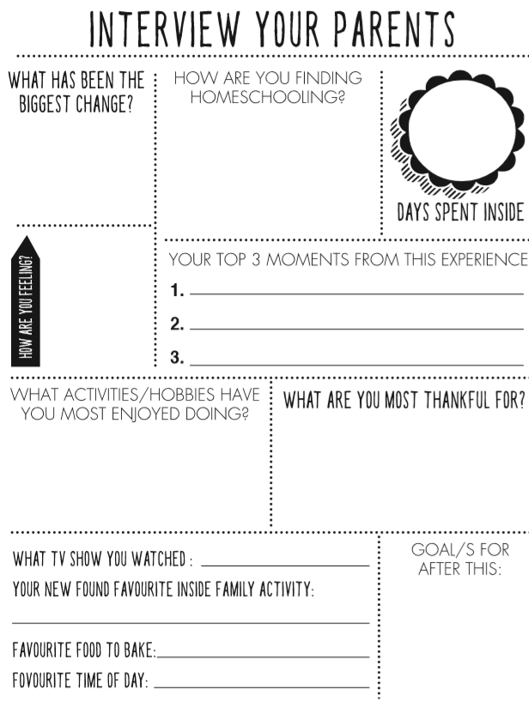 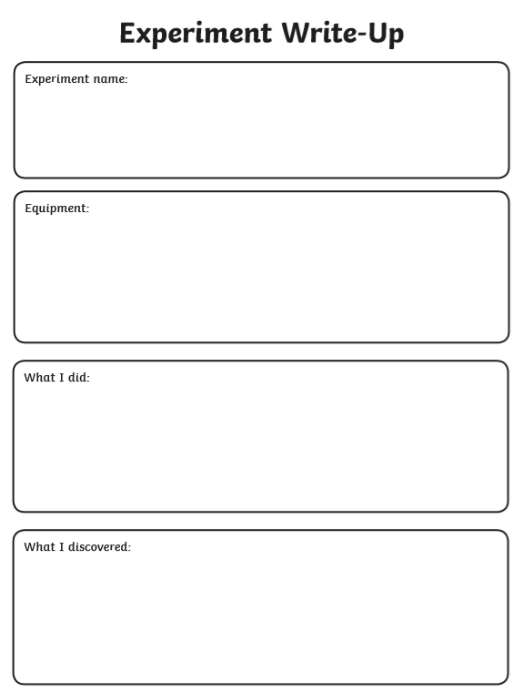

**Letters from your teachers** 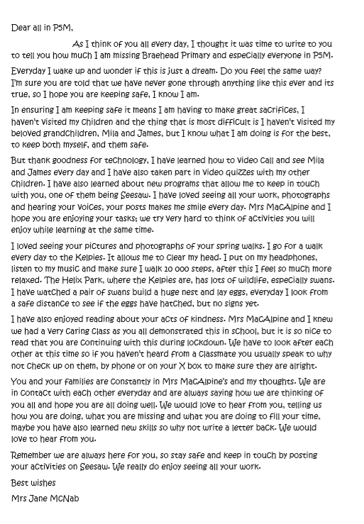

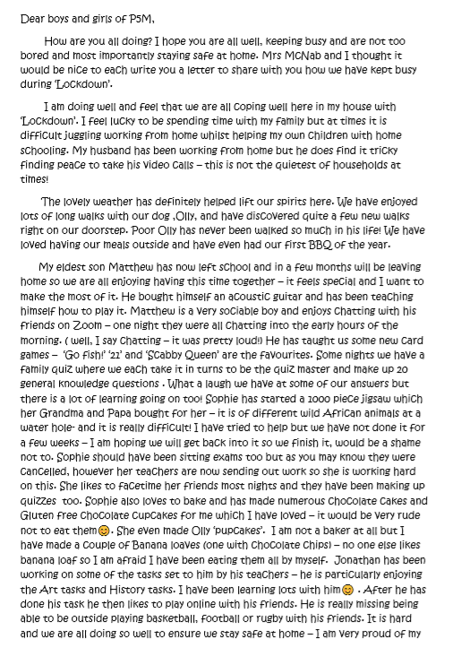 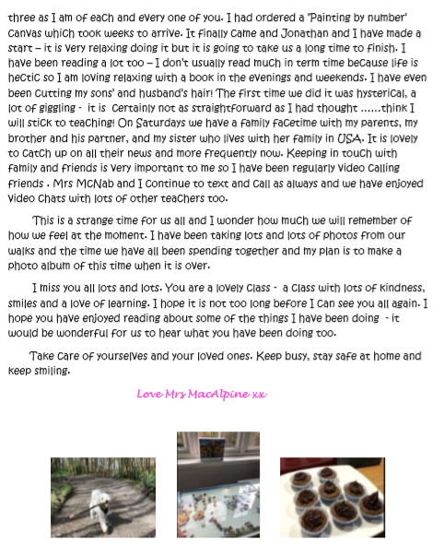

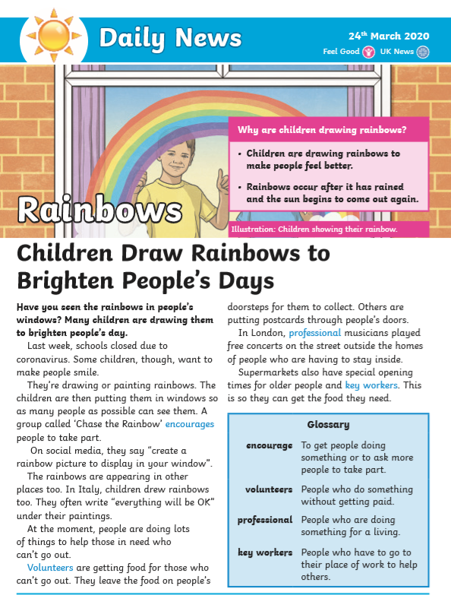 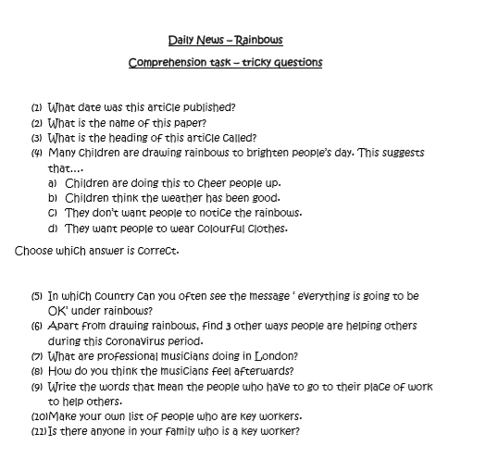

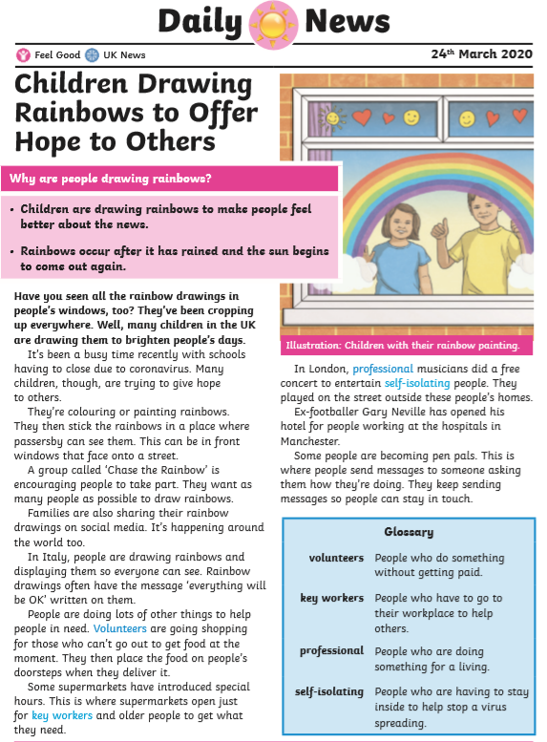 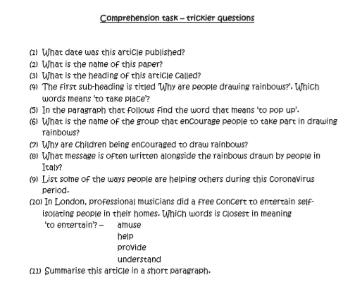

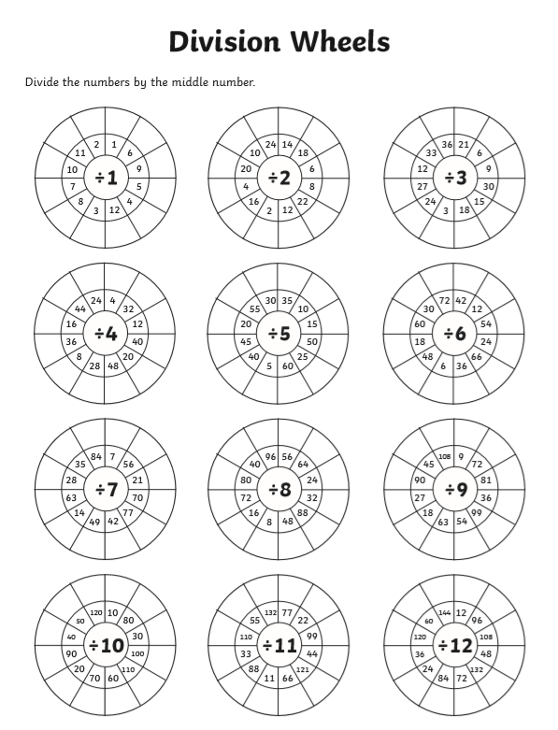 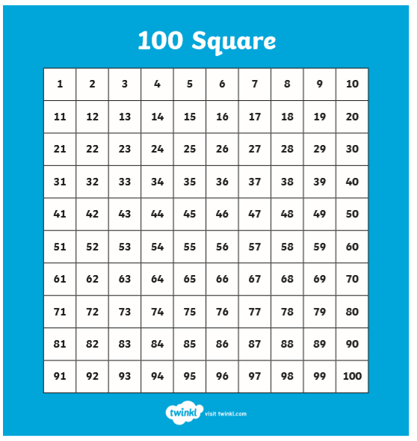

**Adding and Subtracting 9**

|  |  |  |
| --- | --- | --- |
| Add 9 to :   1. 4 2. 7 3. 5 4. 8 5. 6 6. 12 7. 18 8. 36 9. 49 10. 63   Subtract 9 from :   1. 85 2. 74 3. 92 4. 66 5. 51 6. 37 7. 28 8. 26 9. 22 | Add 9 to:   1. 64 2. 72 3. 85 4. 167 5. 328 6. 429 7. 855 8. 976 9. 827 10. 950   Subtract 9 from:   1. 73 2. 88 3. 94 4. 173 5. 286 6. 869 7. 948 8. 993 9. 1 653 | Add 9 to:   1. 684 2. 877 3. 984 4. 1 679 5. 3 248 6. 4 729 7. 8 515 8. 9 276 9. 8 027 10. 9 150   Subtract 9 from:   1. 7 380 2. 8 865 3. 9 422 4. 11 373 5. 28 465 6. 86 219 7. 94 228 8. 99 563 9. 164 751 |

