Tel: 01786 273555
E-mail: hendersonr@activestirling.org.uk
Date: 28/11/17

NEW ACTIVE KIDS CLASS – P1-3 Mini Ballers

Dear Sir/Madam,

We have a brand new opportunity for your child to take part in basketball!

This is a brilliant opportunity for anyone in Primary 1 – 3 to try out basketball for the very first time, introducing basketball skills and team games for boys & girls.

The sessions will be led by coaches from Active Stirling and structured to focus on skill development, as well as fun games. No matter what level your child is, we welcome anyone who is keen to learn.

P1-3 Mini Ballers
Venue | Day | Dates | Time | Cost | Age
The Peak | Monday | 8th Jan 2018 – 19th Mar 2018 (Exc. 12th Feb) | 5pm – 6pm | £40 | P1 – 3
Please see details below:
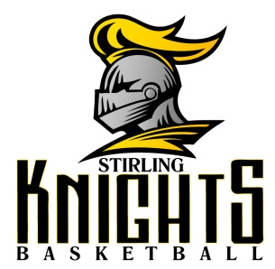
Working in partnership with Stirling Knights, these classes will help set your child up to be a Stirling Knights star of the future!
Fancy watching Basketball done at its very best in Scotland? Stirling Knights have a BRILLIANT opportunity to watch their Scottish Basketball Championship league game versus St Mirren on Friday 8th December, 7pm at The Peak, in Stirling. This is also the same night the club will launch their great partnership with Stirling: Alive with Scotland. Entry is completely FREE for all children and adults. A great evening out for all the family, and a perfect way to get your child excited about the Mini Ballers classes starting next year!
If you would like to book your child onto P1-3 Mini Ballers sessions, please contact our bookings team on 01786 448308. Payment will be made to our bookings team.
Please make sure your child wears appropriate sports kit and a drink of water for their Mini Ballers sessions.
Best Wishes,

Ruth Henderson
Ruth Henderson, Club Development Officer (Wallace Cluster)

