
Borestone Primary School
Newsletter

August / September 2016

2012

Dates for your diary:

September
2nd – Meet the teacher 2.45pm
13th – Roald Dahl 100th Birthday (see item in newsletter)
19th – Parent Council AGM 7pm
28th – Nursery Powerful Play 10.30-12.00/2.00-3.30

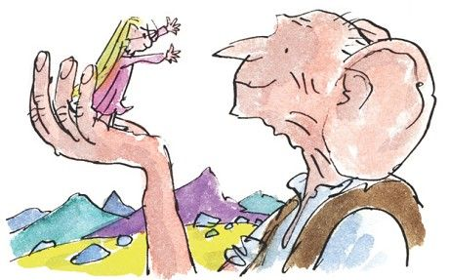





October
w/b 3rd – P6 Max in the Middle
7th – P6 Max in the Middle celebration (parents invited), am
7th – P_ class assembly (Harvest) & Celebrating Success 2.20pm
19th-21st – P7 to Dalguise
26th & 27th – School photos (individual and family groups)

Dear Parents and Carers

Welcome back, I hope you had a lovely summer break. Children are all looking so smart wearing their school uniform, we really appreciate your support with this. We’re all set for an exciting year of learning and look forward to sharing this with you.

We have several new members of staff in school and on Friday afternoon there’s the opportunity for you to come in to school, put faces to names and find out a bit about how learning will be organised in your child’s class. We look forward to seeing you then.

Alongside this newsletter, you’ll receive our school calendar for the year. Although there will be additions as the year goes on, it gives an overview of key events.

Nursery

Our nursery has undergone huge changes over the summer holidays and is looking great. The old nursery classroom and Caterpillar Room have been knocked combined into one larger space with a new family room, nursery office, cloakroom and new nursery toilets and purpose-built changing room. We also have a new decked area with ramp, a fire pit, and lots of other features in the garden. There’s an open evening planned on Tuesday 13th September from 3.30-5.30pm and anyone who wants to is welcome to come along for a look.

Just before the summer break we had a visit from the Care Inspectorate to check on our nursery provision. On this occasion, the inspection focused on the themes of transition and on how we meet the needs of children who require additional support. We are delighted that the commitment and dedication of our staff team to achieving high-quality learning experiences and outcomes for all our children has been recognised in a glowing report.

Gradings were:
- Quality of care and support – Excellent
- Quality of environment – Very Good
- Quality of staffing – Excellent
- Quality of management and leadership – Excellent

Some comments in the report were:
“excellent flexible ethos” around supporting children with additional support needs, in particular, through “effective and sensitive communication with parents that linked to individual children’s learning and development”
“rich opportunities for children to communicate”
“sensitive and responsive interaction with staff in a nurturing, adaptable setting”
“the service works in partnership with parents/carers and visiting professionals to develop a child centred learning plan that challenged and supported children to be happy, successful and achieve a high standard.”

Stirling Council Education Convenor Alistair Berrill said: “Once again we have good cause to be proud of one of our nurseries and our dedicated nursery staff. A fantastic result and I am delighted to be able to congratulate everybody concerned.”

You can access the full report on the Care Inspectorate website.

Staffing

We welcome several new staff this session and welcome back some familiar faces.

We are delighted to welcome back Mrs Susan Wynne to the nursery team and Mrs Duncanson to Primary one. Mrs Jaime Duncanson will now be working three days a week, this session alongside Mrs Young.

We welcome four new teachers to our team. Miss Elaine Thomson (P2) and Miss Rebecca Balfour (P7) join us for this session and Mrs Beattie(P3) joins us on permanent basis. Mrs Natalie Johnstone, also a permanent teacher will be teaching in some classes this session. Mrs Hazel Chohan joins our team of Support for Learning Assistants.

Since all teachers have some non-class contact time and some have additional responsibilities - PT time, nurture group time etc., no class has one teacher for the whole week. For your information, classes and teachers this session are as follows:

 | Key teacher(s)
P1 | Mrs Duncanson (Mon, Thurs from 10.30, Fri)  Mrs Young (Tues, Wed, Thurs to 10.30)
P2/1 | Miss McAnish | Mrs N Johnstone (Fri)
P2 | Miss Thomson | Mrs N Johnstone ( Mon pm & Wed)
P3 | Mrs Beattie | Mrs Young (Thurs pm)
P4/3 | Mrs Lamont | Mrs N Johnstone (Tues & Thurs)
P4 | Miss McQueen | Mrs Lochore (Thurs pm)
P5 | Miss L Johnstone | Mrs Lochore (Mon am)
P6 | Miss O’Hare | Mrs Lochore (Tues pm)
P7/6 | Miss Sewell | Mrs Lochore (Mon pm)
P7 | Miss Balfour | Mrs Lochore (Tues pm & Fri)
Nurture  Group | Mrs Lamont (all day Tues & Thurs pm)
Support  For Learning | Mrs McMahon

This can change occasionally e.g. due to staff absence or training but we aim to minimise disruption to children.
Well done Aimee-Leigh!

We would like to say well done to Aimee-Leigh Summers, now in Primary 5 for her fantastic fundraising.

Aimee Leigh heard of a young boy from Fallin who was battling cancer, and whose family were fundraising for him to travel to America to undergo further treatment. She decided to help by having her very long hair cut and being sponsored to do so. She raised an amazing £920! As if this wasn’t enough, she also donated the 14 inches of hair which was cut off to the Little Princess Trust, who make wigs for children who have lost their own hair through cancer treatment.


Before After



Roald Dahl 100
Tuesday 13th September would have been Roald Dahl’s 100th birthday and there are a range of events planned across the country to mark the occasion.
This term in school, all classes will have a Roald Dahl story or poems as their main learning context.
On 13th September we invite all children and staff to come to school dressed as a favourite Roald Dahl character. We’ll be having a special assembly with a parade for those dressed up and there will be prizes for best costumes in each class. Homework for that week will be Dahl-inspired and there may even be some Revolting Recipes!
If you’re looking for some costume inspiration, there are loads of ideas on: http://www.roalddahl.com/charity/fundraising-and-events/dahlicious-dress-up-day/information-for-parents
Children dressing up can bring £1 which we’ll donate to Roald Dahl’s Marvellous Children’s Charity which aims to make life better for seriously ill children in the UK.
Who will you be?

School Improvement Plan 2016-17
Following extensive consultation, our improvement priorities for this session are as follows :
RAISE ATTAINMENT IN LITERACY (NIF 1 & 2):
Priority 1 (whole school)
Raise attainment in reading through:
- Introducing Reflective Reading
- Developing pedagogy and assessment
- Increasing reading engagement
- Developing links with library service
- Developing involvement of parents
- Development of school-based libraries

IMPROVING CHILDREN’S HEALTH AND WELLBEING (NIF 3):
Priority 2 (whole school)
Improving children’s emotional wellbeing through:
- Developing Emotional Health & Wellbeing through ICE Pack framework.
- Improving children’s resilience
- Developing positive attitudes towards learning (growth mindset, visible learning)
- Developing emotional intelligence & self-regulation

DEVELOPING SKILLS FOR LEARNING, LIFE AND WORK (NIF 4):
Priority 3 (whole school)
Developing digital literacy through:
- Developing digital literacy progression of skills
- Greater use of digital technologies to enhance learning
- Greater use of technologies to effectively share learning with families
- Increased use of GLOW by staff and children

TACKLING BUREAUCRACY
Priority 4
Tackling bureaucracy through:
- Streamlining Staffshare
- Reviewing planning procedures to provide clarity and minimise workload.
- Updating Tracking and Monitoring tool

IMPROVE ATTAINMENT IN NUMERACY & TACKLE DISADVANTAGE (NIF 1 & 2):
Priority 5 (Learning Community Focus)
Raising attainment in numeracy through:
- Increased parental engagement in numeracy
- Shared understanding of developmental numeracy across the learning community
- Consistent pedagogical approaches in teaching of numeracy

CLOSING THE ATTAINMENT GAP BETWEEN MOST AND LEAST ADVANTAGED CHILDREN (NIF 2):
Priority 6 (Learning Community Focus)
- Develop the use of mentoring to support moderation and improve pupil learning
- Develop a Confucius Cluster to support the teaching of Mandarin and Chinese culture

A copy of our full School Improvement Plan is available on our school website. If you would like a paper copy, please let us know.

Twitter

We regularly use Twitter to share information, updates and photographs of what’s happening in school. If you’re not already using Twitter, it’s easy to set up an account. You don’t need to “tweet” yourself, you can start by just following us.

If you’re new to Twitter, here’s a guide to signing up: (from www.support.twitter.com)

To create an account on the web:
- Go to http://twitter.com and find the sign up box, or go directly to https://twitter.com/signup.
- Enter your full name, phone number, and a password.
- Click Sign up for Twitter.
- In order to verify your phone number, we will send you an SMS text message with a code. Enter the verification code in the box provided.
- Once you've clicked Sign up for Twitter, you can select a username (usernames are unique identifiers on Twitter) — type your own or choose one we've suggested. We'll tell you if the username you want is available.
- Double-check your name, phone number, password, and username.
- Click Create my account.You may be asked to complete a Captcha to let us know that you're human.
Note: if you'd like to sign up with Twitter using an email address, you can do so via the "Use email instead" link at the bottom of the sign up page.

You’ll find us by following:

@BorestoneP (School account)

@BorestoneNu (Nursery account)

@BorestoneParent (Parent Council account)

We currently have 606 followers; let’s see if we can increase that!



Parent Council

Dear Borestone Parent,

A big welcome back to school and a special welcome to the new P1 children and their families!

Our first meeting will be the Borestone Parent Council Annual General Meeting (AGM) on Monday 19th September, 7:00pm in School, to which all parents and carers with children at Borestone Primary School are invited. The AGM will include a report on the activities of the Parent Council during 2015/16 and the election of Parent Council Members and Office Bearers.
We are always keen to attract new members to the parent council. If you think you might be interested in becoming a Member of the Parent Council please do join us at our AGM or get in touch via e-mail. As a Member of the Parent Council you provide a voice for all parents at Borestone PS on issues that are important to us and our children.

The Parent Council plans to meet 7 times over the year, on a Monday evening 7:00-8:30pm: meeting dates for 2016/17 are published in the school calendar.
We will continue to use the school newsletter to keep you informed. If you would like to find out more about our activities or have any questions, comments or suggestions then please do email us, or contact us @BorestoneParent on Twitter. We are keen to hear your thoughts and suggestions.
Thank you for supporting Borestone Parent Council.

Lucy Fraser
Follow us on:
Twitter: @BorestoneParent
Email us at: borestonepc@gmail.com

Pupil Success
Over the summer Anna Fraser (P4/3) auditioned to be part of the Young Cast in balletLORENT's production of Snow White. Anna is very excited to have been selected as one of 11 children from across Central Scotland who will form the Young Cast at the Macrobert this October. The Snow White show will be performed by eleven of balletLORENT's professional dancers, as well as the Young Cast. A contemporary dance performance commissioned by Sadlers' Wells, the show has a world class production team: written by Carol Ann Duffy (former Poet Laureate), with music by Murray Gold (Doctor Who composer) and costumes by Libby Everall (Game of Thrones). This adaption of Snow White has been created for family audiences. There will be an evening and matinee performance during the October holidays on 11th / 12th October.
“In the cold heart of winter, when snow fell as though the sky was a story that had been ripped into a thousand pieces, a beautiful Queen sat by her window...”
A mother who longs for a daughter with unrivalled beauty gets her wish, with devastating consequences. In the deep dark forest, seven miners are Snow White’s only hope - and temptation is her biggest threat...

Recommended age 7+

Tickets are available from MacRobert Arts Centre

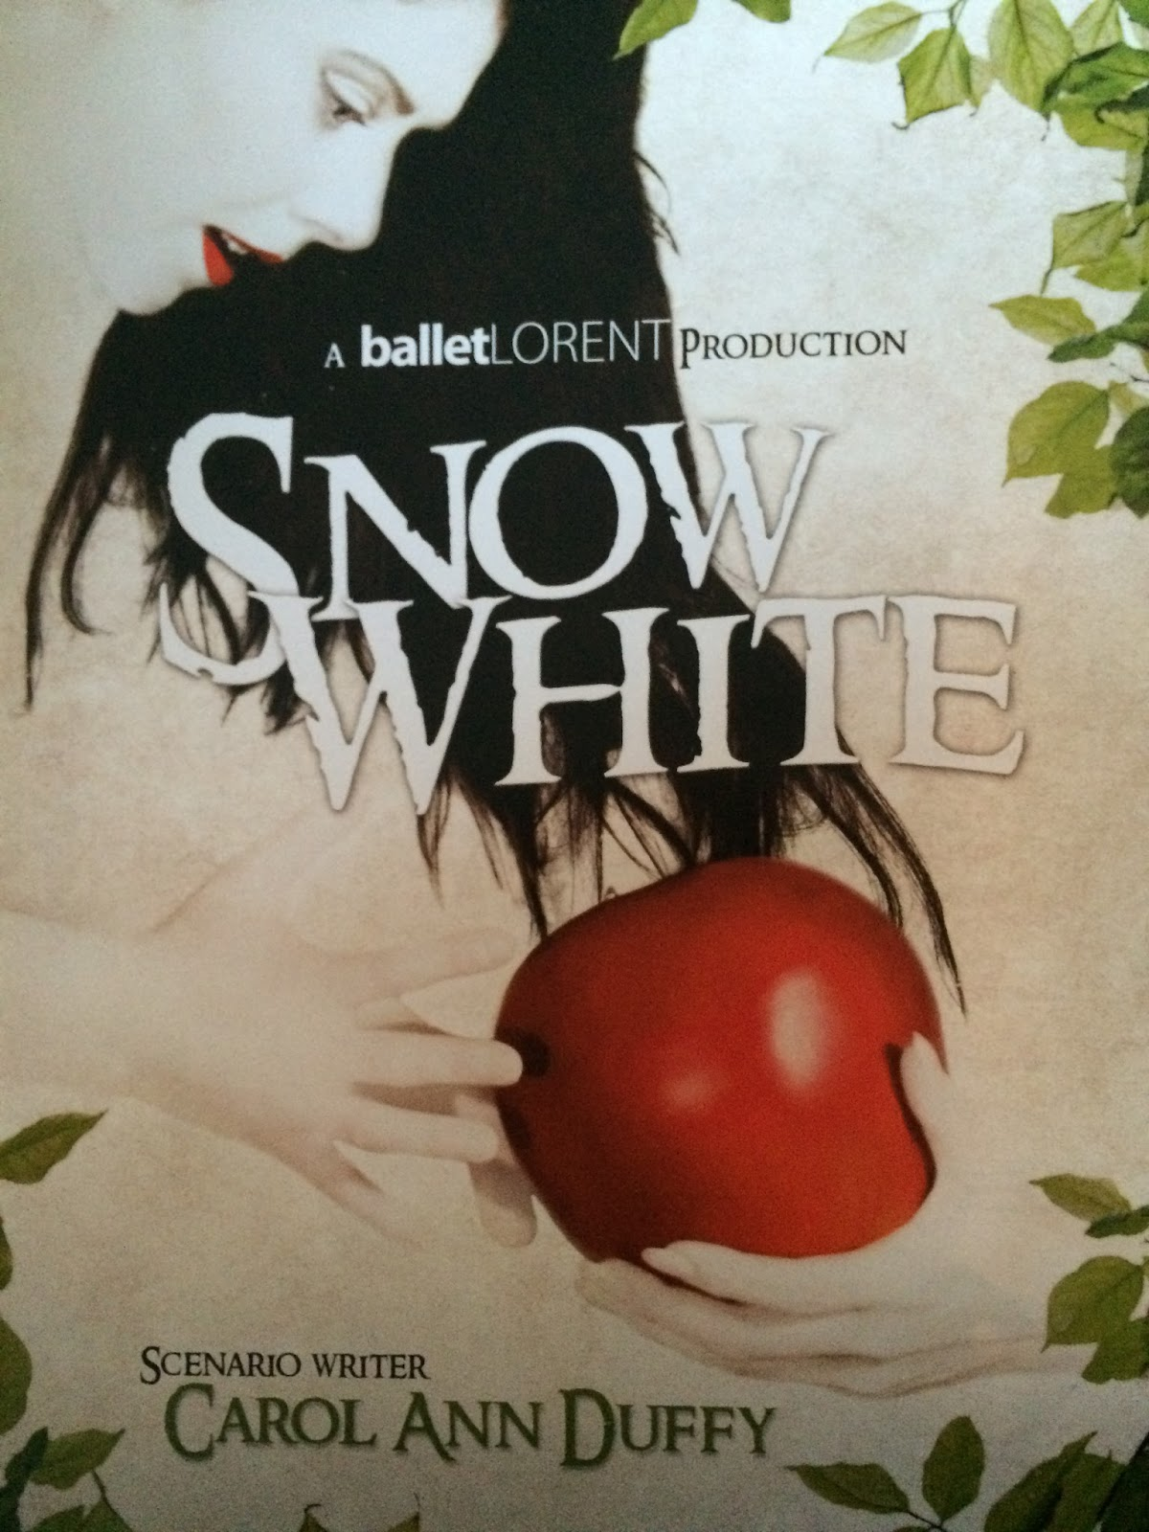
Active Stirling Taster Sessions

Throughout the session, classes will have taster sessions of a range of sports, all of which have opportunities to lead to community clubs and festivals. Children will receive information about this at the time of their involvement. This term, it’s curling for P6 (2 sessions) and football for P3 (5 sessions)

Standards and Quality Report

Our Standards and Quality Report for Session 2015-16 is now available on our school website:

https://blogs.glowscotland.org.uk/st/borestoneprimary/

A Google search for Borestone Primary generally brings this website up first.

This details our improvement work over the last session and our plans for the coming year.

