
Borestone Primary School
Newsletter

February 2017

2012

Dates for your diary:

February

3rd – P7/6 class assembly
13th- 17th –February break, school closed to children
23rd – Parent appointments (by request)
23rd – P7 Rugby Taster session
27th – Nursery Powerful Play 10.30-12.00

March

2nd – World Book Day, children can dress as book character
3rd – Nursery Powerful Play 2.00-3.30
17th – P1 Assembly Celebrating Success
21st – Sharing Learning Evening, Book Fair
24th – Red Nose Day

Dear Parents and Carers,

Thank you for all your support in helping your children to learn their Scottish poems. Judging was a real challenge as all the children did so well. Winners are listed on page 2. Although we were disappointed not to win the funding to improve our library through our Reading Revolution campaign, we are so proud of all the support from families for the project. We have been able to source some funding from Parent Council, from previous fundraising efforts and through some other sources and are about to get started on refurbishment. Although it won’t be as ambitious as what we’d originally planned, we’ll do the very best we can to make our library an attractive and exciting place to read. If you have any suggestions of other potential funding sources, please let us know.

Parentpay

Parentpay online payments for school meals, excursions etc. will go live for Borestone on Monday 20th February.

We aim to move to a completely cashless system as far as possible. Parents will be able to make payments online by setting up an account. Information on how to set up your account will be sent out on the day we go live.

The system allows you to see your child’s lunch balance, top up this balance and even check when they’ve had meals whenever you want. It’s great from a parent’s perspective and also reduces administration time spent on lunches and money significantly.

You’ll be able to pay for school trips and check what still needs to be paid e.g. for P7 residential which is paid in instalments.

Lunch orders will be done electronically in the classrooms and sent to the kitchen. Ordering lunches for children who arrive late will be more difficult so we would urge you to ensure that children arrive by 9am.

We have previously offered some flexibility e.g. cheese sandwich on offer if children didn’t like the choices on the menu, but the new ordering system doesn’t allow this facility. Selections can only be red, blue or green tray. Teachers will ensure children are aware of this change.

Visitors

We’ve had lots of visitors recently, supporting children with their learning in a range of areas.

Visit to P4/3 by Neil Dickson from Stirling Archives by Riley M and Ethan
Mr Dickson from Stirling Archives came to talk to us about Famous Scots. He told us about lots of really famous people like Robert Burns and Bonnie Prince Charlie. He showed us pictures of some Scots from a long time ago, and some that were from now. He showed us the two brothers from Stirling who tried to make a plane work. They tried to fly from Scotland to France. They went to go from Stirling Castle, but it didn’t work, they just dropped down. Bonnie Prince Charlie wrote the people of Stirling asking for carts and horses and shelter for his men. We had to write a letter replying to him.

Visit to P7 by Miss Song the Mandarin Teacher from Stirling High.
In term 2 primary 7 were studying China & Scotland, Miss Song from Stirling High School visited on many occasions to support our learning with her cultural knowledge and to teach Mandarin. Everyone enjoyed the lessons she taught and we all look forward to future lessons with Miss Song at Stirling High.


Scottish Poetry Competition Winners 2017
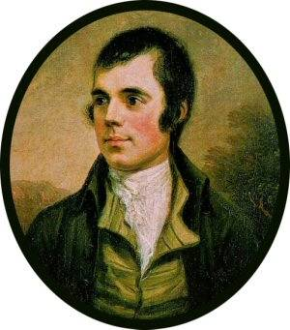

Poetry performances on Friday 27th January were fantastic, judging was very difficult.

Winners were:
P1 – “Fireworks aff the Castle” – Matthew Fitt
1st = Boe Sprowl & Zack McVicars
2nd – David McEwan

P2/1 – “Mince n’ Tatties” – J K Annand
1st – Sophia Allan
2nd – Aaron Taylor
3rd – Sophie Morris

P2 – “The Magic Pizza” – Alison Fitt
1st – Craig Hamilton
2nd – Ruby Swindells
3rd – Laura O’Keefe

P3 – “The Crocodile” – J K Annand
1st= Freya Gill & Joshua McIlwaine
2nd – Sophia Clarkson-Maley

P4/3 – “The Crocodile” – J K Annand
1st – Ellie Powell
2nd – Amber Gillies
3rd – Riley McDonald

P4 – “Feart” – Liz Niven
1st – Emily McFarlane
2nd – Aaron Vincent
3rd – Daniel Stewart

P5 – “Street Talk” – J K Annand
1st - Olivia Duthie
2nd - Opkeerat Bains
3rd – Gabriel O’Rourke

P6 - “A Dug a Dug” – Bill Keys or “Lament for a Lost Dinner Ticket” – Margaret Hamilton
1st – Olivia Young & Paige Wheater
2nd – Jack Dennehy
3rd – Jenifer Gillespie & Max Cook

P7/6 - “Jenny wi the Airn Teeth” – Alexander Anderson
1st – Sarah Ferry
2nd – Mylo Preston
3rd – Caitlyn Allan

P7 - “A Man’s A Man” – Robert Burns
1st – Ellena Young
2nd – Charlize Clark
3rd – Heather Thom

A massive well done to everyone!
Global Play Day – 1st February

We had a fabulous time during our 1st global Play Day. Everyone was engaged in their play with lots of discussions happening between children. The children played imaginatively and the feedback so far from everyone has been very positive. Some of the children from the Health and Wellbeing Community group said the following;

Jack Duffy p6
“It was really fun, everyone got to play. It was good that classes mixed up as we got the chance to play with other friends, I hope we do this again”

Jayden McConnell p6
“It was fun because we got to play a nerf war outside and we wouldn’t normally be allowed. Everyone loved it and was really well behaved”

Shannon Downes P7/6, “It was really fun. I would like to do it again. I thought it was a great way to relax and switch off from all the hard work we do”

Harry p2/1
“It was really good. I liked playing with my toys”

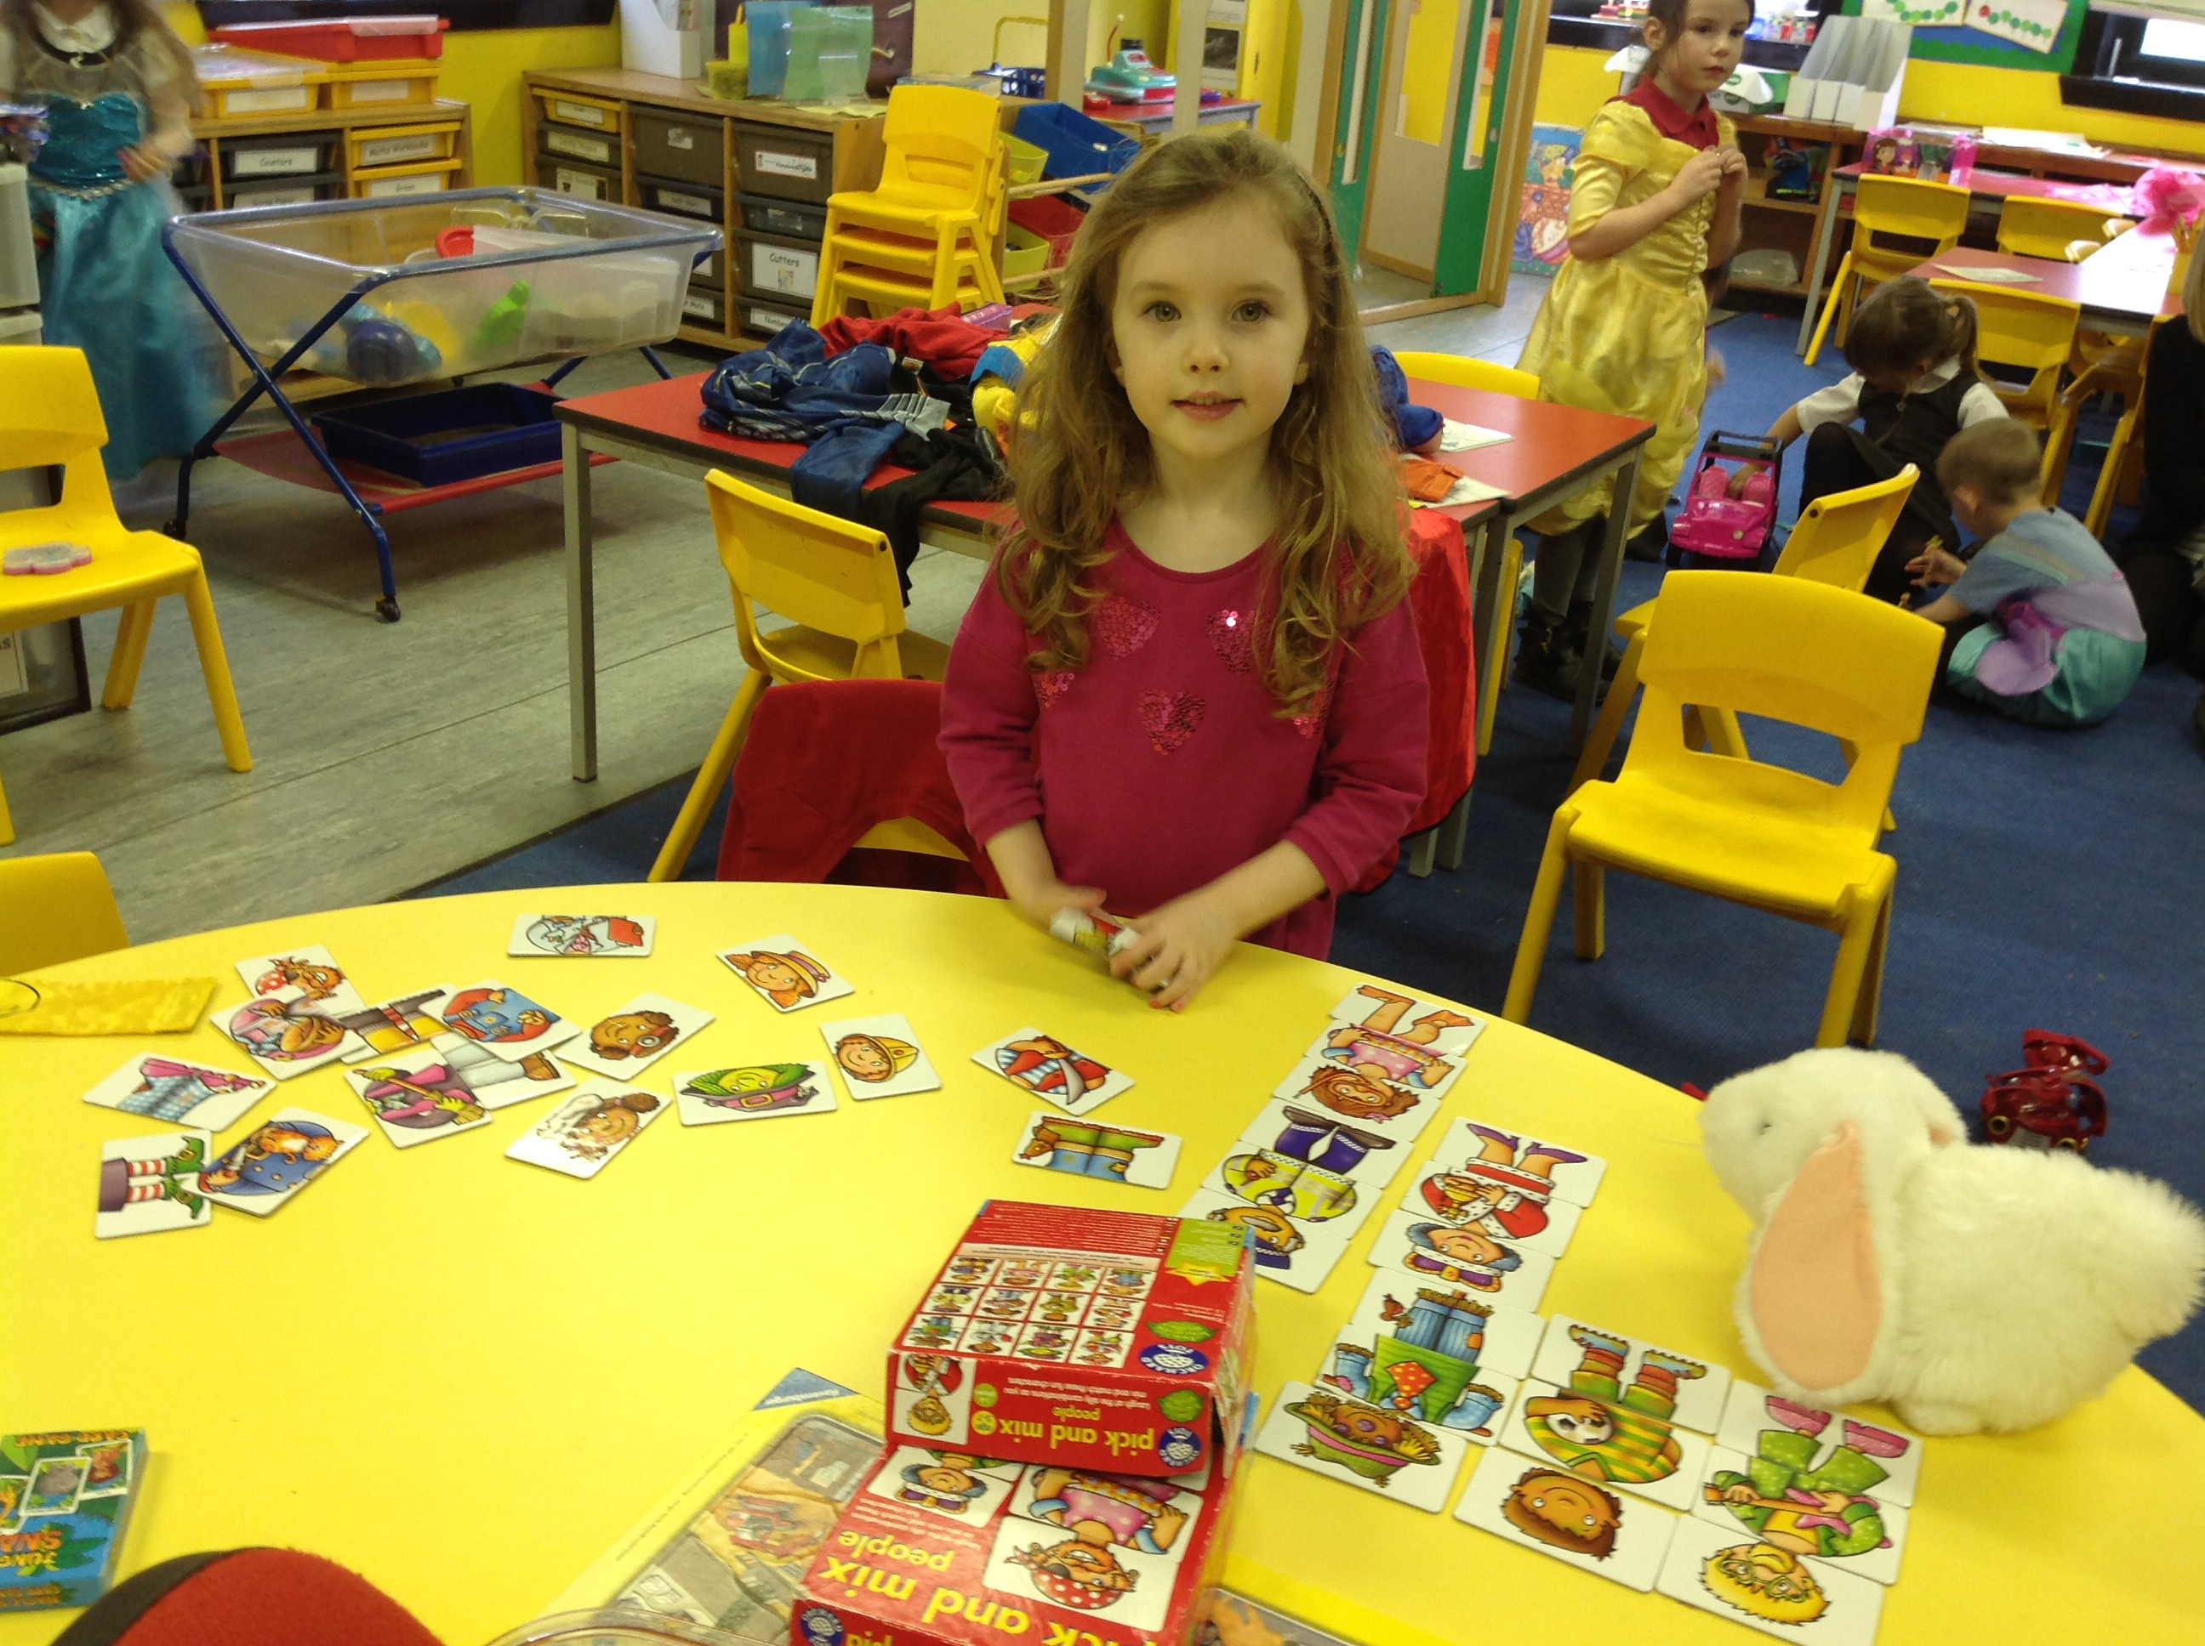

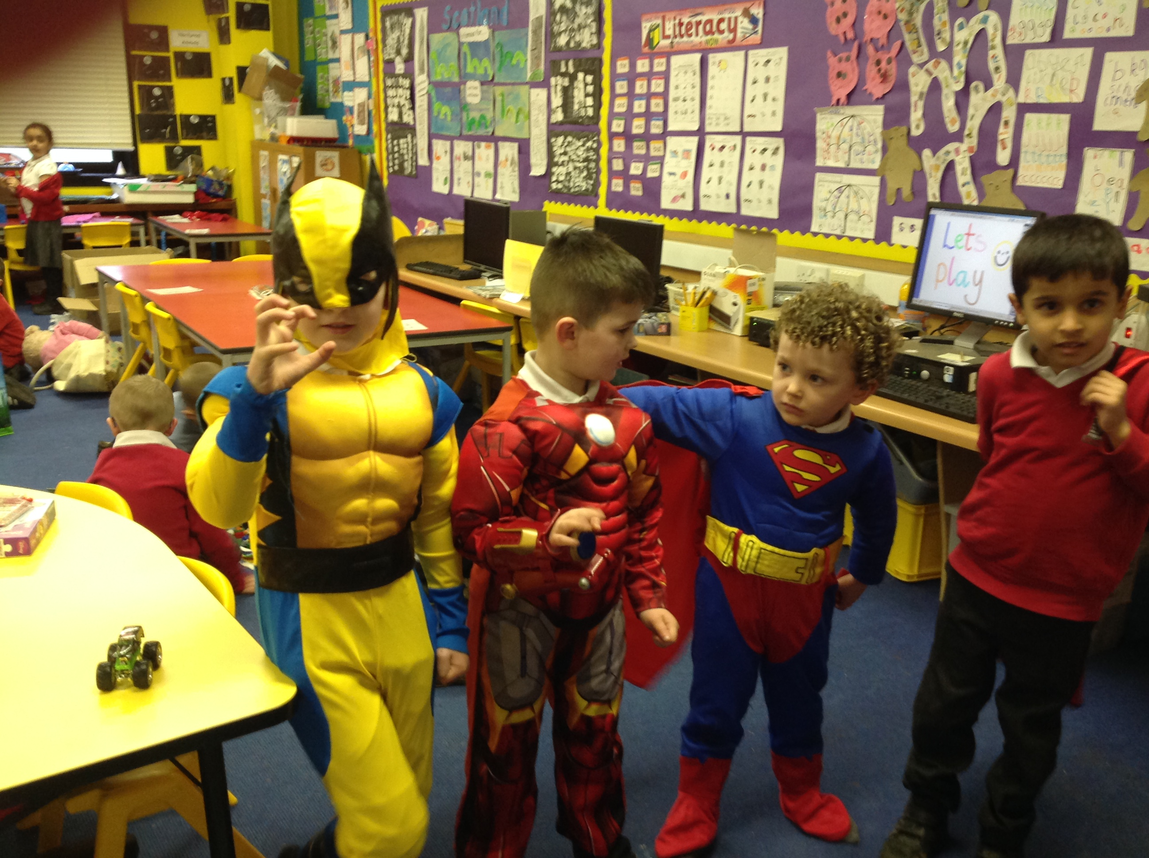

Healthy Snacks – The A-Team
The 'A(pple) Team' have organised a reward system for healthy snacks. All children will be awarded a special dojo point for bringing a healthy snack instead of a sugary snack for break everyday. Children who earn 5 in a week will receive a house token and the class with the most Healthy Snack dojo points will receive a class reward at the end of the month.
We hope that you will agree that this is a very important habit to teach our young ones and after the P7 presentations at our Health Event we realise it is also cost effective too.


Late arrivals to school

Whilst we would always prefer that children arrive late to school rather than not at all, persistent latecoming causes a number of difficulties. We ask for your support in ensuring children arrive by 9am.

Macrobert Youth Dance Classes

We’ve been asked to share information about dance opportunities at Macrobert Arts Centre.

Macrobert Youth Dance (MYD) classes explore a range of dance styles and techniques. Improve your choreography skills and learn new routines!

Spring Term:
P4 - P7 | 60mins
4.30-5.30pm at Macrobert Arts Centre, University of Stirling
19th, 26th January 2017
2nd, 9th, (No Class the 16th), 23rd February 2017
2nd, 9th, 16th, 23rd, 30th March 2017

The full term costs £55, however at Macrobert we are dedicated to providing creative opportunities free of barriers, so we also offer a bursary to those in need of financial assistance. Please get in touch if you would like to find out more.

Please wear comfortable clothing and trainers, and water is recommended. If you have any questions at all, please do not hesitate to get in touch.

Samantha Gurrey
Creative Learning Officer
sam.gurrey@macrobertartscentre.org

Rag Bag Collection 27.2.17

The Recycling Community Group will be distributing bags for this textile recycling collection. We need your old clean clothes, paired shoes, handbags, belts etc. This helps raise funds for the school and saves sending textiles to landfill. More information can be found at www.rag-bag.co.uk

Please return your filled bags to school by Friday 24th February at the latest. Thank you.

Read Write Count

Thank you to all P2 & P3 parents who came along to our Read Write Count event.

Scottish Book Trust are evaluating the first year of the campaign and the bags. There are surveys for teachers and parents, I would be grateful if you could promote these with staff and parents. There are prizes up for grabs!

For parents the prize is a personal Read, Write, Count Goodie bag filled with books, games and activities for all the family to enjoy.
https://www.surveymonkey.co.uk/r/FCP6MQN

The deadline to complete the survey is Tuesday 28 February.

Although only P2 and P3 received Read Write Count bags and P1 received Bookbug bags, there are LOADS of ideas on how everyone can help support their child’s learning at home on the website and on Twitter and Facebook pages.

http://www.readwritecount.scot/

BORESTONE BOOKS 4 LIFE


The literacy community group have been providing a weekly book stall on a Wednesday. Books are on sale for 10p each or children can bring a book from home to swap for free. This has been very popular with the children and we are now at the stage where the book supply is getting a bit thin on the ground. We would therefore like to invite you all to have a look through your bookshelves at home and if there are any books that you have outgrown or no longer need then please consider them for our bookstall.

Donations can be handed into the school office and the literacy group will add them to our bookstall collection. Thank you in advance for your donations.

Parent Council

Dear Borestone Parent,
First off, a big thank you to everyone who supported our Burns Night Family Ceilidh. There was lots of music, dancing and great poetry recitals from the children - with a lovely community feel to the evening. You can check out the photos on the school facebook page.
Our Reading Revolution Campaign is not forgotten, and we continue to search for ways to fund improvements to our library and some new books. If you know anyone who can help us, or have any suggestions for ways in which can raise some money towards an updated library please get in touch.
We are also looking for a parent ‘Travel Champion’ to represent parents’ views with regards to active journeys to school (walking / cycling / scooting), safe routes, and traffic and parking issues. This is an important role as it can directly impact the safety of our children’s journeys to school. Our new champion will liaise with school and have an input into the school travel plan. The role could be for one person, or if you prefer shared between two people. (And you don't need to call yourself the Travel Champion, you can think of a different name if you prefer...!). You don’t need to commit to anything now, if you think you might be interested please get in touch and we can have a chat about the role.
The Parent Council funded Hopscotch Theatre’s recent trip to school to perform “Scotland – the Nation of Innovation” (which may explain why your children have been singing ‘I just can’t do it – yet!’). We hope your children enjoyed the show.
And finally, we are starting to think about activities for after Easter and the Summer term. We hope to have a reading challenge sponsored event that the children can take part in and will be supporting the School Summer Fayre and P1 Transition activities. If you have any comments, questions or ideas, please do get in touch with us via email or come along to our next Parent Council meeting on Monday, 27th February, 7:00-8:30pm in school - everyone is welcome.
Thank you, Lucy Fraser
Follow us on:
Facebook:
www.facebook.com/BorestoneReadingRevolution/
Twitter: @BorestoneParent
Email: borestonepc@gmail.com

Anna’s Aiming High!

At the weekend, Anna Fraser from P4/3 took part in the first round of a regional Youth Climbing competition (Southern Scotland) run by Climb Scotland in Edinburgh and came first in her category, well done Anna! She now progresses to the next round at the end of February. The top three from this round will go through to Scottish finals in March.

Good luck in the next round Anna!

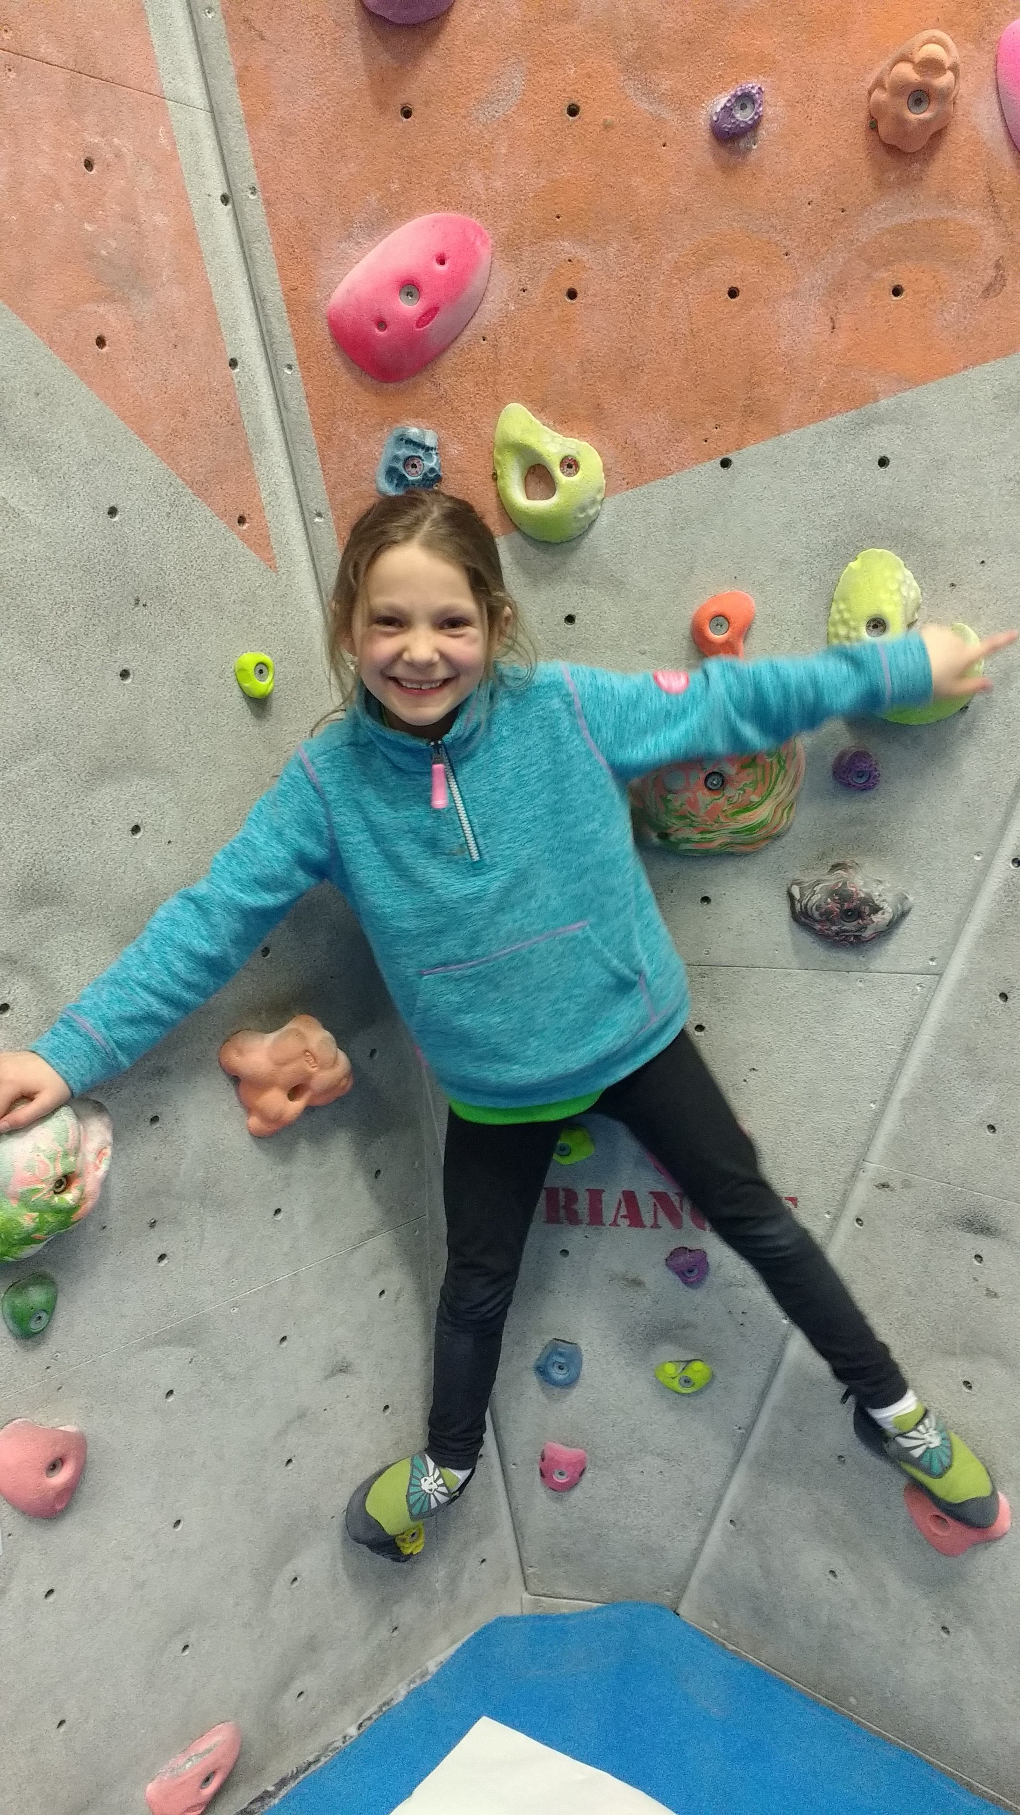

Dogs Trust – P4/3

Rachel Bliss from the Dogs Trust came to visit P4/3
Hayden: “She gave us all a pen with information on it.”
Anna: “She told us the different species of dogs evolved.”
Natasha: “She demonstrated what she us to us.”
Luke: “She taught us that dogs have better hearing than us.”
Brooke: “She taught us that dogs can look exactly the same as wolves.”
Layton: “Humans domesticated wolves to be dogs.
Connor: If you don’t want a dog to jump on you, you do the X-Factor symbol with your arms.”
Summer: “You must ask the owner first if you want to pet a dog, and how to pet it.”
Daniel: “She gave us advice about how to stay safe around dogs.”

Nursery News
We made a busy start to 2017: Lucy Niu, from Stirling High School, has been visiting twice a week to teach us some Mandarin. We are using this to say hello - Nǐ hǎo - adding to our growing list of languages used at Welcome Time; Spanish, French, Polish and Makaton. Lucy also brought us Chinese decorations and we have learned about Chinese New Year traditions and cooked stir fry with noodles for snack.
Following on from the visit to Bannockburn Heritage Centre children have been building castles with the large blocks, role playing 'goodies and baddies' and agreeing how to play fight safely. Junk modelling has also added to their play, with children making 'blasters, shooters and canons'.
A dinosaur habitat has been introduced with bark, stones, sand, water and pot plants. Children decided what is needed and so a volcano is currently under construction from papier mache and will be added once complete. The herbivores are enjoying playing in the plants.
We have also enjoyed visits from St Ninian's librarians who have shared books supporting these topics. The plans for learning are displayed in the cloakroom, along with group time plans and the snack menu. Please feel free to comment on them.
The February break is nearly upon us. When we come back we will reintroduce getting changed for gym. This helps children practice their independence skills which builds their self-confidence. Gym sessions are Monday 1045 and Thursday 1445. A letter will follow separately with suggestions for a gym kit. We are beginning to make plans for our next Powerful Play family sessions on 27 February at 1030 to 12pm and on 3 March from 2 to 3.30pm. We will be holding a numeracy week from 6 March and parents' sharing learning appointments will take place during the week beginning 13th March – appointment sheets will be available in the cloakroom nearer the time.
Finally, a few thank yous: to Mrs Helen Heppenstall who has been covering Mrs Imrie's post until a longer term appointment is made; to all our parents for their continuing and generous contributions of fruit, vegetables and non perishables for snack and for donations of recycled materials for junk modelling; and lastly to Mr Larry Gilmour, school janitor, for slicing up our Christmas tree trunk into 'coins' for imaginative play.
A reminder of session times:-
AM sessions 0845-1155
PM sessions 1220-1530
All day sessions 0845-1505

Priority Based Budgeting

Stirling Council is beginning year 4 of Priority Based Budgeting (PBB), which has involved significant consultation and engagement with our communities. Stirling Council are looking for your feedback on how you feel the first three years of PBB went. What we can do differently and what can we do better? Have your say at: https://www.surveymonkey.co.uk/r/PBByear4

The survey went live on Thursday (26th January) and will be open for responses until Sunday the 12th of February.

World Book Day
On Thursday 2nd March Borestone PS will be celebrating World Book Day! There will be opportunities for your child(ren) to dress up as their favourite book character for £1 as well as other fantastic competitions throughout the day. We will be hosting a teacher competition and the pupils will vote for the best decorated classroom door (with a book theme, of course!), as well as whole school competitions for everyone to get involved in! Further details will be sent out shortly listing all of the events for the day.

