
Borestone Primary School
Newsletter

November 2016

2012

Dates for your diary:

November

2nd – Sharing Learning afternoon
7th – Nursery parent appointment week
16th – Parents Evening Appointments 4-6pm
18th – Children in Need Spotacular (see item in newsletter)
22nd – Parents Evening Appointments 6-8pm
22nd – Nursery Powerful Play 10.30-12.00
23rd – Nursery Powerful Play 2.00-3.30
24th & 25th – Staff Development days, school closed to pupils
28th – Celebrating Success assembly P4/3, 2.15pm

December
2nd – P4/3 Assembly Celebrating Success
5th – Parent Council Meeting 7.00-8.30pm
8th Senior Citizens Christmas Concert 9.30am
9th – Flu Immunisations
12th – Christmas Concert pm
13th – P5 & P6 party
14th – P7 party
14th – Nursery Christmas Fayre
15th – P4 & P4/3 party
16th – P1, P2/1 & P2 party
19th – Nursery party
21st – Last day of term, school closes 1.30pm

Dear Parents and Carers

I hope you all had a good October break. We’ve had an exciting start to the term with lots happening as usual. Whilst continuing with our school Twitter posts, following feedback from parents we’ve now started a school Facebook page. We plan to use this to share information about school events as well as reminders for parents when newsletters etc. are put in children’s school bags. Please like and share our page. We’re really looking forward to welcoming you to our first Sharing Learning event of the session this week. We have lots of partner services coming to support us at this event, and there will be a prize draw.


Sharing Learning Afternoon
Wednesday 2nd November, 2pm

We’d like to invite you to join us to find out about the work we’ve been doing to improve children’s health and wellbeing.

You’ll have the opportunity to:

- hear about how you can support your child’s wellbeing
- see what your child’s class have been learning about health and wellbeing
- visit our “Marketplace” area with your child, which will include information on school lunches, healthy snacks, Active Stirling activities, Childsmile, Flu Immunisation programme and much more
- see a range of displays of children’s learning

We look forward to seeing you all!

Lost Property – again!

Since last month we again have a huge quantity of un-named and unclaimed items in our lost property box. As usual we put the box out in the foyer in the last week of the month. Please come along and have a look if your child has any missing items. Can you please put your child’s name on everything they bring to school as then we can return items to them.

In addition to what we had last month, from October alone we have 5 cardigans, 3 jumpers, 9 sweatshirts, 7 hoodies/fleeces, 7 poloshirts/tshirts, 2 gym kits, 2 pairs of gym shoes/trainers, 7 jackets, one pair of shorts and a packed lunch box.

We will be offering unclaimed items for sale for a small charge at Parents Evenings in November.

Children in Need



On 18th of November the Fundraisers will be hosting a SPOTACULAR event, Children in Need day.
There will be 6 events which are:

- Guess the spots in the jar (20p)
- Guess the spots on the cake 20p)
- Sponsored spot challenge (20p)
- Hide and seek spots
- Wear your spots (£1.00)
- Face dotting/painting (50p)

We will be holding it at Borestone Primary School and all the money will be donated to Children in Need!!!

Come along, don’t be dotty, just be spotty!

Primary 5 Harvest Service

Primary five were delighted to showcase their learning at their Harvest Assembly. They would all like to give a BIG THANK YOU to everyone who gave food to their donation station.

Ian from Start-Up Stirling wrote
“Just a quick thanks for all the hard work that the children put into helping the charity. I thought they were a real credit & did a fabulous job at the school assembly! Just to let you know there were
98.5 kilos of food donation so a huge thanks from us here at Start-Up.”

Thank your for your generosity in your donations. We hope that you also enjoyed the Harvest Assembly.

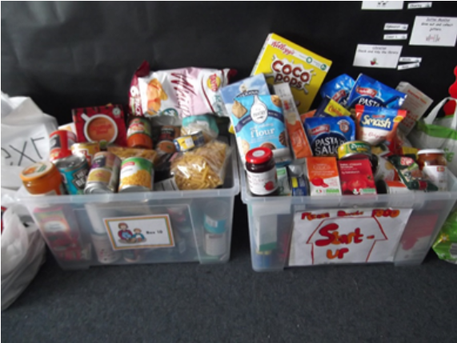

Staff Development Days

The school will be closed to pupils on Thursday 24th & Friday 25th November to staff development.

On Thursday 24th all teaching staff will be receiving training in “Reflective Reading,” a new approach to teaching reading across the school. On Friday 25th we’ll be taking part with colleagues from other schools and nurseries in Coaching and Mentoring training as part of a whole Learning Community focus. Some of our support staff will receive training in MAPPA (Management of Actual or Potential Aggression) and support staff will also be working on organising reading resources using reading age calculations.

Primary 6 – Max in the Middle

All the Primary 6 children took part in an exciting Max in the Middle week. The week consisted of dance, drama and healthy choices.

‘I enjoyed taking part in the still pictures that showed what ‘Max’ might be in the middle of’ - Josh
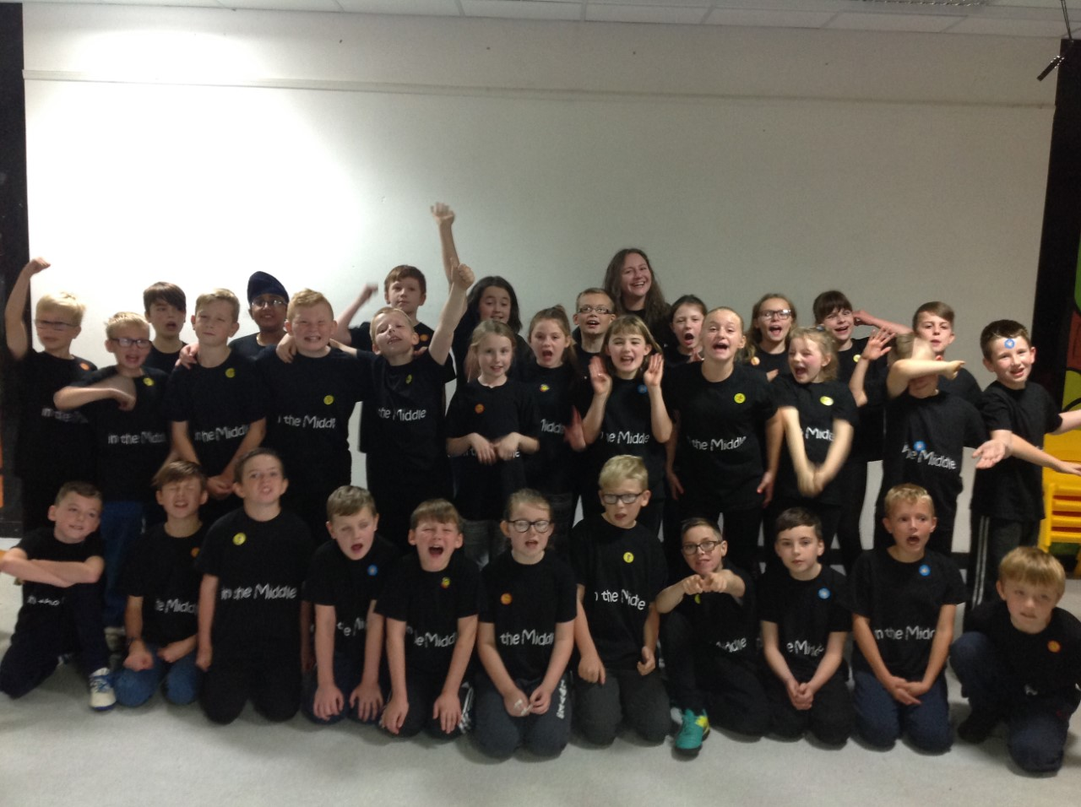
‘I enjoyed the Friday showcase because It was a new experience and it was great fun’ - Seren

Facebook
At Borestone Primary we want to keep parents informed as much as possible about what’s happening in school. We’re delighted that Borestone Primary School is now on Facebook, and we invite you to follow and like our page and share it with your family and friends.
https://www.facebook.com/BorestonePrimarySchool/
We are looking forward to using our Facebook page to share information about school events, and to send out notifications. We are keen to make this a positive forum for the school community to communicate and share information, and we ask for your support. Please do let us know what sort of information you would like to see on our facebook page.
We will be using photographs to share with you what children are learning, as they give you a flavour of what’s happening and can really bring learning alive. As a parent at Borestone Primary School you will already have signed our Social Media Permission Statement letting us know whether we can use photos of your child on social media. Our commitment to you is that when we use Social Media:
- Children’s full names are never used
- Children’s first names are only used if there is very good reason
- Full face images are avoided where possible
- Images will show the learning and the context
- No photos which have the potential to show distress, upset or embarrassment will be used
- We will promptly respond to any reasonable requests to remove a post
- We comply with the Data Protection Act 1988
- We will follow Stirling Council Social Media policy

We ask that you please be aware that your comments on our Facebook page can be read by members of the public. Our Facebook page is not intended to be a forum for public debate. If you have issues that you would like to address with the school then please come into school for a chat; we have an open door policy and are always very happy to discuss any issues with you in person. Alternatively you can raise your issue with Borestone Parent Council (their contact details are in this newsletter) who will be happy to talk to the school on your behalf. If required, the Parent Council can also raise issues with our Community Councils, Stirling Council and our local MSP and MP.
Please note that the school reserves the right to block visitors to our facebook page who make inappropriate comments and may remove their comments from posts.
For details of Stirling Council's Social Media Acceptable Use Policy please follow the link on the 'about' section of our facebook page.

ASN Parents Reference Group

Dear Parent / Carer

Within Stirling Council we are always keen to hear your views and continually seek to improve the service to you and your children / young people.
One way in which we would like to do this is through an ASN Parents Reference Group

TERMS OF REFERENCE
The ASN Parents Reference group would meet together to promote parental participation and parental consultation.

PURPOSE
The purpose of the ASN Parents Reference group is to support parents to have voice in decision making at a strategic level and have a role in providing support, information and contributing to events for other parents.

MEMBERSHIP
The membership would consist of a number of parents with different experiences of additional support needs; Dyslexia, ASD, Complex Needs, SEBN, Young Carer etc .Senior managers from Children’s Service would also attend along with representative from Parent Council.

PURPOSE:
To contribute to draft guidance and policy through consultation process
To share information at other parent networks and forums
To gather views of other parents
To contribute to parental events
To inform future priorities

WORKING ARRANGEMENTS:
The group will meet 3 times a year, November, February, May.
Dates and time: tbc

If you would like further information or would be interested in being a representative at this group please contact Elaine Murray - murraye60s@stirling.gov.uk



Nursery
The nursery children have been learning about Diwali. They have been listening to the story of Sita and Rama. Children have been making Divas and have been dressing up in traditional clothes and have been putting bindis on their foreheads. 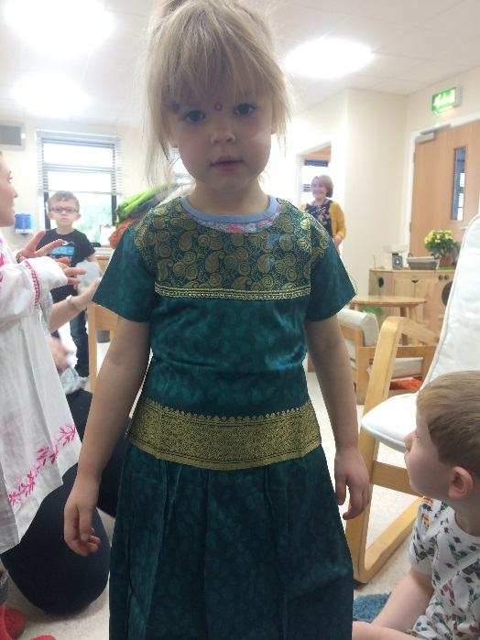 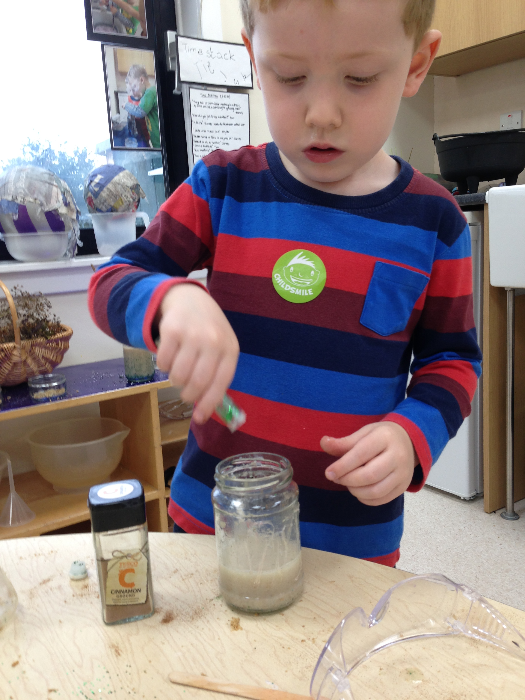
Sophie dressing up as Sita Aidan making his potion

The children have also shown an interest in mixing and making potions. The children have been using the art area and a range of resources and have made potions and ‘Time Stamps’ Some children have also been mixing colours to see what it changes into to.

The nurser are holding parents meetings starting the week beginning 7th November. There is an appointments sheet available in the nursery cloakroom.

The Nursery is continuing with the Daily Mile; we went to Rio with the school and are now Trekking to Tokyo. As well as building fitness children are enjoying exploring the school grounds, developing resilience and challenging themselves whilst engaging in social interactions.

Well done!

P7 Dalguise Residential

Shortly after the October break P7 embarked on their 3 day outdoor learning visit to Dalguise. The trip was extremely successful and, although they came home thoroughly exhausted, the children had a wonderful time experiencing a range of activities. Opportunities to try archery, abseiling, survival skills and a challenge course went down well with all concerned. Although there were many highlights, giant swing and canoeing seemed to be most memorable for many of the group.
"The canoes could go ridiculously fast however you had to coordinate the rowing well" Ruari

"When we were canoeing I was scared at first but then I got the hang of it. I loved playing the games" Jamie

"Once you pulled the string on the giant swing you zoomed off and it felt like your face was turning inside out but it was by far the best activity" Shannon

"The giant swing is certainly not like any regular swing as you get clipped onto a metal bar by your top and bottom harness. It's a great feeling when you release the cord" Ross

"You get a great view from the giant swing - I could see people from Borestone canoeing down on the lake" Ellie

During the evening sessions pupils from Borestone joined their peers from St Ninian's and Allans to take part in whacky races and a traditional campfire with singing, stories and toasting marshmallows.

Socks and Tights – A Plea
Often children get wet socks & tights when the weather is bad and although we had a stock, have almost run out as those masarl5pyi90ru89y7yu8ry7ewf4908y5uu=69059=+
j56*/ty of those we’ve loaned haven’t been returned.
If possible, could you make sure your child has some spare socks or tights in their school bag in case they are needed.
If you have any spare socks or tights your child no longer needs or has grown out of, we’d be very grateful of donations.
Thank you.

PE Kit


We provide children’s entitlement of 2 hours of PE each week but several children are regularly not bringing their PE kit to school, and so cannot receive the whole experience.

Can you please ensure your child has a PE kit in school. This should include shorts or joggers, t-shirt and gym shoes. Even if children wear trainer-type shoes to school, they must also have an additional clean pair of gym shoes for indoors.

We prefer if children can keep their kit in school so they don’t need to remember it on a daily basis. They can then take it home for washing from time to time.

OneFamily Foundation Community Award

We’re shorlisted for a £25,000 Award – please help with Public Vote!


THE PUBLIC VOTE:
This is where you come in! The more people who vote for our project the more likely we are to win this funding!

Please can you help us by:
- Voting online for our project. (see below for how to do this, voting opens 12pm, Weds 2nd Nov.)
- Talking to your family, friends, work colleagues etc and asking them to vote for us
- Liking and sharing our facebook posts and tweets on social media
- Letting us know if you have any useful contacts that could help with our campaign: e.g. somewhere to put up a poster, or contact details for groups happy to promote our project (like a Charity Committee at Work). Please send details to either Miss McAnish (via School Office) or Lucy Fraser (Parent Council email to: borestonepc@gmail.com).
- If you’ve not already, joining the parent council email distirbution list (to do this email us at borestonepc@gmail.com and ask to be added to our list)
HOW TO VOTE
Voting opens at midday on Wednesday 2nd November: when it does, here’s how to vote....

- Visit our project page: https://foundation.onefamily.com/projects/borestones-reading-revolution/
- Click the blue VOTE button in the top right corner of the page
- You’ll be promoted to register to vote
- You’ll need to activate your registration – follow on screen instructions
- Once registered click the blue 'vote' button again on our project page
- The vote count will increase and the button will change colour - this means your vote was successful and has gone through.
Voting closes on Wednesday 30th November 2016 (midday) and the winners will be announced on Wednesday 14th December 2016....
For more detailed instructions on how to vote see:
https://www.onefamily.com/your-foundation/community-awards/gaining-support/how-to-vote-for-a-community-project/

THANK YOU!

Thank you so much for your support. To find out more and keep up to date with how we’re getting on your can check out our project page, website and social media accounts:
- Project page: https://foundation.onefamily.com/projects/borestones-reading-revolution/
- Website: https://blogs.glowscotland.org.uk/st/borestoneprimary/reading-revolution/
- Facebook: facebook.com/BorestonePrimarySchool/
- Twitter: @BorestoneP

We are delighted to let you know that we have been shortlisted for a OneFamily Foundation Community Award of £25,000 for our project Borestone’s Reading Revolution. If successful this award will allow us to refurbish our existing library room and increase our resource bank for reading, helping us to support a school priority to raise attainment in reading.
This is great news, but there’s still a way to go. To actually get the funding we need to do well in a public vote, which opens at midday this Wednesday, 2nd November.

Parent Council

Dear Borestone Parent,

Thank you once again to all parents, pupils and staff who have supported our various activities in the last month.

The Halloween Disco last week was once again a big success. We would like to say a huge thank you to everyone who helped out. Whether it was hanging decorations, making up the wee goody bags, preparing your children's Halloween costumes or braving the Halloween Disco craziness! Know your support was very much appreciated...ohh and the kids had a great time!

Thank you also to everyone for supporting our Christmas Card fundraiser. The last date for orders forms to be returned to school was Friday 28th October. We expect the cards back from the printers in the next 2-3 weeks and will get them out to you as soon as they arrive.

We are very excited that school has launched a new Facebook Page. We think this will be a great way for parents to keep up with events at school and to receive information. For those parents who don’t already use facebook, you can look at the school’s new page without joining the facebook community.

We have been working with the school over the last month to apply for funding to refurbish the school library and increase our range of reading resources. We have called this project ‘Borestone’s Reading Revolution’. We are very excited that the project has been nominated to go forward to the next stage and the award is now in the hands of a public vote. If you would like to help us with this campaign get in touch and let us know.

Finally, please get in touch if you have any questions, comments or suggestions. In particular, please let us know if you have any issues that you would like us to raise with school or ideas for fundraising. All parents are very welcome to attend all our meetings; the next Parent Council Meeting will be on Monday, 5th December 7-8:30pm. We would be delighted to see you there.

Best wishes,
Lucy Fraser,

Follow us on:
Twitter: @BorestoneParent
Email: borestonepc@gmail.com

Lines

As you may well be aware, we often have difficulties at this time of year with flooding at side entrance where P2, P3, P6 & P7 line up. The grass area there also becomes increasingly muddy as the weather deteriorates. We have made the decision that from Monday 31st October all classes will line up at the main entrance.

Children will also exit from the front door.

Parent Appointments

You will soon be receiving a letter about Parent Appointments which will take place in November. This is an opportunity for you to meet your child’s teacher and find out about your child’s progress with learning.

Please complete and return the attached slip to indicate which of the dates suits you best. When we’ve received the slips back, we’ll allocate slots and return times to you as soon as possible.

On these evenings, Mrs Lochore will also be sharing some information about GLOW and the benefits it offers.



Breakfast Club

Breakfast club starts at 8.15am every morning and children need to arrive by 8.45am to receive breakfast.

We’ve become aware that some children are arriving as early as 8.00am and are waiting outside in the playground. Please be aware staff don’t start until 8.15am so there is no supervision for children at this time. There’s also no shelter and mornings are increasingly cold and dark.



