
Borestone Primary School
Newsletter

May 2017

2012

Dates for your diary:

May
1st – Holiday
4th – Local Elections, school open as usual
5th – P2 class assembly & Celebrating Success
16th – Nursery Powerful Play 10.30-12.00
18th – Nursery Powerful Play 2.00-3.30
19th – Family picnic & Borestone Marathon (see item in newsletter)
31st – Nursery Sports

June
6th – P1 induction evening 6pm
7th – School Sports Day pm
8th – General Election, school open as usual
9th – P3 class assembly & Celebrating Success
12th – Nursery new starts visit 3.30-4.30pm
21st, 22nd & 23rd – P7 transition to high school
23rd – New P1 induction & lunch 10.45
27th – Summer Fete 3.30-4.30pm
28th – Nursery Garden Party 10.00-2.00 (all children)
29th - P7 Leavers’ Assembly (all P7s)
30th – School closes 1.30pm
Dear Parents and Carers,

Thank you for your fantastic support as usual at our Sharing Learning event at the end of March. It was great to see so many of you and the “buzz” about reading was lovely. We’re planning another family event soon, see below. This was not part of our annual calendar so apologies for the short notice but we thought the Stirling marathon was too good a learning opportunity to miss. We hope you can get your trainers on and come to join us!

Borestone Marathon – Friday 19th May


You may well be aware that Stirling will be having its first marathon on 21st May this year. In recognition of this, and to promote positive health and fitness, we’re having our own Borestone marathon.

Children have already started recording and tracking their running on a daily basis in the hope they can complete the 26.2 mile distance before the Stirling marathon. In nursery, children are running together and tracking their overall progress as a group. In P1-3, children have record cards showing the route of the Stirling marathon. Each time they complete a mile they colour in a section of the route so they can see their progress. Primary 4-7 children are challenging themselves to improve their times each time they run a mile. They are also recording weather, time of day etc. to see what other factors impact on their running. We’re already seeing significant improvements and some very impressive times.

We’ve seen some fantastic teamwork, with older children running alongside and encouraging younger pupils, great to see. Every child who completes the marathon distance will receive a Borestone Marathon medal.

On Friday 19th May we invite you to join us for a celebration. We plan to start with a family picnic at 12.45pm. You’re invited to bring a picnic and join your children. Packed lunches can be ordered from school for children or you may prefer to bring along something from home. Feel free to bring rugs, picnic blankets etc. After having lunch, we invite you to join us in completing the final mile – walking, running or jogging – it’s up to you!

We’ll then have a competitive race for the children in P1-3 and P4-7 who have been fastest in their classes. Each teacher will select the two fastest children from their class and awards will be presented. A trophy will also be presented to the pupil who completed the fastest time overall. If it’s a wet day, we’ll hold the event on the next dry day but will be unable to have the picnic.

We hope you can join us – fingers crossed for sunshine!

Local and General Elections – Arrangements

The school will again be used as a polling station on Thursday 4th May and 8th June. Voting will take place in the school hall and the school will be open to pupils as usual. In order to ensure smooth running of the school and minimal disruption we have made some adaptations.

Access
Access to the playground will be using the side gate by the nursery/Alsorts only. Children will line up at the same places as usual. Staff will help direct children and parents to this entrance in the morning.

Breakfast Club
Breakfast Club will be available from 8.15am as usual, but will take place in the nurture room & library. Children should enter via the main door of the school for that day only. We have put additional staffing in place to ensure this can run smoothly.

School Security
The school hall will be used as the polling station, and therefore will be unavailable for school use all day. Voters will enter the polling station via the side door of the hall, and will not have access to the main school at any time. Locks have been fitted to all doors between the school and the hall so there is no access into the school from the hall area. This will mean adaptations to toilet access for P2 and P3 children on that day, but we are confident that this is manageable by using upstairs or disabled toilets.

In the playground, fencing from the top gate will guide voters to the entrance of the polling station, and there is additional staffing to supervise this area when children are in the playground. Signage will direct voters to the appropriate entrance.

Lunches
Since the hall is unavailable, only the packed lunch option is available on election day. Lunches will be delivered to classrooms, where children will eat their lunch before going outside. Additional supervision has been arranged in the playground. If it is raining, children will remain in their classes as usual, where they will be supervised by support staff as usual.

Playground
When children are outside on Thursday, they will be kept away from voter entrance/exit route. There will be no access from the front entrance of the school round to the side entrance due to fencing, and children will instead go round the back of the school. We have additional staffing available to supervise this.

Meeting Andrew Butchart

Stirling High School are also doing their own marathon challenge, and Andrew Butchart came along to help with their launch. We were invited to take along a few pupils to run with him.

Andrew is a local athlete from Dunblane who competed last year in the Rio Olympics, qualifying for the 3000m final alongside Mo Farah.



Scholastic Book Fair

When families buy books from our book fair, we get commission which enables us to buy books for the school.

Thanks to your generous purchases, we have
£570 to buy some new books for our fantastic new school library. Thank you!

Healthy Snacks – The A-Team
The 'A(pple) Team' have organised a reward system for healthy snacks. All children will be awarded a special dojo point for bringing a healthy snack instead of a sugary snack for break everyday. Children who earn 5 in a week will receive a house token and the class with the most Healthy Snack dojo points will receive a class reward at the end of the month.
We hope that you will agree that this is a very important habit to teach our young ones and after the P7 presentations at our Health Event we realise it is also cost effective too.


Primary 5 Think Dancing

On Wednesday 26th April, Primary 5 took part in Active Stirling’s Think Dancing show at Macrobert Arts Centre.

They did a fantastic job, presenting a really creative dance about a journey through space. Everyone was a credit to themselves and to the school. We were very proud of them all!

Nursery News

We welcome Mrs Gayle Reid to our nursery team. Mrs Reid will be job sharing with Mrs Wynne until June. This means that the Red Group will have Mrs Wynne on Monday, Tuesday and only the morning on a Wednesday. Mrs Reid will then be with the Red Group for Wednesday afternoon, Thursday and Friday.
We wish to thank Mrs Scott for all her help recently.
Important dates for your diary:
Powerful Play: Tuesday 16th May from 10:30-12.00 for morning children. Thursday 18th May from 2pm-3:30pm for afternoon children.
Sports Day: Wednesday 31st May from 10:30-12:00 then 2:00-3:30pm.

Powerful Play
Our last powerful play session was a success and the children did some wonderful singing to the adults of their favourite nursery rhymes.

Transition
The children moving on to P1 this August will have received a timetable for the transition. We aim to make the transition from nursery to P1 as smooth as possible for the children. We have started having visits from the primary 1 teachers and we are beginning to explore the school and will be visiting the classes. Children will soon be allocated buddies from our current Primary 6 class who will get to know them and support them as they move into school.

Literacy
The nursery children have participated in the Readathon within the school and we have launched our lending library in conjunction with the new school library being opened. The children are enjoying choosing books to take home and writing about it in the jotter that is part of the lending library.

Marathon
The children are participating with the school in completing the Stirling Marathon. The children are thoroughly enjoying getting out in the field to do as many laps as we can! We have counted that 5 laps equals 1mile. The fastest mile so far has been 11:42. We have some promising young runners in nursery!

P1 and P2/1 Trip to Glasgow Transport Museum.

“First we went to an old car I found the car interesting. After we walked in I found out that the museum is the Riverside Museum. My favourite part was the train going round and round the room. My second favourite thing was going on the boat. We also saw the Flying Scotsman. I like the penny farthing bicycle.” James Unsworth P2/1

“I saw old cars and I learned about the old trains. My favourite was going on the big boat.”
Jessica Nicol P1

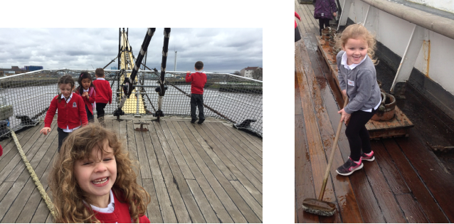
P4 Cricket Tasters

Primary 4 have recently been having cricket tasters with Active Stirling. Here’s what P4/3 thought:

Anna: “We played a lots of games. I liked the one where one person hit the ball and another person had to catch it.”
Hayden: “The wind was blowing and the cricket stumps kept falling over!”
Riley Mc: “Tony was a really experienced player and kept us right.”
Erin S: “Tony was very nice, but his accent was a bit funny!”
Cameron: “I liked when we played all the games and I can’t wait for a final match.”

Red Nose Day – 24th March

We all had fun dressing up in RED or wearing something silly for Red Nose Day. A big thank you to everyone for their generosity and for taking part.
We raised a fantastic £476.02!

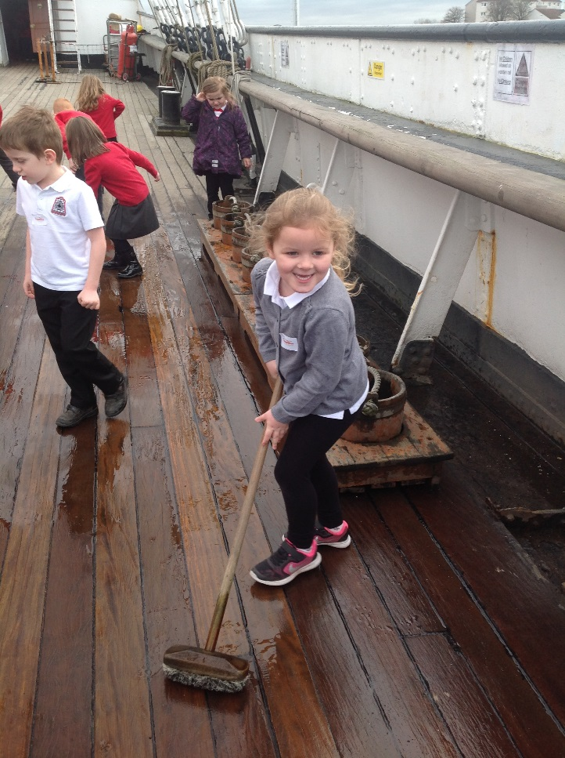
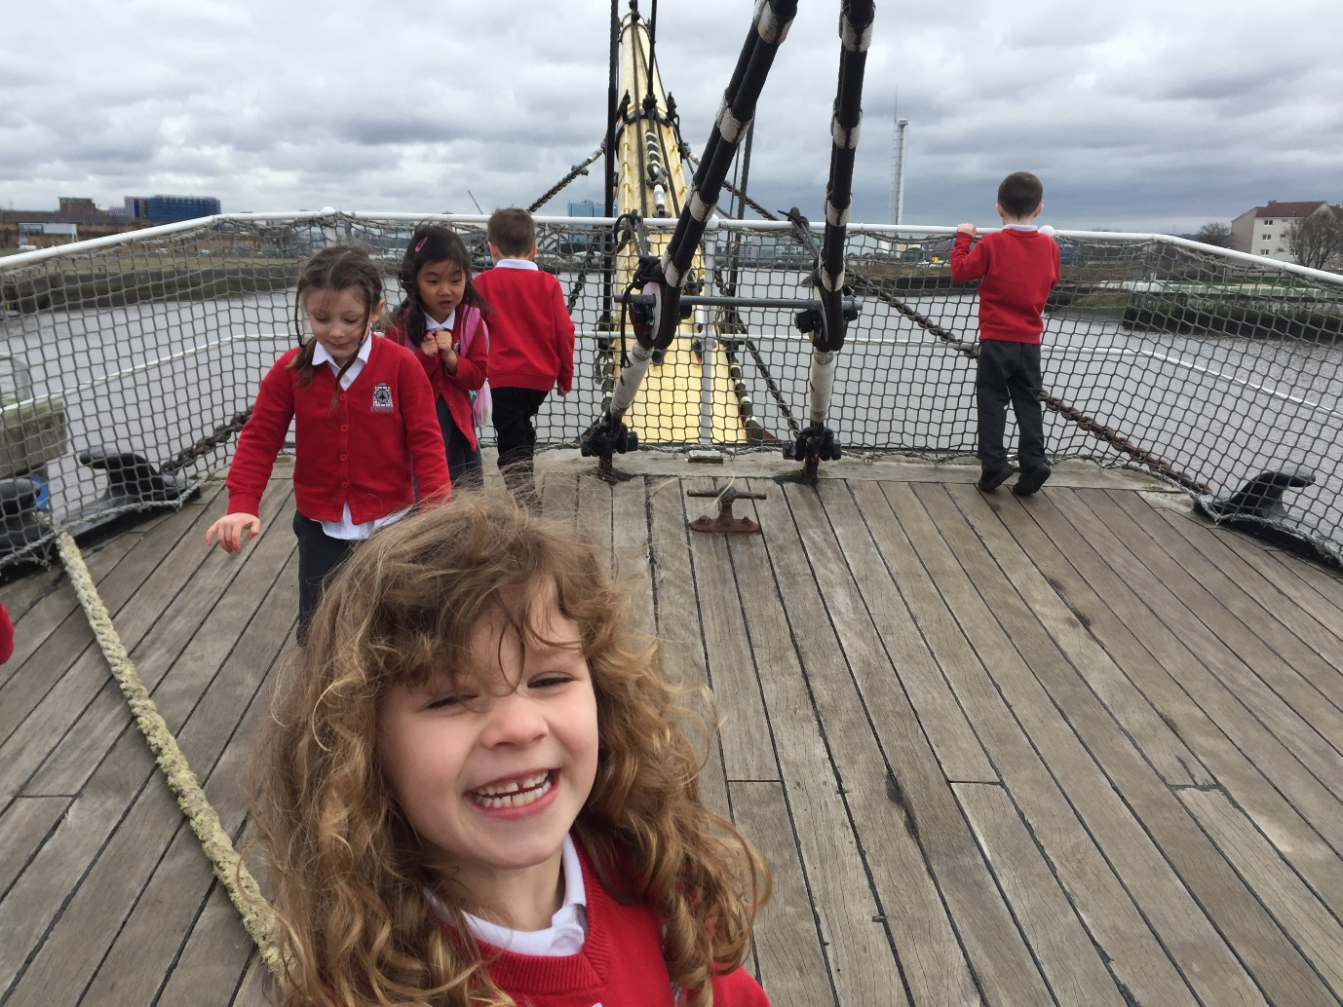
Parent Council

Dear Borestone Parent,

We are very excited that our new School Library is now open – what a magical place for our children to enjoy reading. We hope you have had a chance to come and look at the library with your children. A big thank you to everyone who has made this happen!

The children have all been busy with their Readathon Challenge over the last few weeks, and we’re delighted with how well they have all done. Thank you for all your support with this. Please do return your children’s sponsorship forms as soon as possible. The funds we raise will go towards covering transport costs for a whole school trip to the Pantomime in December 2017, as well as supporting other initiatives like further investment in IT equipment for the school and books for the school library.

Thank you to everyone who took part in our Walking School Bus online survey – your responses are very much appreciated. Our parent Travel Champion (Kirsteen) is now working with school to understand where our children cross roads on their journeys to school and how we can make these journeys safer.

We hope you all enjoyed Borestone’s Comic Relief video, we really enjoyed working with the school to create this. Well done to all our children for their enthusiastic ideas and acting skills. The video has had lots of support on social media and has been shared widely – thank you. We think the video is a great showcase for the school!

We are looking forward to lots of exciting events planned to include families at school this term, including: Borestone Family Mile, Sports Day, the Summer Fayre and of course welcoming new children and families through P1 induction events and activities.

As always if you have any comments / views / questions then please do get in touch with us via our email address or facebook page. If you would like to be added to our email distribution list just drop us an email to let us know.

Our next Parent Council meeting is on Monday, 5th June, 7:00-8:30pm in school – as always, everyone is welcome, please come along and join us.

Thank you,
Lucy Fraser
Borestone Parent Council

Follow us on:
Facebook: www.facebook.com/BorestoneParent/
Twitter: @BorestoneParent
Email: borestonepc@gmail.com
Sharing Learning Event

Our recent sharing learning event was a great opportunity to showcase new Reflective Reading approaches being used in classes. As always this was really well supported by parents and pupils who were also able to enjoy the wonderful storytelling tents, meet ‘The Trunchbull’ and explore the new library space. A special thanks to Barbara Fullford for cutting the official opening ribbon and to those who bought books from the Scholastic and Mystery bookshelves.
Some feedback from the evening was
‘Good insight into school and what is happening in future. The library is very nice.’
‘We have had a great evening. Lots for the children to do. Reading and books are so important!’
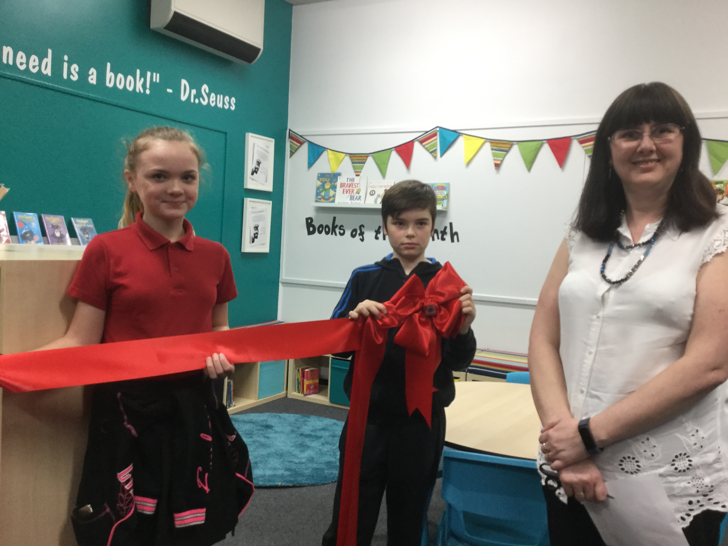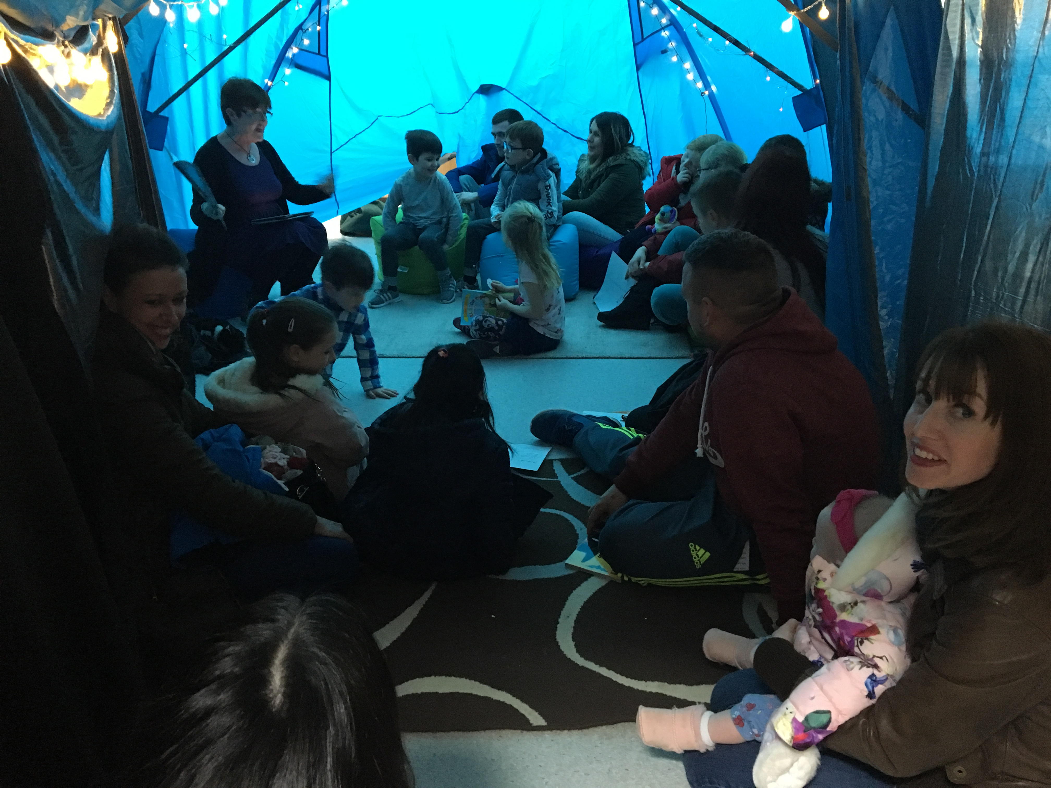

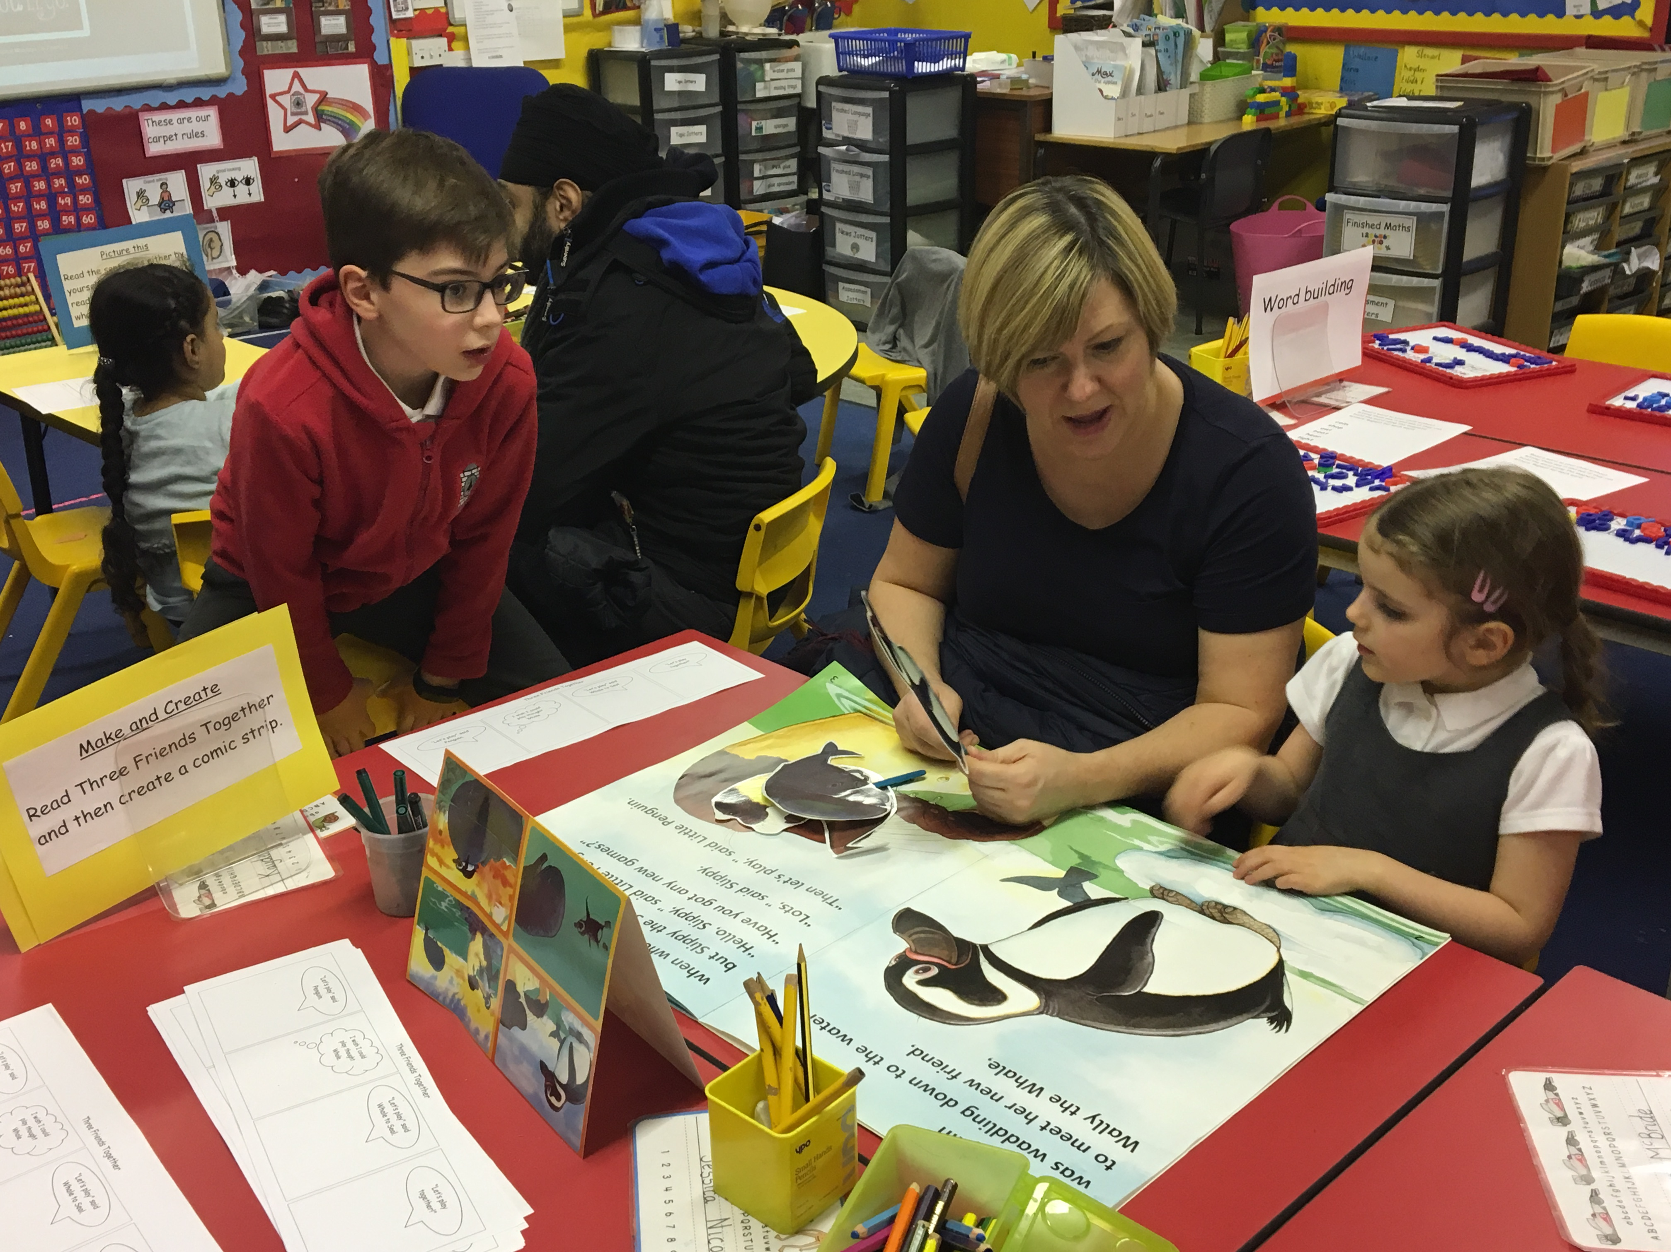

The library is now OPEN! Children are absolutely loving our new space and are already starting to borrow some of the new and exciting books that we have bought with our scholastic commission and world book day fundraising. Next week all children are invited in their classes to come and learn how to organise and look after our new and improved library space to keep it the welcoming and exciting room it is.

Parentpay

Have you signed up yet? If you’ve lost details, please contact Clare in the office.
We’re aiming to go cashless by the end of March. Parentpay can be used to make online payments for lunches, breakfast club and school trips. You can see at a glance what payments have been made and what is still owing.

