- Newsletter  - April 2021  Top Tips for Managing Change  - Good bedtime routine and quality sleep  - Daily exercise  - Mindful minute every day  - Make a list of your positive attributes  - Listen to music to relieve stress  - Eat healthily  - Talk to a friend or parent  - Do a kind act  - Be creative  - Spend time with people who care for you  - Switch off social media for at least an hour a day  - Keep a journal  - Plans or routines  - Ask for help!  Department News  The assessment timetable is now in place, and we are looking forward to supporting pupils with Additional Assessment Arrangements through these unusual times. Please know that our experience and knowledge will ensure you receive the best possible support at this time.  Transition  It’s that time again, when all our P7s will be getting an opportunity to see along with a taster of high school life. Wishing them all a positive experience and hoping they will be excited to join us at BHS.  Karen Fernie has returned resuming her role as Learning Support teacher. We are glad to see you back.  Anna Forbes: one of our SLAs, has been successful in securing a permanent position. We wish her well and thank her for her contribution to the department.  Gardening  Plans are on-going for our polytunnel and gardening opportunities, here’s hoping for some continued good weather to help grow our goodies.  Coming soon….  Teacher how do I?  We are creating our own google site for pupils and parents to get help whenever and wherever you are! Whether its support with how to submit homework, get help with your mental wellbeing, or advice or technology, we hope to answer all your queries.  Watch this space…  Learning Ambassadors  Finally, the Flexible Learning Team will be looking for volunteers to become Learning Ambassadors. This new role will require senior pupils to take an active part in our department and shaping it into a vibrant, fun and inclusive area of the school. More details will follow shortly, but if you think you can make a valuable contribution to the team, please let us know! | Flexible Learning  Returning to school learning  It’s time for change…we only have to look out of the window to see nature leading the way. As all the blooms appear, the sun starts shining and the nights are getting longer- it immediately makes us feel brighter and more optimistic.  But of course, the change in the season is not the only change we are witnessing. As we begin easing lockdown restrictions, our learning is changing again, as Balfron High opens its doors wide to welcome back all our pupils. We will be offering strategies to deal with change and the methods most effective to support change.  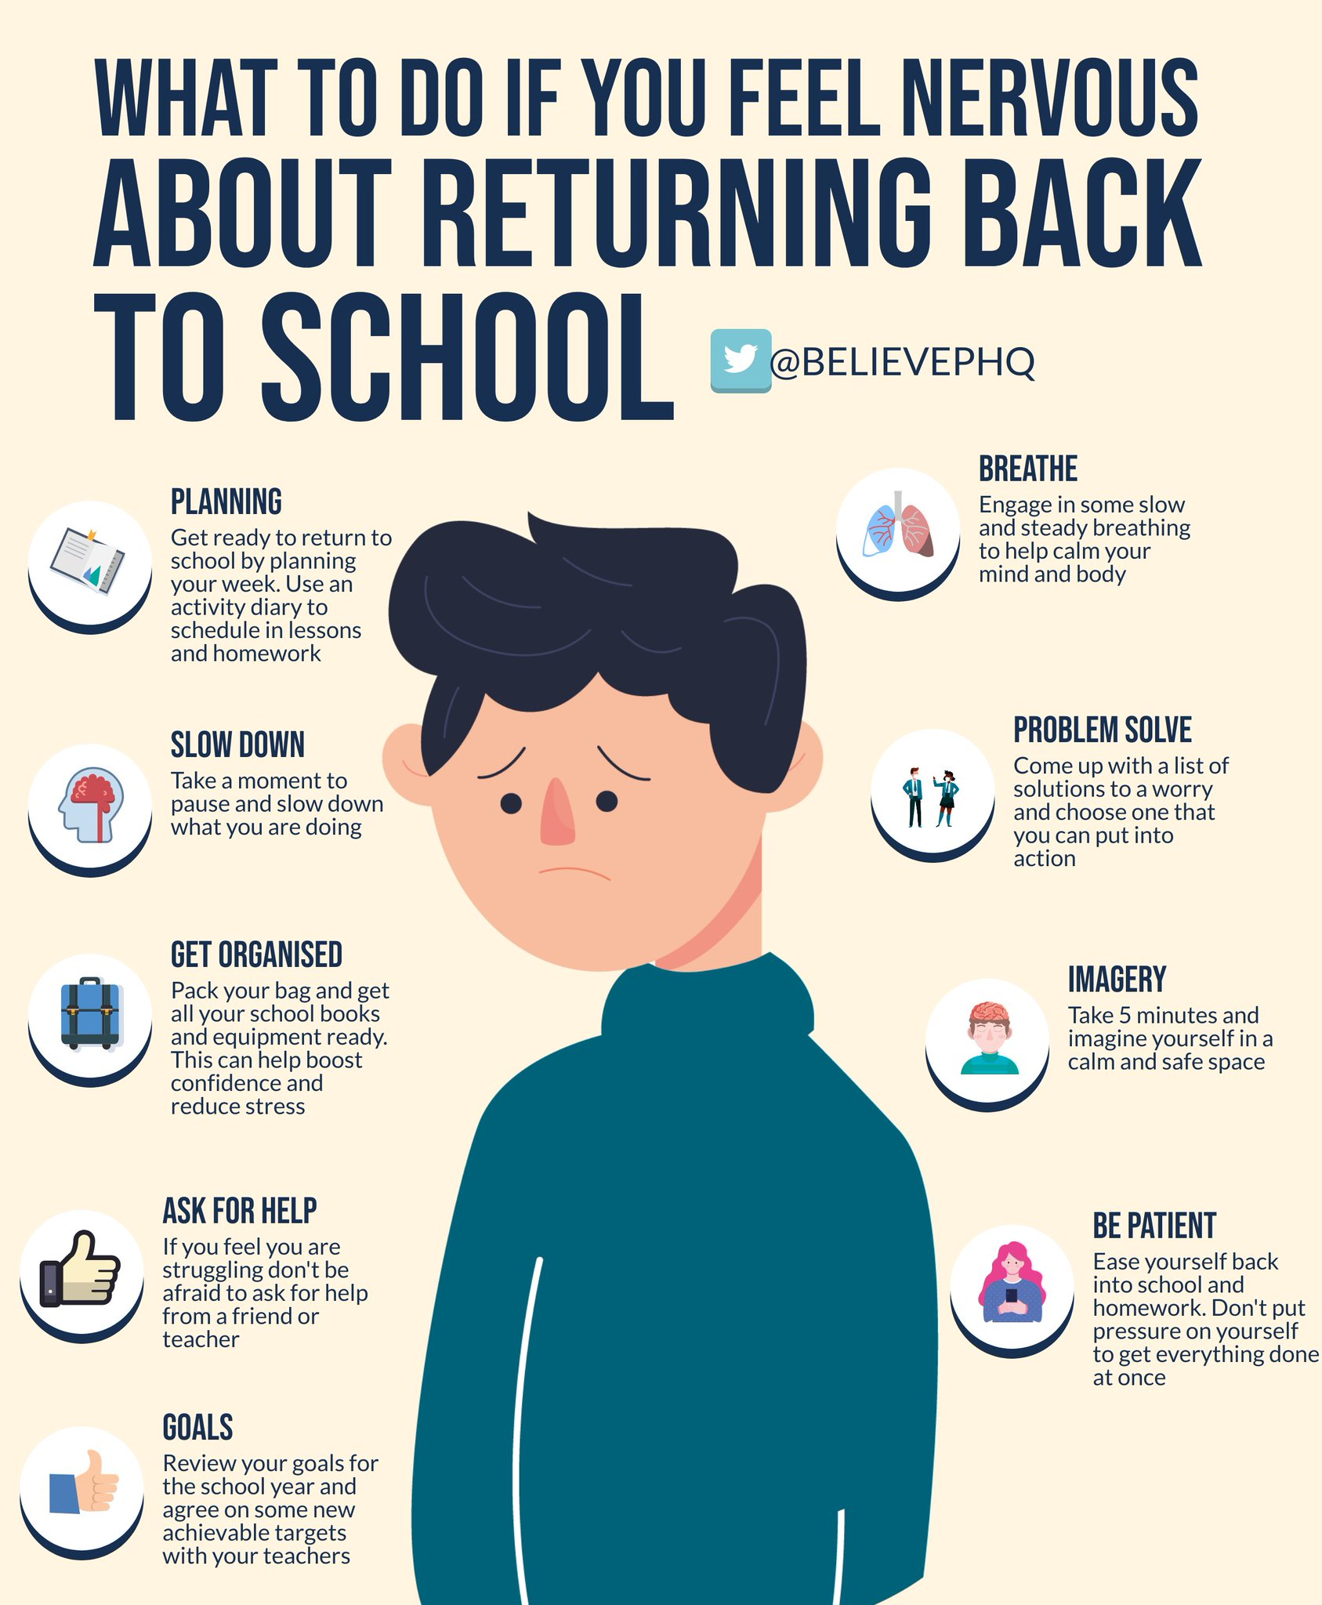  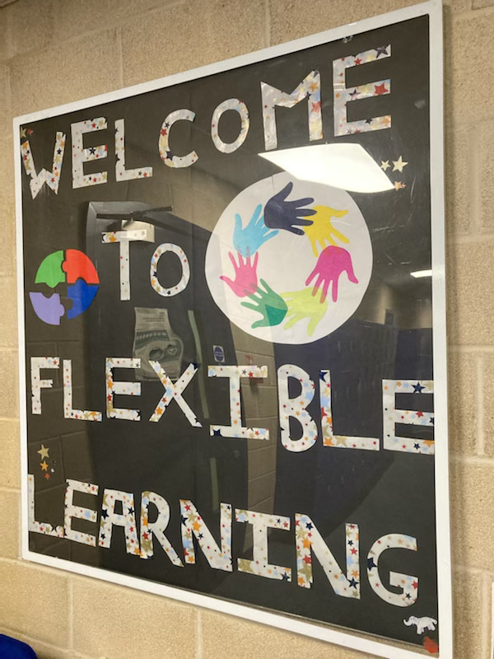  Flexible Learning Team  The Support for Learning Department is changing…we are being rebranded as The Flexible Learning Team. We have listened to the opinions of the young people, who felt the ‘base’ was not inclusive for their needs. We hope the changes we have made and continue to make, will provide a welcoming place for all the students at BHS.  GIRLS with AUTISM GROUP  A fortnightly group will soon be up and running to connect girls with Autism. Mrs. McAllister will run the group, where the main emphasis will be on sharing experiences, resolving issues and supporting each other.  If you have any queries about the group, please do get in touch.  ASDAN  We are delighted to announce that Flexible Learning Team will be offering an extensive range of ASDAN courses. ASDAN is a curriculum development organisation and awarding body, providing courses that develop skills for learning, work and life.  Further information can be found here. https://www.asdan.org.uk/courses  There are courses to suit everyone, including: expressive arts, animal care, football, gardening, life skills, peer monitoring, volunteering, etc. We are confident that there is a suitable course for everyone. Many of the options support on line learning as well as 1:1 teaching.  Do take a look, and get in touch if you’d like to discuss the courses and availability.  Dyslexia Focus Group  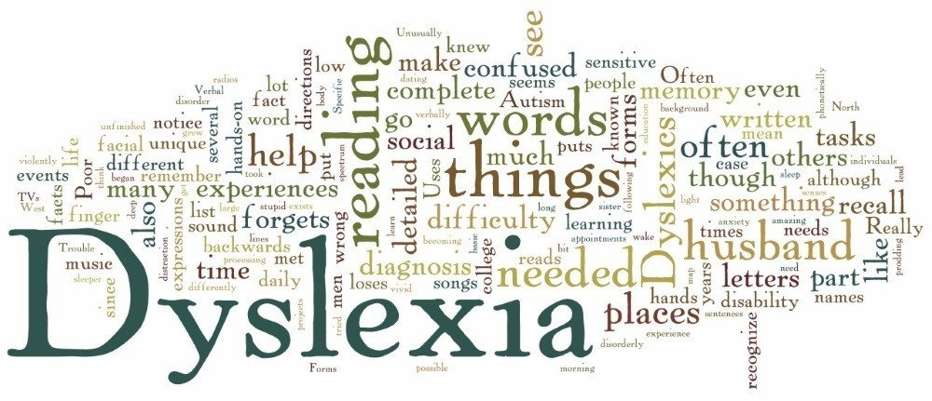  We will soon be starting our Dyslexia Focus Group, where we will be inviting young people who have dyslexia to meet to discuss their issues and best strategies to support their learning. We have often found those with dyslexia are best placed to advise those with dyslexia. Hopefully we will have visits from teachers who have dyslexia too, so they can share their wisdom.  The group will be open to all year groups at different times to reflect the different priorities for pupils throughout their school career.  If you are interested in joining the group, please let a member of the team know.  Homework Club  On Wednesdays in B24, there will be an opportunity for S1-S3s to join us and receive help and support with homework.  We aim to provide a quiet place where you ask questions and receive usual advice for your studies.  The club starts at 1pm. Please come and join us.  Look out for the posters around school.  ONLINE SUPPORTS!  Beginning a new term after a break is always hard, but never more so, after our young people have been working remotely for quite a while.  Dr. Tina Rae provides 20 quick focus 10-12 minute videos, aimed at Teens and Tweens to support well-being in the new term. Check out her first video here. https://www.youtube.com/watch?v=WemEqfnJvyA  This is a short motivational clip about embracing change. Click on the link to view. https://www.youtube.com/watch?v=sOA6_xh4neM  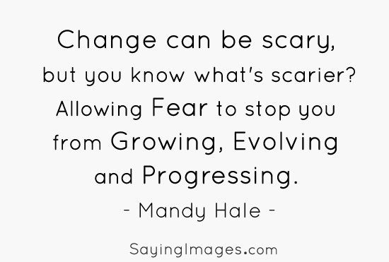  Something on your mind?  If you would like an opportunity to talk to the school counsellor Karin Figliolini, there are time 2 talk lunchtime and form time slots available. Use the QR codes on posters around the school or completing the online form on Balfron’s launch pad on Glow.  We hope you found this newsletter informative. Follow us on twitter @SfL_Balfron

