# Policies to deal with health inequalities

Health problems and inequalities are dealt with in four main ways:

* The NHS
* The individual
* Government policies and legislation
* The private sector

After the Second World War, the (then) Labour government introduced the Welfare State and the NHS as it believed that health inequalities were societies' responsibility and that everyone was entitled to healthcare from the "cradle to the grave". Subsequent Conservative governments (notably Thatcher's) believed that healthcare was the responsibility of the individual and they could seek assistance from the private sector if required. Recent research has led to all political parties agreeing that there is a direct link between poverty and ill health and that, often, an individual cannot better their situation or health. This led to New Labour's ‘third way’ which said healthcare was the joint responsibility of the individual and the state.

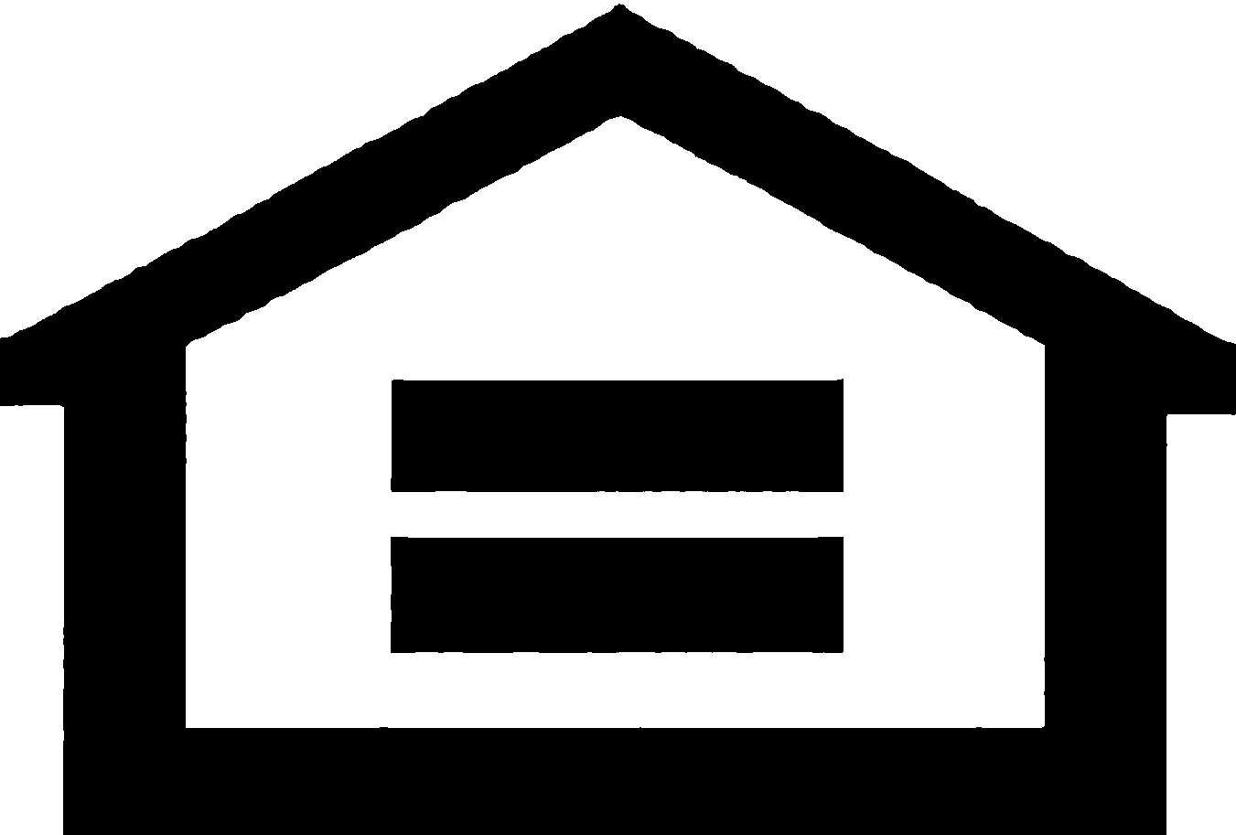**So where are we now?**

In a very interesting position is the short answer! In Scotland, the SNP administration have held a very socialist outlook when it comes to health and firmly believe that the government should do all it can to improve health for all. We will study more on their policies later.

We also have a Conservative government in Westminster who seem to be leaning towards the individual being responsible for their health. Health is a devolved power for the Scottish Parliament; however, you still need to know Conservative policy on healthcare.

**The National Health Service NHS**

The majority of the British public use the NHS to assist with their health problems and inequalities. Health care is split into two sectors to best cater for this demand - primary and secondary.

**Primary care** is usually the first point of contact most people have with the NHS. It is delivered by a wide range of professionals, including:

**Family GPs** - diagnose and treat a wide range of health problems in the local community. Doctors usually work with a team including nurses, health visitors and midwives, as well as a range of other health professionals such as physiotherapists and occupational therapists. Practices run clinics, give vaccinations and carry out simple surgical operations. They also offer health education and advice on things like smoking and diet. Every UK citizen has a right to be registered with a local GP and visits to the surgery are free.

**Nurses** - in many GP surgeries they are taking routine work off doctors.

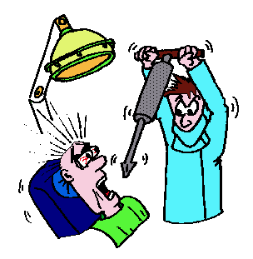 **Dentists** - mainly work in dental practices and provide check-ups and treatments such as fillings, extractions, as well as scaling and polishing. Part of their work involves advising people on how to look after their teeth and gums. Dental practices take private and NHS patients with many being a mixture of both.

**Pharmacists** - supply prescription and ‘over-the-counter’ medicines and health care advice to patients and members of the public. This has increased with the introduction of Minor Ailments Clinics, wherein a pharmacist will diagnose and treat those who were previously entitled to free prescriptions – children under 18, pensioners and those on Income Support.

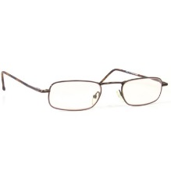

**Opticians** - carry out eye and sight tests, prescribe and fit spectacles.

**NHS 24** is a confidential nurse-led health advice service over the phone 24 hours a day, 365 days a year. The lines are staffed by nurses and professional advisors. If they feel it necessary they will arrange for you to see an out of hours GP. In Scotland, you cannot usually access this service without first going through NHS 24.

**Primary care focuses on the treatment of routine injuries and illnesses as well as preventive care, such as services to help people stop smoking. It is mostly concerned with a patient’s general health needs, but increasingly more specialist treatments and services are being made by primary care providers in clinics closer to where people live.**

**Secondary care** is also called acute care and usually is further treatment required and requested by a primary practitioner – for example a hip replacement operation or kidney dialysis. It usually takes place in an NHS hospital either as an inpatient, a day case patient, or an outpatient consultation. Appointments and treatment at NHS hospitals are free. Hospitals provide a wide variety of services by various specialists.

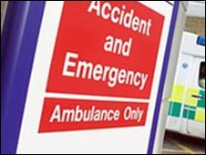 Accident and Emergency (A&E) care is when patients attend hospital as a result of an accident or trauma and require emergency treatment. Some patients will come to A&E themselves and others will arrive in an ambulance. Examples of emergency care include responses to a sudden onset of chest pain or a road traffic accident. Patients using A&E will be seen, treated and discharged – or admitted to a ward for further care.

Other examples of secondary care services include specialist services for mental health, learning disability and older people.

## How the NHS is funded and organised

Essentially the NHS is funded by taxpayer's National Insurance contributions and some of the taxes they pay. In Scotland the 14 Health Boards receive their funding from the Scottish Government who they are directly accountable to. In England, the Department of Health sets its targets and priorities and allocates funding to each Strategic Health Authority board who decide how best to allocate it. Each Authority then decide how to allocate their funding to hospitals and Primary Care trusts.

**Who is responsible for the Nation’s Health?**

**The Individual is responsible**

This approach firmly believes that everyone is responsible for their own health and should ensure they eat sensibly, don't smoke or take drugs, ensure their alcohol consumption is within sensible limits and take regular exercise.

**Society is responsible**

This approach firmly believes that the state is responsible for helping individuals by implementing laws such as the smoking ban, minimum price on alcohol and taxing unhealthy foods heavily.

**Task 1 – Debate**

The class will now be split into two halves to prepare for and hold a debate. The format of the debate will be decided by the teacher.

One half will be arguing that an individual is responsible for their own health and the other half will be arguing that the state is responsible for ensuring the health of the individual.

**To complete the task, each group will:**

* Research arguments to support their side
* Research evidence to support their side
* Research the arguments and evidence for the opposing side in order to prepare questions to challenge them
* Ensure that every group member has a copy of your arguments and evidence as this will be your notes on the topic.

To effectively complete this task, each group need to be aware of the different policies that exist in Scotland and England/Wales and be able to assess their impact.

**The Private Sector**

## Private Medical Insurance (PMI)

PMI is designed to help towards the cost of private treatments for curable, short-term illness or injury. It enables people to receive prompt treatment from a specialist of their choice at a private hospital at a time convenient to them.

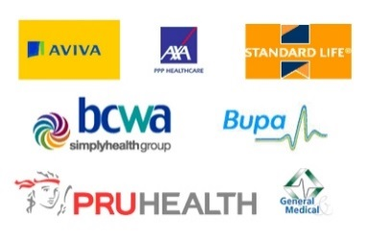 Premiums are based on a number of factors, including age, gender, state of health and pre-existing medical conditions, among others. The premiums increase as the policy holder gets older or if they make an insurance claim for treatment. Medical insurance also excludes chronic conditions that require permanent or prolonged treatment, or routine dental treatment and cosmetic surgery, except when required following a disfiguring illness or an accident.

PMI excludes cover for ‘pre-existing’ conditions. For example, if someone has a history of heart disease then cardiac surgery would be excluded. Cancer patients with private health insurance discover that their policies fail to cover them for the full course of their treatment. Vital therapies are excluded from the cover such as chemotherapy and certain breast cancer treatments.

Rosemary Thompson's story

The cost of the insurance is high, averaging about £1,000 per year, and it increases as a person gets older. Increases in long-term care premiums are forcing many elderly people to abandon plans despite having already poured thousands of pounds into them. In 1993, when she was 71, Cambridge resident Rosemary Thompson signed up to a £36.76 a month plan from Axa PPP. It was meant to provide her with £100 a week if she needed care. She paid in £36.76 a month for 11 years. In 2004 Axa PPP told her to choose between increasing the monthly premium to £64 or face a benefit cut to £75 a week. As she was on a fixed income she could not afford the extra premium so was forced to write off all the money she had invested.

In 2010, the elderly could be charged as much as £2,000–£3,000 a year, even for basic private medical insurance cover. Even a healthy 40-year-old male with no dependants will be charged £500–£750 a year for PMI with restrictions around the amount of out-patient care offered. A luxury plan with no restrictions will cost a 40-year-old in London more than £2000 a year.

MCj03340280000[1]The Labour government was opposed to offering tax incentives for private medical insurance. Labour ended tax relief on private medical insurance when it came to power. The Conservatives want to see the private sector expand both by making the NHS buy more private care and by encouraging a greater take-up of private health insurance.

There are several private insurers providing health insurance such as AXA PPP, BUPA, Norwich Union and Standard Life. The cost of premiums is high to cover administration costs, the cost of private operations and the profits of the private health care providers. Some examples of the cost of private operations are:

• Cataract removal £1,800–£3,000

• Coronary artery bypass graft £13,500–£17,500

• Cruciate ligament repair £3,750–£4,800

• Epidural injection £650–£1,000

• Hip replacement £7,200–£10,000

• Vasectomy £300–£900

• Vasectomy reversal £1,000–£2,200

• Wisdom teeth extraction £1,100–£1,400

### Table: The extent of Private Medical Insurance cover in the UK

|  |  |  |
| --- | --- | --- |
|  | 2002 | 2009 |
| Persons covered by PMI | 6.9 million | 7.2 million |
|  |  |  |
| PMI providers |  |  |
| Company paid schemes | 4.71 million | 3.05 million |
| Personal sector schemes | 2.00 million | 1.06 million |
|  |  |  |
| Value of UK market | £2.9 billion | £3.58 billion |
| Claims of UK market | £2.2 billion | £2.8 billion |

Source: Adapted from Laing and Buisson’s Private Medical Insurance UK Market Report 2010

Laing & Buisson says the drop in demand for medical insurance in 2009 was the biggest it had seen in almost 30 years of monitoring the market.

Given the depth of the recession, however, a fall of some 5% could be seen as a sign of product strength. "Certainly, private medical cover retains its popularity with employers," said Philip Blackburn, author of the survey report.

|  |
| --- |
| **Task 10: Private medical Insurance:**  Your teacher will assign you a PMI company to prepare an investigative report on. You will then present your report and findings to the rest of the class. You should include:  • Company details  • what policies cover  • how much it costs  • examples of treatment costs  • whether you advise taking out a policy or not |

## Private hospitals

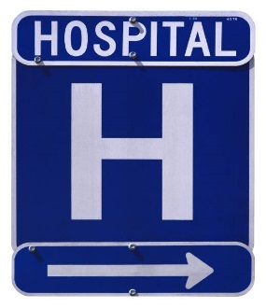

Private health care provided an estimated £25.5 billion in health services in 2013. There are about 230 independent hospitals. More than half of them run by the three main providers – General Health Care Group, BUPA and Nuffield Hospitals.

The private sector performs about 20% of all non-urgent surgery, one-third of all hip replacements and almost half of all abortions. There are also about 3,000 ‘pay beds’ in the NHS, about half of which are in dedicated private patient units.

Private medical insurance accounts for 75% of the income in the private sector with 20% from direct payments by patients and about 5% from treatment funded by the NHS.

## Scotland

## Ross Hall Hospital

Scotland has nine private hospitals, with a total of 900 beds available for patients who pay for their health care. These include Murrayfield Hospital in Edinburgh, Ross Hall and Nuffield in Glasgow, Abbey Carrick Glen in Ayr, Abbey King’s Park in Stirling, Fernbrae in Dundee and Albyn in Aberdeen.

In 2002 the Scottish Executive block-booked spare beds in Scotland’s private hospitals at a cost of £4 million in a bid to cut waiting lists. Since then, the numbers of NHS patients who have had their operations done privately has increased four-fold and the government has bought the Golden Jubilee National Hospital to cut waiting times across Scotland for cardiac conditions and for those seeking hip and knee replacements, cataract surgery, general surgery, plastic surgery and diagnostics. However, there are still concerns that a major expansion of the private health market would mean a contraction of the public sector because both sectors rely on the same pool of staff and these staff get paid more for their private sector work.

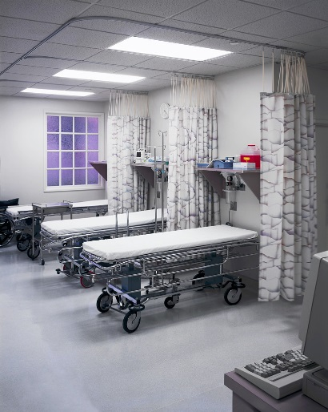Further, private hospitals in Scotland continue to enjoy major increases in business because of the *increase* in NHS waiting lists. In 2008, in-patient and day-case waiting lists between March and June increased by 4,215 to 86,549. As a result some private hospitals in Scotland had a 40% rise in the number of people opting to spend thousands of pounds on their treatment in order to jump the queues.

These patients are painful but non-urgent conditions such as hernias, varicose veins, cataracts and hip and knee replacements are paying for their own care to avoid the long wait for free treatment on the NHS. Over 7,400 patients out of 34,150 who were admitted for inpatient or day patient treatment at Scotland’s acute private hospitals in 2008 paid out of their own pockets.

The private sector provides most of the residential provision for elderly and physically disabled people and, with almost 70 independent mental health hospitals, more than half the health service’s medium-secure places for seriously mentally ill patients are now provided independently.

## Task 11: Private Hospitals

Answer the following question in detail:

- Do you think the use of private hospitals over the past decade has helped or hindered the NHS and people of Scotland?

## Public Private Partnership (PPP)

The PPP, also known as the Private Finance Initiative (PFI), is a way of using private-sector finance to build hospitals. Under a PFI, a private-sector consortium pays for a new hospital. The local NHS Trust pays the consortium a regular fee for the use of the hospital, which covers construction costs, the rent of the building and the cost of support services. This means that most new NHS hospitals will be designed, built, owned and run by a consortium or group of companies. A consortium usually consists of a construction company, a bank or financier, a facilities management contractor and consultants.

The NHS will employ some of the staff – mainly doctors and nurses – and will rent the building and other facilities from the consortium for at least 25 years. Most of the staff including the domestics, catering, porters, security and maintenance staff will be employed by a private contractor.

PFI hospitals usually have a private wing or even a separate private hospital next door. Equipment and facilities are shared between NHS and private patients. New PFI hospitals have fewer beds than the services they replace.

The medical care will remain free but even within the public part of the hospital there will be a growing introduction of charges, perhaps presented as optional extras. If you want better food or more privacy then you will have to pay for it.

### http://comps.fotosearch.com/comp/LIQ/LIQ119/plus-sign_~vl0004b007.jpg*Benefits of PFI*

• The government can have new hospitals built in the short term without having to raise the finance and passing the cost on by increasing current tax rates or by reducing other spending.

### *Arguments against PFI*

• The additional costs of funding PPP hospitals are passed on to future taxpayers who have to pay the charges. To pay for the building work, the private companies borrow the money from banks at high rates of interest as they aim to make a profit. This also includes going for cheap options, which are likely to reduce the quality of care.

• The contracts setting up PFI hospitals are not made public and there is little or no competition for these contracts, meaning the companies involved make huge profits.

The Skye Bridge, built in 1995, cost £15 million and in the seven years it was run by the Skye Bridge Company they earned £50 million: £23 million from the tolls and £27million from the Scottish Government’s buyout. The capital value of the PFI hospital in Norfolk and Norwich is £214 million. If similar levels of profit are made on this project the taxpayer could be charged over £1 billion for the facility.

• Staff employed by the PFI hospitals will find their jobs, pay and conditions squeezed to achieve ‘efficiency savings’ for the Trust and to boost profits for the consortia.

## Task 25: Public Private Partnerships

Make detailed notes on

– how they work

– arguments for

– arguments against

• compulsory competitive tendering

– how it works

– its impact on the NHS.

Use these notes to answer the following essay question:

Practice Essay:

## “Evaluate the impact of the private sector on the NHS.” (12 marks)

**To conclude:**

Britain is one of the richest countries in the world

Britain suffers from large inequalities in terms of Health and Wealth

Gender inequalities and racial inequalities are also particular problems

The governments of Britain and Scotland as well as local councils have policies to try to deal with inequalities