**Policies to deal with Wealth Inequalities**

**Policies to deal with wealth inequalities**

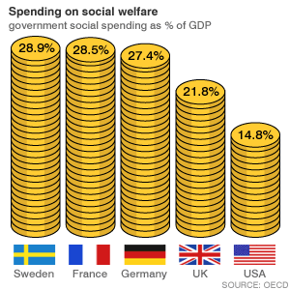The central theme of government social policy since 2011 is to encourage people to work and to offer them the support they require to find and keep a job. The government has designed its social policy around getting the unemployed off of welfare and into work by simplifying the various welfare to work programmes into one so that everyone can more easily access support available. This will also make it more difficult for individuals to avoid the programme and so claim benefits without looking for work.

It has increased the financial attraction of work by increasing the tax threshold (the amount a person can earn before they have to start paying tax) as well as ensuring that couples gain more from their tax credits The government also fully supports the National Minimum Wage and will endeavour to raise it in accordance with inflation to ensure work is the most attractive option. The government also introduced a new Work for Yourself initiative which made it easier for people wishing to start up a new business to find investment and support, as well as introducing Work Clubs so that unemployed can meet, share skills and offer support to others. The government aims to help people find work through these ventures. The government tries to reduce the ‘attractiveness’ of benefits by ensuring benefits such as Job Seekers Allowance are time limited and by allowing benefits to fall as a proportion of average incomes. Therefore there is an increased difference between the incomes of those in work and those who are not, which is aimed to increase the attraction of work.

The previous government set a specific target to reduce child poverty. It targeted more support for families with dependent children, both through tax credits and through other initiatives such as Sure Start. The government has committed itself to reducing Child Poverty and one of the key ways it aims to achieve this is by ensuring that Sure Start is invested in so that families in difficulty find it easier to gain support, be it financial, practical or emotional.

**Current Measures taken to increase levels of employment:**

* Universal Credit
* Work for Yourself
* Work Clubs
* National Minimum Wage
* Childcare and Tax Credits
* Modern Apprenticeships

**Measures taken to provide income for those not employed:**

• Jobseeker’s Allowance (being phased out)

• Pension Credit (replaced and enhanced Minimum Income Guarantee for Pensioners)

• Winter Fuel Payments

• Changes to income tax and National Insurance contributions

## Task 1: Employment initiatives

## You are a Labour policy advisor in charge of re-designing Labour’s Welfare to Work policy in time for the next General Election. Your class will be divided into 6 small groups, each of which must advise the Labour party of the strengths and limitations of one of the Government’s policies.

* Universal Credit
* Work for Yourself
* Work Clubs
* National Minimum Wage
* Childcare and Tax Credits
* Modern Apprenticeships

In order to complete this task successfully, you will have to consult both Conservative Government policies on the initiative as well as Newspaper articles commenting upon the effectiveness.

[www.direct.gov.uk/](http://www.direct.gov.uk/) is a very useful website to look at for up-to-date figures on the benefit system.

**Measures to increase levels of employment**

**The Coalition’s government ‘Universal Credit’**

Universal Credit is a new benefit that has started to replace 6 existing benefits with a single monthly payment into your account. Universal Credit will help you to be better off in work, start a new job or work more hours. Universal Credit started to be introduced in stages from April 2013 and is increasingly available in each part of Great Britain during 2016. It will consist of a basic personal amount (similar to Jobseeker’s Allowance) with additional amounts for disability, caring responsibilities, housing costs and children.

Universal Credit will eventually replace:

* Income-based Jobseeker’s Allowance
* Income-related Employment and Support Allowance
* Income Support
* Working Tax Credit
* Child Tax Credit
* Housing Benefit

## Making work pay

There are no limits to the number of hours you can work a week. Your Universal Credit payment will reduce gradually as you earn more - you won’t lose all your benefits at once if you’re on a low income. It is expected to be withdrawn at a constant rate of around 65 pence for each pound of net earnings.

How much you’ll receive depends on your personal circumstances, but Universal Credit will be payable in and out of work so the complicated rules that apply currently when people start and leave a job, including hours rules, will disappear, improving the incentive to work.

## How you’ll be paid

Universal Credit is paid differently to current benefits. It’ll be paid once a month into your bank or building society account.

Any help you get with your rent will be included with your Universal Credit payment and you’ll then pay your landlord yourself.

### Work for Yourself

*Work for Yourself* will be rolled out as a high-profile national scheme. It will be distinct from other aspects of the Work Programme and will include:

• training and practical advice for would-be entrepreneurs delivered by business experts with a track record of success;

**•** business mentors who are given incentives to establish commercially viable businesses which stand the test of time;

**•** government support in obtaining loan funding from the Small Firms Loan Guarantee Scheme for each participant to provide an injection of working capital in order to get new businesses going;

**•** additional support to obtain capital to kick-start a new business, for people who want to operate a franchise; and

### • continued JSA payments for *Work for Yourself* participants for a six month period.

### Work Clubs

Work Clubs are a progression from existing Job Clubs, which are a voluntary, community based response to local unemployment. The key priority for a Job

Club is to provide access to a wide range of support to those looking to find work, bringing together local businesses, statutory agencies, educational organisations and volunteering bodies. In addition they offer a much needed friendly ear, emotional support and a place to go on a weekly basis to keep motivated and meet others in the same predicament.

Job Clubs are all different, some welcome 100 plus people on a weekly basis whilst others support 10 to 15 individuals. Some run workshops on communication skills and interview technique, others run job fairs. Each Job Club is tailored to meet local needs. In December 2008 Hazel Blears admitted to being surprised to find that only 10% of jobseekers found employment through Job Centre Plus, whilst 30% found jobs through family or friends. The local Job Clubs seek to exploit that statistic by encouraging people to develop social networks.

### The National Minimum Wage

The National Minimum Wage (NMW) was introduced to set a base level of hourly income for low-paid workers in the UK. The NMW for an adult (21 and over) is £6.70 per hour in 2016, £5.30 per hour for workers aged 18-21 inclusive and £3.87 per hour for all workers under the age of 18, who are no longer of compulsory school age. There is a separate amount of £3.30 for those in an apprenticeship. National Minimum wage is designed to encourage more workers to find jobs because it will be a better financial option than remaining on benefits. The amounts paid change every October so make sure you stay up to date with these figures. From April 2016, the national living wage will be £7.20 an hour for workers aged 25 and older. The minimum wage will still apply for workers aged 24 and under.

### Childcare and Tax Credits

Originally introduced as Working Families Tax Credit, this tax adjustment was extended to all low-paid workers to encourage an increase in net income to create a larger difference between these workers and those remaining on benefits, aiming to end the ‘benefit-trap’. Working Tax Credit (WTC), allows low-paid workers to retain more of their wages. By getting a tax credit they pay less tax on their gross wage and therefore take home more income. The NMW in combination with WTC has significantly increased the difference between those in work and those remaining on benefits by choice. You can get extra tax credits to help pay for some of your childcare costs while you’re working. You cannot claim Child Tax Credits and Universal Credit at the same time.

You can get a ‘basic element’ amount of up to £545 per year. In addition to this, you can get. You can’t get 100% of your childcare costs and how much you get depends on things like:

* your income
* how often you pay for childcare

**Childcare Vouchers**

Workers can also claim Childcare Vouchers, which is an extra tax-free allowance of £243 per month. This can only be redeemed by a registered nursery or childminder and so only those in work using childcare can benefit. Childcare Vouchers can interfere with the amount of Tax Credits that an individual can receive. Childcare Vouchers are usually used by individuals earning higher incomes.

### Modern Apprenticeships

The aim of Modern Apprenticeships was to help address the perceived decline in the number of people holding intermediate level vocational qualifications. Apprenticeships take between 1 and 4 years to complete depending on their level and they combine practical training in a job with study. Anyone who is 16 or over and not in full time education can apply by using the online database or by arranging their own apprenticeship. During their training, an apprentice:

* works alongside experienced staff
* gains job-specific skills
* earns a wage
* studies towards a related qualification (usually 1 day a week)

80% of firms acknowledged that involvement with Modern Apprenticeships has encouraged them to recruit more young people or provide better training. The main benefits of Modern Apprenticeships to businesses were found to be:

* the development of a workforce with recognised qualifications
* a better trained workforce
* training taken more seriously by recruits
* benefits in recruiting the right people
* staff retention.

**Education Policy**

The government has also introduced significant changes to education in England and Wales in order to better prepare individuals for the world of work. One of the key changes is the introduction of Academies or ‘free schools’.

The following information is basic information on academies. You will be completing a group task to find out more about Academies and their effectiveness.

The following information is adapted from the BBC news article dated 3rd Septermber 2012

Basic

**What is a free school?**

Free schools are set up by groups of parents, teachers, charities, businesses, universities, trusts, religious or voluntary groups, but funded directly by central government.

They can be run by an "education provider" - an organisation or company brought in by the group setting up the school - but these firms are not allowed to make a profit.

The schools are established as academies, independent of local authorities and with increased control over their curriculum, teachers' pay and conditions, and the length of school terms and days.

**What sorts of groups have applied to set up free schools?**

In the first round, there were 323 applications; 115 were from faith groups. Chains behind academies also came forward to set up schools. Applicants included the journalist Toby Young, who went on to set up the West London Free School, which opened last September and Katharine Birbalsingh, the teacher who strongly criticised the state education system at the Conservative party conference in 2010.

**What money is available for free schools?**

Free schools will receive no additional money per pupil for their day to day running. Funding is worked out on a per pupil basis, like other schools.

A total of £50m - taken out of an axed technology fund for schools - was initially allocated for free schools for the first year of the policy, up to April 2011. And in November 2011, the government announced it had ear-marked an extra £600m on building 100 new free schools in England over the next three years.

The Department for Education said last year that the first 24 schools would cost a total of £110-130m, but many of these were opened in temporary buildings and details of the cost of acquiring many buildings have not been revealed so the cost of permanent accommodation is not clear. Cost vary widely, depending on the size, location and circumstances of the school.

**How will free schools be regulated?**

They will be subject to inspections by England's schools watchdog, Ofsted, just as other schools are, usually within two years' of opening.

Their Sats (primary national curriculum tests), GCSE and A-level results will be published in league tables in the same way as those of other state schools.

Free schools do not need to employ qualified teachers and anyone can work in them. This means that individual staff members cannot be regulated by the General Teaching Council, as they would be in other schools.

**What do critics say?**

The government says the free schools programme gives parents and teachers the chance to create a new school if they are unhappy with state schools in a local area, and that competition will drive up standards.

But critics - including the Labour party and several teachers' unions - say they will prove divisive, are likely to be centred disproportionately in middle-class neighbourhoods, to weaken already weak schools by attracting the best performing pupils, and will contribute to creating a two-tier system.

There are also fears the changes will give too much freedom to faith-based schools or fundamentalist agendas - although schools must show their curriculum is "broad and balanced" and government guidelines say creationism must not be taught as a valid scientific theory.

And some critics are angered by the funding and administrative time going into what they consider to be a "pet project" promoted by the education secretary, which looks likely to benefit relatively few children at a time of spending cuts in education and youth services.

Teachers' unions are also critical of the fact that free schools do not have to employ qualified teachers.

Meanwhile, others say Mr Gove has missed an opportunity by not allowing free schools to be run for profit.

## Measures to provide income for those not employed

MCj02333090000[1]

### Jobseeker’s Allowance (JSA)

Jobseeker’s Allowance (JSA) is paid to unemployed people who are actively seeking work, not in full time education and between 18 and retirement age. You can receive JSA if you and/or your partner work less than 24 hours per week.

Before an individual can claim JSA they must have a JSA interview. At this interview a Jobseeker’s agreement will be made and signed. This agreement will include promises such as what a claimant will do to help them find work and to make them more employable. The claimant has to ‘sign on’ every two weeks or when asked to if more frequently. When ‘signing on’ the claimant has to show how they have been actively seeking work.

The amount of JSA varies according to circumstance, but the 2016 figures are:

|  |  |
| --- | --- |
| Status | Weekly amount |
| Single (under 25) | £57.90 |
| Single (25 or over) | £73.10 |
| Couples (both aged 18 or over) | £114.85 |
| Lone parent (18 or over) | £73.10 |
| Lone parent (under 18) | £57.90 |

## http://news.bbc.co.uk/nol/shared/spl/hi/pop_ups/05/business_comparing_welfare_states/img/5.jpg

|  |  |
| --- | --- |
|  |  |
|  |  |

### Income Support

The government are trying to phase out Income Support in accordance with their plans to streamline the benefit system. Income Support is currently only available to those between 16 and retirement who are not working and not seeking work because they are a carer, a lone parent with a child under 5 or long term sick/disabled so unable to work

Like JSA, the amount you receive will depend upon your personal circumstances, but it ranges from £57.90 for a single person to £114.85 for a couple, both of whom are aged 18 and over.

These rates are standard rates, but they can be combined if individual circumstances necessitate. For example, a carer of a child under 5 who is disabled will receive more than a carer of an under 5.

Those not normally be entitled to Income Support include:

* people working 16 hours or more a week
* people with a spouse or partner working 24 hours a week or more
* people studying full-time (although there are exceptions for certain single parents, certain disabled people, and certain students estranged from their parents)
* those with capital or savings over £6000

Other benefit entitlements for those in receipt of Income Support:

• Housing Benefit and Council Tax Benefit

* + Housing Benefit can cover all or part of an individual’s rent, but will not cover heating or other costs. However, the amount received will be reduced if the property has an empty bedroom. The so-called “bedroom tax”

• Health cost assistance - for example free prescriptions (In England and Wales), free NHS dental treatment, vouchers for glasses, and help with fares to hospital for hospital appointments

• Free school meals (from P4 onwards)

Income Support is normally paid directly into a bank or building society account.

### Pension Credit and Pension Savings Credit

Pension Credit guarantees a minimum income for people of pensionable age. In 2015, a single pensioner with an income under £151.20 per week would receive a pension credit to make up the difference. For example, a pensioner with a combined state pension and occupational pension of £120 will receive pension credit of £31.20. For a pensioner couple the threshold is £230.85.

Those who have additional needs, such as caring responsibilities, or those who are severely disabled or have particular housing costs may be entitled to more.

Savings Credit is an extra payment for people who saved some money towards their retirement, e.g. a pension. A single pensioner can receive up to £14.82 while a married couple can receive up to £17.43 per week.

MCj02857880000[1]Everyone aged over 75 gets a free TV licence.

### Winter Fuel Payment

Winter Fuel Payment is paid to pensioners once yearly at the start of winter to help meet the costs of keeping their homes warm. The rates vary between £100 and £300 depending on age and other benefits claimed.

|  |  |  |
| --- | --- | --- |
| **Situation** | **Born on or before 5 January 1953** | **Aged 80 or over** |
| You live alone or are the only person in the household who qualifies | £200 | £300 |
| You receive other benefits. | £200 | £300 |
| You live with another qualifying individual | £100 | £200 if they are under 80.  £150 if they are over 80 |

**Universal Benefits**

These are benefits that you can receive regardless of whether you work or not. They don’t help to reduce wealth inequalities as such, but it is still important that you know about them.

* child benefit
* pension

**Child Benefit**

Child Benefit is a four-weekly payment to anyone responsible for a child under 16 (or under 20 if they stay in approved education or training), but only one person can get Child Benefit for a child. If an individual has an income of over £50,000 they may have to pay a tax charge on their child benefit.

The current rates are £20.70 per week for the first child and £13.70 per week for any subsequent children.

**Pension**

The basic State Pension is a regular payment from the government that you can get when you reach State Pension age, which is currently 65 for men and 66 for women but increases to 68 for both by 2020. To get it you must have paid or been credited with National Insurance contributions (credited with NI contributions, instead of receiving childcare benefits.)

The most you can currently get is £115.95 per week for an individual and £185.45 per week for a couple.

## Task 2: Help for the unemployed and elderly

One of you should design a leaflet to be handed out to the unemployed which clearly explains the benefits which they are allowed. Your leaflet should include the following:

• Jobseeker’s Allowance

• Income Support

The other person should design a leaflet for pensioners which clearly explains the benefits which they are allowed. Your leaflet should contain the following:

• Pension and Pension Credit

• Winter Fuel Payments.

## Other initiatives to tackle social exclusion

## Task 3: Sure Start

Use the information below to answer the Enquiry Skills Question which follows.

## Source A

**What is a Sure Start centre?**

Sure Start children’s centres are defined in the Childcare Act 2006 as a place or a group of places:

* which is managed by or on behalf of the local authority to ensure that early childhood services in the local authority’s area are made available in an integrated way
* through which early childhood services are made available (either by providing the services on site, or by providing advice and assistance on gaining access to services elsewhere)
* at which activities and/or childcare for young children are provided



Early childhood services included are:

* early years education and childcare);
* social services to support young children, parents and prospective parents;
* health services to support young children, parents and prospective parents;
* training and employment services to assist parents or prospective parents;
* information and advice services for parents and prospective parents.

Much is therefore expected of Sure Start centres. The Minister described them as

**“a gateway for families “[...] a one-stop-shop that gives them access to a wide range of services available locally”.**

The Coalition Government’s new “core purpose” for children’s centres, developed in collaboration with local authorities and early years staff, is

**“to improve outcomes for young children and their families and reduce inequalities between families in the greatest need and their peers in: child development and school readiness; parenting aspirations and parenting skills; and child and family health and life chances”.**

This is intended to “provide a greater scope for local authorities and children’s centres to better respond to local need, helping to take Sure Start back to its original purpose of early intervention”.

# Source B

# Hundreds of Sure Start centres have closed since election, says Labour

Adapted from a Guardian news article dated 28th January 2013

More than 400 Sure Start children's centres have closed during the first two years of the coalition government, with over half of those still open no longer providing any onsite childcare, according to Labour. Despite claims by the prime minister, David Cameron, before the last general election that he "backed" Sure Start, Labour says £430m was cut from English local authority Sure Start budgets between 2010-11 and 2012-13.

Ministers have said that of the 401 closures, only 25 were what it termed "outright closures". The other 376 centres were reduced by reorganisations, including the merger of two or more centres. A Department for Education spokesperson said of the Labour figures: "This is nonsense. There are over 3,000 Sure Start centres in England and as this PQ [parliamentary question] states just 25 have actually closed, less than 1%. They are open to all and targeted at the poorest children. "Less than 4% of full daycare is offered by Sure Start centres. We will give poorer two-year-olds 15 hours of free childcare every week and we are reforming funding arrangements to make sure more money goes to the frontline.”

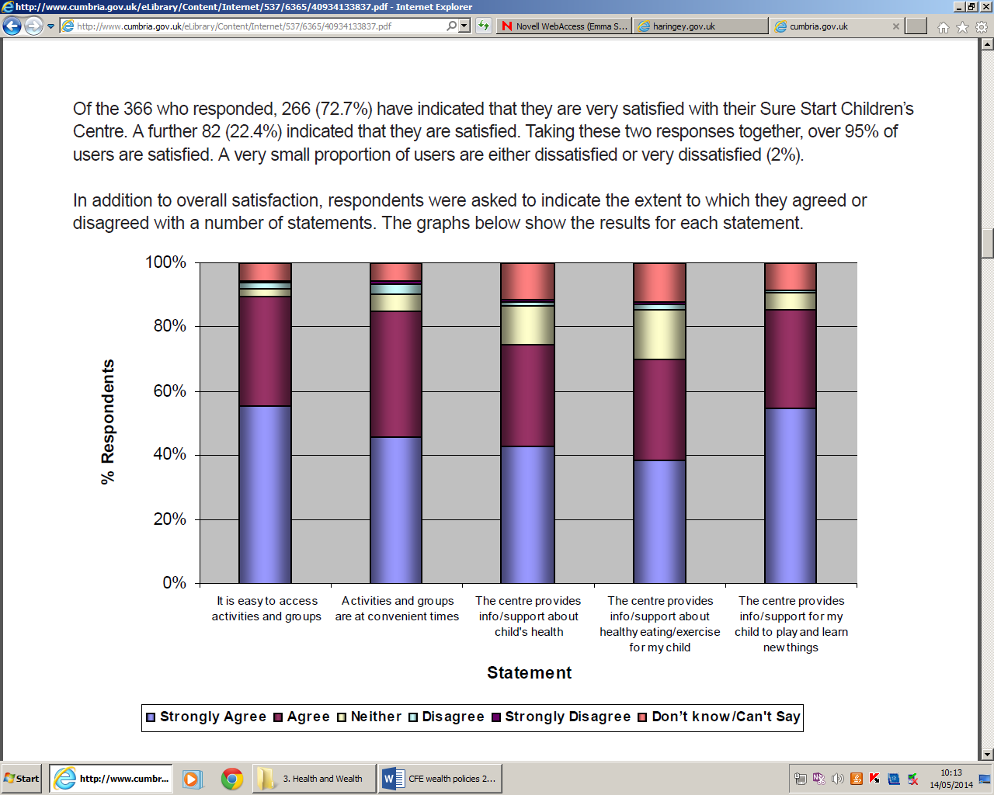Labour cites a census of 500 Sure Start children's centres published by the 4Children charity last July, which showed that 55% had abandoned onsite childcare, and a fifth were charging for services that were formerly free. A fifth had reduced the number of qualified teachers and a further 20% reported they would have to reduce childcare staff. That report concluded that despite heavy cuts, many local authorities had tried to protect Sure Start funding, and children's centres were "a picture of resilience and creativity". But 4Children warned that this "impressive fortitude" may not be sustainable in the long run.

Source C

Respondent’s views on Sure Start Centres.

Attempt the following question, using **only** the information in Sources A, B and C above.

What conclusions can be drawn about the effectiveness of Sure Start?

You must draw conclusions about:

• the links between the aim of Sure Start and the impact of funding

• the links between the aim of Sure Start and the numbers using the services

You must give an overall conclusion on Sure Start **8**

## Task 4 – Investigation Practice

The government has recently made a lot of changes to its pension policy to try and ensure that there is enough funds in the pension pot so that everyone entitled to the state pension will receive one upon retirement. Currently, we have an aging population and less people working and paying taxes which means the current situation is unsustainable.

Your task is to investigate whether these measures are likely to be successful or not.

You should complete your investigation in the same way you completed your N5 Value Added Unit. Your hypothesis is,

**“Current government pension policy will not prevent a pension shortfall in the future”**

In order to fully research this, you should:

* Choose two different sources of information on the Government’s pension policy and its effectiveness.
* Evaluate the usefulness of each source.
* Write an 8 mark response, which clearly shows and justifies whether you support or oppose the hypothesis.

## Practice essay

Analyse different government policies in tackling inequalities in wealth. (12)