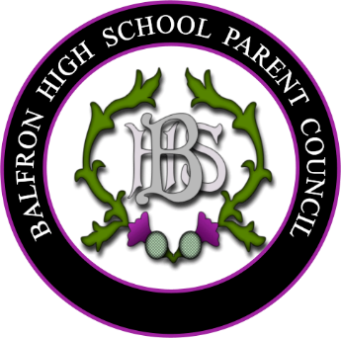


AGENDA Parent Council Meeting 9th September 2025
(6.30pm Strathendrick Suite, Balfron High School)

1. Welcome and Introductions
2. Parent Council Update
3. Election of new volunteers for the Committee, election of Chairperson and
Vice Chair
4. Head Prefect’s introductions
5. Scott Kennedy- Forth Environment Link
6. Headteacher’s Report
7. Treasurer’s report
8. Blazer Buy Back Scheme (Balfron Clothing Company)
9. Fundraising & BHS School Lottery update
10. Parental queries- to be emailed in advance of meeting to
balfronhighschoolpc@gmail.com
11. AOB
12. Dates of next meetings:
• 18th November 25 (online- TBC)
• 20th January 26 (online- TBC)
• 17th March 26 (in person)
• 12th May 26 AGM (in person)

