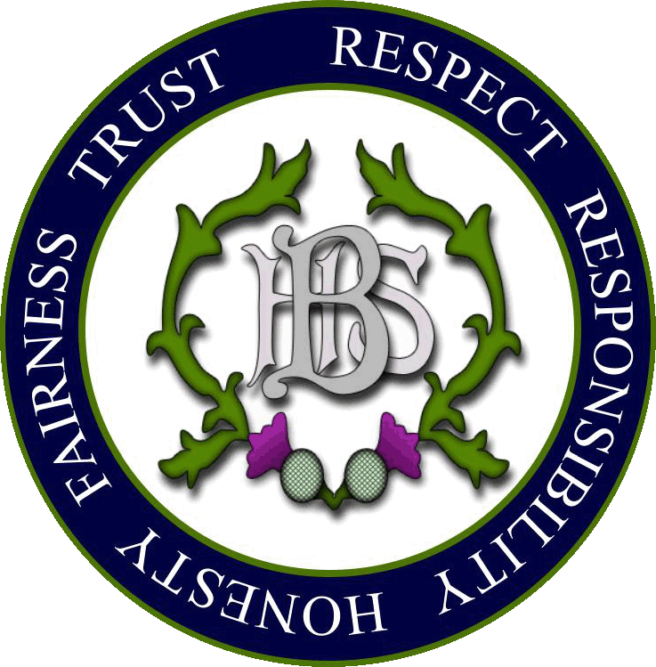
Balfron High School
Our Skills Rationale & Framework

‘Education is the passport for the future,
for tomorrow belongs to those who prepare for it today’
- Malcolm X

Our vision
We are committed to providing a caring, inclusive and high achieving school community where young people have a positive and meaningful experience. We have high expectations and are ambitious for all of our young people. We are committed to ensuring that they are equipped with the resilience and mind-set to compete and contribute confidently and compassionately in a modern, ever changing world. We recognise that the right blend of knowledge, skills, attributes and qualifications will provide the foundation for our young people to succeed in life beyond school.

Rationale for embedding key skills into the curriculum and L&T at Balfron High School

A young person is entitled to opportunities to develop skills for learning, life and work, focusing on literacy, numeracy and health & wellbeing

Curriculum for Excellence – Learner Entitlements

We know that learners remember more effectively when they can use skills to access, process and express their knowledge. We see this in the classroom when they teach and assess each other or share thoughts and ideas. An active or project-based approach that draws on the development and use of skills is far more engaging and relevant than simply listening to a lecture. We are committed to providing opportunities for young people to develop skills at the same time as they acquire knowledge.

The Balfron High Skills Framework has been devised to ensure that our learners:

- are effective and successful learners with high levels of attainment and achievement
- are equipped and ready to adapt and succeed in a changing modern world
- can transfer these skills innovatively into a range of contexts – learning, life and work
- are prepared to confidently lead and contribute while working responsibly and ethically
The Balfron High Skills Framework
- communication
- digital intelligence
- emotional intelligence
- innovation & problem solving
- leadership
- thinking

We recognise that key skills are planned and delivered in the Broad General Education (BGE, S1-3) through the Experiences and Outcomes and are assessed through the Benchmarks. The purpose of our skills framework is to complement these while recognising that future developments will continue to impact our changing, modern world. We believe that these skills will best prepare and support our learners in navigating these changes.

Developing skills in the BGE
communication
Technologies
Sciences
RME
Numeracy & Maths
Languages
HWB
Expressive Arts
Social Studies
digital intelligence
Young people at Balfron High will
develop skills in the contexts of the
emotional intelligence
curriculum. This will include
courses and programmes,
innovation & problem solving
Inter-Disciplinary Learning, through
our ethos - inter-house, clubs, trips
leadership
and activities and personal
achievements.
thinking

In all lessons, learning intentions and success criteria are linked to Blooms, skills for learning - remember, understand, apply, analyse, evaluate and create. These are our thinking skills. We believe that the Balfron High Skills Framework will complement and enhance learning and engagement when they are developed side-by-side.

The Balfron High Skills Framework should be integrated and sign-posted in all lessons in the same way as Blooms thinking skills are explicit in learning intentions.

How did we get here?

- Building the Curriculum 4 (Education Scotland)
- Skills 4.0 (SDS)
- Skills Framework (SQA)
- Consultation with Balfron High DYW group
- Consultation with Balfron High Partners
- Consultation with Balfron High Learner DYW group
- Consultation with the Balfron Learning Community
- Consultation with 21st Century Stirling Council Skills Group

So what now?

- PTs awareness raising and feedback discussion
- Inclusion in SIP and TIP 2019-20
- Staff awareness raising session / CLPL 2019-20
- Pupil assemblies – DYW ambassadors with T Patrick
- Included in lessons and programmes of work from 2019-20
- Review and improve

Impact & Evidence
We will test the impact and look for the following evidence:

- Pupils will be able to talk about their skills development and progress within our framework
- Skills will be reflected in the S3 profile
- Teachers and SLAs will plan activities to signpost skills development
- Classroom observations will confirm the extent to which skills are embedded
- Attainment, wider achievement & destinations will be tracked and analysed

