**Higher Modern Studies**

**International Issues**

**USA**

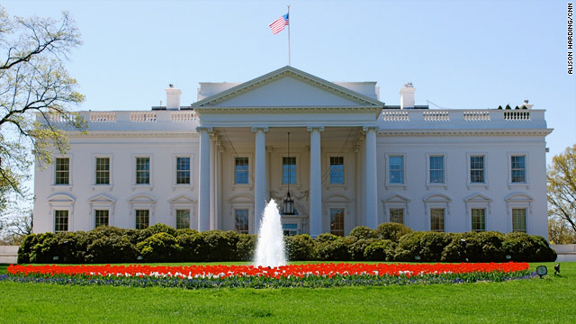

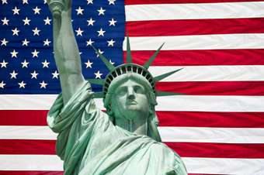

Introduction:

This section will explore the political power held by American politicians and the American people. By examining the powers the President of the United States possesses and the extent to which politicians can counter those powers, you will understand how the decisions over laws and policy in the US are made. Also, by looking at the election process you will gain an appreciation of the factors which determine support for political parties and the influence different groups have on politics in the USA.

**Section 1 – Political system**

[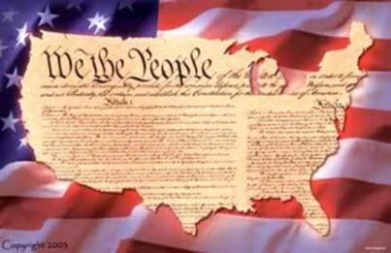](http://www.google.co.uk/url?sa=i&rct=j&q=&esrc=s&source=images&cd=&cad=rja&uact=8&docid=hnez6rQUIuWibM&tbnid=i3iqpFRsXqAqEM:&ved=0CAUQjRw&url=http://www.examiner.com/article/constitution-day-september-17-observed-by-pbc-students&ei=XLd0U9GmMciJ7AapyoHADw&bvm=bv.66699033,d.ZGU&psig=AFQjCNHdRessY-HhxLlXn5dBfmejJtJsPQ&ust=1400244399590213)**The US Constitution**

The Constitution is the written law that defines clearly the rights to be enjoyed by its citizens and where political power should lie. It is this document which helps to guard against dictatorship and exclusion from the political process. It is very difficult to amend the Constitution and so its laws are binding and long-lasting.

**Issues to be covered in this section**[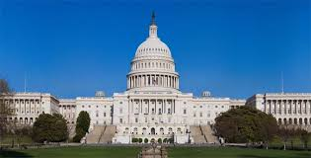](http://www.google.co.uk/url?sa=i&rct=j&q=&esrc=s&source=images&cd=&cad=rja&uact=8&docid=34wtJWsaqcUxdM&tbnid=QdNSXGZqCGN8hM:&ved=0CAUQjRw&url=http://www.diabetesmine.com/2012/10/the-politics-of-diabetes-in-election-season.html/112th-congress&ei=s7d0U97AM8yS7Ab244CoBw&bvm=bv.66699033,d.ZGU&psig=AFQjCNG55cPOS9vk8CNHoE-PHPGmxOCe4w&ust=1400244522227729)

1. **Separation of Powers**

* **Powers of the President**
* 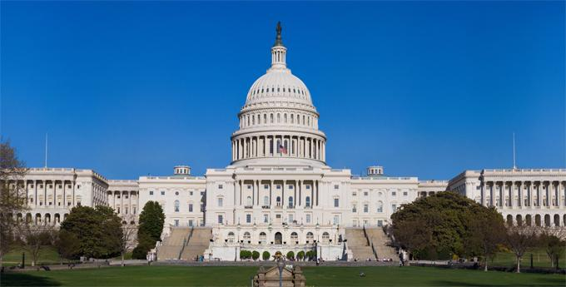**Power of Congress**
* **Power of the Supreme Court**
* **‘Checks and balances’ between each branch of government**

1. **Political progress**

* **Factors affecting support for main political parties**
* **Representation and participation among ethnic minorities**

**US system of Government**

**Separation of Powers**

The US government (or Federal government) has three branches that work together but also scrutinise the actions of one another. By having clearly defined powers in different institutions, there is no opportunity for one branch to become all-powerful or dominant. The powers enjoyed by each branch are clearly outlined in the constitution. The three branches are:

* 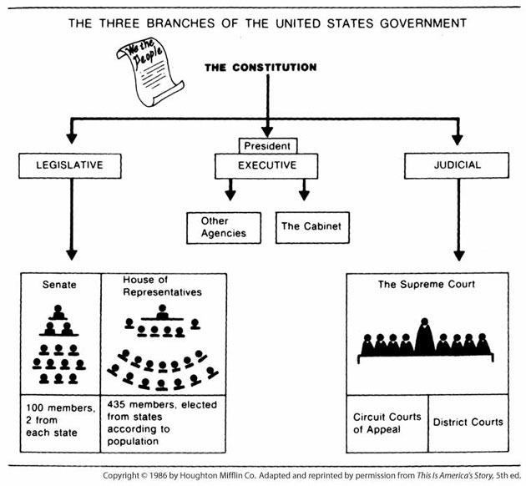The legislature
* The executive
* The judiciary

**The legislative branch** – This is the body which makes laws in the US. All laws must be discussed and voted on by the **Senate** and **House of Representatives** which make up the legislature (similar to the House of Commons and Lords in the UK Parliament).

**The executive branch** – This branch makes sure all the laws made by the legislature are carried out and implemented. Essentially, this means the **President** and the heads of each government department make sure laws are adhered to.

**The judicial branch** – The main judiciary in the United States is the **Supreme Court.** This bodyscrutinises and checks all laws that are passed by the legislature and enforced by the executive to ensure they are ‘constitutional’. If a new law is thought to go against the values and rights of the Constitution then the Supreme Court can force the law to be scrapped or amended to bring it line with the Constitution. For example, a law banning the use of all guns in America would be impossible because the Constitution clearly states that one of the rights of all US citizens is the right ‘to bear arms’ (own a weapon).

**Powers of the President**

1. Propose legislation

The President is not in the legislative branch of government but he can put forward ideas for laws. Each year, in the State of the Union Address, the President outlines to Congress and the American people which laws he feels should be written and implemented.

**Example** – President Obama submitted the proposal for The Patient Protection and Affordable Care Actin 2009 as his solution to the problem of millions of Americans being without health insurance and at risk of illness or death as a result. Obama took such a personal interest in the law that it is now commonly known as ‘Obamacare’.

1. 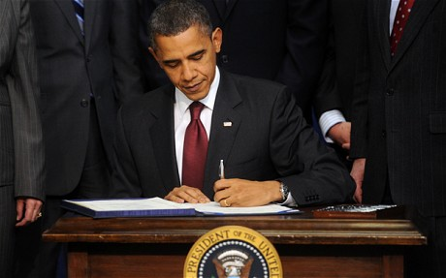Veto legislation

President has the power to veto any piece of legislation passed by congress. As the final stage of a bill is the President signing it into law, the President refusing to sign the bill can prevent the law from being finalised. The President will only do this if he feels the law is not in the interests of the American people.

**Example** - Barack Obama has used the Veto twice, the last coming in October 2010; the Interstate Recognition of Notarizations Act of 2010.

1. Submit the budget

It is the President’s responsibility to decide on how much spending will be carried out by government each year. This involves setting out what funding each State Department will be allocated.

**Example** – This is an annual procedure. Each year the President must set out the spending plan for the coming 12 months.

1. Selecting Ambassadors and Supreme Court Judges

[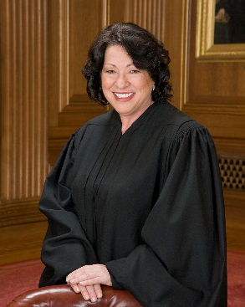](http://www.google.co.uk/url?sa=i&rct=j&q=&esrc=s&source=images&cd=&cad=rja&uact=8&docid=5wBqlJB6X2FDjM&tbnid=C-PqtWPID76MIM:&ved=0CAUQjRw&url=http://www.oyez.org/justices/sonia_sotomayor&ei=Qrl0U6u3DMLY7Aatk4HQCQ&bvm=bv.66699033,d.ZGU&psig=AFQjCNGM0iGg4NOLYUUIwqsDstt4r8lOHA&ust=1400244924092237)The United States has representatives in countries and institutions, around the world, such as the United Nations, Great Britain or Germany. It is their responsibility to discuss matters in which the US has an interest. If a country has an issue with an action the United States has carried out then the US ambassador to that country can be ‘summoned’ and the country in question’s concerns relayed. It is up to the ambassador to put across the reasons for the US being correct in its actions.

In the case of Supreme Court Judges, those in the Supreme Court must be of the highest calibre to be able to read and interpret complex and intricate pieces of legislation and make judgements about their legality. The nine judges who make up this body are responsible for decisions that could have consequences for the entire country.

It is the President who decides who will represent the interests of America well and so are worthy of taking up these posts.

**Example** - Barack Obama selected Sonia Sotomayor for the position of Supreme Court Judge, the first Hispanic to hold such a post. As Sotomayor had a liberal political outlook she would be more likely to look favourably on Obama’s and his Democrat party’s legislation, which would also be more liberal. Presidents tend to choose judges that have political views in line with their own.

1. Sending troops overseas

As Commander-in-Chief of the American armed forces, it is the President’s responsibility to ensure the safety and national security of the country. He is the highest military officer in the country and has the last say on actions during crisis situations. To ensure threats are neutralised before they spread to the USA, or if America’s interests overseas are threatened, the President can order combat troops in action in foreign countries. (However, he cannot declare full-scale war. This will be discussed later in the booklet.)

**Example** – In 2011, Barack Obama ordered the bombing of Libyan government military and administrative sites to help rebels in the country who were attempting to overthrow the long-time dictator of the country, Muammar Gaddafi. He did not seek Congressional approval as he did not believe this constituted full-scale war.

1. Negotiate treaties

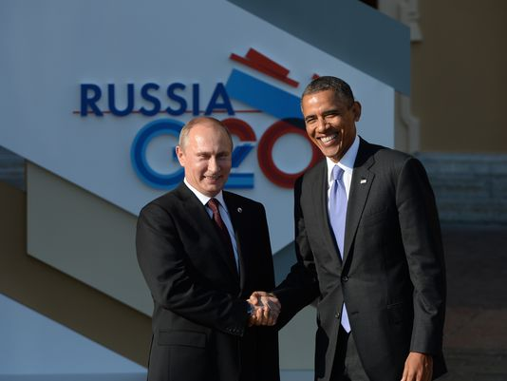The President will negotiate agreements, called treaties, with other countries which he believes will allow the countries who sign it to work better together. It is up to the President to get the best possible terms in each treaty he works on. Ultimately, he will only sign these agreements if he thinks it is in America’s interest to do so.

**Example** – In April 2014, Barack Obama signed a military treaty with the Philippines that would give America more freedom to use military bases in that country. It is claimed this will help keep peace in Asia. Critics say this is to counter the growing military might of China.

1. Executive Orders

As discussed previously, the President cannot introduce a law on his own without having it scrutinised and voted on by Congress. However, the President can implement an order that is in line with already existing laws. This may be outlining small details on how a law could be implemented better or dealing with an emergency.

**Example** – President Obama found it difficult to implement new legislation to curb climate change so his advisor John Podesta said in May 2014 that Obama would use executive orders to alter the already existing Clean Air Act to limit carbon emissions which cause global warming.

**Checks and balances**

To ensure there is no one branch of government that enjoys too much power, each can limit the power of the others. Mostly this will involve Congress or the Supreme Court limiting the powers of the President but there are examples of the President checking the other branches. It is important to understand how each power is checked / balanced and that you can analyse and explain how this power is checked.

1. Propose legislation

There are several checks and balances to the President’s power of proposing legislation;

**Congress**

* 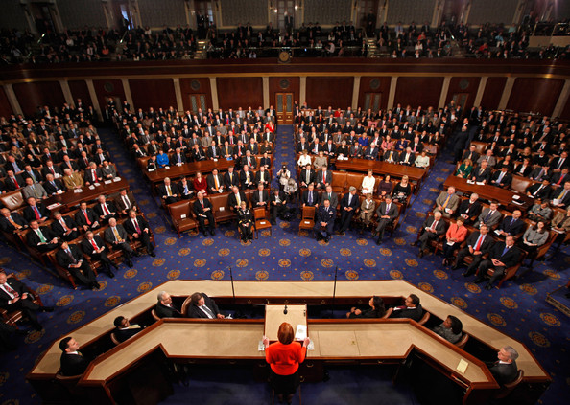While the President can propose the idea for a law, it must be a member of Congress which submits it to be discussed. The President cannot take the bill to Congress by himself. This means if a member of Congress cannot be found who supports the bill, and is willing to take the bill forward, it will not go any further. This helps prevents the President implementing poor laws which are not in the nation’s interest.
* Members of Congress must lobby on the bill’s behalf. This means persuading enough other members to vote yes to the President’s piece of proposed legislation. After lobbying has been done the bill will be voted on. Only if **more than 50% of both houses** vote yes is the bill sent to the President to be signed into law. If even one house votes no the bill is either scrapped or has to be amended and discussed again in the hope of a more favourable outcome.

**Supreme Court**

* 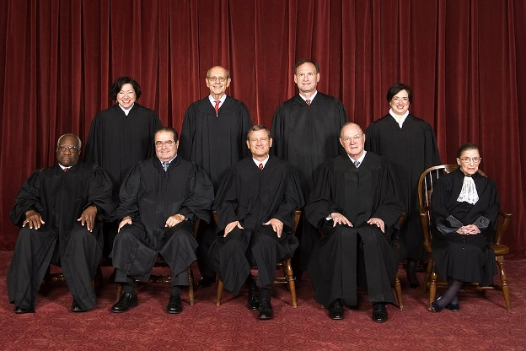All laws in the United States must fall within the framework of the Constitution, even those proposed by the President. If the President proposes a law which some feel goes against the Constitution they can challenge this and have it scrutinised by the Supreme Court. The judges in the court will examine the law and then vote on it. If five or more of the nine judges vote that it is indeed unconstitutional then the law will not be allowed to be implemented.

**Examples**

* President Obama had to get Congressman John Dingell to sponsor his ‘Obamacare’ bill. Obama also had to give concessions to Republican Congressmen before enough would vote yes to ‘Obamacare’.
* In 2006, the Supreme Court overruled President Bush’s decision to have war crimes tribunals for Guantanamo Bay detainees, saying this was illegal under US law.

1. Veto Legislation

Congress can overturn a veto with a two-thirds majority in both the Senate and the House of Representatives.

**Example** - In 2007 Congress overturned a bill which authorised government money to be used on water projects like dams and sewage plants.

1. Submit the budget

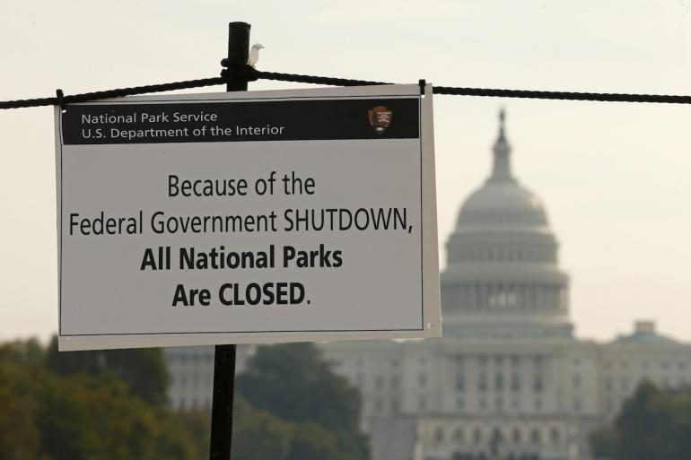A majority vote (more than 50%) in **either** house can stop the budget from passing. As the budget needs authorisation from both houses to pass, the budget can be cancelled by either the Senate or House of Representatives if enough members feel the budget is not value for money or funding is being spent on the wrong priorities.

**Example** – The House of Representatives voted no to the 2013 budget as the Republican members of the House, who were in the majority, felt the budget was too large and needed too much money was being borrowed to pay for it. This caused a major government shutdown for several weeks, meaning agencies like tax offices and national parks shut down and many government employees did not get their wages on time.

1. Selecting Ambassadors and Supreme Court Judges

Congress can scrutinise / investigate these appointments and reject any appointment they believe to be unfit for the job.

**Example** – In 2005, President George W. Bush had nominated Harriet Miers as his choice to be an Associate Justice of the Supreme Court. However, enough members of Congress from both main political parties were against the nomination that it was clear the appointment would be rejected if it went through. Bush withdrew the nomination when this became apparent.

1. Sending troops overseas

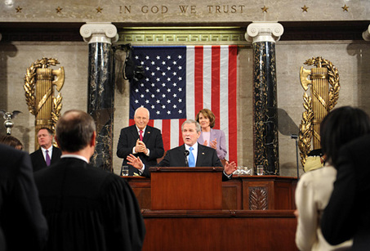Congress must be consulted and vote upon an official declaration of war. The President can urge Congress to vote yes to war if that is what he wishes to happen but he must get a majority in both houses for full military action to take place.

**Example** – George W. Bush had to seek the approval of Congress before the invasion of Iraq in 2003. Only when a yes vote had been secured did ‘Operation Iraqi Freedom’ take place.

1. Negotiate treaties

Before a treaty can be fully ratified it must be voted yes to by Congress.

**Example** – In 2012, the Senate voted to stop the US entering into the United Nations Arms Trade Treaty. They believed limiting the import and export of guns worldwide would prevent law-abiding Americans from obtaining guns to use for self-defence.

1. Executive Orders

Executive orders, just like other legislation, must be within the constitution. If orders are thought to be unconstitutional they can be challenged in the Supreme Court, and repealed if found to be so.

**Example** – Obama’s decision to carry out the bombing campaign in Libya in 2011 was an Executive Order. He did not seek Congressional approval and did not declare war. Some members of Congress claimed this went beyond dealing with an emergency, which is allowed under Executive Orders, as the United States itself was not under any threat, and so was an act of war and therefore unconstitutional. Although this did not go to the Supreme Court, it has sparked a debate in the United States as to what the President can or cannot do with regard to military action in future.

**Other checks on Presidential power**

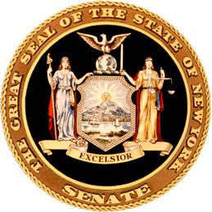**State and Local Government**

The USA has a federal system of government. Each of the 50 states has its own government headed by a State Governor, like a President on a smaller scale, and its own legislature split into two houses, Senate and House of Representatives as well as a State Supreme Court. American states have more power than Scottish councils or even the Scottish Government. For example they decide on state taxes and policies on law: the penalty for murder varies from state to state, some have the death penalty some do not.

At a more local level there are cities and counties which elect their own mayors and councils. Many posts in the US are elected, for example, the local head of police (in the UK this would be the Chief Constable) is appointed by the local authority police board. This means that officials in the USA are very concerned about public opinion.

**Voting patterns in the 2012 Presidential Elections**

**Political parties and their support**

|  |  |  |  |  |
| --- | --- | --- | --- | --- |
| **2012** | | **Group** | **Obama** | **Romney** |
| http://www.ropercenter.uconn.edu/elections/images/line_sm.gif | | | | |
| **All Voters** | | Pct. | 51% | 47% |
| http://www.ropercenter.uconn.edu/elections/images/line_sm.gif | | | | |
| **SEX** | Men | 47 | 45 | 52 |
| Women | | 53 | 55 | 44 |
| http://www.ropercenter.uconn.edu/elections/images/line_sm.gif | | | | |
| **RACE** | White | 72 | 39 | 59 |
| African-American | | 13 | 93 | 6 |
| Hispanic | | 10 | 71 | 27 |
| Asian | | 3 | 73 | 26 |
| Other | | 2 | 58 | 38 |
| http://www.ropercenter.uconn.edu/elections/images/line_sm.gif | | | | |
| **AGE** | 18-29 | 19 | 60 | 37 |
| 30-44 | | 27 | 52 | 45 |
| 45-64 | | 38 | 47 | 51 |
| 65 & over | | 16 | 44 | 56 |
| http://www.ropercenter.uconn.edu/elections/images/line_sm.gif | | | | |
| **INCOME** | <$50,000 | 41 | 60 | 38 |
| $50,000-90,000 | | 31 | 46 | 52 |
| $100,000 & over | | 28 | 44 | 54 |
| http://www.ropercenter.uconn.edu/elections/images/line_sm.gif | | | | |
| **UNION HOUSEHOLD** | Yes | 18 | 58 | 40 |
| No | | 82 | 49 | 48 |
| http://www.ropercenter.uconn.edu/elections/images/line_sm.gif | | | | |
| **EDUCATION** | Some HS | 3 | 64 | 35 |
| HS graduate | | 21 | 51 | 48 |
| Some college | | 29 | 49 | 48 |
| College graduate | | 29 | 47 | 51 |
| Postgraduate study | | 18 | 55 | 42 |
| http://www.ropercenter.uconn.edu/elections/images/line_sm.gif | | | | |
| **PARTY** | Democratic | 38 | 92 | 7 |
| Republican | | 32 | 6 | 93 |
| Independent | | 29 | 45 | 50 |
| http://www.ropercenter.uconn.edu/elections/images/line_sm.gif | | | | |
| **POLITICAL PHILOSOPHY** | Liberal | 25 | 86 | 11 |
| Moderate | | 41 | 56 | 41 |
| Conservative | | 35 | 17 | 82 |
| http://www.ropercenter.uconn.edu/elections/images/line_sm.gif | | | | |
| **MOST IMPORTANT ISSUES** | Economy | 59 | 47 | 51 |
| Budget deficit | | 15 | 32 | 66 |
| Foreign policy | | 5 | 56 | 33 |
| Health care | | 18 | 75 | 24 |

**Outlook of parties**

Unlike political parties in the UK, US political parties are not tied to an ideology. This means both main parties contains a range of people from across society. In US elections, candidates seek to build political support across different regions and groups. In America, a candidate’s views on particular issues such taxes, gun control or welfare are more important than which party they represent.

**Factors which determine elections / party support**

**Race**

**African-Americans** are the Democrats’ most faithful supporters. 95% of AA voted Democrat in the 2008 presidential election and 93% in 2012. This is partly because blacks are still more likely to be poor than any other ethnic group so the fact that the Democrats are more in favour of improving social services and improving education for the poorest encourages AA to vote for them. Also, a Democrat government is more likely to intervene in the economy to save jobs, as Obama’s government did with the American Recovery Act. Democrats have been the traditional party of civil rights, for example John F. Kennedy’s push as a Democrat President for black equal rights.

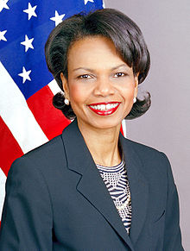However, there are some black Republican voters, particularly in the emerging black middle class. Famous black Republicans Colin Powell and Condoleeza Rice made it into George W. Bush’s cabinet to lessen the ‘white’ image of the Republican Party. The slight dip in support among blacks for Obama can be put partly down to black Americans losing faith in him as he did not deliver on the hype before he was elected, when many believed he would dramatically lower poverty and hardship in America, ills which the AA community suffer badly from.

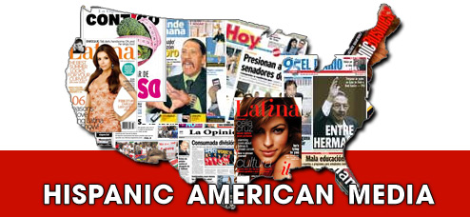**Hispanics** tend to vote Democrat but they are not as loyal as African Americans. While there is a new black wealthy class, there is a long established wealthy Hispanic population. In areas like Florida Hispanics have found success in areas like banking and so many look for the low taxes and small government offered by the Republicans. The importance of the Hispanic vote is proven by the fact George W. Bush actively sought Hispanic support by claiming he had Hispanic ancestry; he gained 42% of the Latino vote by doing this, an all-time high for a Republican candidate. In 2008 and 2012, the Hispanic vote swung back to the Democrats as Obama was seen as a representative of all ethnic minorities and someone who could improve the situation for poor people. As with black Americans, many Hispanics live in poor areas with low incomes and Obama was thought to be the man to improve that.

**Whites** are more likely to vote Republican, particularly white men, with 62% voting for Mitt Romney in the 2012 election. This group are most likely to be in stable, high paying jobs. Older white people are also extremely likely to vote Republican, with 61% of white 45-64 year olds voting for Romney.

|  |  |  |
| --- | --- | --- |
| **Race** | **Democrats** | **Republicans** |
| White | 39% | 59% |
| African American | 93% | 6% |
| Hispanic | 71% | 27% |
| Asian | 73% | 26% |
| Other | 58% | 38% |

**Geographical location**

Democratic support is mainly concentrated in larger city and coastal areas, such as New York and California. However, this support can overlap greatly with other factors. For example, in California a large number of those living in the state are from ethnic minority backgrounds of Black or Hispanic who tend to favour the Democrats. These coastal states also hold many of the poorer industrial areas and inner-cities with blue-collar workers and low incomes, further groups which tend to give their support to the Democrat Party.

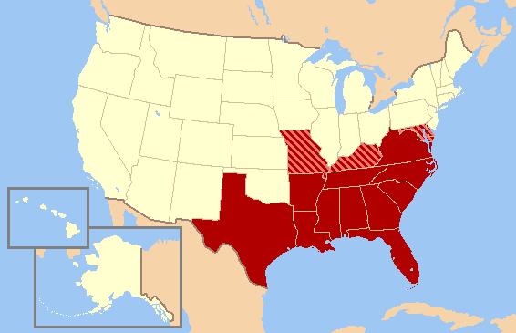The Republican Party gains strong support from the Southern states like Texas and Alabama. Voters in small towns, rural and suburban areas tend to favour Republicans. Again, there is evidence of cross-over. Southern states often place a higher emphasis on religion, especially Conservative religion like evangelical Christianity. Values such as homophobia and anti-abortion are born of this understanding and draws them to the Republican Party which has similar views. Suburban areas also house middle and upper class citizens who would benefit from the lower tax, smaller government approach of the Republicans.

The table below shows how different geographical locations voted in the **2008 Presidential election** (2012 unavailable):

|  |  |  |
| --- | --- | --- |
| **Location** | **Democrats** | **Republicans** |
| Urban | 63% | 35% |
| Suburban | 50% | 48% |
| Rural | 45% | 53% |

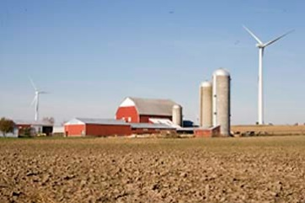

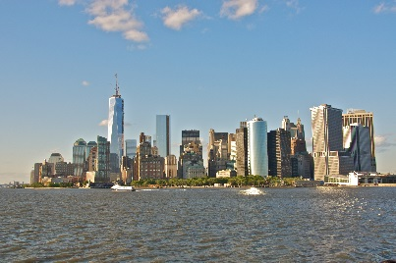

**Income**

Those dependent on welfare or the government health provision of Medicaid are much more likely to support the Democrats due to them being slightly more in favour of government support for those in poverty. Democrats are more sympathetic to the less well off. Many poor people live in urban areas. Those on very low incomes of under $15,000 vote for the Democrats in large numbers (73% in 2012)

Wealthy Americans tend to vote for the Republicans as they both favour low taxes and limited government intervention in the economy. Rich Americans do not require state assistance and so their taxes essentially help others. Lower taxes means more money staying in the individuals’ pockets. Many wealthy Americans live in sub-urban areas or in more rural States of the Mid West (Iowa) or the South (Alabama).

The table below shows voting patterns by income:

|  |  |  |
| --- | --- | --- |
| **Income** | **Democrats** | **Republicans** |
| Less than $50k | 60% | 38% |
| $50-100k | 46% | 52% |
| $100k or more | 44% | 54% |

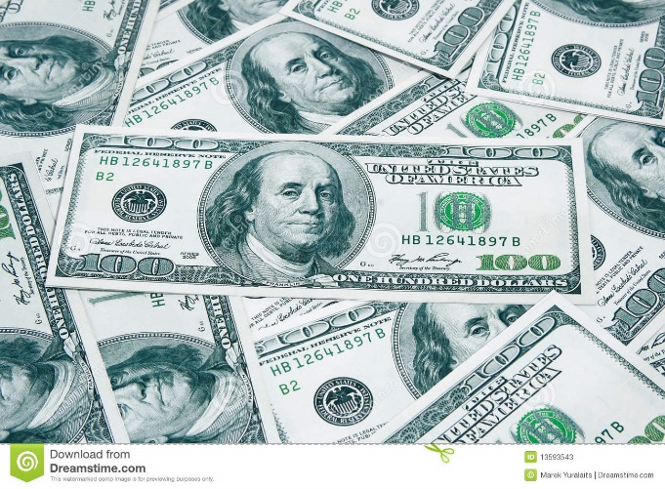

**Religion**

In his re-election victory, Democrat Barack Obama narrowly defeated Republican Mitt Romney in the national popular vote (50% to 48%). Obama’s margin of victory was much smaller than in 2008 when he defeated John McCain by a 53% to 46% margin, and he lost ground among white evangelical Protestants and white Catholics. But the basic religious contours of the 2012 electorate resemble recent elections – traditionally Republican groups such as white evangelicals and weekly churchgoers strongly backed Romney, while traditionally Democratic groups such as black Protestants, Hispanic Catholics, Jews and the religiously unaffiliated backed Obama by large margins.

Religiously unaffiliated voters and Jewish voters were firmly in Obama’s corner in 2012 (70% and 69%, respectively). Both of these groups have long been strongly supportive of Democratic candidates in presidential elections. Black Protestants also voted overwhelmingly for Obama (95%).

At the other end of the political spectrum, nearly eight-in-ten white evangelical Protestants voted for Romney (79%), compared with 20% who backed Obama. Mormon voters were also firmly in Romney’s corner; nearly eight-in-ten Mormons (78%) voted for Romney, while 21% voted for Obama.

Compared with religiously unaffiliated and Jewish voters on the left and white evangelicals and Mormons on the right, Catholics and white mainline Protestants were more evenly divided. Among white mainline Protestants in the exit poll, 54% voted for Romney, while 44% supported Obama. This is virtually identical to the 2008 election, when 55% of white mainline Protestants voted for McCain and 44% backed Obama.

White Catholics, by contrast, swung strongly in the Republican direction relative to 2008. Nearly six-in-ten white Catholics (59%) voted for Romney, up from 52% who voted for McCain in 2008. Three-quarters of Hispanic Catholics voted for Obama, and Catholics as a whole were evenly divided in 2012 (50% voted for Obama, while 48% backed Romney).

The table below shows different part support by religion. Try to establish links between certain religions and race, political philosophy or others.

|  |  |  |
| --- | --- | --- |
| **Religion** | **Democrat** | **Republican** |
| Protestant | 42% | 57% |
| Catholic | 50% | 48% |
| Jewish | 69% | 30% |
| Other | 74% | 23% |
| None | 70% | 26% |

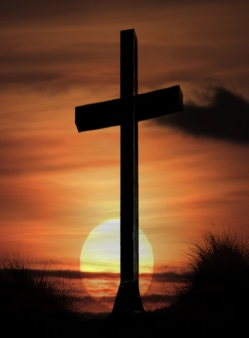

**Gender**

Traditionally women are more likely to vote for the Democrat Party. In 2008, the Republican Party had Sarah Palin run as their Vice-Presidential candidate to try to woo female voters but female support for the Democrats remained strong. With 53% of all voters at the last election being female according to exit polls, their importance in elections could be said to be increasing.

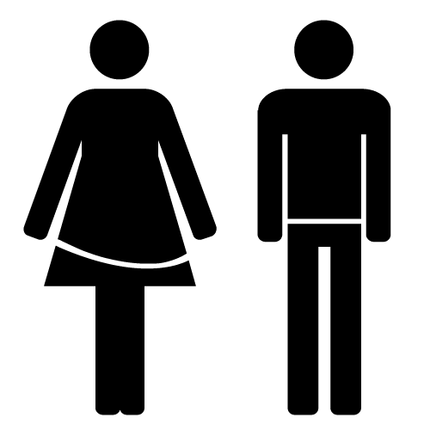The male vote in 2008 was quite evenly split but in 2012 Mitt Romney and the Republicans secured a larger percentage of the male vote. White males in particular, who tend to be the breadwinners of families, tend to vote Republican as they are more likely to have good jobs and seek lower taxes.

|  |  |  |
| --- | --- | --- |
| **Gender** | **Democrats** | **Republicans** |
| Male | 45% | 52% |
| Female | 55% | 44% |

**Age**

Younger people tend to vote Democrat. This has especially been the case since Barack Obama became the Democrat candidate and President as his energetic, ‘cool’ persona appealed to them. Younger people also tend to be more liberal in their views and on lower incomes as they are at the beginnings of their career, as well as being more likely to be on state benefits. In the past young people have tended not to vote in as large numbers but in 2008, 3.4 million more young people voted than in 2004. This number may not be maintained as there was an element of the ‘Obama bounce’, where young people connected with one candidate. As people age they move up the income scale and also tend to have more Conservative views, such as on matters like abortion and homosexuality. These are groups which attract Republican voters.

|  |  |  |
| --- | --- | --- |
| **Age group** | **Democrats** | **Republicans** |
| 18-29 | 60% | 37% |
| 30-44 | 52% | 45% |
| 45-64 | 47% | 51% |
| 65 and older | 44% | 56% |

**Issue Voting**

Particular problems or debates happening within the USA can sway voters to one candidate or another as the electorate decide who they believe would be the best person to deal with that problem. In 2012, the state of the American economy was a major issue, with 59% of voters believing this was the most important matter facing the country. Of those who felt the economy was the key issue, 51% thought Mitt Romney was the best person to deal with it compared to 47% Obama. Other issues which helped determine voting behaviour can be seen in the table at the beginning of this section.

**Opportunities and equality in the political process**

Politics in the USA, as in the UK, has been dominated for decades by wealthy, white men. While there have been many famous examples of female and ethnic minority Americans reaching the highest levels of politics, they remain under-represented compared to the proportion of the US population they make up. Factors such as historic discrimination, poorer education and disillusionment with politics has also led to a much lower participation in the political process among ethnic minorities. There is evidence this situation is improving but inequality has stubbornly remained. This section will examine three areas to depict the extent of inequality in the system;

* Voter registration
* Voter turnout
* Representation

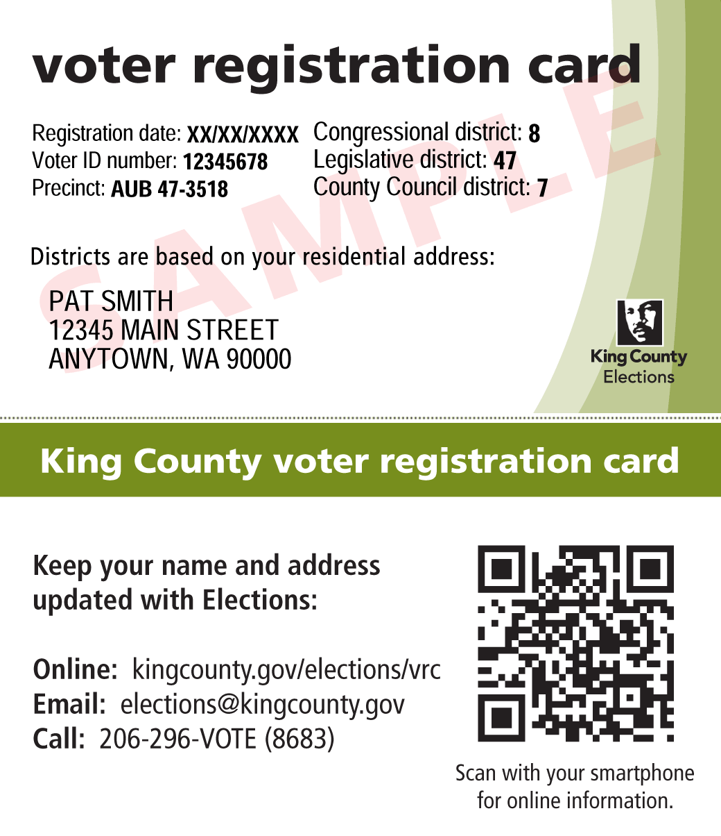**Participation**

**Voter registration**

In the USA, if people wish to vote in an upcoming election they must first register at a local government office. The percentage of minority groups registering to vote has always been lower than that of whites. This could be argued to show that ethnic minorities do not have as much influence over the election result as their white counterparts. Before the 2012 election the registration rates were as follows:

|  |  |
| --- | --- |
| **Ethnic Group** | **% registered prior to election** |
| White | 74% |
| African American | 73% |
| Hispanic | 59% |
| Asian | 56% |

A principal reason for lower registration and turnout rates among minorities in the past has been apathy. A sense of disillusionment set in among many minorities, especially those in poverty, who saw Presidents of different parties come and go with no real change in their personal circumstance. Many in this situation simply refused to vote as they did not believe anything would be achieved. The feeling of being alienated also put many off politics altogether, with a lack of role models from their own ethnic group to look up to. However, the emergence of Barack Obama, as well as other significant minority appointments, has helped to reverse this trend. As can be seen in the table above, African American registration is now of a similar rate to whites. This will be monitored in future elections when the candidates for President are not black.

**Voter turnout**

Just because a person is registered to vote does not necessarily mean that they will go to a polling station on election day. The turnout figures are therefore lower as a result. In 2012, the figures were:

|  |  |
| --- | --- |
| **Ethnic group** | **Turnout** |
| White | 64% |
| African American | 66% |
| Hispanic | 48% |
| Asian | 47% |

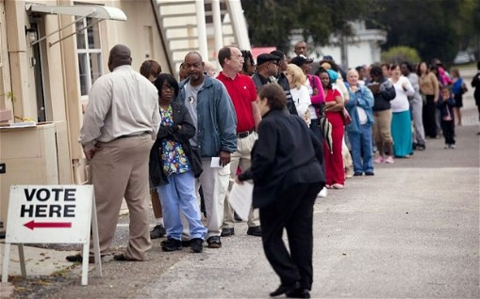Traditionally, low turnout among minorities, as well as being linked to apathy, can be linked to poor education. A poorer education often leads many minorities to lead a lifestyle that takes no interest in politics, such as not reading a newspaper or being aware of current affairs, as they have issues with making ends meet day-to-day. Higher rates of illiteracy can make ballot papers and voter registration forms difficult to understand. Among Hispanics, many do not speak English as a first language which makes the voting process more difficult. The act of voting itself can be more stressful for the poor, among which is a large number of minorities. Problems such as having no transport to get to a registration building or polling place or having to navigate through dangerous neighbourhoods can put many off voting.

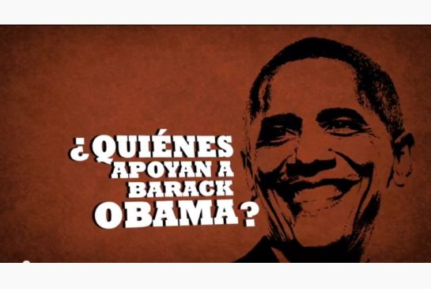Despite the Hispanic turnout being much lower than whites, there is evidence that the Hispanic vote is becoming ever more important. In 2004 just 29.8% of Hispanics turned out to vote so the increase has been substantial. The importance of the Hispanic vote can be further seen by the fact that both parties run Spanish speaking elements in their campaigns, with advertisements on Spanish TV channels and Spanish leaflets and billboards distributed. There have also been moves to have instructions on ballot papers in Spanish. The Hispanic group is also the fastest growing in the US and as a result will only continue to grow in importance and political clout.

**Responses to participation rates being poor**

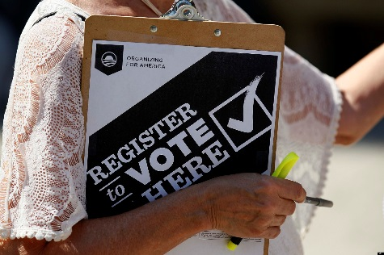**Motor-voter law** – Due to the difficulties of certain groups registering to vote, particularly poorer Americans, among whom ethnic minorities are a sizeable proportion, the US government introduced the Motor-voter law to make the process easier. This allowed US citizens to register to vote at the same time as carrying out other federal actions, like renewing a driver’s licence or applying for social services. This would also allow federal workers to support those going through the process who may find it difficult, such as those with poor literacy. Minority registration has risen since it was introduced in 1995.

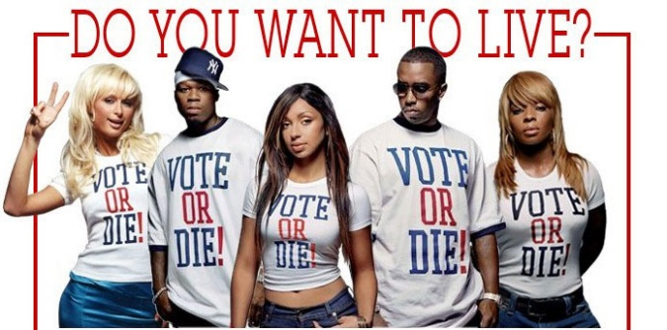**Celebrity endorsed campaigns** – Campaigns such as **‘Vote or Die’** set out to increase the number of young and disillusioned people registering to vote in the US by encouraging them to become more interested in politics and see that they can make a difference. By inviting popular black celebrities, like P Diddy, to join the campaign it was hoped that young black people in particular would have someone for the first time speaking on their level, telling them why it was important to register. This campaign was viewed as successful as the number of young people registering to vote increased by 4.6 million from the 2000 to 2004 Presidential elections. **Rock the Vote** is a similar project which has been running more recently and also aims to increase the numbers of young people voting. Celebrity backers like Christina Aguilera, Samuel L. Jackson and Jamie Foxx all used national television appearances to encourage young people to vote in the 2008 elections.

[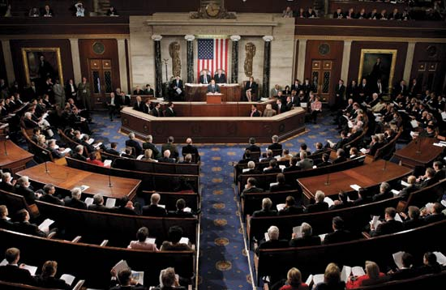](http://www.google.co.uk/url?sa=i&rct=j&q=&esrc=s&source=images&cd=&cad=rja&uact=8&docid=7al07pK-tYC_eM&tbnid=8JmhT2_2qyaUBM:&ved=0CAUQjRw&url=http://www.britannica.com/blogs/2009/09/congress-resumes-let-us-pray/&ei=YON9U4CbLabb7AbmuID4Bw&psig=AFQjCNFuiqzfQOtNyyV3fdSFuO3lTkJgZA&ust=1400845520744821)**Representation**

**Ethnic minorities** are traditionally under-represented in US political history, particularly blacks within the Republican Party. A lack of education at the level required means many don’t stand as candidates. Political parties have been reluctant to put forward ethnic minority candidates in case it loses votes. Money is needed to run successful campaigns and become elected, with the cost generally going up the more prestigious the post, and Blacks are under-represented within the wealthiest groups of America. Although minorities are better represented at local level, it has been hard to make progress up to higher levels of government, for example, state senator or federal congress.

**Females** are under-represented as the American political system favours those who are already in government and most elected positions are filled by men. For example, it is easier for someone in state government to progress to federal government. Women also do not put themselves forward as candidates because the traditional role of wife and mother is very strong in the USA. Even successful female politicians are keen for the media to witness them successfully juggle both roles, Sarah Palin in the 2008 campaign being a perfect example.

Ethnic breakdown of the 113th Congress

|  |  |  |  |  |
| --- | --- | --- | --- | --- |
| **Ethnic group** | **Senators (% of Senate)** | **House of Representatives (% of House members)** | **Total % of Congress** | **Total % of population** |
| White | 93 (93%) | 348 (80%) | 82% | 66% |
| African American | 2 (2%) | 41 (9%) | 8% | 13% |
| Hispanic | 4 (4%) | 32 (7%) | 6.7% | 15% |
| Asian and Pacific Islanders | 1 (1%) | 10 (2%) | 2% | 5% |
| Native American | 0 | 1 (0.2%) | 0.19% | 1% |

Gender breakdown of the 113th Congress

|  |  |  |  |  |
| --- | --- | --- | --- | --- |
| **Gender** | **Senators (% of Senate)** | **House of Representatives (% of House members)** | **Total % of Congress** | **Total % of population** |
| Male | 80 (80%) | 358 (82%) | 81.8% | 49% |
| Female | 20 (20%) | 77 (18%) | 18.2% | 51% |

Evidence of better representation

**Congress**

* The number of Hispanics is in the current Congress is the highest there has ever been
* The 100 females (including 3 delegates) in Congress is a record high
* African Americans have the highest level of representation of any minority ethnic group in the House of Representatives

Examples of minority representatives -

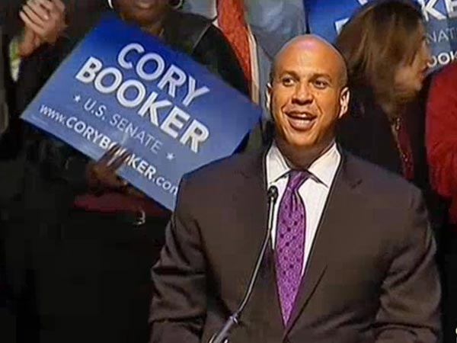

**Cory Booker** – African American Senator

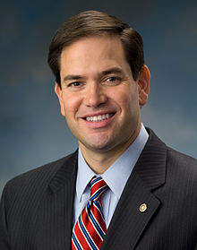

**Marco Rubio** – Hispanic Senator

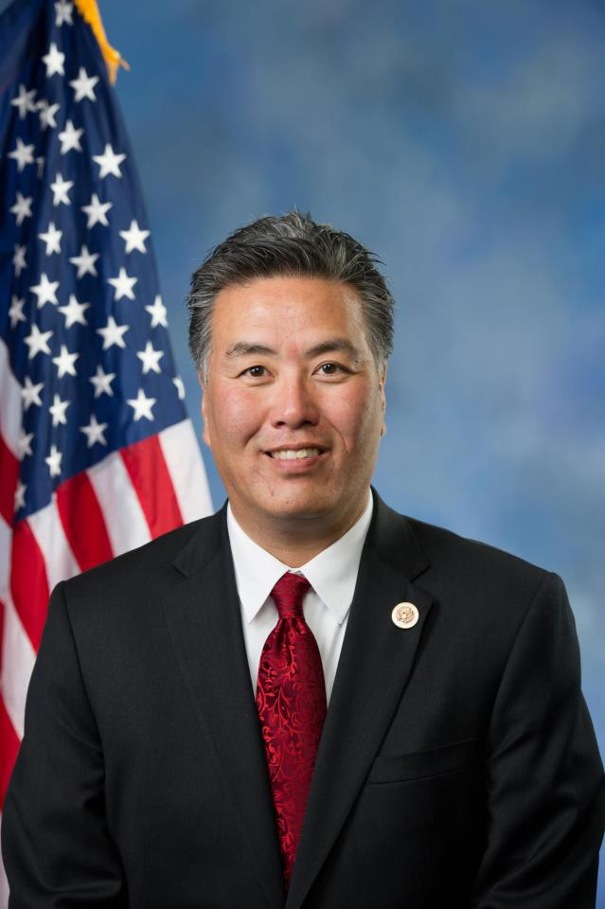

**Mark Takano** – Asian Congressman

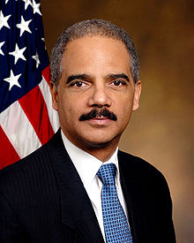

**Eric Holder** – Attorney General until 2014 (First African American to hold this post)

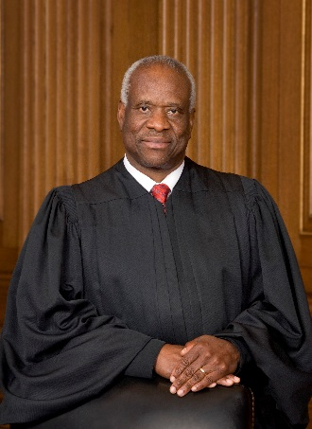

**Clarence Thomas** – African American Supreme Court Judge

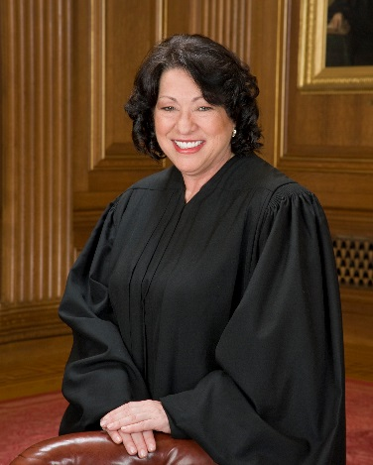

**Sonia Sotomayor** – Hispanic Supreme Court Judge

**Responses to poor representation / Increasing fairness and equality in the political system**

**Majority-minority districts** – This is the name given to ‘gerrymandering’ of district lines to ensure there is a majority of a particular ethnic minority in a voting area. For example, streets that have majority white residents may be excluded from a district while three streets that are majority black are included. In this hypothetical scenario a black candidate could easily be chosen for this district as the majority black electorate will not be put off by his/her ethnicity. This has happened many times in America, particularly benefitting the number of Hispanics elected to lower political positions like city councils and African Americans to the House of Representatives.

**Black and Hispanic Caucuses** – A Caucus is a group which will work and vote together on certain issues within Congress. Often they are cross-party with Democrat and Republican members. The Black Caucus, for example, has all black members of the House of Representatives. If they all vote together on an issue they account for around 20% of the votes needed to pass a bill. They can use this voting power as a bargaining chip to get better rights for African American citizens. This power has also allowed Caucus members to get into important positions on committees and push through reforms that will benefit the black community. Similarly, the Hispanic Caucus has spoken out about matters that affect the Latino community, such as calling for measures to increase the numbers of Hispanics who stay on at school and get a university degree. Both have acted as role models for their communities, have proven minorities can wield power in politics and have increased the numbers of their respective groups who have become interested and involved in the political process.

[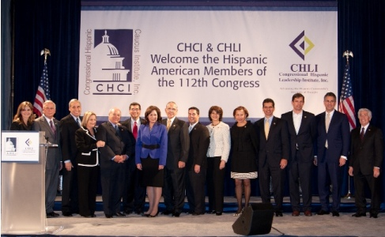](http://www.google.co.uk/url?sa=i&rct=j&q=&esrc=s&source=images&cd=&cad=rja&uact=8&docid=4XMsYLImq4LVtM&tbnid=axHp1w3B0hhcHM:&ved=0CAUQjRw&url=http://www.hispanicallyspeakingnews.com/latino-daily-news/details/congressional-hispanic-caucus-institute-welcomes-members-of-112th-congress/4651&ei=wuR9U9KcMsnm7Aaek4HYDg&psig=AFQjCNEEKB5WGYmFAfxaJgAy2PlXx50f5A&ust=1400845879627102)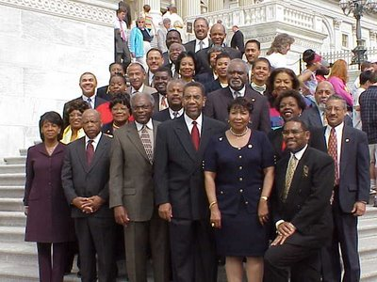

Introduction:

This section will explore the position of different groups within American society. Through exploration of areas such as income, educational attainment and quality of health, you will discover that different ethnic groups within America have vastly differing fortunes in terms of their success in life. You will also look at the laws the US government have introduced to raise the success rates of the underprivileged. It is important that you evaluate how successful this response has been i.e. has the situation for the poor improved at all?

**Section 2 – Socio-economic issues**

**The ‘American Dream’**

The American Dream is the idea that any person in the USA can achieve wealth, success and happiness through hard work and ambition. Barriers to success which may exist in other countries, such as religion, race or gender, should be irrelevant in America. No matter what a child’s circumstances at birth he/she can work their way to a high standard of living. To an extent this is the case, but, as you will discover, there are many areas in which people from certain backgrounds do not enjoy the same standard of living as others in the population. By many definitions, the USA is a very unequal country. A history of racial intolerance by a sizeable proportion of the population, especially towards blacks, has led to discrimination and division.

**Issues to be covered in this section:**

1. **Inequality (especially between different ethnic groups) in areas such as;**

* **Income and unemployment**
* **Education**
* **Crime and Justice**
* **Health**
* **Housing**

1. **Immigration**

**Inequality in the USA**

**Income and unemployment**

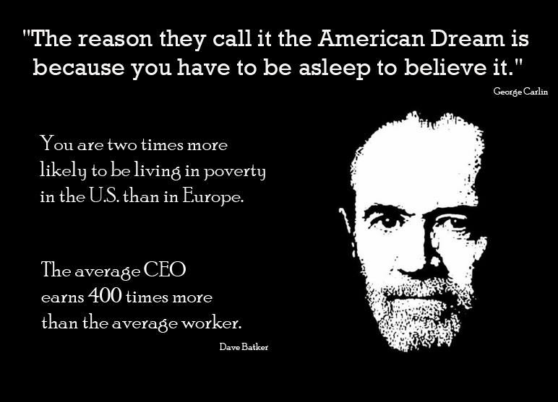Income levels of the different ethnic groups in the USA vary greatly. On average, Blacks and Hispanics earn less than Whites while Asians earn more. Many Blacks and Hispanics are trapped in the ‘poverty cycle’, where the area they live in prevents them having access to a quality education, high paying job, encouraging peer groups and so on. This environment is extremely difficult to break out of. The poverty cycle is more visible in inner-city areas. The ‘White flight’ (White people were the ethnic group which could afford to move from the inner city to the suburbs, taking their much-needed cash and taxes and leaving behind other ethnicities) exacerbated this problem.

Issue / Problem

1. Vast differences between incomes of the different ethnic groups. (Average income among all races $51,017)
2. Different unemployment levels among the ethnic groups (especially after the recent economic recession). The chart below shows the % of each ethnic group who were unemployed in the first quarter of 2014.

Government Response

1. TANF (Temporary Assistance for Needy Families) – Money is given to those who are out of work and have dependent children. The primary goal of this aid is to get the recipient off of ‘welfare payments’ and back into employment. As a result, the typical maximum single period one can receive TANF payments is 24 months, and the maximum across an entire lifetime is just 60 months.
2. Various laws made during and after the recession to secure jobs. Two most notable are the Recovery Act 2009 and the JOBS Act 2011.

**NB -** Affirmative Action has been used to lessen the employment gap between the different ethnic groups.

Success of government response

1. From its introduction in 1996 until the recession in 2008, the number of people claiming TANF fell every year, from around 10 million claimants in 1997 to around 3.79 million in 2008. There was an increase during the years of recession but the number has once again began to fall. This could be evidence that TANF is helping millions of Americans, particularly lone-parents, back into work and off the need for welfare.
2. – It is claimed that through the Recovery Act around $800 billion was spent which saved or created around 1.6 million jobs between 2009 and 2012.

-The JOBS Act:

* Gives tax cuts to small businesses to help them grow and create jobs.
* Cuts the taxes paid by over 160 million workers.
* Prevented 280,000 teachers from losing their jobs.
* Set up the ‘Pathways to Work’ programme for the long term unemployed e.g. tax credits given to employers hiring from this group.

Failures of government response

1. The amount of money in real terms made available by the federal government for TANF payments has fallen every year. While the actual amount has remained steady, it has not been adjusted for inflation. This means that families receiving TANF in 2014 are not able to buy the same amount of goods (e.g. food, clothes) as those receiving welfare in 1996. TANF has actually increased poverty levels for some families and because it is only temporary and families have to find work under the arrangements, some end up having to take jobs which pay very poorly and leave them with less money. Some parents have to work 2 or 3 jobs just to make ends meet – this is not good for family life.
2. The levels of unemployment during the recession did not grow at an equal rate. Blacks and Hispanics lost their jobs at a much faster rate than Whites. This was mostly due to these groups being employed in manufacturing type jobs, like car building, which were hardest hit by the recession. The Acts brought in by the US government did not address the additional hardship felt by certain ethnic groups.

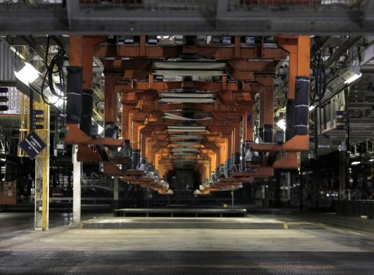

A Ford production facility lying empty in 2009

**Educational Inequality**

Issue / Problem

1. Numbers of ethnic minorities in higher education (university) is far lower as a percentage than Whites.
2. Children from poorer backgrounds and certain ethnic minorities do much worse at school than others.

Government Response

1. 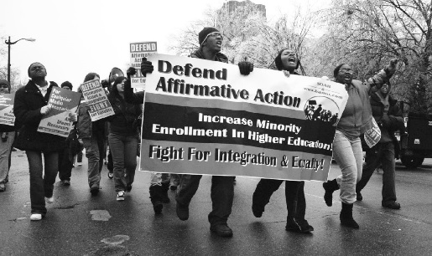Affirmative Action – Beginning in the 1960s with President Kennedy, positive steps would be taken to actively encourage underrepresented groups into universities, particularly Blacks and Hispanics. To this day, universities in the USA have targets and quotas for a minimum number of ethnic minority students in many of the courses.
2. Scholarships for Opportunity and Results (SOAR Act) – Provides scholarships to children from underprivileged backgrounds to attend private schools (up to $8,000 for lower school and $12,000 for high school).

Success of Government Policies

1. Affirmative action programs have resulted in doubling or tripling the number of minority applications to colleges or universities, and have made colleges and universities more representative of their surrounding community. Statistics show that after California abolished its affirmative action programs in 1998, the minority student admissions at UC Berkeley fell 61 percent, and minority admissions at UCLA fell 36 percent. Graduates who benefited from affirmative action programs say that they have received better jobs, earned more money, and ultimately are living better lives because of the opportunity they received.
2. In 2010, a controlled study of the effects of the scholarship vouchers found that 91% of students who used the vouchers graduated from high school, compared to only 70% of those from similar backgrounds who did not receive vouchers. The study received the Department of Education’s highest rating for scientific rigour. Over 90% of the study’s participants were African American, and most of the remainder were Hispanics. Further research found that students who received vouchers were 25% more likely to enroll in college than students with similar demographic characteristics who did not receive vouchers.

**NB -** Asian Americans are a real success story in terms of education, with just 2.1% dropping out of high school and over 50% graduating from college or above.

Limitations of Government Policies

1. The policy is outdated, however, and causes a form of reverse discrimination by favoring one group over another, based on racial preference rather than academic achievement. Further, there is concern that minority groups may be stigmatized and treated differently by peers and professors who may believe that the success of minority groups in higher education institutions is unearned.

The table below shows the vast difference between ethnic groups and their attainment at university level. This could be seen as a failure of Affirmative Action.

1. In 2011, a study by the National Centre for Education Statistics found that certain states within America were doing much better than others, and the determinate factor was poverty / income. States with high average incomes (Massachusetts, Vermont etc.) do far better in core subjects like Science and Maths than ‘poorer’ states like Alabama. High school dropout rates also point to continued inequality among the different races. While dropout rates for all races have dropped over recent decades, there remains large discrepancies. With just 4.3% of whites dropping out of high school with nothing, rates for Hispanics are almost 3 times as high (12.7%). African American rates are also high (8.6%). See graph below.

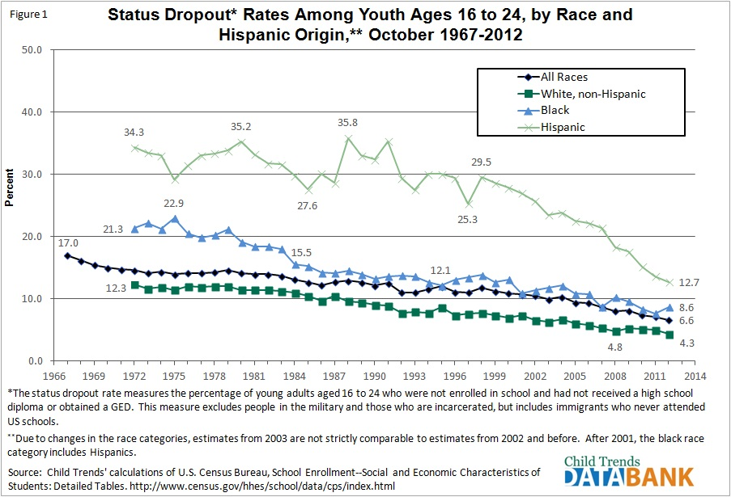

**Crime and Justice**

**Violent Crime**

[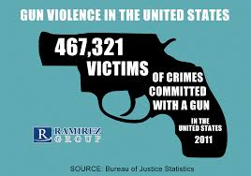](http://www.google.co.uk/url?sa=i&rct=j&q=&esrc=s&source=images&cd=&cad=rja&uact=8&docid=obZvwDZcZiKfCM&tbnid=_tfAK8PYxaQ5gM:&ved=0CAUQjRw&url=http://ramirezgroup.com/factoids/467321-victims-of-gun-violence-in-united-states/&ei=8_Z9U-_BG-aq7QbzjoHgBw&psig=AFQjCNGtkOPr44J7YZ_aR-vTmIFFUmtKpA&ust=1400850523718243)Inequality

Certain ethnic groups in the USA are more likely to be involved in violent crime. For example, African Americans are much more likely to be arrested for murder or be the victim of murder;

* 36% of people arrested for murder were African American compared to just 13% of population.
* 47% of all murder victims in 2008 were African American.
* Between 2000-2010, of the 165,068 murder victims in the USA, 78,521 were Black (47.6%)

Balance

* If whites are murdered they are more likely to have been murdered by a white person. 83% of white people murdered in 2008 were killed by another white person.
* Asians under-represented in terms of violent crime. Only 1.1% of violent criminals are Asian but they make up around 5% of the population (lower % of violent criminals than % of population).

**Prisons**

Inequality

Evidence of tougher sentences handed to blacks, especially if the victim is white, and a disproportionate number of blacks being in prison compared to whites. A study by the Rand Corporation concluded that in California sentences average 6.5 months longer for Hispanics compared to Whites. Blacks make up around 40% of the US prison population but only 13% of the total US population.

If you are a male born in the USA you are far more likely to end up in jail if you are black. Statistically your chances of being in jail at some point are;

* 32% if black
* 17% if Hispanic
* 6% if white

Among males aged 25-29 in prison;

* One in ten (10.4%) of young black men were in prison
* One in 28 (3.6%) of Hispanics
* One in 59 (1.7%) of whites

Balance

There are some statistics which show the white majority are more likely to be convicted in certain cases and some ethnic groups are incarcerated less on average than the white majority.

* Whites are more likely to be guilty of committing many types of crime, for example hate crimes. 61% of those in prison for hate crimes were white while 73% of victims were black.
* Asians are around 5% of the population but less than 3% of prison inmates are from this ethnic group.

**Government response to Crime and Justice Inequalities**

The government has increased law enforcement resources to investigate and prosecute violent gangs. One such piece of legislation is the Gang Prevention, Intervention & Suppression Act, passed in February 2009. This aims to deter and punish violent criminal gangs and protect citizens/communities from these violent criminals. Due to the fact that a majority of gang members come from the ethnic minorities most likely to end up in prison (African American and Hispanic), reducing the numbers of gangs / gang members will, in the long term, reduce the number of ethnic minorities sent to prison.

**Health**

**Insurance**

Inequality

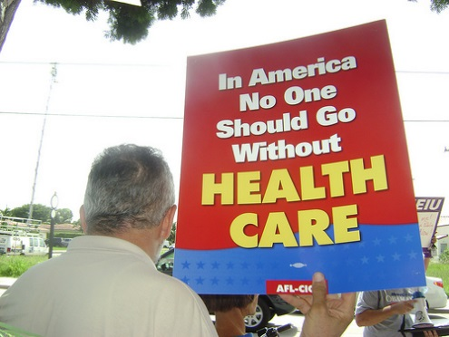The American healthcare system is run by private companies on a system of private health insurance, unlike the UK which has a taxpayer funded system free to those in need of a service. The American system is run for profit and so, some would argue, is efficient and, for those who are able to afford health insurance, the care is of a high quality. The problem is that many Americans are unable to afford health insurance. Due to their lower social and economic status, ethnic minorities are much more likely than whites to be in the uninsured category, and so suffer more medical complications and illnesses. Currently levels of uninsured are;

* 20% blacks
* 34% Hispanics
* 16% Asians-Pacific Islanders
* 10% whites

Balance

‘Obamacare’ aims to ensure every American has health insurance. An estimated 32 million uninsured Americans will be able to afford health care for the first time thanks to this government policy (This will be discussed at length in the government responses to health inequality).

**Ill-health**

Inequality

Blacks, Hispanics and Native Americans suffer far worse levels of health than whites. In health surveys, these ethnic groups are more likely than the white and Asian Americans to rate their own health as fair or poor as opposed to good or excellent.

Listed below are some of the increased levels of ill-health, organised by race.

**African American**

* The maternal mortality rate (the number of mothers who die during the birthing process) for black women is almost five times as high as that of white women.
* Among adults, death rates for black Americans are approx. 55% higher than they are for white people.
* Infant mortality rates for black infants are twice as high as for white infants (13.9 deaths per 1,000 births versus 5.8 per 1,000 for whites)
* Death rate among black adults is around 55% higher than that of white people.
* Black women have the highest rate of the main killers like heart disease, breast cancer and stroke among the female population.

**Hispanic**

* Hispanics are more likely to be employed in high risk occupations and so suffer from related ill-health.

**Native American**

* Native American rates of Sudden Infant Death Syndrome are twice the US average

**Government responses to health inequality**

**Medicare** – Elderly Americans over the age of 65 who have worked and paid tax can apply to be on the Medicare system. This will help pay for hospital and doctor’s bills, as well as many prescription drugs. The system is funded by the Federal Government.



**Medicaid** – This is funded partly by the Federal government and partly by states, acting as a type of government funded health insurance policy for poor families. It is means-tested, however, and so not all of those in poverty will qualify. Some of those who do qualify may be those living in poverty with children or those with certain disabilities.

Government funded schemes help poorer Americans get access to health care. Particularly helps Blacks and Hispanics who are more likely to be poor. For example, the **Children’s Health Reauthorisation Act (2009)** provided just under $33 billion to provide health care cover for over 11 million children who do not qualify for Medicaid but are too poor to afford health insurance.

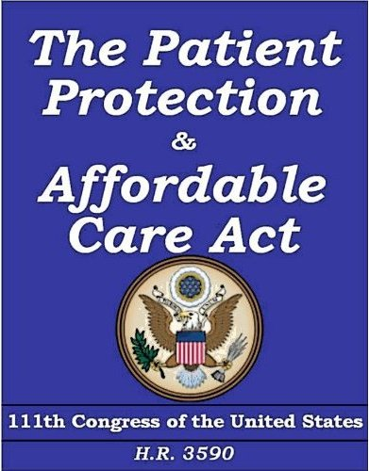**The Patient Protection and Affordable Care Act** - Known as ‘Obamacare’ due to the President’s personal interest and proposal of the idea, this is the largest overhaul of the US healthcare system since the 1960s. Its aim is to extend health insurance coverage to some of the estimated 15% of the US population who lack it. Those people receive no coverage from their employers and are not covered by US health programmes for the poor and the elderly.

To achieve this, the law requires all Americans to have health insurance, but offers subsidies to make coverage more affordable and aims to reduce the cost of insurance by bringing younger, healthier people into the health insurance system.

It also requires businesses with more than 50 full-time employees to offer health coverage, although this provision was delayed until 2015 to allow more time for compliance.

The law creates marketplaces - with websites akin to online travel and shopping sites - where individuals can compare prices as they shop for coverage.

In addition, the law bans insurance companies from denying health coverage to people with pre-existing health conditions, allows young people to remain on their parents' plans until age 26, and expands eligibility for the government-run Medicaid health programme for the poor.

The law aims eventually to slow the growth of US healthcare spending, which is the highest in the world.

Opposition to Obamacare - Republicans say the law imposes too many costs on business, with many describing it as a "job killer". They have also decried it as an unwarranted intrusion into the affairs of private businesses and individuals.

**Housing**

**Home Ownership**

Inequality

|  |  |
| --- | --- |
| **Ethnic Group** | **Home Owners** |
| White | 74.9% |
| Asian | 59.1% |
| Hispanic | 48.9% |
| African American | 47.5% |

As well as the inequalities shown in the table above, the recession of 2008 led to many people losing their home, as well as banks becoming more stringent as to who could qualify for a mortgage. These factors affected Blacks and Hispanics more than other racial groups and in turn helped to increase the inequality gap.

**Government response to housing inequality**

**Housing and Economic Recovery Act –** The government made $300 billion available to give to homeowners who were hit badly during the recession and were in danger of losing their home. It also helped first-time buyers get a mortgage if they did not have their own financial capabilities to do so.

**Source-based Questions**





Attempt the following question using only **Sources 1,2 and 3**.

What conclusions can be drawn about inequality in the USA?

You must draw conclusions about:

* Inequalities in education
* Inequalities in health

You must give an overall conclusion on inequality between men and women in the USA.

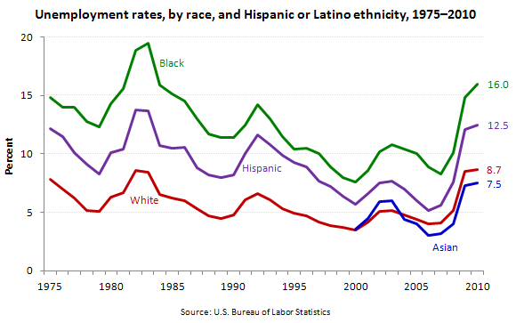**Source A**

The jobless rates for Blacks (16.0 percent), Hispanics (12.5 percent), Whites (8.7 percent), and Asians (7.5 percent) were much higher than their prerecession levels.

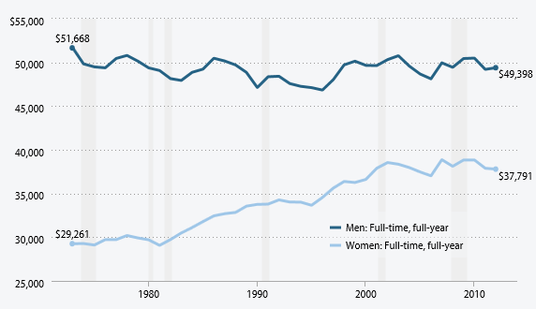**Source B Real earnings of workers, by gender, 1973–2012 (2012 dollars)**

**Source C**

|  |
| --- |
| **Poverty Rates of All Persons by Race and Ethnicity 1979-2011** |

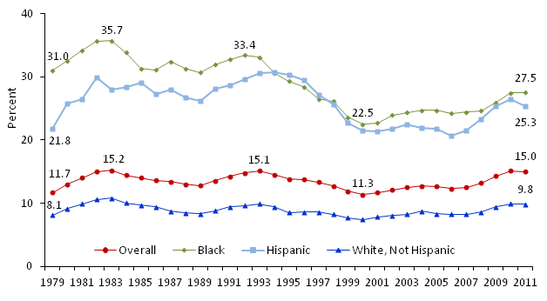

**Source D**

In 2012, 46.5 million people were counted as poor in the United States—the number, statistically unchanged over the past three years, is the largest recorded in the measure’s 54-year history. The *poverty rate*, or percent of the population considered poor under the official definition, was reported at 15.0% in 2012, a level statistically unchanged from the two previous years. The 2012 poverty rate of 15.0% is well above its most recent pre-recession low of 12.3% (2006) and remains at a level not last seen since 1993. Poverty in the United States increased markedly from 2007 through 2010, in tandem with the economic recession (officially marked as running from December 2007 to June 2009). Little if any improvement in the level of “official” U.S. poverty has been seen since the recession’s official end, with the poverty rate remaining at about 15% for the past three years. Some analysts expect U.S. poverty to remain above pre-recession levels through much, if not most, of the remainder of the decade, given the slow pace of economic recovery. The pre-recession poverty rate of 12.3% in 2006 was well above the 2000 rate of 11.3%, which marked an historical low (a rate statistically tied with the previous historical low of 11.1% in 1973).

Attempt the following question using only **Sources A, B, C and D**.

To what extent is it accurate to state that there have been improvements in economic inequality indicators such as employment, poverty rates and earnings?

**Immigration**

The debate over immigration is one that has been had for years in the United States. The social and economic impact of continued high levels of migration to the USA remains a divisive issue, with both positive and negative arguments based around the ideas of the economy, American culture and jobs.

**Arguments for immigration**

Tradition of Immigration

Historically, the USA has been a hive of immigration. All American citizens, with the exception of the Native Americans, can trace their ancestors back to immigrants that moved to the USA at some point in the past. Many of these immigrants moved to America as it was seen as the ‘Land of the Free’; peoples of Europe in the 17th century who were persecuted for their religious beliefs found tolerance and sanctuary in the USA. Black Africans, while initially brought to the country as slaves, were eventually freed and given opportunities to thrive. America has a proud tradition of accepting immigrants and this ethnic diversity is seen as a cause for celebration.

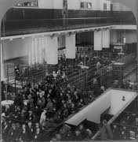

Ellis Island, New York. The main US immigration centre from 1892-1943. Millions of Americans can trace their ancestry back to these buildings.

The diverse nature of the American population is said to be one of the most important factors in the country’s success. One well-known analogy is that America is a ‘melting pot’. Different ingredients (people of different backgrounds, races, religions) are fused together to make a successful final product (American society, culture, success). Look back at the mix of races and backgrounds prevalent in the US Congress as an example of different cultural backgrounds working together (reasonably!) successfully.

Stimulating the Economy

Immigrants stimulate demand for housing, medical care, education and other sectors like retail. For example:

* When immigrants come to the USA, many will pay for private medical insurance as there is no free, universal health service. This contributes valuable funds to health plans.
* Landlords can rent rooms or homes to immigrants, giving them an income. Some immigrants will also buy homes which can cause property prices to stabilise or increase.
* Immigrants tend to have larger and younger families than many US-born citizens, protecting teaching jobs.
* Immigrants buy goods. The more people buying goods in an area the healthier the economy in that area will be.

Some immigrant groups are even said to be stimulating the economy to a greater extent than White Americans. Asian American immigrants, particularly, Korean Americans, are now out performing White Americans in terms of academic qualifications and average salary. Many work in high tech computer companies of California’s Silicon Valley. It can be argued that Korean Americans are now the most successful ethnic group in the USA. As well as helping high tech businesses, such as Google and Microsoft, grow, these higher earning citizens have huge buying power, to the advantage of local shops and businesses.

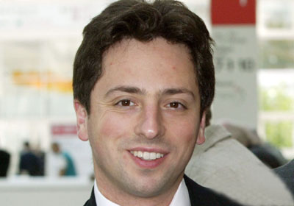

Sergey Brin – co-founder of Google. Born in Moscow, Russia.

Many people argue immigrants cost tax payers money due to increased pressures on public services like schools and social services. Immigrants will have instant access to these services without having paid anything into the tax system prior to entering the United States. In the longer term, however, immigrants contribute more than they cost to assimilate. Most are young, economically active and, in many cases, highly skilled. A young workforce is essential to maintain tax incomes to support older people or those unable to work. On average, immigrants are also less dependent on welfare payments than native born Americans. Most immigrants go to America to work and seek a better life, not take government handouts.

Providing Employment

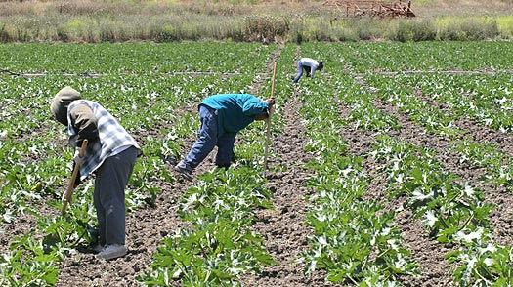Those who immigrate to America provide US businesses with a steady reserve of workers prepared to do low paid, low skilled menial jobs that many US citizens won’t do. Occupations such as cleaning or the construction industry, which are labour intensive and can only offer low wages are still vital for the US economy but many US citizens are unwilling to take up these jobs. Certain states are hugely reliant on immigrant labour, for example, Hispanic immigrants are vital to the economy in states such as Texas or California. It has been argued that the agriculture sector in California would collapse without the flow of Hispanic immigrants from South and Central America, particularly illegal immigrants who work for very little and expect no benefits like pension or health insurance plans.

In the recent past, the US government has recognised the valuable contribution of immigrants to employers. President George W. Bush’s ‘Guest Worker Program’ attempted to recognise the economic contribution of immigration by allowing US employers to sponsor

Non-US immigrant employees (support an application which would allow immigrants to stay in the country for an extended period of time). Many businesses support changes in the law that allow illegal immigrants to remain legally in the country, having recognised how essential these people are to business in America.

**Arguments against immigration**

Driving down wages and keeping US citizens unemployed

There are some in America who argue that wage levels of US citizens are being forced down by immigrants, and that immigrants take the jobs that unemployed Americans could do.

Many of the unemployed in America have a very limited education and rely on finding a low-skilled, low-paid job to get themselves into employment. Likewise, many of the immigrants who go to America are seeking low-skilled work and so if they are given these jobs then a US citizen can no longer take it. California is said to rely on immigrant labour for its agriculture industry and yet the unemployment rate in that state in April 2014 was 7.8%, 1.5% greater than the US average.

Due to the fact that immigrants are often willing to work for very low wages, US citizens must work for the same or less amount of money if they are to have any hope of competing for these jobs. Illegal immigrants make it even tougher for US citizens. They will often work for less than the minimum wage and expect no health or pension benefits, dragging down wages further.

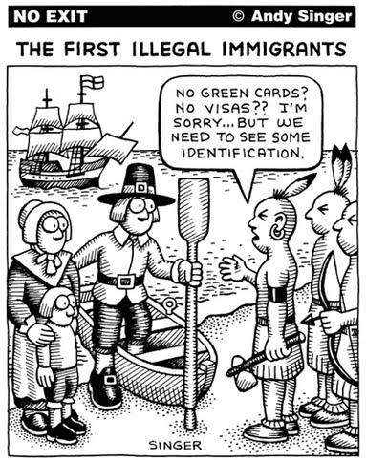Additional pressures on society

Increased immigration has led to greater competition for social services like education, healthcare, housing and other essentials.

Immigrants tend to be drawn to areas which already contain high numbers of immigrants so that they can be with people of the same language or background. Unfortunately, many of these areas are in poorer, inner-city areas. These areas already suffer from a lower standard of local services so large influxes of people place strain on the system. For example, in education, larger class sizes in schools may be more common and immigrant children whose first language is not English mean time, effort and money must be put in place to allow for translation and these children to access education. More people moving to an area through immigration without additional or adequate housing capacity means rental prices and property prices will rise. This will have an adverse effect on US citizens living in that area, especially those on low incomes, whose disposable income will be squeezed due to more money having to be spent on rent.

The low education levels of immigrants is a prominent point in the immigration debate; many immigrants lack any formal education. They are unskilled and are seen as a drain on the welfare and other social provisions. Being of lower educational attainment and lower category occupations, immigrants are more likely to seek assistance in the form of welfare. 33% of immigrants use at least one welfare program, compared to 19% of US citizens. Claims by anti-immigration groups like the Federation for American Immigration Reform (FAIR), that the high levels of immigration is hurting the economy and society are common in the American press. They estimate the cost of immigration to the US taxpayer per annum is $100bn.

Security risk

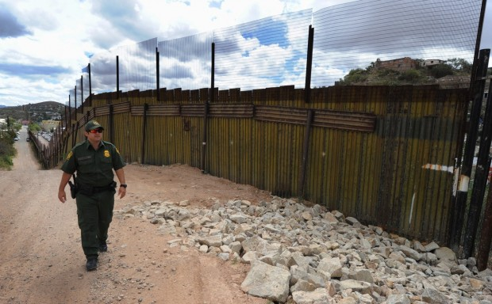After the events of 9/11, the USA has increased its security measures considerably. The introduction of various laws, such as the Patriot Act which gave government agencies like the FBI and NSA greater powers to look into the personal lives of US citizens, highlight how determined the USA is to root out national security threats. Many Americans now see immigration no longer an economic issue but as a national security issue. Unchecked migrants coming into the USA could be criminals or terrorist; therefore managing and reducing the number of migrants to the country decreases the possibility of threats from this source.

As a result, many Americans welcome tighter border controls. Huge investment has been made in border security, including heavy steel fencing along much of the 2,000 mile US/Mexican border. The Dept. of Homeland Security was created with the intention of securing America’s borders, a clear sign that State and Federal authorities are determined to prevent illegal immigration.

The perceived security threat posed by illegal immigrants has seen an increase in militia like the ‘Minutemen’, volunteers who patrol the US/Mexican border and detain illegal immigrants as they enter the United States. They then hand these people over to immigration control authorities to be deported back to Mexico.

High levels of legal and illegal immigration unpopular

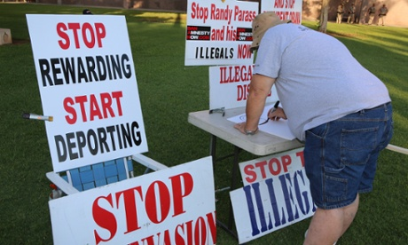Immigration (legal and illegal) remains high on the US political and media agenda. Immigration is a major political issue in border states such as Texas, California and Arizona, with the topic also a major topic in the 2012 US Presidential election. Arizona introduced a new law in 2010 which allows police to check the immigration status of anyone giving ‘reasonable suspicion’, increasing tensions in areas of high immigrant populations as it opens up the police to accusations of racial profiling (targeting Hispanics as they are most likely to be illegal aliens). However, these types of laws are often popular among the general US population.

A new worry for the authorities in border states is the huge increase in young migrants:

Tens of thousands of children unaccompanied by parents or relatives are flooding across the southern U.S. border illegally, forcing the Obama administration and Congress to grapple with both a humanitarian crisis and a budget dilemma.

An estimated 60,000 such children will pour into the United States this year, according to the administration, up from about 6,000 in 2011. Now, Washington is trying to figure out how to pay for their food, housing and transportation once they are taken into custody.

The flow is expected to grow. The number of unaccompanied, undocumented immigrants who are under 18 will likely double in 2015 to nearly 130,000 and cost U.S. taxpayers $2billion, up from $868 million this year, according to administration estimates. (Reuters News Agency)

American culture overwhelmed?

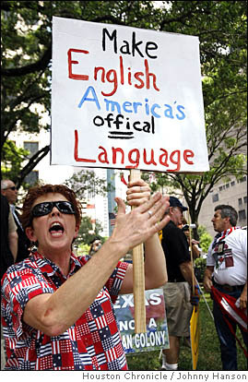There is a fear developing that US culture is being ‘overwhelmed’ in areas of concentrated immigration. For example, English is no longer the main language in some areas, having been replaced particularly by Spanish in border state ghettos and ‘barrios’ (Hispanic ghettos). The taco has replaced the burger as the traditional dish in some neighbourhoods! Hispanics are predicted to be majority ethnic group in California by 2030. These facts could be said to make a case that immigration should be reduced.

**Case Study: Obama’s stance on immigration**

President Obama’s record on immigration is muddled in that it has both pro- and anti-immigration features. For example, in 2012, Obama enacted an executive order called the ‘Dream Act’ after Congress had failed to pass the bill:

“In June 2012, President Barack Obama announced he would be signing an executive order to stop the United States from deporting young illegal immigrants by claiming, ‘As long as I'm president I will not give up on this issue, not only because it’s the do right thing to do for our economy, and CEO's agree with me, not just because it’s the right thing to do for our security, but because it’s the right thing to do period."

However, during the same period Obama put forward this order, which would allow people who were brought to the United States as children to have an easier route to full US citizenship, his administration was deporting illegal immigrants at a higher rate than any previous President and putting forward a tough message on immigration:

“As of July, Obama deported 1.4 million illegal immigrants since the beginning of his administration — that's 1.5 times more immigrants on average than Bush deported every month, according to official numbers from the Department of Homeland Security. But that's only part of Obama's deportation strategy: The administration's stated goal is to prioritize the deportation of criminal, dangerous illegal immigrants. And it's promised to make a new program called Secure Communities mandatory by 2013, which would force local law enforcement to share fingerprints of those arrested with the Department of Homeland Security, which has immigration records, through the FBI.” (Washington Post)

However, even this may not be the full story. Some analysts have claimed that the Obama administration have over-exaggerated the numbers deported to look tough on immigration and take support from the Republicans, who are generally tougher on this issue. One claim is that:

“Of the 12 million undocumented immigrants living in the country, fewer than 70,000 who have led generally peaceful lives here were deported last year” (USA Today)

**Practice End of Unit Assessment (Immigration)**

**Part 1** (Assessment Standard 2.1)

* **Explain, in detail, the argument that immigration is positive for the USA economy**

In your answer you should:

* Explain at least two ways immigration to the USA impacts the country economically
* Refer to arguments in support of the impact of immigration on the economy in the USA you have studied

**Part 2** (Assessment standard 2.2)

* **Analyse the significance of immigration on US society**

In your answer you should:

* Consider the significance of how immigrants affect US society
* Refer to arguments for and against the impact immigrants have on American society

**Part 3** (Assessment standard 1.1 and 1.2)

* **Use the sources to draw a conclusion about immigration in the USA**

In your answer you should:

* Draw one clear conclusion
* Link evidence across the sources to support your conclusion

**Source 1**

Thirteen years after welfare reform, the share of immigrant-headed households (legal and illegal) with a child (under age 18) using at least one welfare program continues to be very high. This is partly due to the large share of immigrants with low levels of education and their resulting low incomes — not their legal status or an unwillingness to work. In 2009 (based on data collected in 2010), 57 percent of households headed by an immigrant (legal and illegal) with children (under 18) used at least one welfare program, compared to 39 percent for native households with children. Immigrant households’ use of welfare tends to be much higher than natives for food assistance programs and Medicaid. Their use of cash and housing programs tends to be similar to native households.

A large share of the welfare used by immigrant households with children is received on behalf of their U.S.-born children, who are American citizens. But even households with children comprised *entirely* of immigrants (no U.S.-born children) still had a welfare use rate of 56 percent in 2009. Immigrant households with children used welfare programs at consistently higher rates than natives, even before the current recession. In 2001, 50 percent of all immigrant households with children used at least one welfare program, compared to 32 percent for natives. We estimate that 52 percent of households with children headed by legal immigrants used at least one welfare program in 2009, compared to 71 percent for illegal immigrant households with children. Illegal immigrants generally receive benefits on behalf of their U.S.-born children.

(Centre for Immigration Studies)

A report by the Small Business Administration in the United States has found that immigrants are nearly 30 percent more likely to start a business than are non-immigrants, and represent 16.7 percent of all new business owners in the United States. Immigrant business owners make significant contributions to business income, generating $67 billion of the $577 billion in U.S. business income, as estimated from 2000 U.S. Census data. They generate nearly one-quarter of all business income in California—nearly $20 billion— and nearly one-fifth of business income in New York, Florida, and New Jersey. Nearly 30 percent of all business owners in California are immigrants, compared with about 12.5 percent of the population of U.S. business owners.

Immigrants own 11.2 percent of businesses with $100,000 or more in sales and 10.8 percent of businesses with employees. Immigrants also own a large share of businesses in the lowest and highest skill sectors and in several industries.

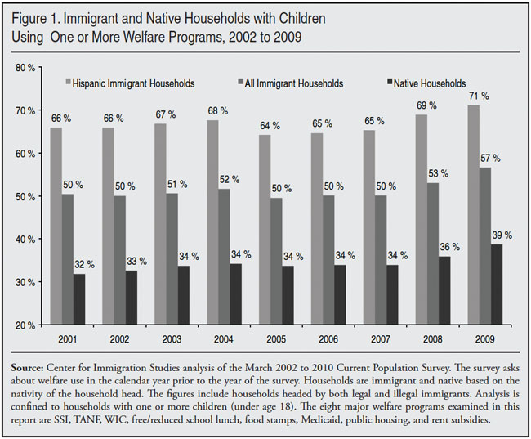

**Source 2**

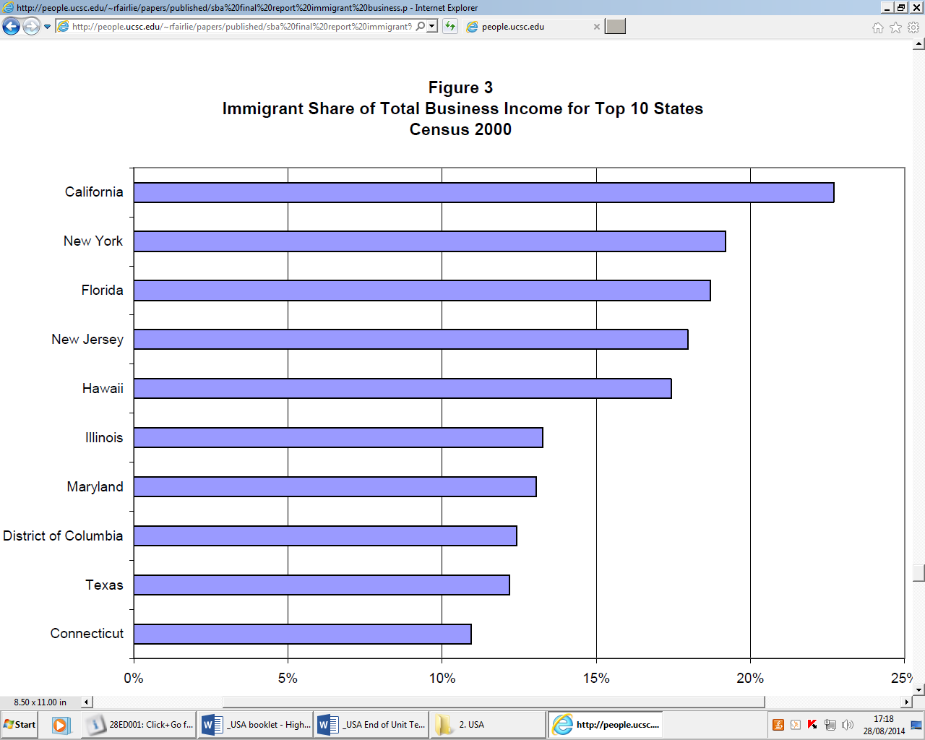

**Source 3**

Introduction:

The USA is undoubtedly one of the most, if not the most, influential countries in the world. For decades the USA has had a major say in the running of powerful multi-national organisations like the UN, NATO and the WTO. It can call upon military allies from every continent of the world and trades with almost every country in the world. However, the years succeeding the undertaking of the ‘War on Terror’ have seen new challenges to America’s dominance of world influence.

**Section 3 – Role of USA in International Relations**

**Issues to be covered in this section:**

**America’s role with regard to;**

* **International Organisations**
* **International treaties and obligations**
* **Other nation states**
* **Power in International Relations**
* **Limitation in International Relations**

**International Organisations**

**United Nations**

Power

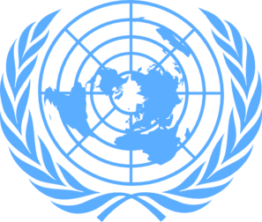America is one of the founder members of the UN and the UN headquarters are based in New York City. It is also one of the five permanent members of the UN Security Council, the body responsible for settling conflicts and securing peace, and as a result can ‘veto’ any Security Council resolution (any idea put before the council to be voted on which one or more members think will solve a problem can be blocked with a veto by any of the permanent members if they think the idea is not in their interest). Since 1972, the USA has used the veto more than any other permanent member. These vetoes have regularly concerned the Israel-Palestine conflict, with the Obama administration vetoing several resolutions which have proposed to condemn illegal Israeli settlements in occupied territories. The USA also blocked a statement from the Security Council which would have criticised Israel for their role in the 2014 operation against Hamas in the Gaza Strip. This position gives Israel, America’s strongest ally in the Middle East, greater flexibility in how it deals with its Arab neighbours.

More generally, the USA contributes more money to the funds of the United Nations (around 22%) than any other country as the amount is worked out on an “ability to pay” ratio. In 2008, a group of American Senators had recommended cutting America’s contributions to the UN by half if it did not stop what it called ‘anti-US and Israeli sentiment’. The plan was never implemented. As the UN building is in the United States, the US can block people entering the country who are travelling to the UN. While this goes against the principles of the UN and has only happened rarely, for example blocking Iran’s choice of Ambassador to the UN in 2014 as he had been part of a group that had taken hostages at the US embassy in Iran in 1979, it does show that USA wields power and influence over the United Nations.

Limitations

The invasion of Iraq in 2003 had been preceded by UN resolutions and discussions going back to 2002. The USA had used its influence to get Resolution 1441 passed in the Security Council, a document which called for the immediate disarmament of Iraq’s chemical and biological weapons. However, when the USA claimed this had not been done, they felt this gave international clearance for a military invasion. Other permanent members disagreed, particularly France, who threatened to use their veto to block any authorisation of invasion. America carried out the operation regardless, leading many to claim the war violated international law.

The more recent conflict in Syria has also shown America does not always wield unlimited power within the UN. During this civil war, both China and Russia have regularly vetoed America and the West’s attempts to make life difficult for President Assad of Syria’s regime. For example, in 2014 a resolution which would have allowed for members of the Syrian regime to be taken to the International Criminal Court was vetoed by China and Russia, while in 2012 a plan to use economic sanctions against the Assad regime if it did not follow a UN peace plan was also vetoed by the same to countries.

**NATO**

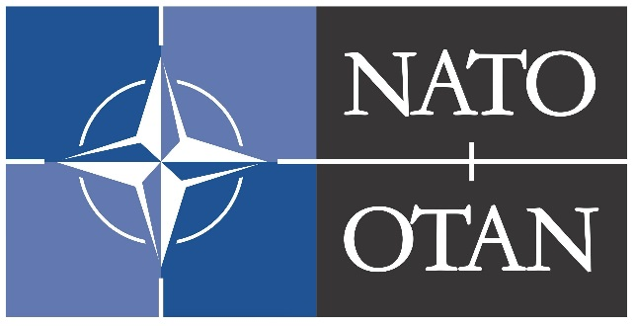Power

NATO (North Atlantic Treaty Organisation) was set up as a military alliance to combat the military threat posed by the Soviet Union during the Cold War. It has since transformed itself into a symbol of Western ideals and cooperation among members, not just militarily but in other spheres as well. America has always been at the forefront of this organisation. In military missions carried out by the organisation, such as its peacekeeping role and the training of Afghan security forces since the 2001 invasion of Afghanistan, it has been the US which has provided the largest number of troops and equipment from a single country. America also provides three-quarters of NATO’s budget. Recently, NATO has increased its presence in countries which used to be part of the USSR, for example flying more military air patrols over the Baltic States (Latvia, Estonia and Lithuania). In 2014, NATO increased the number of jets used to patrol from 4 to 10. All of these are US jets.

Limitations

America has by far the largest military budget in the world. However, it also has more military commitments than any other country. When a NATO mission to protect civilians with bombing from aircraft was decided upon during the Libyan people’s campaign to oust the dictator Colonel Gadaffi in 2011, it was Britain and France who took the lead, carrying out the majority of missions. America has been keen to see more ‘burden-sharing’ within the organisation, a stance which could be argued to highlight America’s unwillingness to always have the majority of responsibility in the role of bringing about peace in the world.

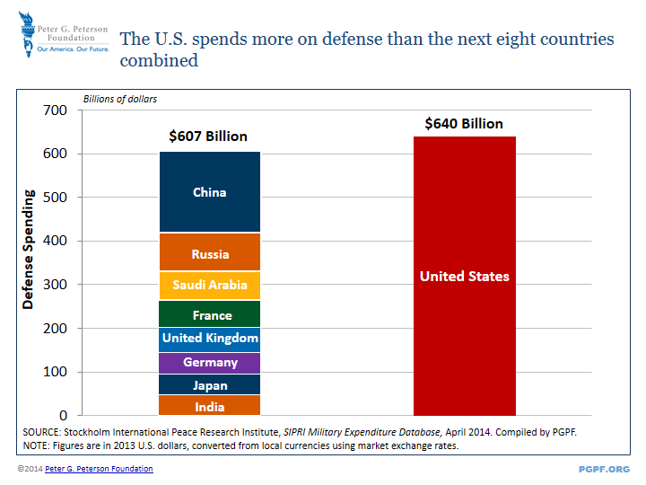

**International Treaties and Obligations**

[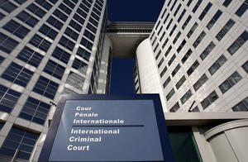](http://www.hrw.org/sites/default/files/media/images/photographs/2011_Icc_building.jpg)**Rome Statute and the International Criminal Court**

The International Criminal Court (ICC) came into being with the signing of the Rome Statute in 2002. Since then, well over 100 countries have signed the statute. The USA supported the setting up of the court, which focusses on crimes which are huge in scale, such as genocide, crimes against humanity and war crimes. Bill Clinton, then President, signed up to the Statute but did not have Congress ratify (finalise) the treaty. America withdrew completely from the process during the Presidency of George W. Bush and proceeded to ensure no US citizen could be tried in the ICC, threatening to cut off aid to countries who refused to set up guarantee agreements with the United States that US citizens could not be turned over to the court. Major concerns for the USA were American troops on foreign soil not being tried for crimes under American law in the American court system and American citizens being tried outside the USA for crimes committed on US soil, an act many believe contravenes the US Constitution. Under Obama, the US has reengaged with the ICC, for example working with them to pave the way for the ICC to prosecute members of the LRA (the terrorist group of Joseph Kony operating in Uganda), however, there are still no plans for the US to join.

**Free Trade Agreements**

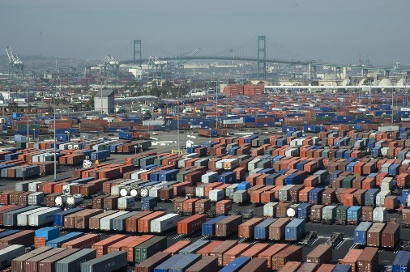

Port of Los Angeles

The United States can attribute much of its power and wealth to trade. To promote trade with other countries, the US has entered into ‘free trade agreements’ with 20 countries, including Canada, Mexico and Australia. This means America does not charge import duties or tariffs on many goods and services, and the fellow country in the agreement does the same for American goods. The fact that America has so many trade agreements, and is currently negotiating a further agreement with the EU, shows that America is a dominant player in world trade.

**Other examples**

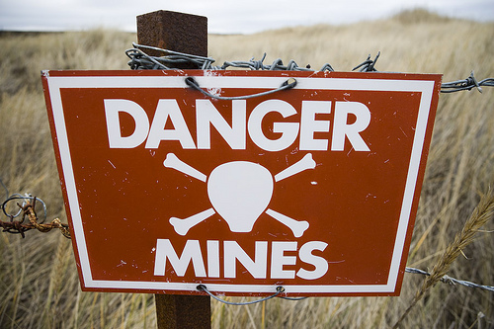As is evidenced by the example of the ICC, the USA will refuse to sign up to treaties and obligations if it is not in its interest, even if closely allied countries have ratified these treaties. A further good example is the international treaty banning the use of landmines. Every country in the Western Hemisphere, with the exception of Cuba, have signed up to this agreement. However, the US continue to refuse as they see landmines as necessary to protect US soldiers stationed on foreign soil, such as those stationed in South Korea using landmines in the de-militarized zone with North Korea. This leads into a key point about America’s obligations around the world, namely that it is the country relied upon most in the world to give military protection to allies against would-be enemies. It is estimated that at any time there are over 250,000 US military personnel stationed overseas in over 60 countries, including the UK. Others have claimed that there could be US military personnel in over 150 countries. American policymakers believe that due to its unique status as a military ‘guardian’ in so many different countries, it cannot sign up to many international obligations as they would put their ability to carry out this special role at risk. The relationship between America and other countries will be examined further in the next section.

**Relations with other nation states**

**Trade and investment**

A further example of the USA’s power can be seen in the investments it makes in other countries, and in turn the investments other countries look to make in the United States. In total the US had $230 billion directly invested into it in 2011 and $166 billion in 2012, mostly into sectors like finance and manufacturing. In turn, the US directly invested $388 billion in foreign countries in 2012. The UK and USA invest more in each other’s countries than any other single nation. To date, UK companies and individuals have invested $487 billion in the US. The US meanwhile holds 27% ($433,000,000) of the UK’s foreign direct investment stock.

**Security**

Power

1. As previously mentioned, the United States is the undisputed military power in the world and this position has allowed/forced the US to become the security guardian of many nations. The US backs up its allies with military bases and joint military drills, which is a show of force to any ally’s enemies. The clearest example of this are the annual drills between the US and South Korea which tend to imitate a North Korean invasion of the South. This is intended to show readiness for such an attack and so will prevent the North from actually carrying out such a move.

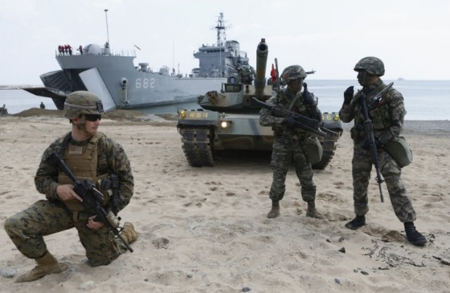

US and South Korean marines practise joint amphibious landings.

1. US military power can be projected into almost every country in the world, and the most common method for this projection of power in current times is the use of drones. America has flown missions over countries it considers allies to target and destroy militants who may threaten the government in the allied country or American interests. This has been done often in Yemen, where al-Qaeda militants have regularly attacked Yemeni armed forces and government officials to try to destabilize the country. America would feel they have helped push back terrorists on behalf of their allies in this way.
2. America has developed working relationships with most countries around the world, many of whom have been enemies in the past. One example is Russia. America has signed several treaties with its old Cold War foe, the latest being the ‘New START’ Treaty signed in 2011 which limits the amount of nuclear weapons each country is allowed to stockpile. In 2012 President Obama signed legislation that guaranteed normal trade relations between Russia and the US, and in 2013 the US exported $11 billion worth of goods to Russia. However, when Russia annexed Crimea in 2014, the US imposed sanctions on Russia which prevented or limited US companies’ dealings with Russian banks, technology and oil firms. This has hurt the Russian economy, putting the price of essentials like meat up by around 20% and causing the Russian currency (the Ruble) to lose around 19% of its value.

Limitations



The South Korean warship *Cheonan* being lifted from the seabed after a North Korean torpedo attack.

1. Often, the US continuation of ‘war games’ with its ally South Korea has backfired. North Korea views these exercises as an offensive gesture and intimidatory. In response, North Korea has launched small scale military attacks on South Korea, such as sinking a South Korean warship in 2010. Incidents like this, it could be argued, mean that the US cannot fully protect its allies and actually help their ally become a target for attack.
2. 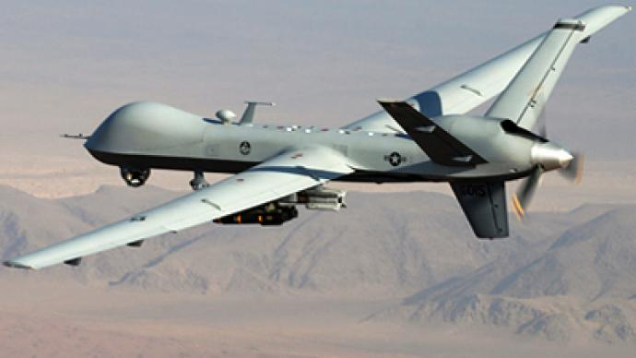Drone strikes are extremely unpopular in the countries where they take place. In Pakistan, for example, the continued US strikes against Taliban fighters near the border with Afghanistan, which have resulted in many civilian casualties, have caused outrage and have turned some in the country towards joining the Taliban or other anti-American groups. Even the Pakistan government has publicly criticised and questioned its partnership with America. A clear example of this came after the US Special Forces mission to execute Osama bin Laden in 2011, who was in Pakistan at the time. The US did not inform Pakistan that it was launching a major mission on its soil, despite the fact Pakistan is widely touted by the USA as an important ally.
3. The US does not command the same respect from some foreign countries after the war in Iraq which began in 2003. Russia, for example, has openly challenged the USA, viewing it as an aggressive country which is morally and financially weaker due to its recent, long, drawn-out wars. The military actions to protect people of Russian ethnicity living in Georgia in 2008 and to annex the Crimea from Ukraine in 2014 happened despite strong protests from the US. Russia also blocked any move by the US through the UN to bomb Syria, as the Assad regime in the country was an ally and major military trade partner with Russia. These examples show that Russia is now more willing to use force and power to protect its ‘sphere of influence’, and ignore the wishes of the US in foreign policy matters. Despite sanctions from the US, Russia has held onto Crimea and continues to support anti-government forces in Ukraine.