Democracy in Scotland

Unit 3

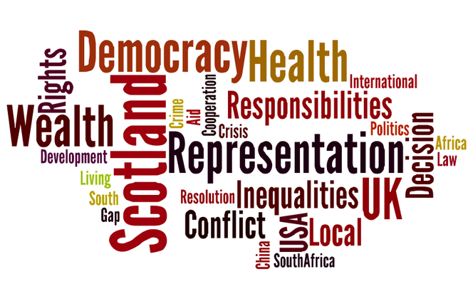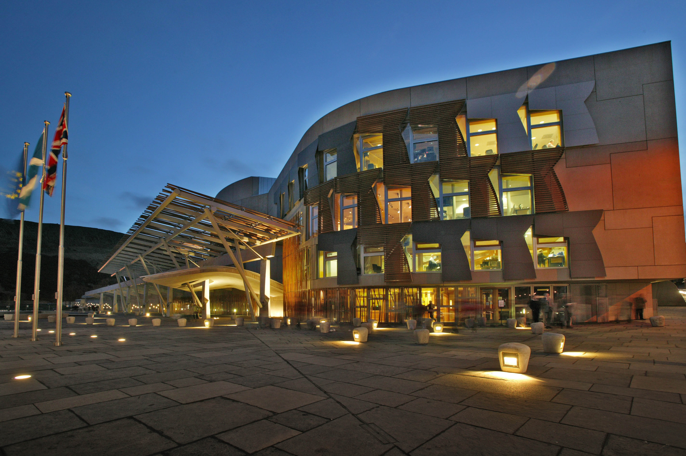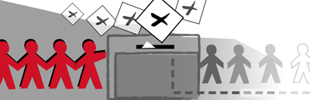

**Contents Page**

**REPRESENTAION**

* Devolved/ Reserved Powers 3
* Role of MSP’s (Constituency, Debates, Committees) 6
* Making Laws 9
* Work of committees 11
* Role of the First Minister 13
* Local council budgets 16
* Role of local Councillors 18
* The First Minister 21

**PARTICIPATION**

* SNP 23
* Labour 24
* Conservatives 25
* Liberal Democrats 26
* Green 27
* Scottish Socialist Party 28
* UK Independence Party 29

**ELECTION CAMPAIGNS**

* Why vote? 32
* Additional Member System (AMS) 34
* Coalition Governments 38
* Majority Governments 40
* Single Transferable Vote (STV) 42

**INFLUENCE OF MEDIA**

* Definition 44
* Control 45
* Newspapers 46
* Television 48
* New Media 50

**REPRESENTATION**

**The Scottish Parliament**

The **Scottish Parliament** is the devolved national, legislature of Scotland. Located in the Holyrood area of the capital city, Edinburgh.

The Parliament is a democratically elected body comprising 129 members known as Members of the Scottish Parliament (MSPs), elected for four-year terms under the Additional Member System (AMS): 73 MSPs represent individual geographical constituencies elected by the First Past The Post system, while a further 56 are returned from eight additional member regions, each electing seven MSPs. The most recent general election to the Parliament was held on 5th May 2011.

**Powers of the Scottish Parliament**

The main function of the Scottish Parliament is to make laws, which affect the Scottish people.

The Scottish Parliament is part of a process known as devolution. Devolution is a system of government which allows decisions to be made at a more local level. In the UK there are several examples of devolved government including: the Scottish Parliament, the Welsh Assembly, the Northern Ireland Assembly and the Greater London Authority.

Under this system of devolution, Scotland is still part of the United Kingdom and the UK Parliament in Westminster is sovereign (has ultimate power).

The Scottish Parliament has power to introduce new laws on a wide range of important issues which affect our everyday lives. These are known as **devolved matters**.

The Scottish Parliament does not have the power to pass laws in other areas known as **reserved matters**. Only the United Kingdom Parliament can pass laws on reserved matters.

**Devolved powers**

The following areas are decided in Scotland.

* Health
* Education
* Housing
* Sport and Arts
* Agriculture, Forestry & Fishing
* Emergency Services
* Planning
* Social Work
* Heritage
* Some Transport
* Tourism

**Reserved powers**

Decisions (mostly about matters with a UK or international impact) are reserved and dealt with at Westminster.

* Defence
* UK Foreign Policy
* Social Security
* Financial & Economic Matters
* Employment
* [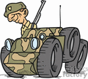](http://www.graphicsfactory.com/Clip_Art/Transportation/Land/Military00003_172850.html)Constitutional matters
* Immigration & Nationality
* Monetary System
* Common Markets
* Some transport
* Data Protection
* Energy
* Gambling
* Medical Ethics
* Equal Opportunities

The UK Parliament at Westminster retains power to legislate on any matter, but the convention (agreement) of devolution is that the UK Parliament will not normally legislate on devolved matters without the consent of the Scottish Parliament.

**Tasks:**

1. Using the cut out cards play pairs. Instructions on PPT (All).
2. From the cards take note of the example laws, which have been made in Scotland in the past 10 years (All).
3. Make a poster to advertise the differences between devolved and reserved powers. You poster must be clear and easy to understand with pictures and examples of recent Scottish and UK Laws (All)
4. SQA Practice Question. The Scottish Parliament has important areas of responsibility. Describe, in detail, the main areas of responsibility of the Scottish Parliament (Nat 5) 6 marks.

**Role of MSPs**

MSPs have several roles to play. Here are five of these roles.

**Committees**

Most MSPs are members of at least one committee. Most committees meet weekly or fortnightly, usually on Tuesdays or on Wednesday mornings, in one of the Scottish Parliament’s committee rooms – or in locations around Scotland. Most meetings are in public. Each committee is given a particular area or subject to examine in detail. For example, the Justice Committee considers and reports on matters relating to crime and law in Scotland.

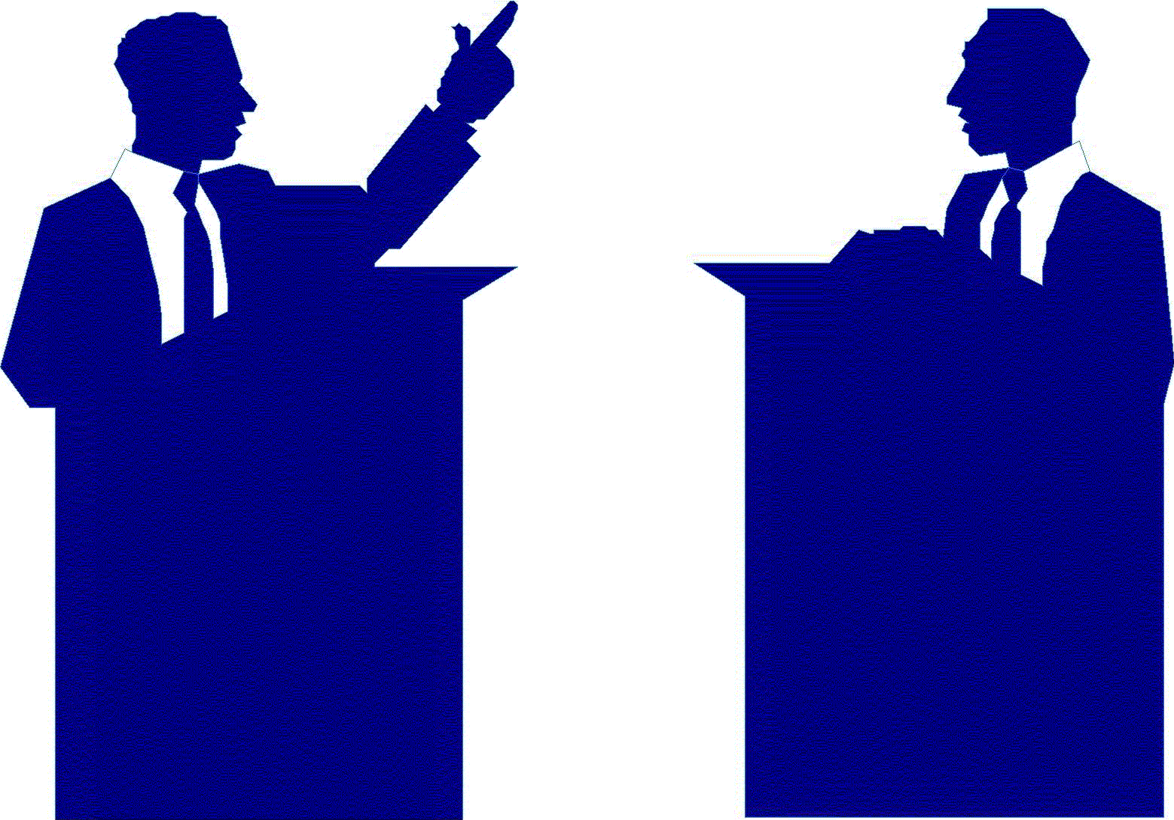**Debates**

MSPs meet in the debating chamber on Wednesdays and Thursdays. They may put forward motions about problems experienced by the people they represent, and they can ask Parliament to consider how to solve them.

They also debate proposals for new laws (Bills).

**Question Time**

On Thursday MSPs get the opportunity to question the Scottish Ministers about Government policy.

**Members’ Bills**

Each MSP has the right to introduce two Bills during one Parliamentary session (four years).

If an MSP is contacted by members of the public about an issue, she/he may decide to try to get a change in the law by introducing a Member’s Bill.

**Votes**

At the end of each day in the chamber, MSPs vote. This is called ‘decision time’, and the results of the vote will decide whether an issue passes on to the next stage of the legislative process.

**Constituency**

MSPs have a responsibility to work on behalf of their constituents. They do this in two main ways:

(1) The work they do in the Parliament  
(2) The work they do in their Constituency or Region

**(1) The work they do in the Parliament**

**All Day Tuesday & Wednesday Morning**.

MSPs may be members of one or two of the **Committees** of the Parliament. There are two types of committee which are,

* **Mandatory committees** - Some key committees are required by the Standing Orders (rules of the Parliament).
* **Subject committees** - The Parliament can create other committees to deal with a particular subject or area. These are known as Subject Committees.

There are 16 Committees that are made up of between 7 and 11 MSPs.

They discuss in **detail** a particular area or subject, e.g. Education

MSPs represent us in the Parliament's Committees by:

* Scrutinising proposed new laws (known as Bills)
* Proposing amendments (changes) to Bills
* Conducting inquiries
* Discussing and writing Committee reports for the Parliament to consider
* Scrutinising Ministers and Officials
* Asking the Committee to propose a Bill.
* Asking outside groups to present evidence helping them to develop informed opinions and to represent the views of a wide range of people.

**Wednesday Afternoon & All Day Thursday**

The Chamber of the Parliament is where all 129 MSPs have the opportunity to debate, discuss and vote on the issues of the day.

It is only in the Chamber of the Parliament that a Bill can be passed.

MSPs might represent us in the Chamber by:

* Speaking and voting in the Chamber
* Putting forward a motion (idea) to be debated
* Suggesting an amendment (change) to be made to a bill.
* Questioning Ministers and the First Minister.

They may try to introduce a Members Bill (according to the Parliament's rules every MSP has the right to introduce two Bills in the four-year term of the Parliament).

**(2) The work they do in their Constituency or Region**

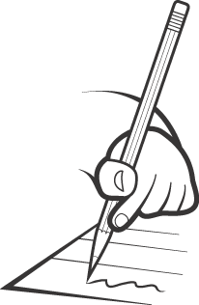**Monday All Day All Day Friday**

* MSPs will be writing replies to letters, emails and replying to phone calls.
* Attending meetings and events where they can discuss issues with groups of constituents and people from other organisations.
* Attending special events in their constituency, for example, the opening of a new community resource centre.
* Holding surgeries, i.e. a particular time and place where constituents can meet their MSP and raise any problems with them.
* Our MSPs, MP and Local Councillor may meet to discuss areas of mutual concern and possibly to pass an enquiry to the appropriate representative.
* MSPs are also involved in working with their Constituency Party seeking
* the views and help of party members.

**Tasks:**

1. Produce a leaflet for the Scottish Government informing the public about the duties of MSP’s from the criteria on the PPT (All).
2. Describe, in detail, how MSP’s represent their constituencies in Parliament. 6 marks (Nat 5)

**Making Laws**

The legislative process starts when a new law is being discussed. There then follow the stages it must go through before it is passed. When a new law is proposed, one of the Parliament’s committees (the committee that the law is concerned with) will examine the general ideas within it and then report to Parliament. At this point, the ideas/proposals are known as a Bill. The Parliament then considers the Bill in three stages.

**Stage 1**

The whole Parliament will debate the Bill. This first debate discusses whether the bill is a good idea or not. The MSPs will then vote on the Bill. If the majority vote in favour the Bill will then pass to the next stage.

If the majority vote against the Bill it will be thrown out.

**Stage 2**

One of the Parliament’s committees will now examine the Bill in detail. This committee will be the one that the Bill is linked to, e.g. a health bill will be proposed and examined by the Health Committee. The committee can make changes that are called amendments to the Bill. The committee then reports to Parliament.

**Stage 3**

The whole Parliament will debate the Bill. This is a full debate where MSPs can submit amendments to the Bill and these are voted on one at a time. MSPs then vote on the Bill and if the majority agree the Bill becomes a law.

**Stage 4**

[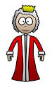](http://www.google.co.uk/imgres?imgurl=http://www.how-to-draw-funny-cartoons.com/image-files/cartoon-queen-008.jpg&imgrefurl=http://www.how-to-draw-funny-cartoons.com/cartoon-queen.html&usg=__tV9RpoFWFykX_I2KjUWoXwmJn28=&h=420&w=250&sz=28&hl=en&start=8&zoom=1&tbnid=OUy_RN54vG3lHM:&tbnh=125&tbnw=74&ei=eEk_UMzrAdSY0QXo-IGwDg&prev=/search?q=queen+cartoon&um=1&hl=en&safe=active&gbv=2&tbm=isch&um=1&itbs=1)The monarch must sign all bills before they can become law. This procedure reflects the fact that Scotland is part of the UK and that all UK legislation must obtain the Royal Assent

In 2014 19 Bills were discussed by the Scottish Parliament.

**Different types of bills in the Scottish Parliament**

It was decided that individual MSPs should have the right to introduce legislation as well as the executive and committees.

**Executive Bills**

These are Bills introduced by the Scottish Government and make up a majority of legislation. Examples include:

* Community Care and Health Act 2002
* Water Industry Act 2002
* Transport Scotland Act 2001
* Education and Training (Scotland) Act 2000
* Abolition of Bridge Tolls (Scotland) 2008

**Committee Bills**

These are initiated by a committee. During the first session of the Scottish parliament (1999–2003) three Committee Bills were passed:

* Protection from Abuse (Scotland) Act 2001
* Scottish Parliamentary Standards Commissioner Act 2002
* Commissioner for Children and Young People (Scotland) Act 2003

**Members’ Bills**

Each MSP has the right to introduce two Bills during one Parliamentary session. Examples include:

* Abolition of Poindings and Warrant Sales Act 2001, introduced by Tommy Sheridan (MSP, until May 2007).
* Protection of Wild Mammal (Scotland) Act 2002, introduced by Mike Watson (MSP, until September 2005).

**Private Bills**

A Private Bill is introduced by an individual, a group or a company. The first Private Bill to be proposed was: Robin Rigg Offshore Wind Farm (Navigation and Fishing) (Scotland) Bill.

The first Private Bill to be passed was the National Galleries of Scotland Bill 2003.

**Tasks:**

1. Make a table in your jotters summarising the process of turning a bill into a law, you must include 1 named example of bill that were introduced by committees, members and by private people. (Nat 4)
2. SQA Practice Question: Describe, in detail, how a bill becomes a law, give named examples in your answer. 6 Marks. (Nat 5)

**The committee system in the Scottish Parliament**

There are 16 Committees in the Scottish Parliament. Committees usually have between 7 and 11 MSPs as members. Members of the Committees are selected so that the balance of the political parties in Parliament is reflected. A Minister (of the Scottish Government) can be called to appear before a Committee to explain policies or take part in an inquiry. This is one more way in which the Government may be scrutinised, committees will be covered later in more detail.

**The work of Committees**

The committee system was designed to be a strength of the Parliament. Here are the aims of the committee system:

– To encourage involvement of the public in Parliament’s activities. For example, individuals as well as members of organisations and groups can appear before committees or write to them to give evidence.

– To enable Parliament to hold the Scottish Government to account effectively. Part of a committee’s work is to scrutinise the work of the Scottish Government. The Ministers in the Government do not sit on committees but can be asked to appear before the committee to answer questions.

– To encourage the sharing of power. Committees can investigate any item that falls within their remit, hold inquiries and make recommendations to Parliament and the Government. Committees also have the power to initiate legislation themselves.

Committees in the Scottish Parliament are where much of the real work of a MSP takes place. Committees are made up of small groups of MSPs. There are two types of committees: subject and mandatory. Mandatory committee committees are those which must exist under the rules of parliament, subject committees are based on the responsibilities of the Scottish Government.

**Public Petitions Committee**

There is also a special committee called the Public Petitions Committee that gives anyone living in Scotland direct access to the Parliament. Any individual or group can petition Parliament to change a law or introduce a new law.

The Public Petitions Committee must consider each petition if it is within the Parliament’s range of devolved matters. In doing so it plays a crucial role in realising the Parliament’s key principles of openness and accessibility.

One important aspect of the petitions system is that of e-petitions. Petitions can be submitted online. Each e-petition also has its own discussion forum where visitors and supporters can discuss and debate the petition.

**Examples of Committees**

**Mandatory**

Equal Opportunities, European & External Relations, Finance, Public Audit, Public Petitions Standards, Procedures & Public Appointments, Subordinate Legislation

**Subject Committees**

Economy, Energy & Tourism, Education, Lifelong Learning & Culture, Health & Sport, Justice, Local Govt & Communities, Rural Affairs & Environment, Transport, Infrastructure & Climate

**Tasks:**

1. Explain what a committee does and give at leads 2 examples of different types of committees (Nat 4).
2. Explain, in detail, the work on committees in the Scottish Parliament. 6 Marks (Nat 5)

**The First Minister and Prime Minister**

Unlike in the USA where there are direct elections for the Head of State, the President, UK voters do not vote directly for the UK Prime Minister. The Prime Minister is head of the Cabinet and selects the most capable MPs to be Government Ministers. The Prime Minister of the United Kingdom of Great Britain and Northern Ireland is the head of Her Majesty's Government in the UK. The Prime Minister and Cabinet are collectively accountable for their policies and actions to the monarch as well as to Parliament. They must appear before Parliament each week to answer questions from MPs at Prime Minister’s Question Time.

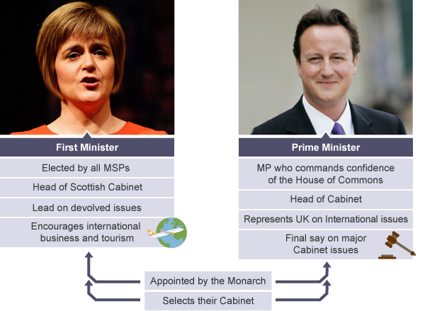

Unlike the Prime Minister, the First Minister is elected by all the MSPs, not just by members of his own party. The party with the most MSPs will normally be in a position to nominate their leader, as First Minister and the election will be a formality. Like the Prime Minister, he/she is then appointed by the monarch.

The main role of the First Minister is to represent Scotland in the areas that are devolved to the Scottish Parliament. The First Minister is expected to have a vision for the country and to lead it in a positive direction.

Like the Prime Minister, he/she is the leader of the Scottish Cabinet and selects MSPs to serve it. The First Minister is accountable to the Scottish Parliament and must appear at the weekly First Minister’s Question Time to answer questions from MSPs.

The First Minister also represents Scotland at an international level, promoting it as a place to visit and do business with.

Some of this work can overlap with the duties of the UK Secretary of State for Scotland. This person is an MP, not an MSP, and a member of the UK government, not the Scottish government. Prior to devolution, the Secretary of State for Scotland was the country's voice at home and abroad. Today he/she continues to represent Scotland at a UK level in the UK Cabinet as well as dealing with issues that are reserved to Westminster, such as defence and foreign affairs

**Tasks:**

1. Watch this weeks First Ministers Questions
2. Explain, in detail, the roles of the First Minister in Scotland. (Nat 5) 6 marks.
3. Compare the powers of the Prime Minister to the powers of the First Minister. (ALL).

**Local Councils**

Local councils are part of the structure of government in Scotland. They are the level below the Scottish Parliament.

We have many elected representatives:

• **MEPs** – Members of the European Parliament (in Brussels and Strasbourg)

• **MPs** – Members of Parliament for the whole of the UK (in Westminster)

• **MSPs** – Members of the Scottish Parliament (in Holyrood)

• **Local councillors** – at district, or local council/government level

• **Community councillors** – within a local council area.

**Areas of responsibility**

Local councils provide a wide range of services. There are three types of services:

**Mandatory**: these services must be provided by law. One of the main mandatory services is primary and secondary education.

**Permissible**: these services do not have to be provided by law but councils usually do provide them, e.g. leisure centres, libraries.

**Discretionary**: local councils may choose to allocate funds to particular local projects, e.g. flood prevention in Perth.

|  |  |
| --- | --- |
| **Mandatory Services** | **Discretionary Services** |
| Education eg schools, teachers salaries | Leisure facilities e.g swimming pools, community centres |
| Police & fire services | Flood control |
| Social work, fostering, adoption | Twin towning |
| Planning e.g new schools & business premises | Residential care for the elderly |

**Council Finance**

Local councils are responsible for meeting the needs of all the people living in the local council area. This means that the council has to employ lots of people across the different services it provides. So, the local council needs money to pay salaries, maintain all council buildings and provide tools and equipment for all the different services that it provides.

Local councils receive the majority of their money (80%) from the Scottish Government, through Aggregate External Finance (AEF). AEF consists of three parts:

* Revenue Support Grants
* Non Domestic Rates
* Income and Specific Grants

There are four main sources of income for local councils:

• ***Council Tax***

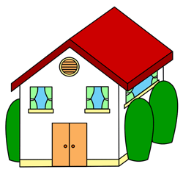 Each council in Scotland charges a property tax on every house. The amount charged is based on the value of the house; so a family living in a small tenement flat will pay less than a family living in a big detached house. There are eight bands of payment – A–H. If there is only one adult living in the house then the council will give that household a 25% discount on their Council Tax bill. There are other discounts available depending on circumstances.



• ***Service charges***

Councils have to provide specific services out of their income, but they can also choose to provide others for which they can charge money. For example, a council can provide gym facilities, swimming pools and sports clubs. The biggest source of service-charge income is rent from council housing.

• ***National non-domestic rate***

This is money paid by businesses in the council area based on the rateable value of their property.

**• *Government grants***

The official name of this is Aggregate External Finance (AEF) and it comes direct from the government. It is the biggest single source of income for local councils in Scotland. Westminster sets the overall amount of money available for Scotland, and then the Scottish Executive allocates money to the 32 local councils.

**Public Private Partnership (PPP)**

Many local councils do not have enough money to pay for big capital projects like refurbishing or rebuilding schools (such as Balfron High). However, these services still need to be paid for. One way of solving this problem without receiving more money from central government or increasing council tax is to form Public Private Partnerships (PPPs). Money from the council and from a private company is pooled to finance large spending projects. Many local councils have argued that they would have been unable to refurbish/rebuild schools without cash from the private sector – using PPP funding. Others argue that it is the responsibility of local government to provide these services with money from the Scottish Parliament and the council tax, and so they should not be taking money from the private sector. There will be examples of PPP-funded projects in your local council. All Glasgow secondary schools have been either refurbished or rebuilt with PPP money.

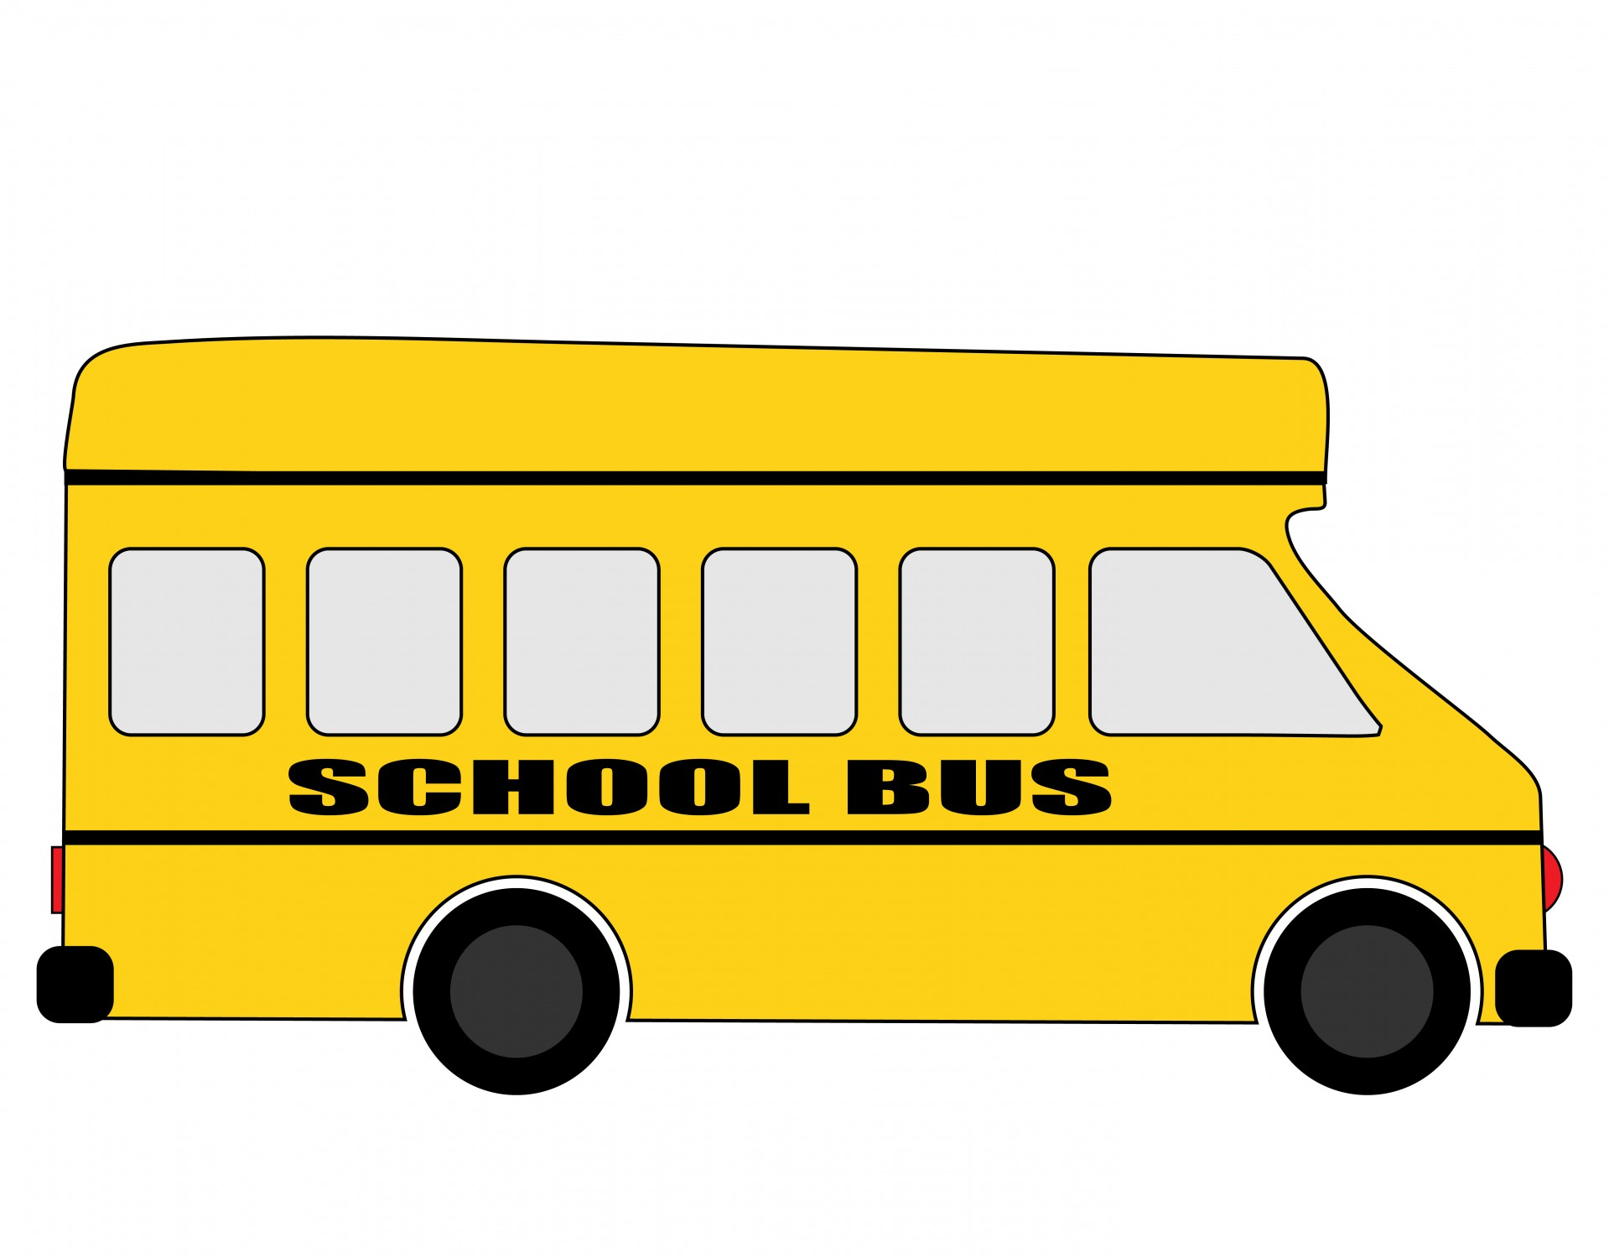

**Tasks:**

1. Describe, in detail, they types of services council can provide for their constituents. 6 Marks
2. Make a mind map of how councils raise money from pages 15-17 of Democracy in Scotland Booklet. Make at least 2 factual points about each.
3. Practice SQA Question – Explain, in detail, they ways in which local councils can raise extra finance in their authority.

6 Marks

**Councillors**

Each local council area is divided into a number of electoral areas called **wards**. Local councillors represent the people in their ward Councillors, are elected using a system of proportional representation called the single transferable vote (STV.)

If local people have a problem regarding a local service then they can meet with their local councillor and ask for advice or support. For example, in Balfron some local people did not want a mobile phone mast near their homes so they started a petition and presented it to the local councillor. The councillor then raised the matter with the planning committee of the local council.

Councillors are members of different council committees. These committees normally reflect the local council services, e.g. the education committee. Most councillors are members of more than one committee.

Councillors also attend meetings of their political party where policies are discussed. The public figurehead of the council (often called the **Provost**) tends to be a member of the party with the largest number of seats. The Provost chairs the local council meetings.

Each council has a councillor who is appointed as Leader of the Council. This person is in overall charge of the policies of the council and is normally a member of the party with the most councillors.

**Main Roles**

Councillors will have a duty to represent the views of their community and their needs. This is not restricted to their own ward as they must be objective and take into consideration the needs and well-being of all residents and the community as a whole.

Councillors also spend a great deal of time with their constituents through holding drop-in surgeries and corresponding and engaging with their constituents on a wide range of matters.

Councillors will also:-

* Provide political / strategic leadership setting out policy framework within which the council operates
* Make decisions on major local and national priority issues
* Provide community leadership by representing the views of the community and community engagement
* Ensure statutory duties of the council are carried out
* Adhere to the National Code of Conduct for Councillors
* Be open and transparent

Councillors have a duty to scrutinise the performance of the Council in delivering against the priorities and targets which are set. Continuous scrutiny of targets against outcomes is vital.

It must be appreciated that Councillors have a duty to deliver the priorities set by the government and to decide how best those priorities can be delivered in a local context.

Some of a councillor’s work will be done through committees. The committees publish their reports in advance and allow the press and public to attend meetings (with some exemptions for confidential matters).

Most of the Council’s income is derived from central government and the Council must work within fairly tight limits when setting budgets therefore balancing these responsibilities.

Consequently, during the regular committee meetings, decisions are made which may take a great deal of time.

Councillors attend local bodies such as Community Councils, Local Area Forums and voluntary organisations.

Work in partnership with outside bodies such as Community Planning Partners, National Health Service, Police, Fire and Rescue Service, HIE Moray, Communities Scotland and the Voluntary Sector to provide better services

If a Councillor is also a member of a political party, they will be expected to attend political group meetings especially before council meetings, and also be required to attend party training, campaigns and events.

**Task:**

Design a job advert to advertise for a local councillor

Your advert must include:

* Roles of the councillor
* Skills and qualities needed
* Types of situations they might have to deal with

**Political Parties – The Scottish National Party**

The SNP supports and campaigns for Scottish independence. It is the third-largest political party by membership in the United Kingdom, behind the Labour Party and the Conservative Party, and is the largest party by far in Scotland itself; the SNP membership number is more than four times larger than the membership numbers of the Scottish Conservatives, Scottish Labour and Scottish Liberal Democrats combined. Its leader, Nicola Sturgeon, is the current First Minister of Scotland.

**Party Ideology**

The SNP has positioned itself to the left of the Labour Party, opposing government cuts and arguing for spending to modestly increase in order to protect public services and vulnerable people. The SNP does not believe the UK should renew the Trident nuclear weapons system based on the Clyde, arguing it is both immoral and too expensive at a time of cuts. The SNP also supports reducing the voting age to 16, the building of affordable houses by councils and housing associations and free university education. The SNP also opposes the building of new nuclear power stations and believes in further investment in renewable energy technology.

**Current Position in the UK Parliament (Westminster)**:

The SNP received 1.4 Million votes and 56 out of 59 Scottish seats in the 2015 General Election (there are 650 seats in total in the UK Parliament).

**Current Position in the Scottish Parliament (Holyrood)**:

In the Scottish Parliament the SNP hold power with 64 out of 129 seats.

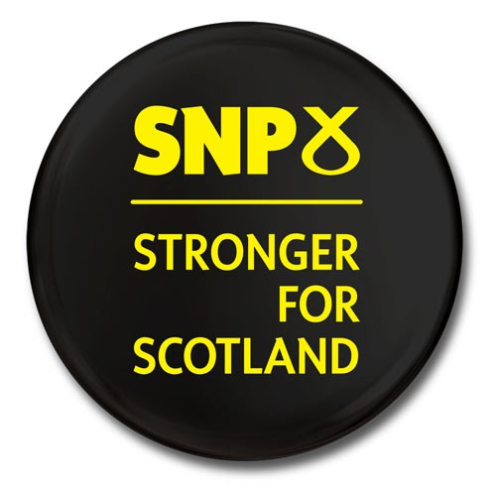

**Political Parties – The Scottish Labour Party**

The Scottish Labour Party is the section of the United Kingdom's Labour Party which operates in Scotland. Labour once held a long dominance over modern [Scottish politics](http://en.wikipedia.org/wiki/Politics_of_Scotland), having won the largest share of the vote in Scotland at every [UK general election](http://en.wikipedia.org/wiki/United_Kingdom_general_elections) since the 1960s, every [European Parliament general election](http://en.wikipedia.org/wiki/European_Parliament_general_election) from [1979](http://en.wikipedia.org/wiki/European_Parliament_election,_1979_(United_Kingdom)) until defeated by the SNP in [2009](http://en.wikipedia.org/wiki/European_Parliament_election,_2009_(United_Kingdom)), and in the first two [elections to the Scottish Parliament](http://en.wikipedia.org/wiki/Scottish_Parliament_general_election), held in [1999](http://en.wikipedia.org/wiki/Scottish_Parliament_election,_1999) and [2003](http://en.wikipedia.org/wiki/Scottish_Parliament_election,_2003). For each of these two terms, Scottish Labour entered into a coalition with the [Scottish Liberal Democrats](http://en.wikipedia.org/wiki/Scottish_Liberal_Democrats), forming a majority [Scottish Executive](http://en.wikipedia.org/wiki/Scottish_Executive).

**Party Ideology**

The Scottish Labour Party competes with the SNP for the votes of centre-left Scots. It argues that it is more progressive than the SNP but as a UK wide party, it also has to appeal to voters who are considering voting Conservative in the rest of the UK. This tension between appealing to traditional working-class and left-wing voters and the more conservative voters of ‘Middle England’ has been a source of debate in the party since the launch of ‘New Labour’ by Tony Blair in the 1990s. This was an attempt to appeal to middle-class and more conservative-minded voters, whilst holding on their traditional base. In policy terms Labour want to raise the minimum wage, promote the Living Wage and abolish the bedroom tax. Labour believe in renewing Trident and think that cuts should be used to reduce the deficit, though at a slower pace than the Conservative government.

**Current Position in Westminster**:

UK Labour received 9.3 Million votes and 232 out of 650 seats in the 2010 election. However, they only won one of the 56 seats in Scotland (down from 41 in 2010). This was Labour’s worst performance in a Scottish General election since the 1920s.

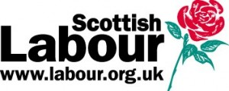

**Current Position in Holyrood**:

In the Scottish Parliament Scottish Labour have 38 out of 129 seats.

**Political Parties – The Scottish Conservative and Unionist Party**

The Scottish Conservative and Unionist Party is the component of the [British](http://en.wikipedia.org/wiki/United_Kingdom) [Conservative Party](http://en.wikipedia.org/wiki/Conservative_Party_(UK)) that operates in [Scotland](http://en.wikipedia.org/wiki/Scotland). Like the UK party, it has a [centre-right](http://en.wikipedia.org/wiki/Centre-right) political philosophy which promotes [conservatism](http://en.wikipedia.org/wiki/Conservatism) and [British unionism](http://en.wikipedia.org/wiki/British_unionism). Its leader in the [Scottish Parliament](http://en.wikipedia.org/wiki/Scottish_Parliament) is [Ruth Davidson](http://en.wikipedia.org/wiki/Ruth_Davidson) [MSP](http://en.wikipedia.org/wiki/Member_of_the_Scottish_Parliament), who has held the post since [2011](http://en.wikipedia.org/wiki/Scottish_Conservative_Party_leadership_election,_2011).

The last time that the Conservatives won the most seats in Scotland was in the [general election of 1955](http://en.wikipedia.org/wiki/United_Kingdom_general_election,_1955). From the early 1960s that role was taken by the [Labour Party](http://en.wikipedia.org/wiki/Labour_Party_(UK)) and the Scottish Conservatives went into a state of decline, which culminated in the loss of all Scottish Conservative seats in [1997](http://en.wikipedia.org/wiki/United_Kingdom_general_election,_1997).

**Party Ideology**

The Scottish Conservatives have adopted several policy positions which differ from their colleagues in the rest of the United Kingdom, for example support for the [Scottish](http://en.wikipedia.org/wiki/Scottish_Executive) Government policy of free [state](http://en.wikipedia.org/wiki/Sovereign_state) [care for the elderly](http://en.wikipedia.org/wiki/Care_for_the_elderly) and their backing of the decision to abolish [university tuition fees](http://en.wikipedia.org/wiki/University_tuition_fees) in Scotland. The Conservatives support cuts in public spending in order to eliminate the deficit and have focused on the welfare budget as a means of finding the areas to cut. The Conservatives believe in individual responsibility, low taxes and low public spending. They wish to continue to reduce the proportion of the UK economy which is in the public sector and increase private sector activity. The Conservatives also wish to renew the UK’s nuclear weapons system, Trident, which is based on the River Clyde.

**Current Position in Westminster**:

The Conservatives received 11.3 Million votes and 331/650 seats. However, they only won one seat out of 59 in Scotland (the same as in 2010).

**Current Position in Holyrood**:

The Scottish Conservatives currently hold 16 out of 126 seats in the Scottish parliament.

**Political Parties – The Scottish Liberal Democrats**

The Scottish Liberal Democrats is a [social-liberal](http://en.wikipedia.org/wiki/Social_liberalism) [political party in Scotland](http://en.wikipedia.org/wiki/List_of_political_parties_in_Scotland).

The Scottish Party decides its policy on devolved matters independently from the [UK party](http://en.wikipedia.org/wiki/British_Liberal_Democrats). The party also believes that the [Scottish Parliament](http://en.wikipedia.org/wiki/Scottish_Parliament) should exercise [greater responsibility on fiscal matters](http://en.wikipedia.org/wiki/Fiscal_autonomy_for_Scotland).

**Party Ideology**

According to its constitution, the party believes in a "fair, free and open society ... in which no-one shall be enslaved by poverty, ignorance or conformity". The party draws on both centre-left social democracy (moderate socialist) and traditional liberalism (a belief in free markets, low taxation and individual freedom). The fact that the party under Nick Clegg entered a coalition with the Conservatives between 2010 and 2015 would suggest that the traditional liberal wing were in the ascendency at that time. Previous leaders such as Paddy Ashdown and Charles Kennedy were always considered much closer to the Labour Party that the Conservatives. The Liberal Democrats believe in making cuts to reduce the deficit but at a slower pace than the Conservatives. They also believe in renewing the Trident nuclear weapons system but think that money should be saved by having three submarines, rather than four.

**Current Position in Westminster**:

Liberal Democrats received 2.4 Million votes and 8/650 seats in the UK Parliament in 2015. However, only one of these was in Scotland (down from 11 in 2010). Many believe that the Liberals loss of seats in 2015 was due to their decision to enter a coalition with the conservatives and particularly their decision in government to raise tuition fees in England from £3000 per year to £9000 per year, despite making a specific pledge during the 2010 election not to vote to raise tuition fees.

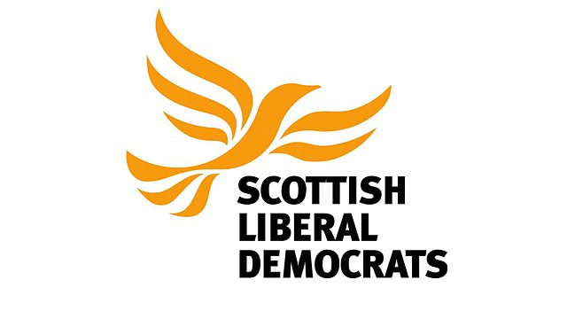**Current Position in Holyrood**:

The Scottish Liberal Democrats currently hold 5 out of 129 seats (4%)

**Political Parties – The Scottish Green Party**

The Scottish Green Party was created in 1990 when the former [Green Party](http://en.wikipedia.org/wiki/The_Green_Party_of_Great_Britain) split into separate parties for Scotland, Northern Ireland and England and Wales. The party is affiliated to the [Global Greens](http://en.wikipedia.org/wiki/Global_Greens) and the [European Green Party](http://en.wikipedia.org/wiki/European_Green_Party).

**Party Ideology**

While associated mainly with environmentalist policies, it has a history of support for communitarian economic policies, including well-funded, locally controlled public services within the confines of a [steady-state economy](http://en.wikipedia.org/wiki/Steady-state_economy). It is supportive of [proportional representation](http://en.wikipedia.org/wiki/Proportional_representation) and takes a progressive approach to social policies. It is the only party other than the [Scottish National Party](http://en.wikipedia.org/wiki/Scottish_National_Party) to both support [Scottish independence](http://en.wikipedia.org/wiki/Scottish_independence) and have representation in Scottish Parliament. The Scottish Greens oppose the renewal of the Trident nuclear weapons system and want an end to austerity in order to fund investment in public services and the abolition of poverty. They support an increase in personal taxation in order to pay for this.

**Current Position in Westminster**:

The Green Parties across the UK received 1.1 Million votes and 1 out of 650 seats in the 2015 UK election.

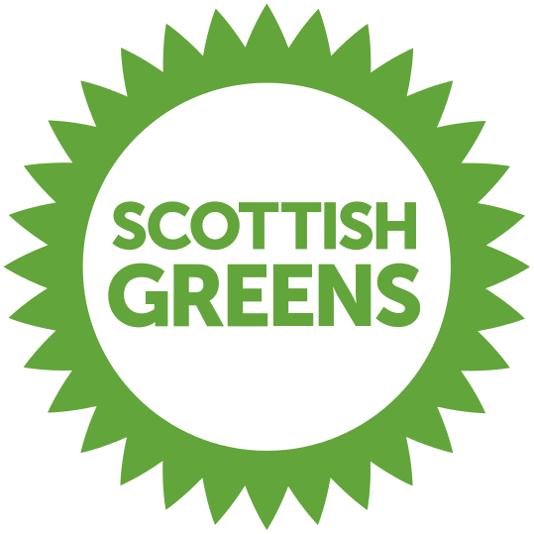**Current Position in Holyrood**:

The Scottish Green Party currently hold 2 out of 129 seats.

**Political Parties – The Scottish Socialist Party**

The Scottish Socialist Party is a [left-wing](http://en.wikipedia.org/wiki/Left-wing) [political party](http://en.wikipedia.org/wiki/Scottish_political_parties) campaigning for the establishment of an [independent](http://en.wikipedia.org/wiki/Scottish_independence) [socialist](http://en.wikipedia.org/wiki/Socialist) Scottish republic. It operates through a local branch structure and publishes Scotland's longest-running socialist newspaper, the [Scottish Socialist Voice](http://en.wikipedia.org/wiki/Scottish_Socialist_Voice). It describes itself as the largest and most successful socialist party in modern Scotland; at the height of its electoral success in 2003, the party had six [Members of the Scottish Parliament](http://en.wikipedia.org/wiki/Members_of_the_Scottish_Parliament) (MSPs) and two councilors.

**Party Ideology**

The party was heavily involved in campaigns for Scottish independence, against cuts to public services and welfare, and for democratic public ownership of the economy. In recent years, it has fought the austerity programme of the [UK government](http://en.wikipedia.org/wiki/First_Cameron_ministry) by calling for the abolition of the [bedroom tax](http://en.wikipedia.org/wiki/Bedroom_tax) and immediate action to mitigate [fuel poverty](http://en.wikipedia.org/wiki/Fuel_poverty).

**Current Position in Westminster**:

Scottish Socialist Party received 875 votes and 0/650 seats in the UK General election.

**Current Position in Holyrood**:

The Scottish Socialist Party gained 8,272 votes in the 2011 election but no seats.

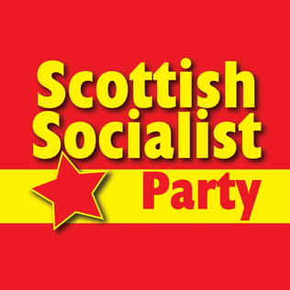

**Political Parties – The UK Independence Party**

The UK Independence Party is a [Eurosceptic](http://en.wikipedia.org/wiki/Euroscepticism) and [right-wing populist](http://en.wikipedia.org/wiki/Right-wing_populism) [political party in the United Kingdom](http://en.wikipedia.org/wiki/List_of_political_parties_in_the_United_Kingdom). It was founded in 1993 by members of the [Anti-Federalist League](http://en.wikipedia.org/wiki/Anti-Federalist_League) with the primary objective of securing the United Kingdom's withdrawal from the [European Union](http://en.wikipedia.org/wiki/European_Union). The party describes itself as a "democratic, [libertarian](http://en.wikipedia.org/wiki/Libertarianism) party".

**Party Ideology**

The Party believes in the withdrawal of Britain from the European Union. The main focus of campaigning with regards to this in recent years has been their desire to reduce migration to the UK from Eastern Europe. They argue that, as EU citizens have freedom of movement throughout the union, Britain can only prevent immigration from Europe if it leaves the EU. The party’s opponents accuse it of intolerance and thinly-veiled racism but UKIP counters that the established parties are ignoring the fears about immigration of ordinary people.

**Current Position in Westminster**:

UKIP received 3.8 Million votes and 1/650 seats in 2015.

**Current Position in Holyrood**:

UKIP gained 18,138 votes in the 2011 election but no seats.

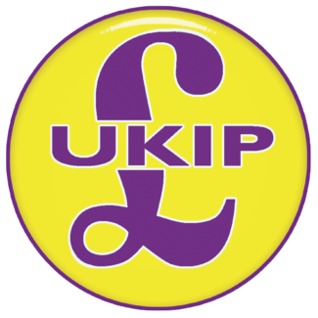

**Task:**

In your groups you have been asked to play the role of a political party. You are going to try and convince the class that your party is the best party to vote for in the Scottish Elections. You must produce:

1. Speech convincing outlining your manifesto.
2. Poster to persuade people to vote for you.

You have 2 periods to prepare and research your speech, you may also want to make a rosette for your speaker to wear.

**Using our Right to Vote**

Many people strongly believe we should use our right to vote. Here are a few reasons for this:

1. **We live in a democracy** - We have the right to vote for whoever we want to in free and fair elections, many other countries do not allow its citizens this right.
2. **Voting gives the Government legitimacy** - meaning they have the people's support to make decisions.
3. **The more young people vote the more likely politicians are to make policies that benefit us** - every vote is important so many politicians are inclined to try and do as much as they can to help and win your votes.
4. **The Suffragettes spent years campaigning to give Women the vote** - many even gave their lives, some say it is disrespectful to them to waste your vote.
5. **Voting gives you the power to choose how the UK is run** - if you have a complaint about the way the country is being run voting is a way can make a change, you can choose a candidate to suit to your views.
6. **Your local MPs can help fight important issues for you such as planning** - voting for them can help them keep their jobs and continue their positive work in your community.
7. **Even if you live in a safe seat voting is important**- living in a safe seat constituency doesn't mean your vote won't make a difference.
8. **The more people vote the more representative Parliament will be of ordinary British people** - a representative Government is important in order to create laws that represent the views of the people.
9. **You can leave your ballot blank**- if you don't agree with any of the parties you can leave your ballot blank, it's a much more effective protest than not voting at all.
10. **It only takes a few minutes and it's really easy!** - You can register to vote from the age of 16, then when the general election arrives just follow the instructions on the polling card you get in the post.

However, some people believe we do not need to vote. Here are some reasons for this:

1. **Many people think their vote does not count.** As they are only 1 person in a FPTP voting system their very small contribution would not matter. For example, in a constituency where nearly all people vote conservative, there would be no point voting Labour as they have no chance of getting in.
2. **Many people have the excuse that they are too busy to vote**. Family, work and other life events 'get in the way' of voting.
3. **Voting registration is a process that people can fear or feel intimidated by**. Some people may not be able to understand the forms or do not bother to go and register or ignore post reminding them.
4. **Apathy is probably the most common reason for not voting**. People often do not vote because they do not like the bickering and infighting or mud slinging between candidates. People believe with a lot of justification that politics is a dirty business, and they want nothing to do with it.
5. **Some people say they do not vote, because the 'lines are too long'**. This means some people do not vote as they don’t like to wait in a queue in a bust polling station.
6. **Some people say they do not vote because they do not like the candidates**. What most people do not realise is there are many political candidates and choices beyond the people on the nightly news.
7. **Some people say that they cannot get to the polling place to vote**. This may have some validity if a person is sick, disabled or without transportation (although people can postal vote in advance).
8. **Some people say that they are traveling, so they cannot get to the polling place**. If they are on holiday or out of the country for an extended period of time.
9. **Some people blame the weather** for not voting. If it’s raining turn out for elections is slightly lower.
10. **Some people do not agree with where party funding comes from.** Some parties may take money from big corporations or owners of media, making some people think it is unfair.
11. Complete your mind map with more detail from pages 31 & 32 of your Democracy in Scotland booklet.
12. Explain, in detail, why some people believe it is important that people use their right to vote and while others believe it is not. (8 Marks)
13. In a group of 4 you are going to create a 3 minute long video with the aim of trying to encourage people to use their right to vote. You can use the IPads to film this. Criteria:
    1. You must include at least 4 reasons why people should vote
    2. You must explain how to register to vote
    3. You must show, in some way, the benefits of voting

**Additional Member System (AMS)**

AMS is a hybrid voting system. It combines elements of [First Past the Post](http://www.electoral-reform.org.uk/first-past-the-post) where voters mark an X next to the candidate they want to represent them in their constituency, and [proportional representation](http://www.electoral-reform.org.uk/proportional-representation), where voters select from a list of candidates for each party who represent a larger regional constituency. This helps to overcome the disproportionally often associated with First Past the Post elections.

**Example Ballot Paper:**

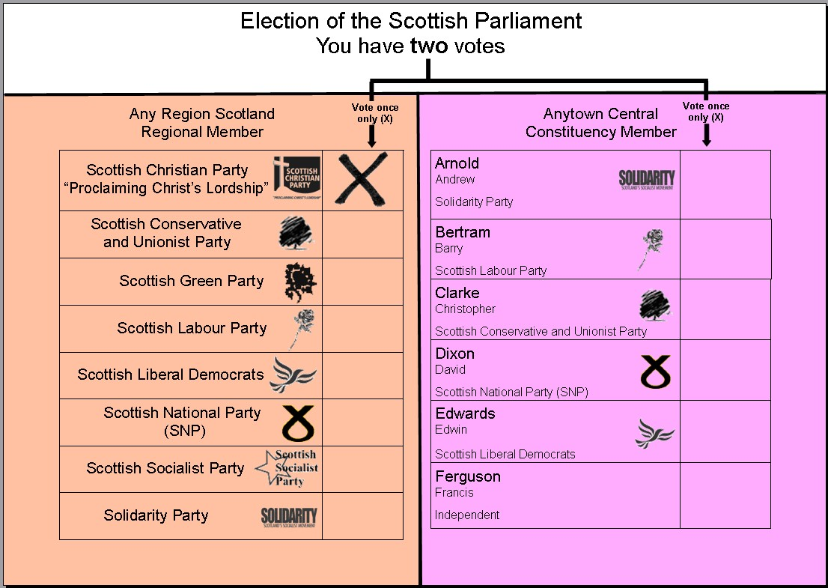Each constituency returns a single candidate, in the style of First Past the Post. The votes for the party list candidates are then allocated on top of these constituency seats to ‘top up’ the number of seats won by each party to represent their share of the votes proportionally. These are the “additional members”.

AMS therefore retains a constituency link while ensuring some proportionality. In elections to the Scottish Parliament there are 73 constituency members and 56 regional (additional) members.

**2011 Stirling Results:**

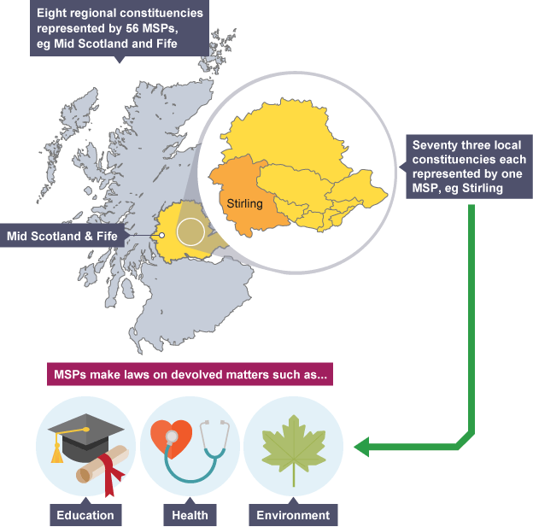

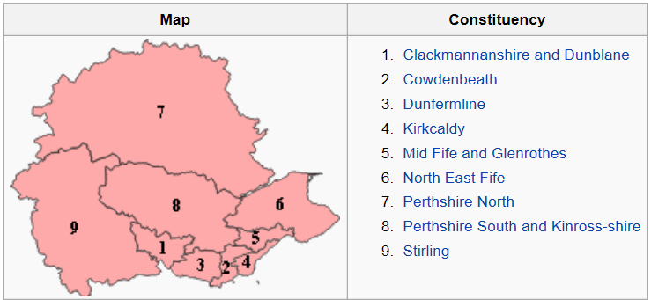

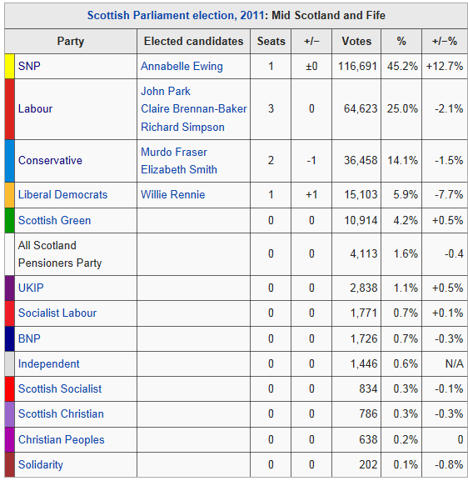**Regional Member Results 2011**

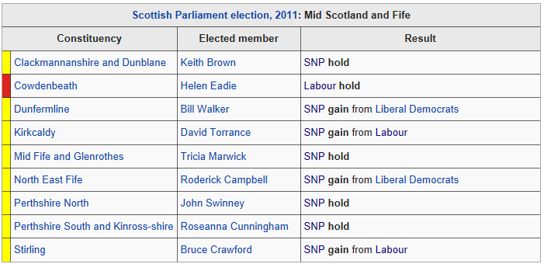**Constituency Results 2011**

**Advantages:**

* Makes the election results more proportional − the MSPs elected more accurately reflect the views of the Scottish people. The MSPs elected more accurately reflect the views of the Scottish people E.g. Labour got 29% of the vote in 2011 and 37 MSPs elected around 29% of the seats.
* Maintains the link between constituent and constituency MSP E.g. people in Stirling know that their local MSP is Bruce Crawford.
* AMS has helped smaller parties win seats E.g. the Green Party has two MSPs.
* May, in theory, reduce confrontation in politics − consensus politics

**Disadvantages:**

* Can result in minority government or coalition government E.g. SNP 2007 – 2011 was a minority government – this made it difficult to pass laws, such as, budgets.
* Break the link between constituents and the seven regional MSPs I.e. political parties decide who becomes a regional MSP – not voters e.g. the Conservatives decided Murdo Fraser would be a regional MSP.
* AMS can confuse voters – how it works – what MSPs should they contact E.g. people might not be sure whether they should contact Bruce Crawford (constituency MSP) or a regional MSP Annabelle Ewing.

**Coalitions**

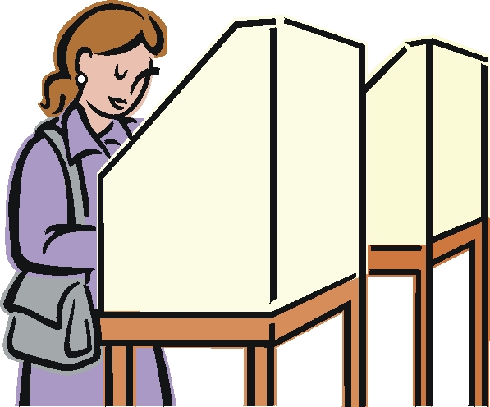Under this system (AMS) that, despite the overall results being fairly proportional, it is less likely that one party will get an overall majority in the Parliament, and therefore coalitions are likely. The current SNP majority is viewed as an exception.

New parties and smaller parties are more likely to get representation than by using the ‘First Past the Post method’ (e.g. Green Party, Scottish Socialist Party).

Elections for the Scottish Parliament take place every four years, normally on the first Thursday in May. Unlike Westminster where the Prime Minister has the power to set the date of the next general election, the First Minister cannot call an election before the end of four years. Only in extraordinary circumstances can the date be changed by a two-thirds majority of all MSPs.

|  |  |
| --- | --- |
| **Advantages** | **Disadvantages** |
| Coalition government is more democratic, and hence fairer, because it represents a wider spread of public opinion than government by one party alone. | Coalition government is actually less democratic as the balance of power is held by smaller parties (Liberal Democrats) who can give their support in exchange for concessions from the main group (Labour) within the coalition. After the 1999 election, Liberal Democrats agreed to join the coalition if certain issues were discussed further. These included free personal care for the elderly and student tuition fees. |
| Coalition government creates a more honest and dynamic political system. | Coalition government is less transparent – not so open and honest. Often the real decisions about specific policies are made after the election. |
| Coalitions provide good government because their decisions are made in the interests of a majority of the people. Because a wide range of opinion is involved, any policy will be debated thoroughly within the government before it is decided upon. | Coalitions provide bad government because they are unable to take a long-term view. |
| Coalition government provides more continuity in administration. There are usually at least some ministers with considerable experience under the previous government, e.g. Jack McConnell was First Minister at the end of the 1999 – 2003 session of Parliament and he continued as First Minister after the 2003 election when Labour and the Liberal Democrats again formed a coalition. | Coalition governments can be very unstable. This greatly restricts the ability of governments to deal with major reforms and means that politicians seldom stay in any particular ministerial post for long enough to get to grips with its demands. |

**Majority Governments**

A majority government is a government formed by a governing party that has an absolute majority of seats in the legislature or parliament in a parliamentary system.

The election delivered the first majority government since the opening of Holyrood, a remarkable feat as the mixed member proportional representation system used to elect MSPs was, according to Jack McConnell (the former Labour First Minister), originally implemented to prevent an SNP government achieving a parliamentary majority.

The Scottish National Party won 69 seats, the most the party has ever held at either a Holyrood or Westminster election, allowing leader Alex Salmond to remain First Minister of Scotland.

Since 2011 the SNP have had a majority in the Scottish Parliament.

This means that, not only is every Government Minister an SNP Member but they also have a majority on every committee. Even the Presiding Officer, Tricia Marwick, was elected as an SNP MSP (though she now stands aside from party politics).

The AMS system was supposed to make this all very unlikely and the minority parties in the Parliament are finding their lack of power and influence hard to accept, especially after the period of minority government from 2007 to 2011.

**Advantages:**

* One advantage is that the governing party can be held fully to account for its actions. For example, if people do not like the SNP policy of freezing the council tax, they can vote against the SNP at the next election.
* Another advantage is that decision making is easier in government, leading to a greater sense of stability. For example, when the SNP governed as a minority from 2007 to 2011, they had to negotiate deals with other parties every year to get their budget passed. This often led to excitement for political journalists but could be argued to have led to rushed decision making.

**Disadvantages:**

* One disadvantage is that the governing party has a majority on every committee, reducing the influence of the committees. For example the SNP has a majority on the finance committee (as well as all others) ensuring that the finance bill proposed by the Finance Secretary, John Swinney, will pass the committee stage without major amendments each year.
* Another disadvantage is that only one party has a major influence in the policies followed by government. For example, the SNP are the only party that has any government ministers presently, whereas the coalition governments of 1999-2007 had both Labour and Liberal Democrat members.

**Tasks:**

1. Discuss, in groups, which type of government you think works best and why. Note down ideas in your jotters.
2. You should know advantages and disadvantages for both Coalition and Majority governments. So you have the information write in your jotter (in the form of a mind map or table) advantages and disadvantages of both.
3. SQA Practice Question – Describe, in detail, why some people like majority governments and some do not. 6 Marks

**Single Transferable Vote (STV)**

The Single Transferable Vote (STV) is a form of [proportional representation](http://www.electoral-reform.org.uk/proportional-representation) which uses preferential voting in multi-member wards, it is used to elect local councilors in Scotland.

Candidates don't need a majority of votes to be elected, just a known 'quota', or share of the votes, determined by the size of the electorate and the number of positions to be filled.

Each voter gets one vote, which can transfer from their first-preference to their second-preference, so if your preferred candidate has no chance of being elected or has enough votes already, your vote is transferred to another candidate in accordance with your instructions. STV thus ensures that very few votes are wasted, unlike other systems, especially First Past the Post, where only a small number of votes actually contribute to the result. To carry out your vote put a 1 next to their favourite candidate, a 2 next to their second favourite, a 3 by their third, and so on. Some people chose to number all the candidates; some choose just three or even just one. This is fine, you can number as many or as few as you like.

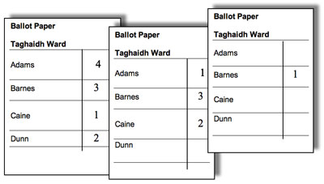

**Advantages**

* Voting is easy, rank candidates 1,2,3 in order of preference
* Can vote for different members of the same party
* Can vote for different parties
* All votes count (highly proportional)
* Ends safe seats
* Empowers voters (voters have multiple choices not just one vote)

**Disadvantages**

* Harder for electorate to understand how votes are calculated
* Harder for smaller parties to be elected than with AMS
* Multi members could confuse voters, who does the voter go to?
* STV often leads to coalitions
* Too many electoral systems used (FPTP, AMS, STV, Party List)

**Tasks:**

1. In your own words, you have to write instructions and design a STV ballot paper for the electorate.

* + Your instructions should be clear and explain the procedure that the voters should take.
  + You should annotate your diagram clearly.

2. SQA Question. Explain, in detail, why some people agree with STV and some don’t. 6 Marks

**INFLUENCE OF THE MEDIA**

**Definition of Media**: the main means of mass communication (television, radio, and newspapers) regarded collectively

The media is an outlet for communicating information and news to the public. Mass Media is a term which basically means any method to communicate with a large audience, i.e. the population of a country or the population around the globe.

[](javascript:edit(15345))There are many media influences on the decision-making process in Scotland.

The aspects of the media that we will study here include:

• The press and Newspapers

• Television and radio

• The Internet

Our elected representatives have power. They make decisions that affect our lives. They can close schools (St Andrews in Clydebank), pass plans that allow motorways to be extended through greenbelt areas, increase our taxes; etc. But if we do not like what our representatives are doing we can vote others in at an election. However, in between elections, the media have an important influence on the decisions that the Parliament and local councils make. This is what makes our system of government democratic. We have the right to say what we think about things, to criticise, and to campaign for or against an issue as long as we act within the law.

A key feature of a democratic society is a free press. It is important that the government does not have total control of the media otherwise we might not learn the truth about what is going on in the country. The media is made up of newspapers, magazines, television and radio. The Internet is also an important factor to consider when looking at how we can influence the people in power.

**Role of the Media**

The media carries many different types of message: news, documentaries, music, advertisements, dramas and quizzes. These messages can all be carried by different media types. Newspapers, radio, TV and the internet, for example, can all carry news. The media industry has many roles in the democratic process. Many would argue that its main role is to inform.

**Informing**

The media is one of the main sources of information about the world of politics. Through the media, people gain information about politics whether it is local, national or international. It reports and broadcasts news, which keeps people informed about what is happening in the world. Regional newspapers and television channels will also broadcast news in the local area, for example STV have regular news bulletins in regional areas in Scotland and the BBC have ‘Scottish news’ at 6.30pm every night. The Edinburgh Evening News is an example of a regional newspaper. The media also has the ability to act as a means of encouraging political debate and discussion. There are also local and national newspapers reporting on political issues.



**Educating**

The media has the means and ability to educate society. It can explain the significance of events happening around the world and the reasons behind the events. Some journalists will try to take an objective view when reporting to allow the public to make up their own minds.

**Influence of the Media**

Whether it is directly or indirectly, television broadcasts and newspaper articles are arguably the most important source of information about what the government and politicians are going. The media has a large role in deciding what the public learns and can shape and influence public knowledge and attitudes.

In an elected democracy like the UK, ‘free press’ is an important feature; this means that the government does not control the media. This is important to ensure that we learn about what’s happening in the country and the decisions that the government is taken. The media therefore has a responsibility to be truthful and accurate in the information it presents.

Television and the radio have strict guidelines on what they broadcast. Reporting must be politically impartial and balanced under Ofcom broadcasting code. Ofcom is the UK regulator for both broadcasting and telecommunications. However, newspapers are slightly different. It is not uncommon for newspapers to support or oppose political parties in an open way via their content. People can be influenced by the editorial view of a newspaper they read through headlines, opinions by columnists, cartoons and so on. Over time this may affect people’s opinions about political parties and their policies. Many readers will not realise that the Daily Record favours the Labour Party and that the Daily Mail favours the Conservative Party unless there is an election taking place and the newspaper makes its political loyalties more obvious.

Due to its importance and influence many political leaders now get lessons on how to deal with the media (i.e. looking and sounding good on TV). How the leader appears on TV is crucial – some would suggest that image is now more important than policies and so less detail is given in interviews and more focus is placed on likeability and personality.

**Does the Media Influence Voting Behaviour?**

The impact of the media, in terms of influencing how an individual votes is a complex issue. It could be argued that the media is growing in influence as the effects of traditional factors such as social class lessen. Do many voters now use TV to form an opinion as to which party and leaders would be best to run Scotland? Most would accept that TV can influence a person to varying extents, which is why news broadcasts are carefully balanced to give opposition as well as government points of view. Some would also argue that people are more influenced by what they see on TV than what they read in newspapers as TV has more visual and moving images which are more effective than printed words.

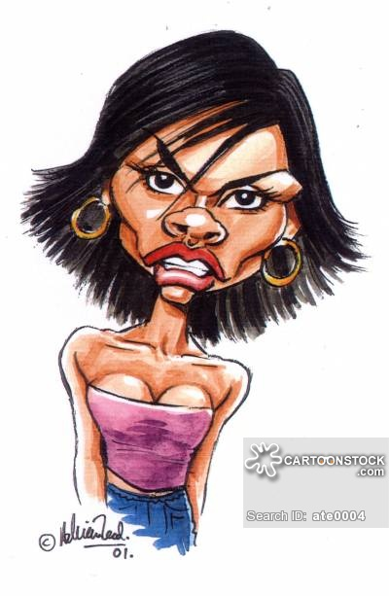TV is also more up to date. Most people trust TV news more than newspapers, which are well known for bias. Many people buy newspapers to get racing tips, TV listings, celebrity gossip etc or to get background knowledge on current affairs. However, over a period of time, readers may be influenced by the political line that a paper takes.

Despite the broadcasting neutrality rules regarding what is reported on TV, many politicians have argued that there can be bias shown in some TV reporting at some point in their career.

**Tasks (ALL):**

1. What is media?
2. Describe the four main types of media
3. Explain how the media informs and educates the public.
4. Why is the concept of free press important in a democratic country?
5. Why could it be argued that television can influence public opinion?
6. How is broadcasting neutrality ensured in TV and radio?

**Newspapers**

Tabloids are smaller-size papers like *The Sun* and the *Daily Record*. They concentrate on human-interest stories and do not always publish political stories. However, tabloids are very influential. Papers like the *Daily Record* pride themselves on campaigning journalism and see themselves as the voice of the people on issues such as the economy and major political matters. Politicians can not afford to ignore the tabloids. Tabloids can influence their readers, but they tend to be biased (support one particular party at one time).

Broadsheets are essentially different from tabloids although many of them have reduced their page size in recent years. The content is much more to do with politics, economics and foreign affairs. Their stories are not usually as biased as those in the tabloids can be. The broadsheets generally give their readers facts as well as both sides of the argument and let them decide for themselves.

Newspaper sales in the UK are in a gradual long term decline. The growth of the internet in particular has had an adverse effect on newspaper sales**.** However it is still a large market and many millions of people still buy newspapers. British people are among the most avid newspaper readers in the world, 82 % of all British adults read a regional paper compared to 61.5% who read a national paper.

The support of newspapers is very important to politicians.

**Is the influence of Newspapers Declining?**

**Case Study**

The Media & the 2007 Scottish Parliament Elections.

The May 2007 Scottish Parliament elections saw the SNP gain a large number of seats (47) in the Scottish Parliament, one more than Labour who gained 46. In this election, the largest party won despite not having the specific support of any conventional newspaper throughout the campaign. However, on Election Day some newspapers decided to run a negative campaign against the SNP.

* The Sun ran a front page image of a looped rope, inside which read the threat ‘Vote SNP today, and you put Scotland’s head in the noose’
* The Daily Mail’s front page warned ‘This man wants to destroy Britain’ beside Mr Salmond’s face.
* The Daily Record urged ‘Do not sleepwalk towards independence. Do not let a protest vote break up Britain. Think about it.’

The SNP victory perhaps challenges the idea that newspapers have a great influence on voters. The negative campaigns did not prevent SNP success, albeit in a very marginal win. Some would argue that this result indicates a decline in the ability of newspapers to influence politics and elections and points to the increasing influence of alternative media forms like TV and internet instead.

**Television and radio**

The broadcasting media must, by law, avoid bias of any sort and give everyone a fair hearing. Organisations and individuals can complain to groups such as the Broadcasting Standards Commission if they feel they have been portrayed in an unfair way. Political parties complain the most. They employ monitors who measure the amount of air time they get on TV or radio and look at whether the coverage is positive or negative. The political party in power gets more attention than the opposition parties. This also means that the party in power will be subject to greater scrutiny. Political parties employ spin doctors to put a favourable slant on news stories.

**Broadcasting Media**

The laws which govern broadcasting (TV and radio) in Scotland are currently reserved to Westminster. However the Broadcasting Commission for Scotland was set up by Alex Salmond in one of his first acts after winning control of the Scottish parliament. Alex Salmond would like to see control over broadcasting devolved to Scotland as he thinks Scotland is underrepresented in terms of news programmes and actors. At the end of 2003, Ofcom replaced the Broadcasting Standards Commission and became the new communications sector regulator. Anyone, including the public and politicians, can complain if they feel that they have been portrayed in an unfair way. For example many people complained when Russell Brand and Jonathon Ross made inappropriate comments on a BBC2 radio programme. They were both suspended and eventually resigned, the BBC confirmed that it had over 27 000 complaints about their prank calls on the radio show.

**What is spin doctor?**

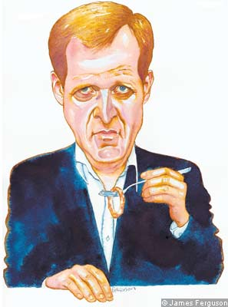In public relations, spin is a term signifying a heavily biased portrayal in one’s own favour of an event or situation. It is often associated with the act of trying to influence public opinion regarding government policy or public figures such as a politician. People who engage in spin are often called ‘spin doctors’. Perhaps the best-known person in the UK described as a ‘spin doctor’ was Alastair Campbell, who headed up Tony Blair’s public relations between 1994 and 2003. Many people believe that Tony Blair related well to the public for such a long time due to the advice and work of Alastair Campbell.

Politicians are often accused of spin by their political opponents. Because of the frequent association between ‘spin’ and press conferences (especially government press conferences), the room in which these take place is now sometimes described as a spin room.

Spin techniques can often mean that people are selective in their use of facts – that they do not present whole truth. One spin technique involves the delay in the release of bad news so it can be hidden in the shadow of more important or favourable news or events. For example, **11 Sept 2001:** Spin doctor Jo Moore sends her infamous e-mail, suggesting to colleagues it was a good day to "bury" bad news.

As mentioned above a famous quote was that of Jo Moore, a former UK Government press officer. She wrote ‘It’s now a very good day to get out anything we want to bury’ in an email which was sent on 9/11. When this email was leaked to the press it caused widespread outrage for which Jo Moore was forced to apologise. She was later made to resign when it was claimed she had sent a similar email following the death of Princess Margaret.

**New Forms of Media**

One of the main developments in recent years in politics has been the increasing influence of new forms of media, in particular the internet. Blogs from well known journalists i.e. Brian Taylor from the BBC and blog space for interactive messages at the bottom of articles posted on newspaper websites are now common. During the elections to the Scottish Parliament in 2007, many websites were set up to focus on the Scottish election campaign i.e. youscotland and Holyrood 2007. Youtube was also heavily utilised with interviews, blogs and party election broadcasts. Politicians are eager to use websites, blogs, podcasts and listings on social networking sites such as Facebook as a way of reaching voters, especially young voters. Perhaps the next election campaign will see more use made of new forms of media.

**The Internet**

The internet is one of the fastest growing forms of communication and media, you will probably find that most people in your class use the internet on a daily basis, many people now have internet access on there mobile phones. Most newspapers will also have an online website reporting the daily news. The internet is a growing influence because so many people use it and access it frequently.

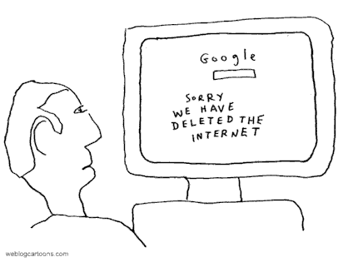Many politicians have acknowledged the influence of the internet and the politicians are keen to engage with online networks to communicate with the public. The government in Scotland and the UK are increasing the amount of information available on the internet. The information on the Scottish Parliament website highlights its commitments to its founding principles. People can access a wide range of information including daily business and Holyrood TV provides archive and live versions of First Ministers questions, committee meetings and debates.

The Internet is a growing part of the media. It is now a significant source from which many people access the daily news. The Internet is therefore a very important medium for the Scottish Parliament.

**Controls on the Media – Newspapers and Magazines**

The Press Complaints Commission (PPC) is responsible for ensuring that a code of practice is followed by the media. The code of practice sets out guidelines to ensure that the rights of individuals are respected and that the media behaves in a professional manner. Editors and publishers are expected to apply the code of practice to its publications. If the code of practice is not adhered to, people are encouraged to write to the editor of the newspaper or magazine to resolve the issue. If it is not resolved then complaints can be made to the PPC who will investigate the enquiry. If the newspaper or magazine has been found to be incorrect, they can be sued for libel damages.

**Tasks:**

1. Create an information poster about the influence of the media. You poster must include:
   1. The definition and role of the media
   2. Types of media
   3. Examples of when the media has influenced or claimed to influence politics in anyway
   4. Controls of the media
2. SQA Practice Question – The media can have an influence on politics, describe, in detail, 2 ways in which the media tries to influence politics in the UK. 4 Marks