**China – Unit 1**

**International Issues**

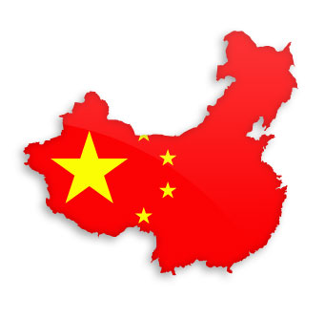

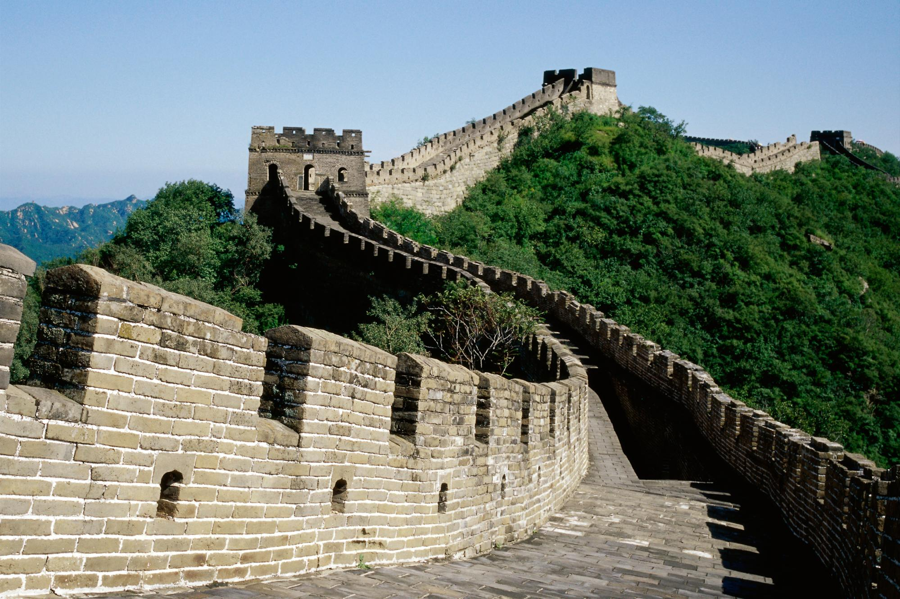

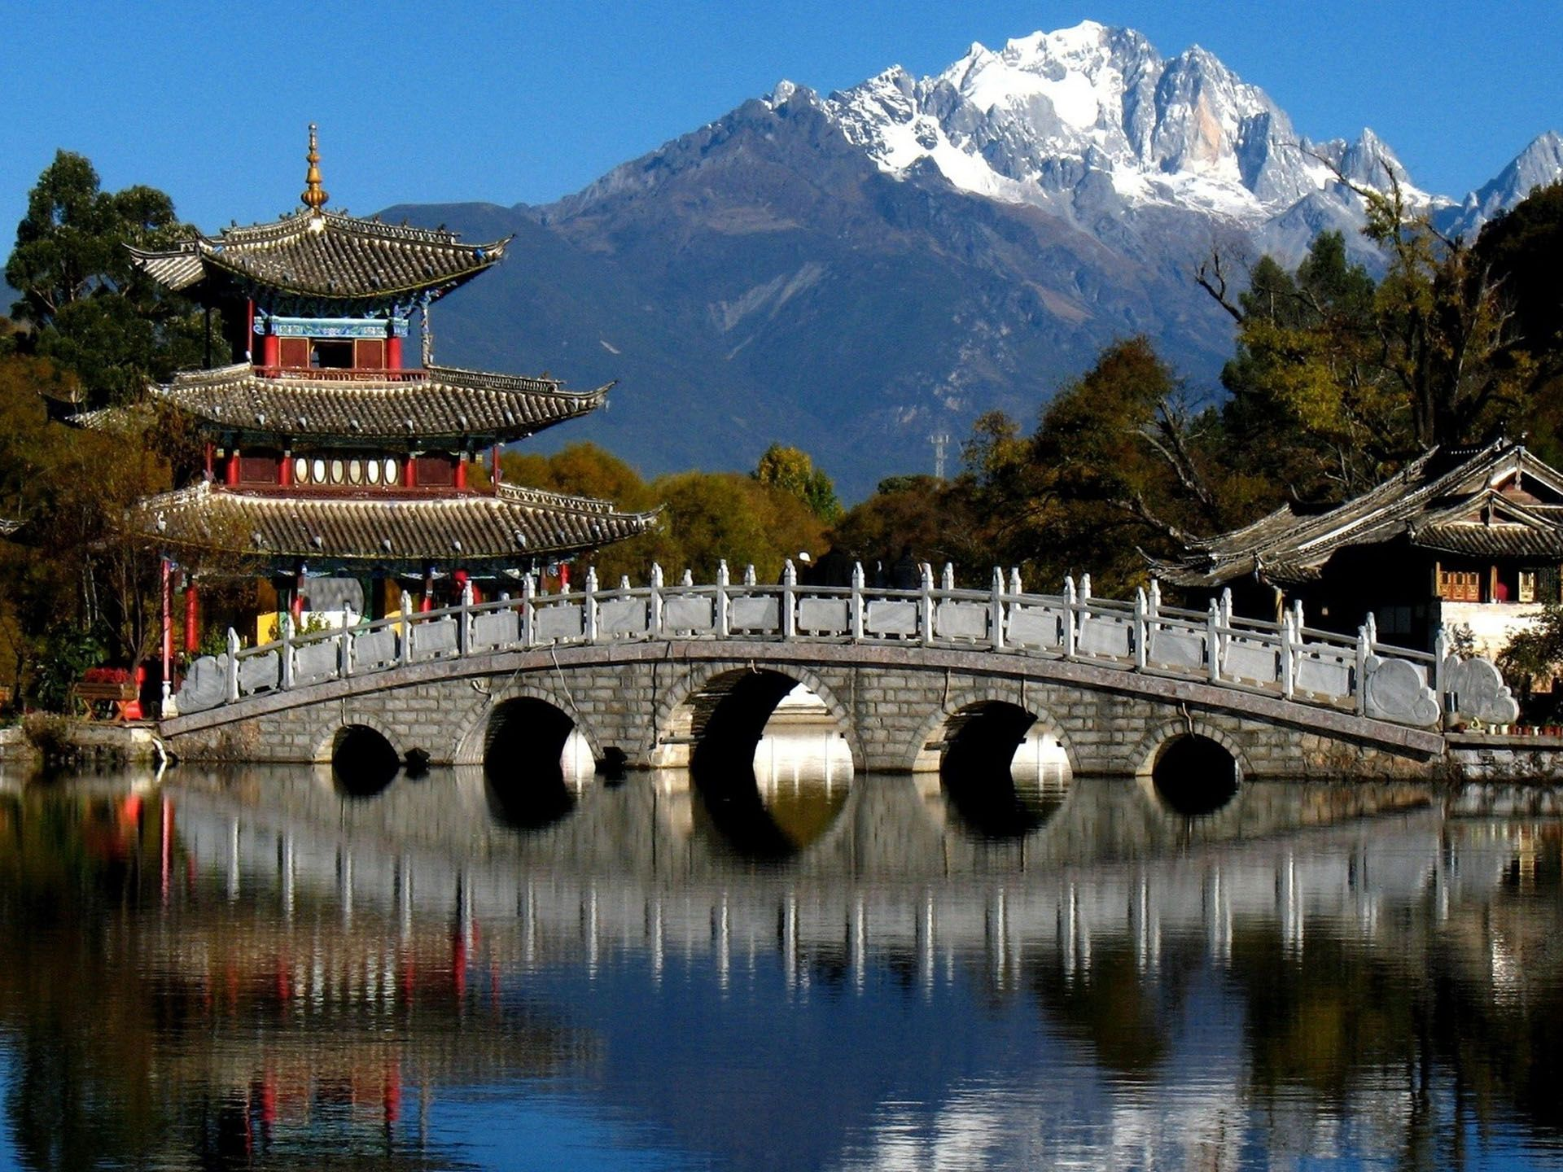



**Balfron High School**

**Learning Intensions Page Numbers**

1. Political Institutions 5
2. Political participation and limitations 8
3. Economy 11
4. Human Rights (One Child Policy, 15

Internet Access, Tibet, Legal Systems)

1. Hukou system 21
2. Inequality (Employment, Education, 25

Sanitation, Health Care)

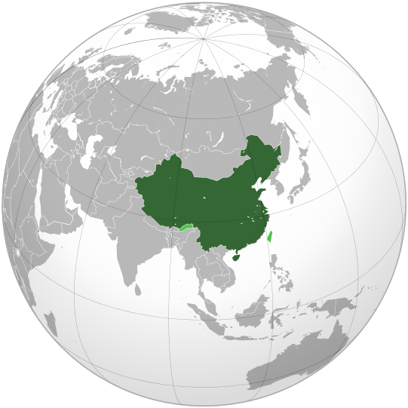

**Political Ideologies**

**Ideology means the system of ideas at the basis of an economic or political theory.**

**CAPITALISM** – Capitalism is a set of ideas which forms the basis of the way some countries run the economy. It is an **economic ideology**. The USA, UK, France, Japan and Germany are examples of countries that have capitalist economic systems. In a capitalist system, individuals are free to own their own land, property and business. Businesses are either owned by individuals, groups of people or shareholders. Profits are kept and decisions about what should be produced are left to individuals.

**SOCIALISM** - Socialism is a political and economic theory or system in which factories, businesses and industries are owned by the community **collectively**, usually through the state. Socialists believe that equality is essential if a society to be free and fair. Socialists believe that the state is central to creating social justice. Therefore, socialists are in favour of state-run health care and education. At the very least, the most important industries should be owned and run by the state in the interests of the people and the workers. In western nations, for example, in the UK and USA, states like China are referred to as “communist states”. However, China does not refer to itself as communist, instead it refers to itself as socialist, A country might call itself socialist but in practice, its political and economic system may not live up to the title.

**COMMUNISM** - Communism is a political and economic system under which **all inequalities would be eradicated.** Wealth would be distributed equally: taken from the bourgeoisie (powerful and wealthy individuals) and redistributed amongst the proletariat (the workers). Unlike socialism, a communist country would be a stateless society. But as with socialism, there would be common ownership of factories, businesses and industries. There are different ideas of what communism actually is. In *The Communist Manifesto* Karl Marx and Freidrich Engels argued that communism was an inevitable process where economies would move from capitalism to socialism and then to communism. Lenin believed that communism would only take place through revolution. The type of communism associated with China and Mao Zedong was influenced by Marxist-Leninism and is often termed Maoism and referred to as “Mao Zedong Thought”. It is defined as “Marxist-Leninism in a Chinese context”. The idea was that a strong political party would seize power on behalf of the workers and peasants and control the state.

**Tasks:**

1. Looking at your Province map of China describe, with named examples, the location of the rural and urban areas.
2. Summarise each ideology in your jotter in a mind map or note form (Nat 4).
3. Describe and explain the 3 main political ideologies, giving examples of countries, which embrace each one. Make at least 2 points about each ideology. (Nat 5).

**Political Institutions**

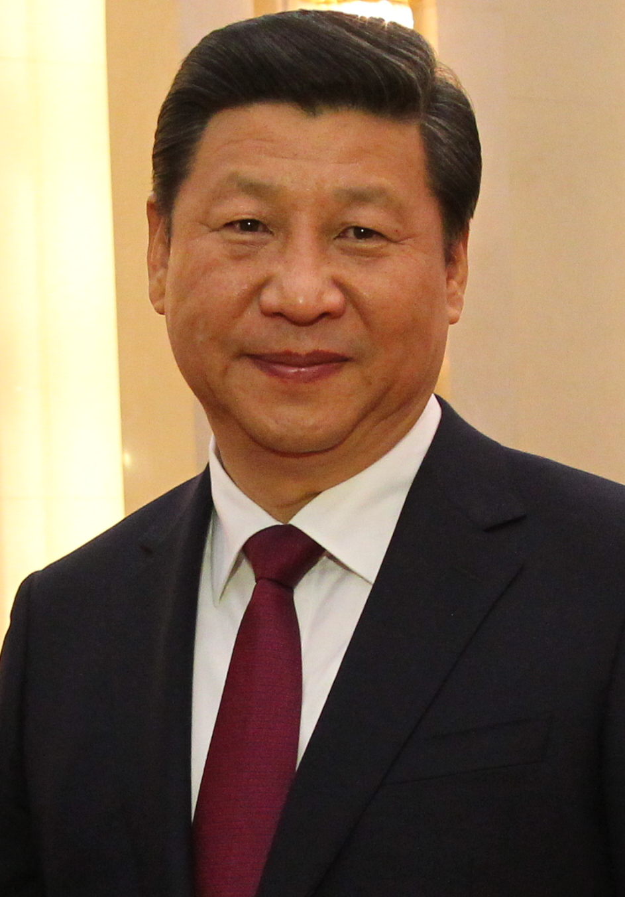The Chinese Communist Party (CCP) has ruled the country since 1949, tolerating no opposition and often dealing brutally with dissent. The current leader of the CCP is Xi Jinping. 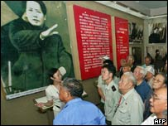The Chinese Communist Party's 73-million membership makes it the biggest political party in the world. Its tight organisation and ruthlessness help explain why it is also still in power. The party oversees and influences many aspects of people's lives - what they learn at school and watch on TV, their jobs and housing, even the number of children they are allowed. It is an elite group made up largely of government officials, army officers and model workers. Business people are also now being invited to join its ranks (so the government can influence and can keep a close eye on them). It is unrepresentative of China as a whole. Only 20% of members are women, 77% are over 35 years old and 31% have a college degree. It is also obsessive about control, regularly showing itself capable of great brutality in suppressing dissent or any challenge to its authority. Joining the party brings significant privileges, which explains why membership continues to rise. Members get access to better information, their children get better schooling, and many jobs are only open to members. Most significantly in China, where personal relationships are often more important than ability, members get to network with decision-makers influencing their careers, lives or businesses.

The Politburo is the country's most senior decision-making body and contains important people who work as part of the standing committee, heading a pyramid of power which tops every village and workplace. Politburo members have never faced competitive election, making it to the top thanks to their patrons, abilities and survival instincts in a political culture where saying the wrong thing can lead to a life under house-arrest, or worse execution.

Formally, their power stems from their positions in the politburo. But in China, personal relations count much more than job titles. A leader's influence rests on the loyalties he or she builds with superiors and proteges, often over decades. Every significant decision affecting China's 1.3bn people is first discussed and approved by a handful of men who sit on the politburo.

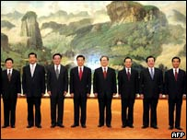The 24-member Politburo is elected by the party's central committee. But real power lies with its 9 member standing committee, which works as an inner cabinet and groups together the country's most influential leaders.

How the standing committee operates is secret and unclear. But its meetings are thought to be regular and frequent, often characterised by blunt speaking and disagreement. Senior leaders speak first and then sum up, giving their views extra weight. The emphasis is always on reaching a consensus, but if no consensus is reached, the majority holds sway. Once a decision has been made, all members are bound by it. Although policy disagreements and factional fighting are widely believed to take place in private, it is extremely rare for these to break into the public domain. However, in 1989 when the leadership battled over how to deal with the Tiananmen protests made it into the local network. New politburo members are chosen only after rigorous discussion and investigation of their backgrounds, experience and views. To reach the top, people need a strong record of achievement working for the party, to have the right patrons, to have dodged controversy, and to have avoided making powerful enemies. The politburo controls three other important bodies and ensures the party line is upheld.

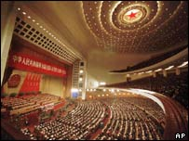The National People’s Congress under China's 1982 constitution, is supposed to be the most powerful organ of state. In truth, it is little more than a rubber stamp for party decisions.

The congress is made up of nearly 3,000 delegates elected by China's provinces, autonomous regions, municipalities and the armed forces. Delegates hold office for five years, and the full congress is convened for one session each year. This sporadic and unwieldy nature means that real influence lies within a standing committee of about 150 members elected from congress delegates. It meets every couple of months. In theory, the congress has the powers to change the constitution and make laws. But it is not, and is not meant to be, an independent body.

For a start, about 70% of its delegates - and almost all its senior figures - are also party members. Their loyalty is to the party first, the NPC second.

**Tasks:**

1. Write down 3 facts about each political institution (Nat 4).
2. Practice SQA Question (Nat 5)

Describe, in detail, 2 political institutions of the government in a world power you have studied. 6 marks

**PEE (Point Explain Example)**

**Example Paragraph:**

One Political Institution of the Chinese Government is the Chinese Communist Party (CCP). This is the only political party that can ever rule China, no one else can be voted in. The party has been in power since 1949 and controls everything in China from Education to the Military.

**Each Paragraph you write is worth 2 marks. 1 Mark for explain and 1 mark for example. You gain NO MARKS for the point. (6 mark question requires 3 paragraphs)**

**Political Participation and Limitations**

Chinese citizens have very few political rights, and what rights that they do have are very limited.

**1. Joining the CCP**

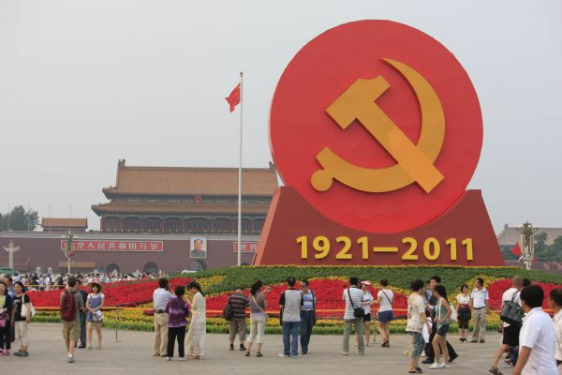Chinese citizens have the right to join the CCP. Applicants need to be recommended by two existing members and then undergo exhaustive checks into their background and examination by their local party branch. They then face a year's probation, again involving assessments and training. The CCP reached 82.6 million members in 2011, making it the world's largest political party. However, this represents just **6%** of the Chinese population.

**2. Voting in elections**

After taking power in 1978, [Deng Xiaoping](http://en.wikipedia.org/wiki/Deng_Xiaoping) experimented with democracy at a local level. Some townships and urban areas have also experimented with direct elections of local government leaders. Villages have been traditionally the lowest level of government in China's complicated hierarchy of governance. In the early 1980s, a few southern villages began implementing "Vote for your Chief" policies, in which free elections are intended to be held for the election of a village chief, who holds a lot of power and influence traditionally in rural society. Many of these elections were successful, involving candidate debates, formal platforms, and the introduction of [secret ballot](http://en.wikipedia.org/wiki/Secret_ballot) boxes. All citizens above age 18 have the right to vote and be elected. Such an election comprises usually over no more than 2000 voters, and the [first-past-the-post](http://en.wikipedia.org/wiki/First-past-the-post) system is used in determining the winner, with no restriction on political affiliation. A higher level of government, usually a member of the CCP, always supervises the elections, held every 3 years. After a village election the winner is usually invited to join the CCP.

**3. Campaigning during elections**

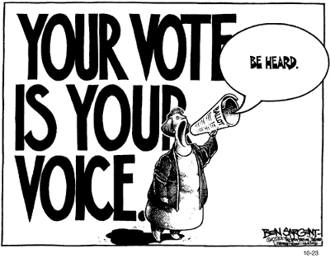Chinese citizens have the right to campaign during village elections. Campaigning can include, posters, banners, door to door visits, badges, mega phones, public speeches. Campaigning has increased significantly at a local level from only an estimated 10% of people campaigning in 2005 to well over 80% of people in 2014. However this right is limited by the CCP and they keep a close eye on all campaigning groups.

Citizens may not campaign against the CCP in any way. Citizens must also wait until 2 weeks before the election to start campaigning. Also when campaigning they must not use logos/symbols/party colours to gain support, this is to discourage them from starting their own political party.

**4. Taking part in protests and demonstrations**

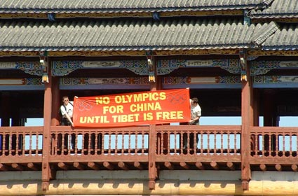China has a wide variety of grievances, including but not limited to corruption, forced evictions, unpaid wages, human rights abuses, environmental degradation, ethnic protests, petitioning for religious freedom and civil liberties, protests against one-party rule, as well as nationalist protests against foreign countries.While Chinese citizens can take part in protests, they are restricted in the issues they are allowed to protest about. For example, they are not allowed to take part in demonstrations which criticise the CCP or the political system. To be able to protest you must apply to the CCP for permission.

Chinese citizens can take part in protests and demonstrations but protest against the supremacy of the CCP is not tolerated nor is putting forward ideas for a new party. This can lead to heavy jail sentences in prison camps.

During the 2008 Beijing Olympics, the Chinese government aimed to show the world that it allows political participation by its citizens by setting up three pre-designated protest parks in Beijing. In order to protest in these parks, people had to submit applications to do so. Chinese authorities reportedly received 77 applications to stage demonstrations. 74 of these applications were withdrawn because they were submitted through incorrect government channels, 2 were rejected for being incomplete and the final application was denied for allegedly violating Chinese law. According to US based organisation, Human Rights in China, two elderly Chinese women (77 and 79 years) were sentenced to one year labour for applying to demonstrate in one of the official protest zones.

**Tasks:**

You have been hired by the CCP to write an information leaflet to advise new citizens of their political rights and limitations on their rights.

You leaflet must include the following:

1. Explain in detail the political rights in a way that is easy to understand
2. Give example of when they can use their political rights
3. Tell the new citizens the limitations on their rights

Your leaflet must also include pictures that aid with understanding and be well presented. Excellence merits will be awarded to the best ones in the class.

**Economy**

China’s economy has opened up substantially in the last 30 years. This was in part down to Deng Xiaoping’s desire to communicate the with western world. He did this in a number of ways.

1. Special Economic Zones
2. Household responsibility system
3. Four Modernisations

**SEZ’s**

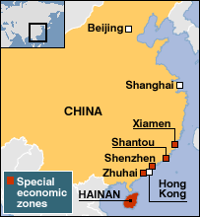Deng began by opening up China to foreign investment. In the south east of China (Shenzhen) and in other designated parts of the country, Special Economic Zones (SEZs) were set up to attract multinational companies such as IBM.

SEZs were essentially free trade areas where the government reduced tariffs or provided financial support to encourage economic investment. SEZs allowed geographical regions to run their economy separately from the rest of the country. The most successful SEZ in China is Shenzen.

Shenzen is a city with over 12 million people. Just over 30 years ago, it was a small fishing village. In 1979, under the leadership of Deng, it became the first SEZ. It is now the largest manufacturing base in the world and southern China’s major financial centre.

It is close to Hong Kong and this has been a reason for its growth. There are plans for the two cities to integrate over the next decade to create a metropolis large enough to rival New York and Tokyo. The cost of living in Shenzen is considerably lower than in Hong Kong.

The SEZ was created to be an experimental ground of capitalism in “socialism with Chinese characteristics”.

As well as welcoming foreign investment, Deng also allowed individual Chinese citizens the right to start up a business or to become involved with foreign companies in joint venture enterprises.

Within a few years, Deng’s policies had proved to be a huge [success and were extended to other areas of China.](http://news.bbc.co.uk/1/hi/special_report/1999/09/99/china_50_years_of_communism/453330.stm)

**Household Responsibility System**

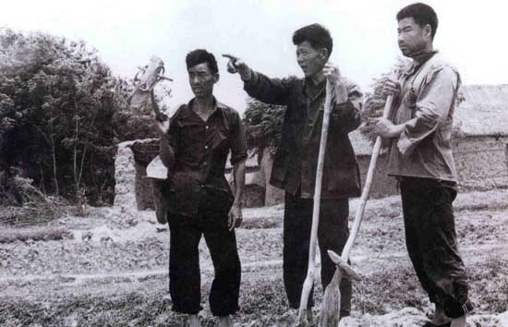In this system each family is independently responsible for managing plots of land. The family units, which could consist of either an individual’s family plot or the combined plots of a group of families, enter into a contract with the government. The land is leased to the unit for a certain number of years and the farmers receive contracts from the government to produce certain crops. The decisions about what to produce and how to produce it are made by the farmers. Once the amount required by the government has been reached, any surplus crops can be sold for profit on the open market.

The fact that surplus crops can be sold on the open market gives the farmers an incentive to work hard and make a return on their efforts. This contrasts with the communist system which rewarded effort and cooperation rather than the end result of that effort i.e. the crops themselves and their market value. This system encourages farmers to take responsibility for efficient production and increasing the range of crops grown and the yield. Farmers can choose to grow non-food crops such as tobacco or cotton. The farmers can spend their profits on reinvesting in the land and machinery or spend it on consumer goods. As a result of the Household Responsibility System, crop yields rose and the national grain harvest shot up from 304 million tonnes in 1978 to 407 million tonnes in 1984.

The changes have brought improved living standards for many farmers and there is now a wider choice of quality food available.

**The Four Modernisations**

Deng Xioping planned to make China an important industrial nation and to do this he introduced the four modernisations:reforms in agriculture, industry, science and technology and the army.

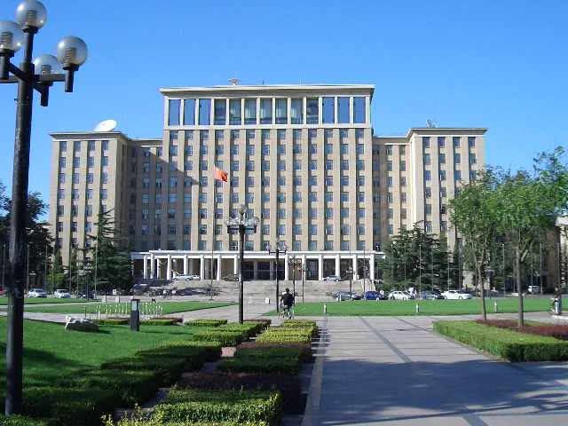Modernisations in agriculture meant that the emphasis on human labour in the communes was replaced by machinery. Modern fertilisers, pesticides and technology increased agricultural output and ensure more reliable food supplies.

Modernisations in industry led to rapid developments in the chemical, textile, metal and engineering industries which created greater efficiency and productivity.

Modernisations in science and technology was spurred on when the scientists who had been imprisoned or sent to work as peasants in the communes were released and their skills employed. Schools and universities were encouraged to help more people gain qualifications to feed the research projects into modern technology, so money was put into universities to allow more people to study in these fields. The fourth modernisation involved defence and the modernisation of the armed forces.

**Modern China**

More recently the economy has opened up in other ways. China now has one of the 10 largest economies and is an important engine for economic growth across the globe. China consumes more steel, coal, meat and grain than any other nation. It is also the world's fifth largest exporter, trading extensively with the EU, Japan and the US. In 2006, 80% of the world's consumer electronics were made in China.

**1990**

Stock Markets open in Shanghai and Shenzhen

**1992**

Fourteenth Congress of the CCP: Officially endorses, “socialist market economy” as the goal of reform.

**1994**

Official renminbi exchange rate starts a market-based, but managed floating rate system.

Establishment of the ASEAN-China Joint Committee on Economic and Trade Cooperation and the ASEAN-China Joint Committee on Science and Technology in July 1994

Tax Reform - A comprehensive management system is set up to coordinate tax service and auditing operations and unifying taxes paid by local and international firms.  Tax revenue grows as a result.

Nation-Wide Liberalization- the CCP permits all of China, not just coastal regions, to attract FDI, private business, etc

**1997**

China provides Thailand and other Asian nations with over $4 billion (US) in aid.

President adopts a policy that attempts to boost domestic demand and stimulate economic growth.

Price Law passed -prices will be set by the market, but CCP retains right to intervene.

**1999**

China and the U.S. start to reach a bilateral agreement on China’s accession to the **World Trade Organisation (WTO).**

**2001**

Removal of trading restrictions- allowing domestic residents to trade stocks.

Jiang Zemin announces that private entrepreneurs can become CCP members.

China becomes a member of the WTO and is forced to revise existing laws and enact new legislation in compliance with the WTO.

- Eliminate price controls to protect domestic industry

- Eliminate export subsidies on agricultural products.

**2005**

**Joint venture schemes.** This has allowed companies like Cadbury and Volkswagen to co-operate directly with Chinese companies

**2007**

China agrees to increase market access, open financial sector, foster energy security, protect the environment, and strengthen the rule of law

**Tasks**:

1. Describe the three ways Deng Xiaoping opened up China’s economy to the rest of the world. You must make 3 points about each way (Nat 4).
2. Modern China has a very large economy. Describe 3 ways China has managed to work with the rest of the world (Nat 4).
3. Describe, in detail, how Deng Xiaoping has helped further develop China. 6 marks (Nat 5)
4. Since Deng’s ruling China has continued to develop, what factors can be attributed to this? 6 marks (Nat 5)
5. China’s economy growing so quickly has caused some problems for China, what are some of these problems? (Nat 5)

**Human Rights**

**One Child Policy**

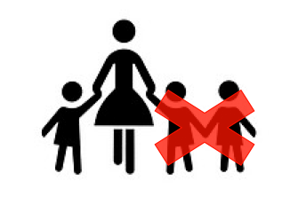In the late 1970s, the Chinese government introduced a number of measures to reduce the country's birth rate and slow the population growth rate. The most important of the new measures was a **one-child policy**, which stated that couples in China could only have one child.

* In 1950 the rate of population change in China was 1.9 per cent each year. If this doesn't sound high, consider that a growth rate of only 3 per cent will cause the population of a country to double in less than 24 years.

Previous Chinese governments had encouraged people to have a lot of children to increase the country's workforce. But by the 1970s the government realised that current rates of population growth would soon become unsustainable.

The one-child policy, established in 1979, meant that each couple was allowed just one child. Benefits included increased access to education for all, plus childcare and healthcare offered to families that followed this rule.

**Problems with enforcing the policy:**

* + Those who had more than one child didn't receive these benefits and were fined.
  + The policy was keenly resisted in rural areas, where it was traditional to have large families.
  + In urban areas, the policy has been enforced strictly but remote rural areas have been harder to control.
  + Many people claim that some women, who became pregnant after they had already had a child, were forced to have an abortion and many women were forcibly sterilised. There appears to be evidence to back up these claims.

**Impact of the policy**

* + The birth rate in China has fallen since 1979, and the rate of population growth is now 0.7 per cent.
  + There have been negative impacts too - due to a traditional preference for boys, large numbers of female babies have ended up homeless or in orphanages, and in some cases killed. In 2000, it was reported that 90 per cent of fetuses aborted in China were female.
  + As a result, the gender balance of the Chinese population has become distorted. Today it is thought that men outnumber women by more than 60 million.

**Long-term implications**

China's one-child policy has been somewhat relaxed in recent years. Couples can now apply to have a second child if their first child is a girl, or if both parents are themselves only-children. If their first child is disabled or dies before the age of 9 they can have a second birth.

While China's population is now rising more slowly, it still has a very large total population (1.3 billion in 2013) and China faces new problems, including the falling birth rate - leading to a rise in the relative number of elderly people. Also fewer people of working age to support the growing number of elderly dependents, in the future China could have an ageing population.

**Internet Access**

Wi-Fi connections are usually available at the best four and five-star hotels in first tier cities like [Guangzhou](http://www.chinahighlights.com/guangzhou/) or [Shanghai](http://www.chinahighlights.com/shanghai/). Outside of the hotels, Starbucks is your best choice for Wi-Fi. Though many Internet cafes stopped offering wireless connections to their customers because of rising costs associated with new regulations, the decrease in availability has been reversed given the expectations of customers.

Generally speaking, Wi-Fi availability in China is following much the same pattern as the rest of the world, although a little more slowly given the additional complications associated with governmental restrictions. Provided you're not too far away from a major city, you should not encounter too much difficulty finding somewhere which caters for your needs. However in rural areas there is still limited or no connection. The more remote the place the more limited the access to the internet.

The Chinese government has announced its intention to make wireless internet available all over the city of [Beijing](http://www.chinahighlights.com/beijing/), but users must log in with a China Mobile phone number to access the Web.

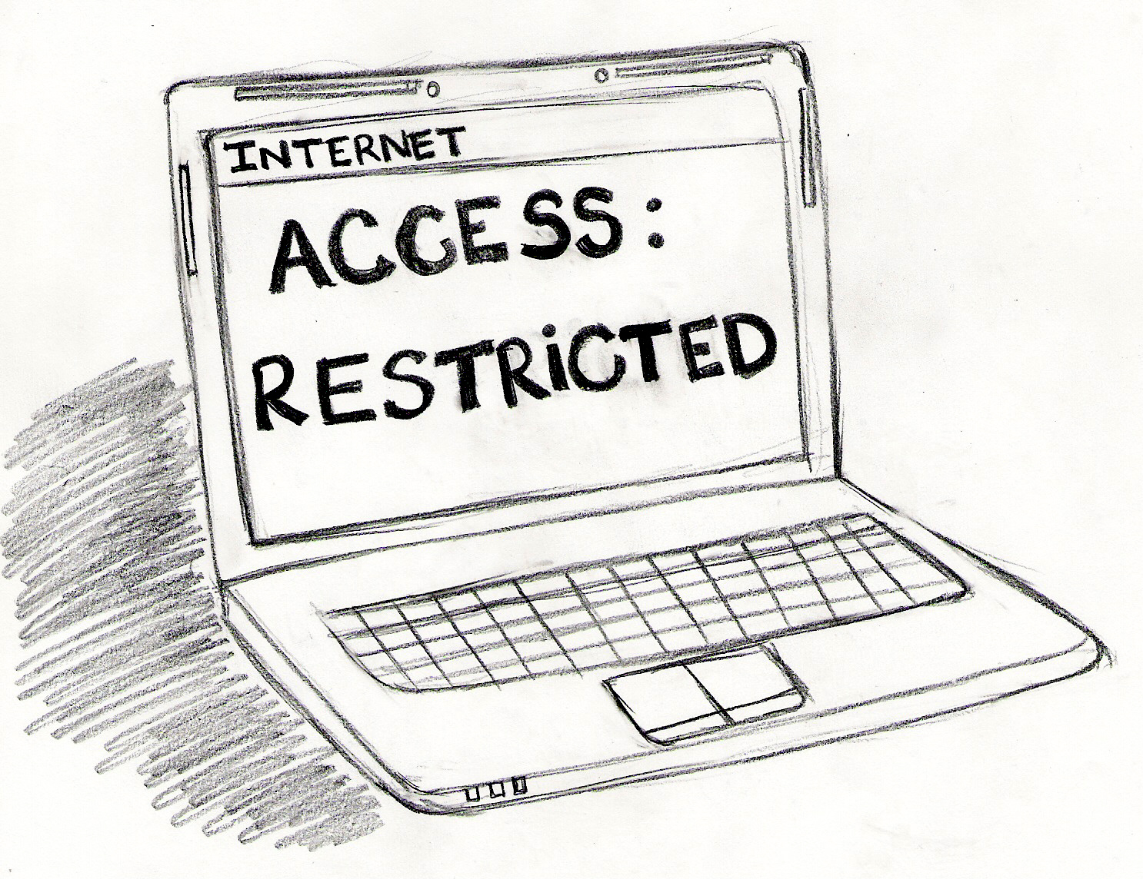When it comes to public access to the internet, the government's controls can make the experience exceptionally frustrating. Quite apart from direct censorship, other blocked services to which sites commonly link can lead to slow page loading, and the regulations imposed upon establishments offering a connection may change overnight, necessitating their changing their approach, even abolishing access altogether.

China does restrict access to certain types of websites, predominantly those which permit free interaction between people, such as social media and sites given to forum-style discussions. Thus you will find Facebook, YouTube, Twitter, and other social network sites are not available in mainland China. However in Hong Kong you would have normal access to these sites.

Of particular concern to many foreign visitors is Google. For some years Google services access has been impeded and, since 2014, access to most of Google has been blocked. *Google Mail*, though blocked from browsers, can be accessed through some home computers, but that service too is now sporadic.

From a foreign perspective, China's Internet now verges upon the dysfunctional, and 2014 has been a year particularly marked for its increase in blocking. 2015 and beyond seem likely to follow suit.

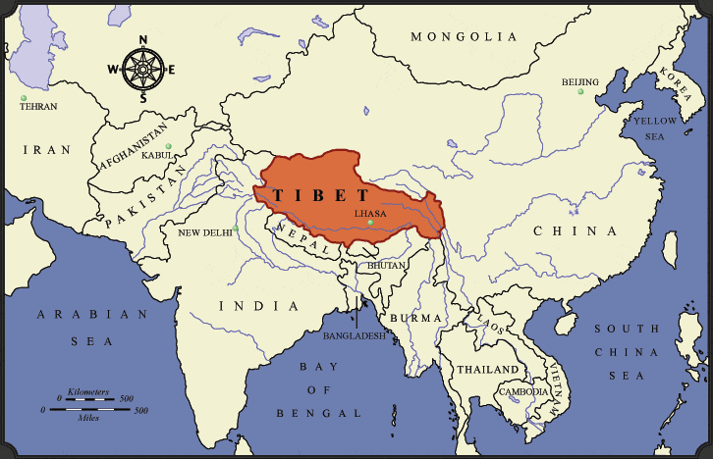

**Tibet**

Tibet currently isn’t a separate country; it is part of China. The reasons the Tibetan people hate the Chinese Government is clear to them. During Mao's rule, Tibet was invaded and taken over by Chinese rule. The Chinese claim they had the right to the land all along, as Tibet was really just part of China. The Tibetans strongly disagree that this was the case, as Tibet had everything it needed to be its own country before China took over including its own government and flag. China does not like that the Tibetans are so religious and are incredibly loyal to the Dali Lama, as this weakens their authority as a government.

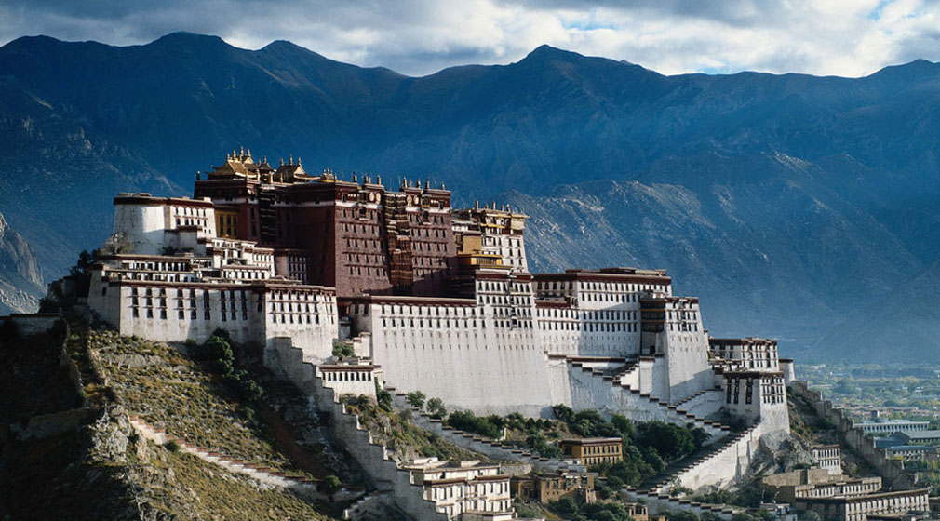Reported abuses of human rights in Tibet include restricted freedom of religion, belief, and association. Specifically, Tibetans have faced arbitrary arrest and maltreatment in custody, including torture at the hands of Chinese authorities. Freedom of the press in China is still absent, and Tibet's media is tightly controlled by the Chinese leadership,making it difficult to determine accurately the scope of human rights abuses. A series of reports published in the late 1980s claimed that China was forcing Tibetans to adhere to strict birth control programs that included forced abortions, sterilisations and even infanticide.

**Legal System**

Amnesty International has documented widespread human rights violations in China. An estimated 500,000 people are currently enduring punitive detention without charge or trial, and millions are unable to access the legal system. China remains the leading executioner in the world.

**Detention Without Trial**

The authorities frequently use administrative punishments, including Re-education Through Labour (RTL), to detain people without trial. According to the government, 190,000 people are held in RTL facilities, down from half a million several years ago, although the real figures are likely to be much higher. Former RTL prisoners reported that Falun Gong (Chinese spiritual organisation) constituted one of the largest groups of prisoners, and political activists, petitioners and others practicing their religion outside permitted bounds are common targets. The authorities also use a variety of illegal forms of detention, including "black jails", "legal education classes", "study classes" and mental health institutions to detain thousands of people.

**Death Penalty**

China continues to make extensive use of the death penalty, including for non-violent crimes. The death sentence continues to be imposed after unfair trials. Statistics on death sentences and executions remains classified as state secrets and, while executions number in the thousands, the government does not release actual figures.

Following the publication in 2008, of a document calling for political reform and greater protection of human rights, police questioned signatories and put them under surveillance for many months.

Liu Xiaobo, a prominent intellectual and signatory originally detained in December 2008, was sentenced to 11 years' imprisonment on 25 December which was for "inciting subversion of state power". His lawyers were given only 20 minutes to present their case, in a trial that lasted less than 2 hours.

[**Work Camps (Laogai)**](http://www.amnesty.org/news-and-updates/blog-my-life-inside-chinese-labor-camp-20091207)

Many of those found guilty of crimes in China, if not given the Death Penatly, will find themselves in prison work camps or laogai (which means ‘reform through labour’) where conditions are extremely harsh. Prisoners are: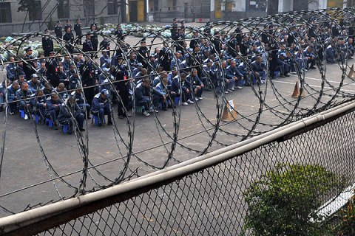

* routinely beaten or tortured
* denied sleep, adequate food or clothing and access to friends and family
* subjected to ‘re-education’ or thought reform
* Forced to work, often in dangerous or unhealthy jobs

Today, thousands of Chinese people are thought to be held in work camps. These camps are most often focused around a farm, mine or factory. It is estimated that one quarter of the tea produced in China is from work camps.

**Task**:

In groups of 4 you are going to investigate and present information one of the following points:

1. The Death Penalty
2. Tibet
3. One Child Policy (Population Problems)
4. Laogai (work camps)
5. HIV
6. Internet Access
7. The Legal System
8. Demonstration & Protests (Tiananmen Square)

Success Criteria:

Your presentations must include:

1. A history in China of your human right
2. Problems of this issue for Chinese Citizens
3. Key case studies of your issue
4. Statistics and facts
5. Any government responses to your issue

Presentation Rules:

1. Presentations must last no more than 5 minutes
2. No more than 20 words per slide
3. Must include pictures

In addition to a presentation you must create a **hand out** for the pupils in your class to stick into their jotters.

You have **4 Periods** to complete this task.

**Hukou System**

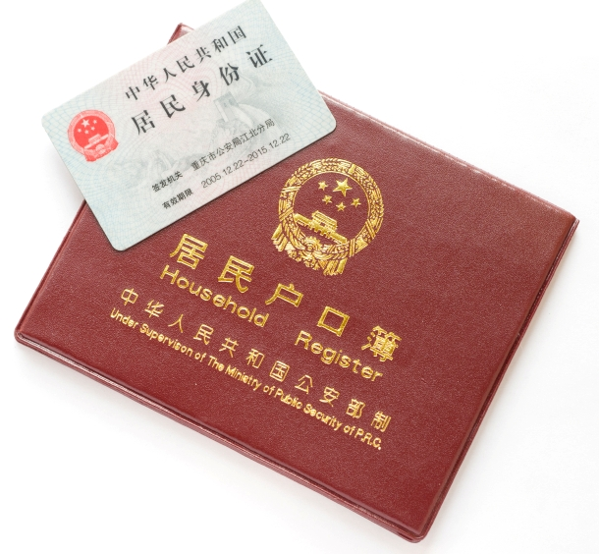

China's Hukou system is a family registration program that serves as a domestic passport, regulating population distribution and rural-to-urban migration.  It is a tool for social and geographic control that enforces an apartheid (or segregated) structure that denies farmers the same rights and benefits enjoyed by urban residents.

**History of the Hukou System**

The modern Hukou system was formalized as a permanent program in 1958. The system was created to ensure social, political, and economic stability.  In order to speed up industrialisation, the government prioritised heavy industry by following the Soviet model.  In order to finance this expansion, the state underpriced agricultural products and overpriced industrial products to induce an unequal exchange between the two sectors, essentially paying peasants less than market price for their agricultural goods.  In order to sustain this artificial imbalance, the government had to create a system which restricts the free flow of resources, especially labour, between industry and agriculture, and between city and countryside.

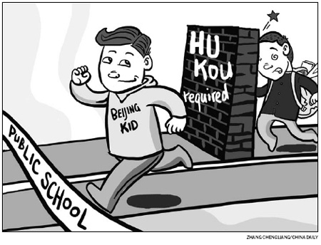Individuals became categorised by the state as either rural or urban, and they were required to stay and work within their designated geographic areas.  Traveling was permitted under controlled conditions, but residents assigned to a certain area will not be given access to jobs, public services, education, health care, and food in another area. A rural farmer who chooses to move to the city without a government-issued Hukou would essentially share the same status an illegal immigrant in the United Kingdom.  Obtaining an official rural-to-urban Hukou change is extremely difficult.  The Chinese government has tight quotas on conversions per year.

**Effects of the Hukou System**

The Hukou system has historically always benefited the urbanites.  During the Great Famine of the mid-twentieth century, individuals with rural Hukous were collectivised into communal farms, where much of their agricultural output where taken in the form of a tax by the state and given to city dwellers.  This led to massive starvation in the countryside, and the [Great Leap Forward](http://asianhistory.about.com/od/asianhistoryfaqs/f/greatleapfaq.htm) would not be abolished until the effects were felt in the cities. After the Great Famine, rural residents continued to be marginalised, while urban citizens enjoyed a range of socio-economic benefits.  Even today, a farmer's income is one sixth that of the average urban dweller.  Farmers have to pay three times more in taxes, but receive a lower standard of education, healthcare, and life.  The Hukou system impedes upward mobility, creating essentially a caste system that governs Chinese society.  Since the capitalistic reforms of the late 1970's, an estimated 260 million rural dwellers have illegally moved to the cities, in an attempt to partake in the remarkable economic development taking place there.  These migrants brave discrimination and possible arrest while living on the urban fringe in shantytowns, railway stations, and street corners.  They are often blamed for rising crime and unemployment.

**Shanty Towns**

China’s shanty towns are becoming the worst in the world. The number of shantytowns in China has exploded. Anhui (Chinese City) had 800,000 households living in shantytowns in 2008, but now finds that 1.5 million people live in shantytowns (2014). Shanty Towns come with their own unique problems.

* **Overcrowding** - the settlement has a high population density.
* **Fires** - fires can spread quickly.
* **Overpopulation** - the area does not have enough resources to support the growing population.
* **Competition for jobs** - jobs are in short supply.
* **Disease** - poor sanitation and limited health care can lead to the spread of disease.
* **Lack of space** - the newest and poorest arrivals may be forced to live on the worst quality land.
* **Infrastructure** - services are poor, public transport is limited and connections to the electricity supply can be limited and sometimes dangerous.

China aims to spend 1trillion Yuan by 2020 improving conditions in Shanty Towns. It hopes to spend this money on improving sanitation and building proper transport networks in and out of the cities. It also aims to build some high rise flats, this is difficult however due to lack of space.

**Reform to Hukou**

With China's rapid industrialisation, the Hukou system needed to be reformed in order to adapt to the country's new economic reality.  In 1984, the State Council conditionally opened the door of market towns to peasants.  Country residents were allowed to get a new type of permit called, “self-supplied food grain” Hukou, provided that they satisfied a number of requirements.  The primarily requirements are that a migrant must be employed in enterprise, have their own accommodations in the new location, and be able to self provide their own food grain.  Holders are still not eligible for many state services and they cannot move to other urban areas ranked higher than that particular town.  In 1992, the CCP launched another form of permit called the "blue-stamp" Hukou.  Unlike the "self-supplied food grain" Hukou, which is limited to certain business peasants, the "blue stamp" Hukou is open to a wider population and allowed migration into bigger cities.  Some of these cities included the [Special Economic Zones](http://chineseculture.about.com/od/businesseconomy/a/Chinas-Special-Economic-Zones-Sez.htm) (SEZ).  Eligibility was primarily limited to those with family relations with domestic and oversea investors.

The Hukou system experienced another form of liberation in 2001, after [China](http://geography.about.com/library/weekly/aa060997.htm) joined the [World Trade Organization](http://geography.about.com/od/politicalgeography/a/wto-world-trade-organization-overview.htm) (WTO).  Although WTO membership exposed China's agricultural sector to foreign competition, leading to job losses, it galvanised the labor-intensive sectors, particularly in textile and clothing, leading to an urban labour demand.  The intensity of patrols and documentation inspections were relaxed.  In 2003, changes were also made to how illegal migrants are to be detained and processed.  This was the result of a media and an internet-frensied case in which a college educated urbanite named, Sun Zhigang, was beaten to death after he was taken into custody for working in the megacity of Guangzhou without the proper Hukou ID. Despite the reforms, the current Hukou system still remains fundamentally intact because of the continuing disparities between the state's agricultural and industrial sectors.  Although the system is highly controversial and vilified, a complete abandonment of the Hukou is not practical, due to the complexity and interconnectedness of the modern Chinese economic society.  Its removal could lead to a migration so massive that it could cripple city infrastructures and destroy the rural economy.  For now, minor changes will continue to be made to the Hukou, as it coincides with China's shifting political climate.

**Tasks**:

Read and takes notes (in any form you wish) about the Hukou and the problems it causes (Nat 4 and 5).

Answer this SQA Practice Question (Nat 5) –

1. Explain, in detail, the population problems in a world power you have studied.
   * 6 marks
   * (Reference - Hukou, One Child Policy, Shanty Towns)
   * PEE (Point, Explain, Example)

2. Make a poster informing new visitors to China about the Hukou (Nat 4).

**Socio-economic Inequalities**

**Employment**

|  |  |
| --- | --- |
|  | |
|  | |
| http://3.bp.blogspot.com/-NYy8qQZai5A/T4WCRNUaHUI/AAAAAAAADRk/q6X9BbORCjU/s1600/Iron+rice+bowl.jpg**The "iron rice bowl" is a Chinese idiom which referred to the now abolished system of guaranteed lifetime employment.** After the Communists came to power, all workers and farmers were put under state control. Their work units controlled every aspect of daily life, including the allocation of housing, food and clothing. They also decided who could marry and when, and who was allowed to have children. In return, work units would look after their workers for life. But China's transition from a centrally planned economy to a market economy has smashed the old guarantees. Millions of workers have been laid off as state-run firms have been restructured or shut down. This has sparked angry protests from their workers, who complain they have been left without the welfare benefits they were once promised. |

Due the Iron Rice Bowl and the 4 modernisations China suffers from an employment problem; too many over qualified citizens. Youth unemployment in China is a simple one, the country is not creating a sufficient number of high-quality positions to soak up its educated youngsters. A record number 6.9 million students graduated from college in 2013, up 190,000 from the year before. However, the number of jobs that require a college education fell by around 15% in some cities. In Beijing for example, 229,000 students graduated in 2013. But according to data from hiring businesses and organisations, there were only 98,000 jobs available for graduates, 16,000 fewer than in 2012. Commentators dubbed 2013 “the worst year to graduate in history.”

One report showed that as of April 2013, only 32% of graduates from the higher vocational schools, 35% of those in undergraduate programs and 26% of those in master programs had secured employment, all these rates were at least ten percent lower than the figures in 2012.

Not only are the number of jobs for graduates limited, the salaries and benefits offered in the available jobs are relatively low. One survey found that the average monthly income for those graduating in 2012 was just 3,048yuan, an increase of 282yuan from 2011. Another survey in 2012 revealed that the monthly incomes of new graduates were basically comparable with those of migrant workers with a middle school education. The results showed that about 69% of graduates earned less than 2000yuan a month in their first job.

Company recruiters and human resources managers routinely complain that college graduates are fundamentally unsuited to the current job market and have unrealistic expectations about salaries, working conditions and career development. Employers complain that graduates can be over-confident and unwilling to compromise. As [one recruiter in Shanghai put it,](http://www.marketplace.org/topics/world/education/tales-shanghai-job-fair-why-chinas-college-grads-employers-mismatched) “college graduates these days think they’re really special. The problem is they’re the only ones who think that. Everyone goes to university, it has become the way of life”

**Government Responses**

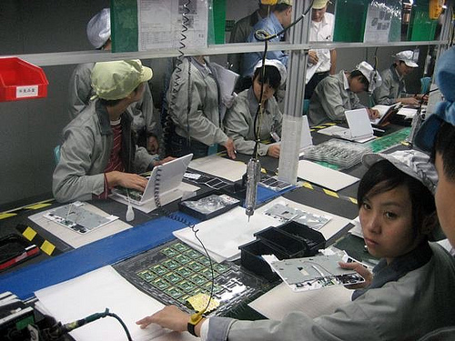In May 2012, the government responded to the crisis by implementing a series of measures aimed at making graduates better-informed and better-equipped to deal with the realities of today’s job market. It suggested creating a registration system for unemployed graduates to better relay information about job openings and making career fairs more specialised. Career counselling services would be provided to all registered unemployed graduates, allowing them to better understand and cope with the demands in the labour market through seminars and mock interviews.

In addition, the authorities have vowed to revamp the vocational college system in China and bring it more into line with the actual needs of business. Several local governments have already pledged to provide free vocational training for students in those industries most in need of skilled labour. Graduates in many regions are also encouraged to set up their own business. For instance, those [setting up their own business in Guangdong](http://cy.ncss.org.cn/cydt/275347.shtml) will be exempted from administration fees and can apply for a low-interest loan of up to 100,000yuan and other subsidies.

Since 2005, the central government has organized a program designed to encourage graduates to work in rural areas and support the development of agriculture, healthcare and education, as well as combat poverty. Graduates participating in the "three supports and one assistance” program receive subsidies and assistance in finding employment. According to the CCP, 28,400 college graduates took part in the programme in 2012.

**Education**

Educational inequalities, particularly according to Province, are evident in terms of access and quality. The higher the level of education, the greater the degree of inequality. This is partly due to the increasing cost of receiving more schooling. Also, there are large differences in education funding, school facilities, teacher qualifications and school achievements across provinces and between rural and urban areas.

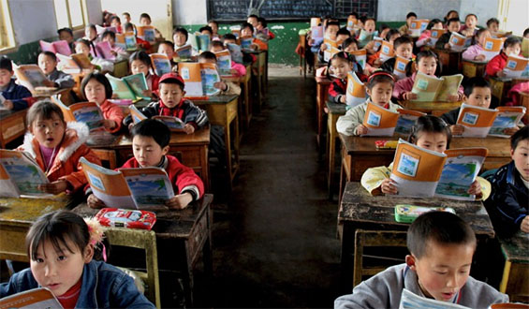25% of students cannot complete their junior high schooling in poor rural areas. Besides the informal fee payment system in schools, the rapid increase in unwages has also tempted young people to drop out of school to work. In terms of education quality, ordinary education in China has gradually changed from a meritocratic competition system to a largely private competition system in which students’ level of achievement is determined by wealth, power and private connections. In urban areas, disparities between higher quality ‘key’ schools and lower quality ‘ordinary’ schools are evident in the differential enrolment rates of local, migrant, and poorer children. The increased importance of private connections and “selection fees” to get children into elite urban public schools reinforces existing social disparities.

Inequalities in educational attainment and school quality are reinforced by the Hukou system. This presents particular challenges for migrant workers and their families who have limited access to social services outside their home province. The effect is that migrant families have to pay fees to give their children an education in urban areas and even then, their children can only attend regular schools, not higher quality ‘key schools’. In higher education, children from rural backgrounds have been increasingly excluded from good quality universities in China. While the proportion of college students from rural areas has increased over the past 20 years, the rural–urban gap continues to exist.

Once in school the problem do not stop. Schools all over China are drastically overcrowded and this has resulted in families ‘paying for the front seat’ whereby parents pay the school (or sometimes the teacher of the class) to allow their child a seat in a prime position to have full access to the education. The urban/rural divide continues here too and teachers pay in urban areas is more than double that of rural areas meaning the best quality teacher go to where the money is, meaning rural school can at time have less good/educated teachers.

**Government Responses**

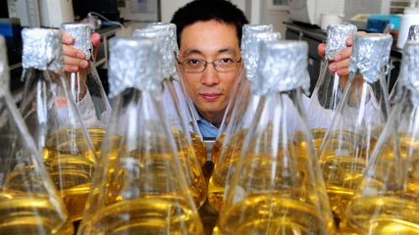In 2009 the Government aimed to fix some of the education problems in China by making schooling mandatory until the age of 9, and the government funds this for every child regardless of geographical location. It includes 6 years of primary education starting at the age of 6. The CCP now also allow ‘private’ schools to be set up to deal with overcrowding, however, they are closely monitored by the CCP to check teaching is of a level they approve of. To cope with the shortage of qualified teachers, the State Education Commission decreed in 1995 that senior school teachers should be graduates with two years' training in professional institutes and that primary school teachers should be graduates of secondary schools. To improve teacher quality, the commission established full-time and part-time (the latter preferred because it was less costly) in-service training programs. However, because urban teachers continued to earn more than their rural counterparts and because academic standards in the countryside had dropped, it remains difficult to recruit teachers for rural areas. Teachers in rural areas also have production responsibilities for their plots of land, which takes time away from their teaching. Rural primary teachers needed to supplement their pay by farming because most were paid by the relatively poor local communities rather than by the state. But the 2000 "National Project of Compulsory Education in Impoverished Areas" involved the allocation of 3.9 billion special funds from the central finance and 10 billion yuan raised by local governments to improve schooling conditions in impoverished areas. This is helping to raise the rural standard of education but very slowly.

**Sanitation**

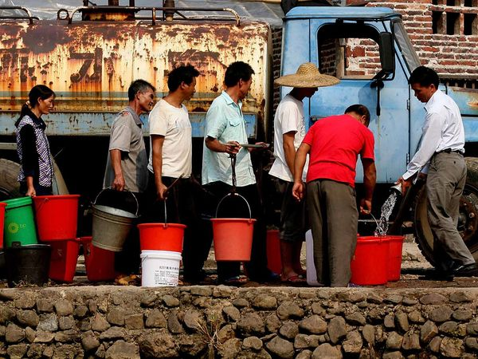There is unequal access to safe water and sanitation, access is related to with income levels. In five selected provinces for safe water projects, found that the proportion of children without safe water in poor households was 33.47%, while the proportion in non-poor households was 14.56%. A survey on water and sanitation conditions of primary and junior high schools in rural areas suggests that the quality of water and sanitation in different regions is closely linked to its economic development. In 2008, more than 16% of schools nationally were without a water supply system, two-thirds of schools lacked hand-washing facilities, and three-quarters of schools had no sanitation facilities. There are also clear differences in the choice of healthcare provider among the richest and poorest in the population. The richest tend to favour provincial and city-level health facilities, which offer the most comprehensive care. In China, community-level clinics offer cheaper and lower- quality healthcare. These services are more likely to be used by the poorest people. Many people from the lowest incomes cannot afford to use health services at all. Unsafe water and poor sanitation and hygiene accounted for 62,800 deaths in 2005.

**Government Responses**

The government have invited in Save the Children to help with sanitation problems. In the last 10 years, 712 million people in China (54% of the population) had access to improved drinking water; 269 million (21%) had access to partially improved drinking water thanks to Save the Children. Approximately 773 million people had access to improved sanitation (59%). Drinking water and sanitation access varied by province, from a high of 99% coverage in Shanghai to a low of 23% in Tibet.

**Health Care**

For many years, the health care system in China was not comprehensive, of poor quality and too expensive for the poor.

While there have been significant improvements in the standard of living of many people in China due to the economic reforms of the past two decades, this progress has not been matched in terms of healthcare. Under the old system, state-owned enterprises provided health care – this is no longer the case.

Rural areas are particularly hard hit, with 39% of the rural population unable to afford professional medical treatment. Only 12% of people in rural areas have health insurance, compared to 54% in urban areas. In 1997, the overall performance of China’s healthcare system ranked 144th in the world.

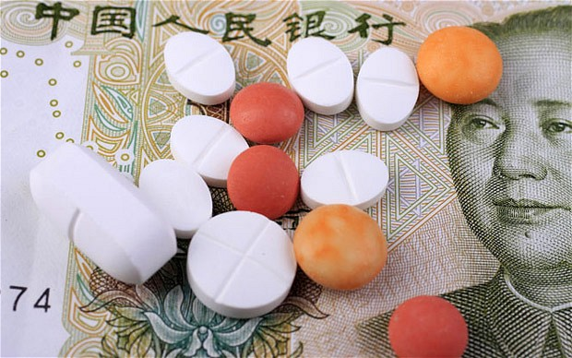This situation is largely due to the end of farming communes and their rural health clinics that were replaced with private medical practices in the 1980s. Over one third of the urban population also find they cannot afford the medical treatment they need.

The state owned enterprises provide health care under the **danwei** system, which was a work unit providing people with a place to live. However, many state owned enterprises have gone out of business. Workers who lose their jobs also lose any medical insurance coverage. The better off can afford private medical insurance. There is also considerable corruption in the system. Half the money for doctors’ salaries comes from drug sales, leading to over-prescribing and unnecessary procedures.

**Government Responses**

The New Rural Co-operative Medical Care System. Introduced in 2005, intends to make health care more affordable to the rural poor. Under the NRCMCS, 40% of the cost of an individual’s health care costs are paid for by the central government, 40% by the provincial government and 20% by the individual themselves. By 2007, around 80% of the rural population of China had signed up for the NRCMCS.

The system is tiered, depending on the location. If patients go to a small clinic in their local town, the system will cover roughly 70-80% of their bill. If the patient visits a county clinic, the percentage of the cost being covered falls to about 60%. If the patient requires a specialist in a modern city hospital, the plan would cover about 30% of the bill. The NRCMCS is an improvement on what went before but many poor people still cannot afford the cost of their health care.

Central government has allocated £270 million to help every province, city and county set up its own disease control and prevention centre. Some initiatives include allocating special funds to central and western China, and funding graduates of medical colleges to serve in rural hospitals for one or two years.

**Tasks**:

Read the case studies provided by your teacher.

1. Order them from 1-6 – 1 being the person who has the best life in China down to 6 being the person you think has the worst life in China
2. Use your jotter to mind map what you think the key problems are in China with relation to:
   1. Education
   2. Health Care
   3. Employment
   4. Sanitation
3. Explain, in detail, the problems with **Education** in a world power of have studied, you may also comment on government responses to inequality. 6 marks
4. Explain, in detail, the problems with **employment** in a world power of have studied, you may also comment on government responses to inequality. 6 marks
5. Explain, in detail, the problems with **health care** in a world power of have studied, you may also comment on government responses to inequality. 6 marks
6. Taking notes to revise from is your responsibility. You need to know inequalities in a work power you have studied. Make sure you have enough notes to revise from pages 25-31.
7. Research task – Research other inequalities – crime, housing, the gender gap and wealth inequalities in China.
   1. Once you have researched facts and statistics about the inequalities you must also look for any government responses to this inequality.
   2. Present your information to the class in the form of a large poster and a pupil hand out.